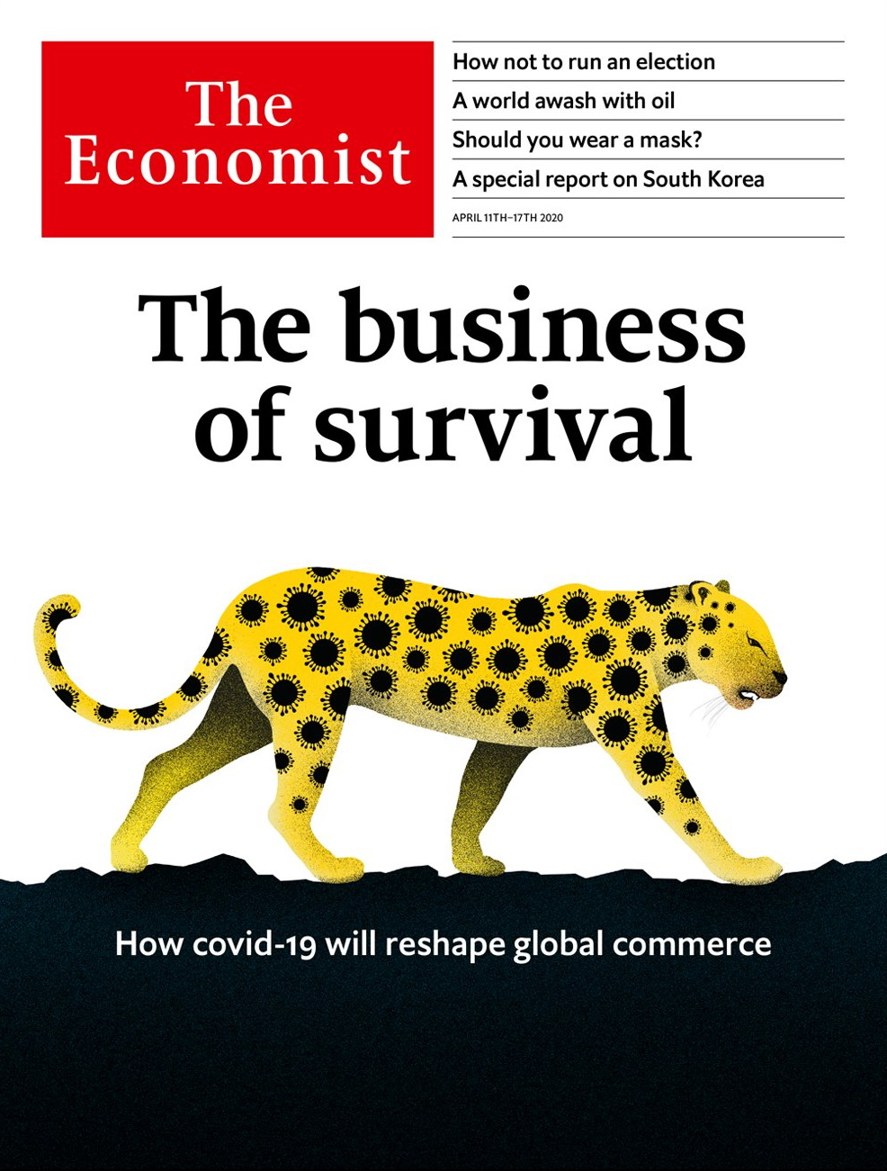

# Table of Contents

The world this week

Politics this week

Business this week

KAL’s cartoon

Leaders

A business survival guide to the economic slump: The business of survival

The euro area: Cut to the chase

Voting in a pandemic: Wisconsin’s warning

The IMF: Break the glass

America v China: Huawei and 5Geopolitics

Letters

Letters to the editor: On covid-19, China, digital payments, cats, Sinn Fein, Jamie Dimon, Tahiti

Briefing

Covid and the company: Sinking, swimming and surfing

Manufacturing at a distance: Still made in China

Ructions in the oil market: Upside down

United States

White House v virus: Bigger than Trump

Race and covid-19: Woes compounded

The intelligence community: The spooky state

The navy: Seasickness

Living spaces: Please shower on entry

Prison gerrymandering: Ghost constituents

Lexington: A river runs through it

The Americas

Latin America and covid-19: Bracing for a battering

A battle in the Caribbean: Bolivarian farce

Bello: A president who is isolating himself

Asia

Singapore and covid-19: No way out

Justice in Uzbekistan: Blind obedience

Taiwan on alert: Strait and harrow

Sexism in Japan: Heels at high water

Criminal justice in Australia: Judges v jury

Politics in South Korea: Voting amid the virus

Banyan: Locked out of the bolthole

China

Traditional medicine: Fighting it the Chinese way

Beekeeping: The honey trap

Chaguan: A window almost closed

Middle East and Africa

Iraq: Dark times ahead

Covid couture: Lebanon gets comfortable

Fiscal ill-health: Debt and disease

Kenya: Tall tales of the city

African agriculture: Dummy farms

Europe

Europe’s response to covid-19: Paying for it

Greece’s vulnerable economy: A terrible toll on tourism

Turkey and covid-19: Perfumed guardian

Russia: The invisible leader

Charlemagne: Zoom diplomacy

Britain

Covid-19: Patient number one

Labour’s new leader: Socialism with a barrister’s face

Lockdown compliance: For queen and country

Misinformation and mobile networks: Dodgy signal

The other sick: Stay home, protect the NHS, unless...

Funerals: Ashes to ashes

The economy: Over the cliff edge

Bagehot: Missing Boris

International

Religious divides: Living on a prayer

Virtual worship: Our Father, who art in cyberspace

Special report

South Korea: Loosening up

New economic models: Another way to work

Men and women: Battle lines

Beyond K-pop: K-pop’s intellectuals

Politics: A flickering legacy

North Korea: A god-king with nukes

The future: The limits of loosening

Business

Telecommunications: 5Geopolitics

Bartleby: It’s cold outside

Technology: SoftBank and sensibility

Online collaboration: Zoom in, Zoom out

Schumpeter: Strategic pile-up

Finance and economics

Banks and the economic emergency: This time we’re different

Price gouging: Signal failure

Buttonwood: Stacked and whacked

Joe Stiglitz and the IMF: Pilgrimage to the gamma quadrant

Taken ill: The labour market’s turn for the worse

Free exchange: Special delivery

Science and technology

Covid-19 (1): Maskarade

Covid-19 (2): Absence of evidence is not evidence of absence

Books and arts

Art and injustice: Vengeance is hers

London fiction: Through the trapdoor

Postcards from doomsday: This is the end

Do the right thing: Walking on by

Soviet dissidents: Keeping the flame alight

Trollope’s world: The way to live now

TV drama: A Flemish Robin Hood

Economic and financial indicators

Economic data, commodities and markets

Graphic detail

Measuring covid-19: Footprints of the invisible enemy

Obituary

Catherine Hamlin: Faith healing



### Thursday, April 9, 2020

|  |  |
| --- | --- |
| The world this week | 3 |
| Leaders | 5 |
| Letters | 1 |
| Briefing | 3 |
| United States | 7 |
| The Americas | 3 |
| Asia | 7 |
| China | 3 |
| Middle East and Africa | 5 |
| Europe | 5 |
| Britain | 8 |
| International | 2 |
| Special report | 7 |
| Business | 5 |
| Finance and economics | 6 |
| Science and technology | 2 |
| Books and arts | 7 |
| Economic and financial indicators | 1 |
| Graphic detail | 1 |
| Obituary | 1 |

|  |  |  |
| --- | --- | --- |
|  | Sections | Leaders |

The world this week

Politics this week

.

Business this week

.

KAL’s cartoon

.

|  |  |  |
| --- | --- | --- |
|  | Sections | Leaders |

|  |  |  |  |
| --- | --- | --- | --- |
|  | Articles | Sections | Next |

# Politics this week

Apr 8th 2020 |

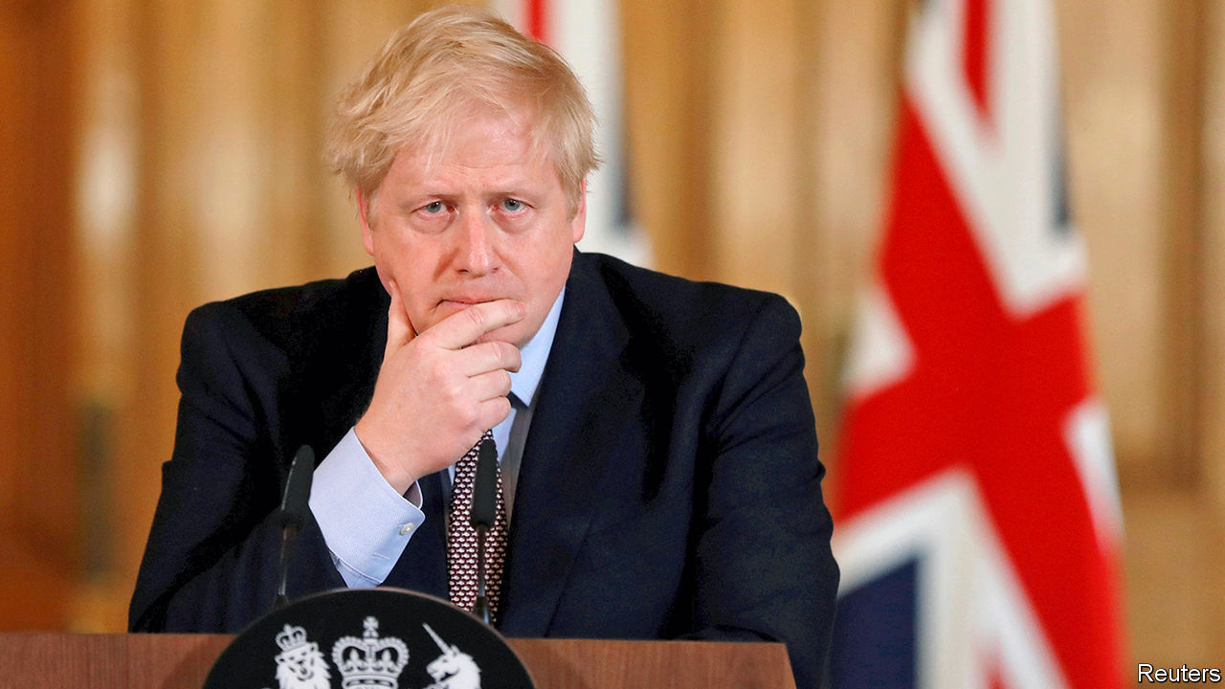

Boris Johnson, Britain’s prime minister, who has contracted covid-19, was admitted to intensive care after a deterioration in his breathing. Dominic Raab, the foreign secretary, is to stand in for him chairing cabinet meetings “where necessary”. See article.

America braced itself for a surge in deaths related to the new coronavirus. There were some tentative signs of good news in Europe, as the number of people dying and the number of new cases registered each day fell in several countries, including Spain and Italy, the two worst-affected. Austria talked of starting to emerge from its shutdown, and in Denmark junior schools and kindergartens are to reopen. But Europe remains the worst-hit part of the globe.

For the first time since it started publishing daily figures in January, China reported no new deaths from covid-19. A cordon sanitaire was lifted around Wuhan, the city where the outbreak was discovered. The country’s borders remained shut to most foreigners. Meanwhile, Donald Trump accused the WHO of being “very China-centric” in its handling of the crisis.

China’s Communist Party said it was investigating a property tycoon, Ren Zhiqiang, for “serious violations of discipline and law”. An essay attributed to Mr Ren accused Xi Jinping of being a “clown” and argued that the covid-19 epidemic had been made worse by curbs on freedom of speech.

Covid-19 infections jumped in a number of big Asian countries, including Indonesia, Japan and Pakistan. The governments of Japan and Singapore, which had not yet placed severe restrictions on people’s movement, did so. But South Korea, which was the first country outside China to suffer a severe outbreak, said elections would go ahead on April 15th, after a slowing of new infections. See article.

The authorities in Myanmar arrested the editor-in-chief of a news website for publishing an interview with the spokesman of a rebel militia that the government had recently labelled a terrorist group. The editor faces life in prison.

George Pell, an Australian cardinal who was once the Vatican’s main financial manager, was acquitted of sexual abuse of minors on appeal, after a two-and-a-half-year legal saga. A court in the state of Victoria had found Mr Pell guilty of assaulting two choirboys when he was Archbishop of Melbourne in the 1990s.

Wisconsin’s Democratic primary went ahead. A last-minute order from the Democratic governor to postpone the election, and other state contests, until June because of covid-19 was overturned by the state Supreme Court. Those voters who did venture out to the polling stations faced long queues. See article.

Meanwhile, the Democrats pushed back the date of their national convention from mid-July to mid-August. It is still supposed to take place in Milwaukee, though Joe Biden has suggested it might have to be held online.

Donald Trump sacked the inspector-general of America’s intelligence services. There was no apparent reason other than that he was the official who alerted Congress to a whistleblower’s complaint about the president’s dealings with Ukraine, which led to Mr Trump’s impeachment. See article.

Twitter removed thousands of accounts linked to the governments of Egypt, Honduras, Indonesia, Saudi Arabia and Serbia for attempting to “undermine the public conversation” in those countries.

Iran’s president, Hassan Rouhani, said that “low-risk” economic activities would resume in most areas. Iran has struggled to contain one of the world’s worst outbreaks of covid-19. But the government is worried about the effect of its mitigation efforts on the economy, which was already reeling because of sanctions.

Negotiations took place to free the leader of the opposition in Mali, Soumaïla Cissé, after he was kidnapped by gunmen believed to be affiliated with al-Qaeda, a jihadist group.

The British Labour Party elected Sir Keir Starmer as its new leader, replacing Jeremy Corbyn, who in December led Labour to its worst election defeat since 1935. The party’s new deputy leader, Angela Rayner, a Manchester native, may help the party recover the “red wall” of northern seats it lost to the Tories in December, though it has its work cut out. As the pandemic deepens the Conservative government’s popularity is hitting new highs. See [article](https://www.economist.com/britain/2020/04/11/keir-starmer-labours-electable-new-leader).

Ecuador’s top court convicted Rafael Correa, who was president of the country from 2007 to 2017, of corruption and sentenced him to eight years in jail. He was charged with accepting $8m in bribes in exchange for awarding public contracts. Mr Correa, who is living in Belgium, can appeal.

A Venezuelan naval patrol vessel fired on an unarmed Portuguese-flagged cruise ship, the RCGS Resolute, which it claimed was in its waters. Columbia Cruise Services said the holiday craft, hardened to withstand polar ice, was rammed by the Venezuelan vessel, which then sank. All 44 Venezuelan sailors were rescued. Their commanders congratulated them on their “impeccable performance”. See [article](https://www.economist.com/the-americas/2020/04/11/venezuelas-navy-battles-a-cruise-ship-and-loses).

## Coronavirus briefs

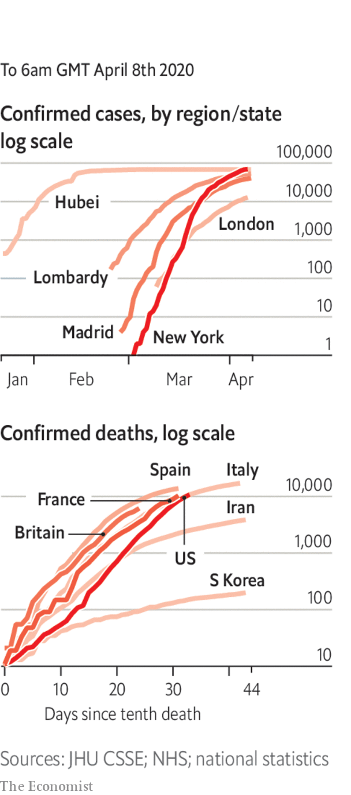

Joe Biden floated the idea that voters in America’s presidential election might have to participate by mail only.

The captain of the USS Theodore Roosevelt was fired after asking for help when covid-19 spread among his sailors. Officials said he had not gone through the proper channels in airing his complaint. The captain was given a rousing send-off by sailors. After a backlash, the head of the navy resigned. See article.

In South Africa a man was charged with spreading fake news about testing.

Scotland’s chief medical officer resigned after she broke the government’s advice by leaving her house, twice, during lockdown to visit her second home. See article.

A tiger in the Bronx Zoo is thought to have contracted covid-19 from an infected zookeeper. There is no evidence that tigers can give the disease to humans.

Read also on: <https://www.economist.com/the-world-this-week/2020/04/08/politics-this-week>

|  |  |  |  |
| --- | --- | --- | --- |
|  | Articles | Sections | Next |

|  |  |  |  |
| --- | --- | --- | --- |
| Previous | Articles | Sections | Next |

# Business this week

Apr 11th 2020 |

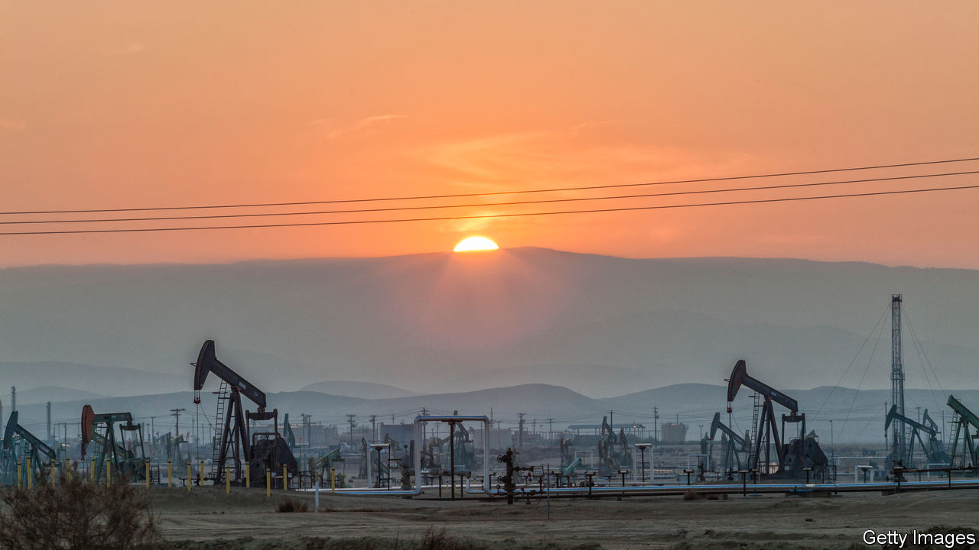

The S&P 500, Dow Jones Industrial Average and NASDAQ stockmarkets all rose by more than 5% on April 6th, as investors reacted positively to slowing death rates from covid-19 in a few places. But with America expecting a surge in new cases, trading remained turbulent. Oil prices whipsawed in reaction to differing reports about the possibility of Russia and Saudi Arabia reaching a deal to end their price war. A meeting between Russia and OPEC was postponed until later in the week, after which a meeting of G20 oil ministers is scheduled to take place. See article.

ExxonMobil reduced its planned capital spending by a third this year, a deeper cut than its rivals, which are also curtailing output amid forecasts of plunging energy demand. “We haven’t seen anything like what we’re experiencing today,” said the chief executive, Darren Woods.

Russia’s central bank said it would continue to sell dollar reserves, and that this was intended to stabilise markets. The rouble has weakened as oil prices have tumbled. The central bank indicated that a cut to interest rates was also on the cards. Non-essential businesses in Russia have been ordered to close.

The British Treasury unveiled yet another scheme to help companies ride out the crisis, this time providing a government guarantee to enable banks to make loans of up to £25m ($31m) to businesses with a turnover of between £45m and £500m. Those midsized firms had found themselves squeezed out of preceding rescue packages.

Bus companies in Britain received additional emergency funding from the Department of Transport in order to keep the services running and “provide a lifeline for those who cannot work from home”. Bus drivers have called for better protection; in London at least eight drivers have died from the coronavirus.

Boeing shut production of its 787 aircraft at its factory in South Carolina because of the covid-19 outbreak, and extended indefinitely the closure of its plant near Seattle. The aerospace company has invited workers to apply for voluntary redundancy, though it is still recruiting new employees “in certain areas”.

In Germany Lufthansa decommissioned around 40 jetliners and ceased operations at its Germanwings discount carrier. The airline warned that it will take “years until the worldwide demand for air travel returns to pre-crisis levels”.

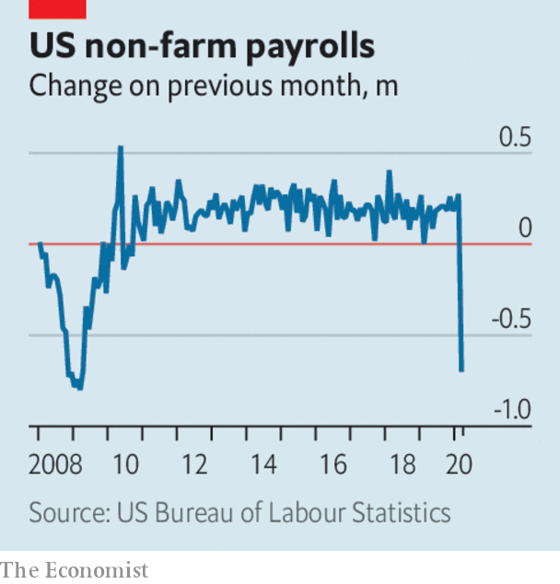

Around 10m Americans filed claims for unemployment benefits in the second half of March, more than had been expected following the virtual lockdown of the economy. Payroll employment plummeted by 701,000 in the month, a number not seen since the depth of the financial crisis. In Britain 1m new people applied for benefits over two weeks, ten times the normal rate. Some 4m workers have been temporarily laid off in France, and Spain has reported its biggest-ever rise in job losses. See article.

The German government said it would relax the border restrictions it has imposed during the pandemic and will allow tens of thousands of seasonal workers to enter the country, after farming groups and retailers warned that crops would otherwise be left to rot. The workers come mostly from eastern Europe and will be quarantined for two weeks.

Jamie Dimon returned to work full-time as chief executive of JPMorgan Chase, four weeks after undergoing emergency heart surgery. Like many people these days he is working remotely, though not isolated from the arguments on Wall Street about whether to cancel dividends. Mr Dimon warned investors that JPMorgan Chase could suspend shareholder payments for the first time.

The decision of HSBC to suspend its dividend payments has sparked a backlash among investors in Hong Kong, its biggest market. Along with other big British banks, HSBC suspended shareholder payouts after the Bank of England leant on them to do so, but a group of investors in Hong Kong has banded together to try to force an extraordinary general meeting on the matter.

Despite interruptions to production because of covid-19, Samsung forecast that its operating profit for the first quarter will be 6.4trn won ($5.2bn), up by 3% from the same three months last year. The South Korean tech giant expects to gain from increased demand for its chips in data centres and the roll-out of 5G networks. However, it could take a hit if consumers feel less inclined to splash out on smartphones and televisions.

## But he still won’t wear one

Donald Trump announced a deal with 3M, an American industrial conglomerate, that will see it import N95 respirator masks to the United States from its factories in Asia. The president had warned 3M that it would have “a hell of a price to pay” if it did not limit overseas sales of the face masks (under the deal it will continue to sell masks to Canada and Latin America). See article.

Read also on: <https://www.economist.com/the-world-this-week/2020/04/11/business-this-week>

|  |  |  |  |
| --- | --- | --- | --- |
| Previous | Articles | Sections | Next |

|  |  |  |  |
| --- | --- | --- | --- |
| Previous | Articles | Sections | Next |

# KAL’s cartoon

Apr 8th 2020 |

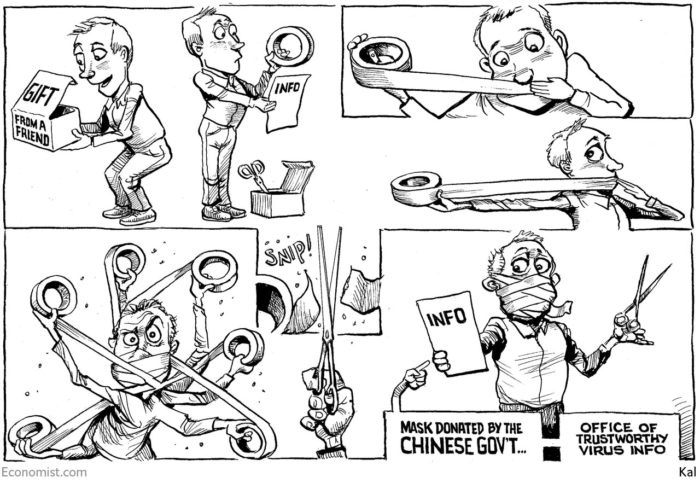

Read also on: <https://www.economist.com/the-world-this-week/2020/04/08/kals-cartoon>

|  |  |  |  |
| --- | --- | --- | --- |
| Previous | Articles | Sections | Next |

|  |  |  |
| --- | --- | --- |
| The world this week | Sections | Letters |

Leaders

A business survival guide to the economic slump: The business of survival

.

The euro area: Cut to the chase

.

Voting in a pandemic: Wisconsin’s warning

.

The IMF: Break the glass

.

America v China: Huawei and 5Geopolitics

.

|  |  |  |
| --- | --- | --- |
| The world this week | Sections | Letters |

|  |  |  |  |
| --- | --- | --- | --- |
|  | Articles | Sections | Next |

#### A corporate survival guide

# The crisis will change the world of commerce

Firms that make it through will face a new business climate

Apr 8th 2020 |

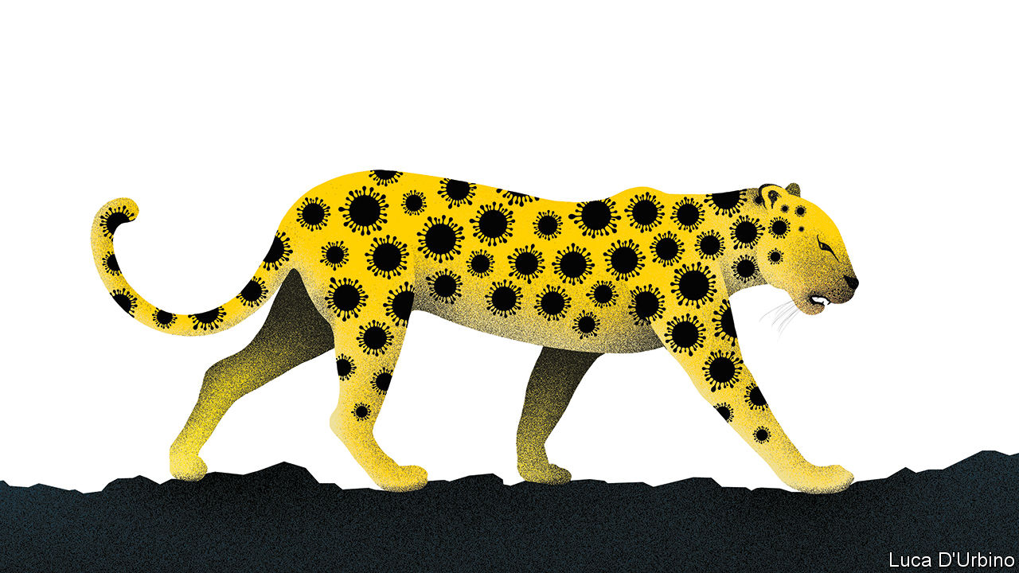

Editor’s note: The Economist is making some of its most important coverage of the covid-19 pandemic freely available to readers of The Economist Today, our daily newsletter. To receive it, register [here](https://www.economist.com/newslettersignup). For our coronavirus tracker and more coverage, see our [hub](https://www.economist.com/coronavirus)

MOST BOSSES and workers have been through economic crises before. They know that each time the agony is different—and that each time entrepreneurs and firms adapt and bounce back. Even so, the shock ripping through the business world is daunting. With countries accounting for over 50% of world GDP in lockdown, the collapse in commercial activity is far more severe than in previous recessions. The exit path from lockdowns will be precarious, with uneasy consumers, a stop-start rhythm that inhibits efficiency, and tricky new health protocols. And in the long run the firms that survive will have to master a new environment as the crisis and the response to it accelerate three trends: an energising adoption of new technologies, an inevitable retreat from freewheeling global supply chains and a worrying rise in well-connected oligopolies.

Many firms are putting a brave face on it. Pumped with adrenalin, bosses are broadcasting rousing messages to their staff. Normally ruthless corporate giants are signing up for public service. LVMH, the Parisian purveyor of Dior perfume, is distilling hand-sanitiser, General Motors wants to make ventilators as well as pickups, and Alibaba’s founder is distributing masks worldwide. Cut-throat rivals in the retail trade are co-operating to ensure supermarkets are stocked. Few listed firms have made public their calculations of the financial damage from the freeze in business. As a result, Wall Street analysts expect only a slight dip in profits in 2020.

Don’t be fooled by all this. In the last recession two-thirds of big American firms suffered a fall in sales. In the worst quarter the median drop was 15% year-on-year. In this downturn falls of over 50% will be common, as high streets become ghost towns and factories are shut. Numerous indicators suggest extreme stress. Global oil demand has dropped by up to a third (see article); the volume of cars and parts shipped on America’s railways has dropped by 70%. Many firms have only enough inventories and cash to survive for three to six months. As a result they have started to fire or idle workers. In the fortnight to March 28th, 10m Americans filed for unemployment benefits. In Europe perhaps 1m firms have rushed to claim state subsidies for the wages of inactive staff. Dividends and investment are being slashed.

The pain will deepen as defaults cascade through domestic payment chains. H&M, a retailer, is asking for rent holidays, hurting commercial-property firms. Some supply chains linking many countries are stalling because of factory closures and border controls. Italy’s lockdown has disrupted the global flow of everything from cheese to jet-turbine components. China’s factories are cranking back into action. Apple’s suppliers bravely insist that new 5G phones will appear later this year, but they are part of an intricate system that is only as strong as its weakest link. Hong Kong’s government says its firms are reeling as multinationals cancel orders and ignore bills. The financial strain will reveal some astonishing frauds. Luckin Coffee, a huge Chinese chain, has just admitted brewing its books.

In the past two recessions, about a tenth of firms with credit ratings defaulted worldwide. Which survive now depends on their industry, their balance-sheets and how easily they can tap government loans, guarantees and aid, which amount to $8trn in big Western economies alone. If your firm sells confectionery or detergent, the outlook is good. Many tech companies are seeing surging demand. Small firms will suffer most: 54% in America are closed temporarily or expect to be in the next ten days. They lack access to capital markets. And without friends in high places, they will struggle to get government help. Only 1.5% of America’s $350bn aid package for small firms has been disbursed so far and Britain’s effort has been slow, too. Banks are struggling to deal with contradictory rules and a flood of loan applications (see article). Resentment could rage for years.

Once exits from lockdowns start and antibody testing ramps up, a new, intermediate phase will begin (see article). Firms will still be walking, not running (China is still only functioning at 80-90% of capacity). Ingenuity, not just financial muscle, will become a source of advantage, allowing cleverer firms to operate closer to full speed. That means reconfiguring factory lines for physical distancing, remote monitoring and deep cleans. Consumer-facing firms will need to reassure customers: imagine conferences handing out N95 masks with the programme, and restaurants advertising their testing regimes. Over a quarter of the world’s top 2,000 firms have more cash than debt. Some will buy rivals in order to expand their market share or secure their supply and distribution.

The job of boards is not just to keep afloat, but also to assess long-run prospects. The crisis is set to amplify three trends. First, a quicker adoption of new technologies. The planet is having a crash course in e-commerce, digital payments and remote working. More medical innovations beckon, including gene-editing technologies. Second, global supply chains will be recast, speeding the shift since the trade war began. Apple has just ten days’ worth of inventory, and its main supplier in Asia, Foxconn, 41 days. Firms will seek bigger safety buffers and a critical mass of production close to home using highly automated factories. Cross-border business investment could drop by 30-40% this year. Global firms will become less profitable but more resilient.

## Don’t go from crisis to stasis

The last long-term shift is less certain and more unwelcome: a further rise in corporate concentration and cronyism, as government cash floods the private sector and big firms grow even more dominant. Already, two-thirds of American industries have become more concentrated since the 1990s, sapping the economy’s vitality. Now some powerful bosses are heralding a new era of co-operation between politicians and big businesses—especially those on the ever-expanding list of firms that are considered “strategic”. Voters, consumers and investors should fight this idea since it will mean more graft, less competition and slower economic growth. Like all crises the covid-19 calamity will pass and in time a fresh wave of business energy will be unleashed. Far better if this is not muffled by permanently supersized government and a new oligarchy of well-connected firms.■

Dig deeper:  
For our latest coverage of the covid-19 pandemic, register for The Economist Today, our daily [newsletter](https://www.economist.com/newslettersignup), or visit our [coronavirus tracker and story hub](https://www.economist.com/coronavirus)

Read also on: <https://www.economist.com/leaders/2020/04/08/the-crisis-will-change-the-world-of-commerce>

|  |  |  |  |
| --- | --- | --- | --- |
|  | Articles | Sections | Next |

|  |  |  |  |
| --- | --- | --- | --- |
| Previous | Articles | Sections | Next |

#### The euro area faces a new test

# Making Europe’s economy work better

Time to integrate further or break-up

Apr 11th 2020 |

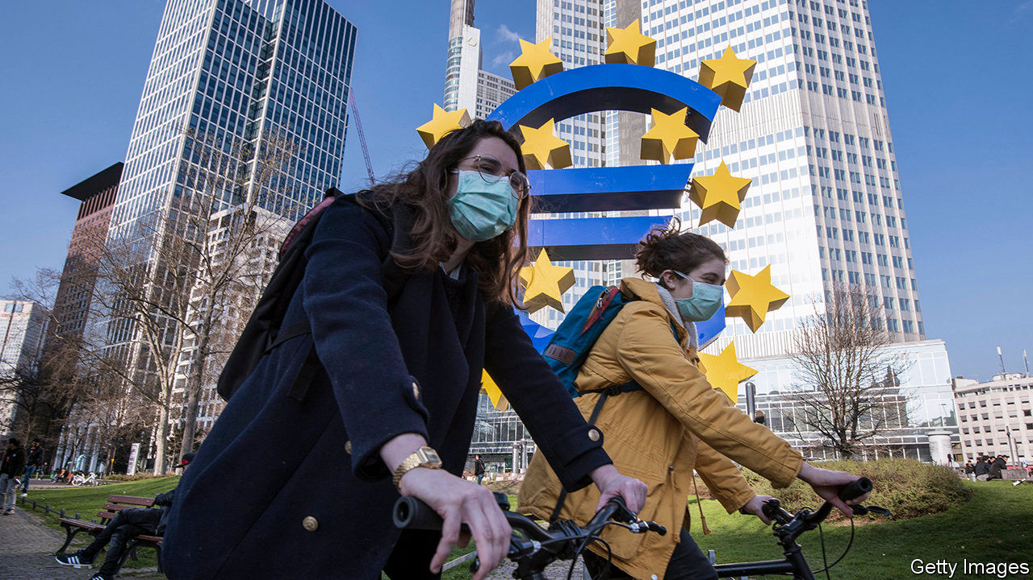

Editor’s note: The Economist is making some of its most important coverage of the covid-19 pandemic freely available to readers of The Economist Today, our daily newsletter. To receive it, register [here](https://www.economist.com/newslettersignup). For our coronavirus tracker and more coverage, see our [hub](https://www.economist.com/coronavirus)

THE EURO area is set for its deepest downturn and its sternest economic test yet. Some forecasters expect GDP to shrink by nearly a tenth in 2020. But as history is being made, it is also being repeated. Talks between Europe’s politicians about the covid-19 crisis have descended into yet another ugly row over which countries gain and lose from a common currency. The acrimony has its roots in Europe’s sovereign-debt crisis in 2010-12, when stricken southerners pleaded for solidarity and northerners refused to bail out what they saw as bad behaviour.

Back then the euro area avoided collapse largely thanks to action by the European Central Bank (ECB). The euro zone has since had a chance to pass deep reforms in order to deal with its fragility once and for all, but the time was ill-used. Having given up their monetary independence long ago and failed to cut public debt, some countries cannot deal with the crisis on their own. They need help from stronger economies in the north.

To avoid a deep and enduring slump, the southern countries need government spending that will shore up their economies today and relaunch them when the pandemic has abated. Yet this spending will sharply increase their debts. In Italy public borrowings are already worth 135% of GDP, and that figure could easily rise to well over 150% with even a modest stimulus. If its government spends freely, investors could panic about an eventual default or debt restructuring. Greece, Spain—and even France—face the same hard choices.

The temptation is to dither. Southern borrowing costs are higher than the north’s but not near panic levels. Italy’s ten-year bonds yield about two percentage points more than Germany’s. After fumbling, the ECB has tried to limit the damage by acquiring bonds and relaxing rules about what it buys.

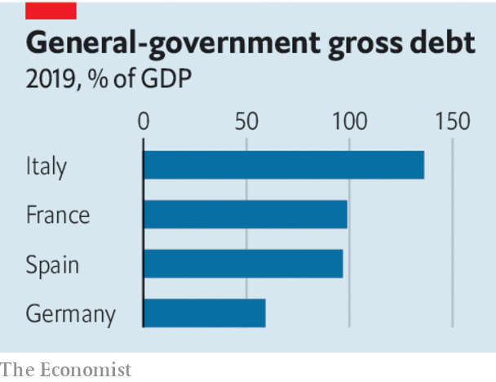

Those actions will buy time, but no more than that. There are still limits on how much the ECB can help the south and extra bond purchases are likely to end before southern economies recover. The bank may feel it lacks the mandate to extend its scheme. A legal challenge in Germany is an ever-present threat. And, aware that they are pushing their luck, southern countries may opt for smaller stimulus packages than they really need. That could still mean they face a doom loop as a shrinking economy makes it harder to service existing debts.

Politically the euro faces a dilemma. In the south millions more might conclude that membership of the single currency brings no benefits, fuelling support for Eurosceptic parties such as Italy’s Northern League and the National Rally of Marine Le Pen in France (see article). In the north bail-outs would bolster the likes of the hard-right Alternative for Germany.

What to do? As The Economist went to press euro-area finance ministers were still struggling to agree on measures, including common funding for unemployment insurance and easier access to credit lines from a common bail-out fund. But the resources available are puny. A proposal, backed by nine member states, for “coronabonds”, or jointly issued debt, is likely to founder. This would have let the south take advantage of the north’s cheap borrowing costs.

Northerners have long resisted mutualisation for fear of underwriting laxity in the south. But without it Italy and Spain will face either a savage crisis now or a lengthy debt crisis in the future. With lockdowns in place from Saxony to Sicily, debt issued today is a result not of bad behaviour but of the pandemic. Mutualisation should be a compromise, signalling that north and south have to live together in their common interest. Even some past opponents of Eurobonds, such as Klaas Knot, head of the Dutch central bank, now see a case for them. Northern leaders must follow. For two decades they have shied away from the fact that the currency union cannot succeed unless its members share more risk. If they do not face up to that today, the euro, and perhaps the European Union itself, will not survive. ■

Dig deeper:  
For our latest coverage of the covid-19 pandemic, register for The Economist Today, our daily [newsletter](https://www.economist.com/newslettersignup), or visit our [coronavirus tracker and story hub](https://www.economist.com/coronavirus)

Read also on: <https://www.economist.com/leaders/2020/04/11/making-europes-economy-work-better>

|  |  |  |  |
| --- | --- | --- | --- |
| Previous | Articles | Sections | Next |

|  |  |  |  |
| --- | --- | --- | --- |
| Previous | Articles | Sections | Next |

#### Voting in a pandemic

# Wisconsin, or how not to run an election while covid-19 is spreading

The mess in a battleground state holds lessons for November’s presidential election

Apr 9th 2020 |

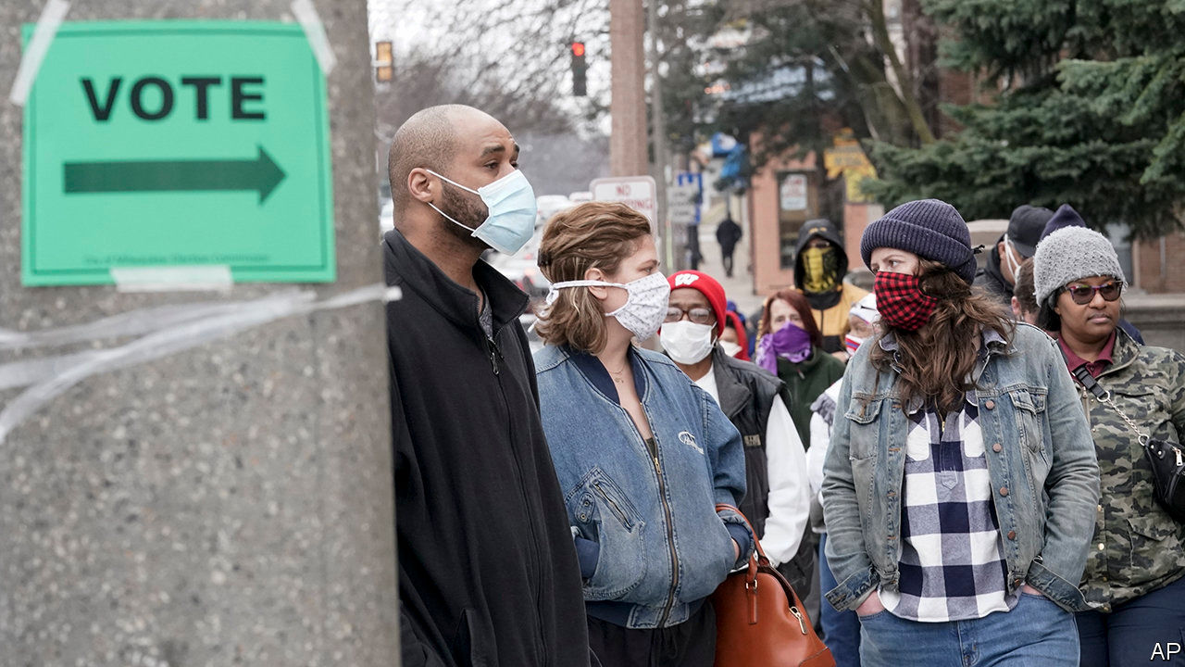

Editor’s note: The Economist is making some of its most important coverage of the covid-19 pandemic freely available to readers of The Economist Today, our daily newsletter. To receive it, register [here](https://www.economist.com/newslettersignup). For our coronavirus tracker and more coverage, see our [hub](https://www.economist.com/coronavirus)

DEMOCRACIES AROUND the world are wondering how to hold elections during a pandemic. The state of Wisconsin, which may well decide the outcome of America’s presidential election in November, has just provided a lesson in how not to do it.

On April 7th, despite a shelter-in-place order from the governor and warnings from the White House about the severity of America’s epidemic, Wisconsin held votes for several offices, including the state Supreme Court. The day before the vote was due, Wisconsin’s Democratic governor, Tony Evers, issued an executive order postponing voting in person until June. That order was disputed by the state’s Republican Party and its challenge went all the way to the state Supreme Court. The judges sided with the Republicans, so an election that had apparently been cancelled a few hours earlier then went ahead anyway.

In the past decade Wisconsin’s politics have been growing steadily more toxic. As a purple state that is bitterly fought over in national elections, Wisconsin shows what happens when partisanship, left unchecked, leaches into the soil from which political institutions grow.

Democratic candidates do well in Wisconsin’s cities, principally Milwaukee and Madison. The cities are where cases of covid-19 have been diagnosed and where people are sheltering at home, afraid to go out. On election day Milwaukee, a city of 600,000 people, was able to staff just five polling stations. In rural Wisconsin, which leans Republican, the epidemic seems a more distant problem and going to vote less of a risk. Because Milwaukee has a large African-American population, the urban-rural divide also has a racial element. Thus the virus has unerringly tugged at the state’s main political fault-line.

A state Supreme Court with a member elected under these conditions will lack legitimacy. Yet the court’s members will be expected to referee bitter political disputes over the next couple of years, possibly including what kind of identification will be acceptable at polling stations and, after the next census, on the legality of newly gerrymandered election districts.

This debacle holds lessons for other states. One is about turnout. Wisconsin’s Republican Party has insisted on going ahead with in-person voting in the midst of the country’s worst public-health crisis in a century. The official line is that this is all about preserving the sanctity and integrity of elections, but it is also more than a little convenient for a party that seeks low turnout in cities and high turnout in rural Wisconsin.

That approach—gaining electoral advantage by discouraging voting—is consistent with the Republican Party’s hostility nationwide to measures that would make voting easier. In any democracy, a party that considers pursuing a lower turnout to be a legitimate electoral strategy does not deserve to win elections.

Another lesson is about partisanship. Wisconsin’s elections have become so bitter that the struggle has shifted from policy, a fit subject for party politics, to the manipulation of the rules, which is hackery. Mr Evers dithered until the eve of the election and then wanted to extend the deadline for voting by post, which would probably have helped his party. The state Supreme Court blocked this by four votes to two along partisan lines, siding with the state’s Republican Party. At the federal Supreme Court, asked to rule on a lower court’s order that postal ballots count even if they are postmarked after the vote, the five justices appointed by Republican presidents sided with the Republicans and the four appointed by Democratic presidents sided with the Democrats.

America needs a dose of political reform aimed at distancing political campaigning from the refereeing of elections. Plenty of states do not have judicial elections, which are fraught with bad incentives. An increasing number of states have taken the power to decide on congressional maps away from politicians.

States must not dither. It does not take a lively imagination to foresee a resurgence of covid-19 before the general election. States need to start preparing for that as soon as possible. That means making it easier to vote safely in person, as South Korea will next week. It also means finding secure ways to vote remotely. This is in the interest of both parties. It may be that in the autumn some rural areas will also be suffering from the virus, which would risk Republican voters being disenfranchised as well as Democratic ones. Wisconsin has issued a warning. Other states need to act now. ■

Dig deeper:

* Sign up and listen to Checks and Balance, our new [newsletter](https://www.economist.com/checksandbalance/) and [podcast](https://www.economist.com/podcasts/2020/02/21/checks-and-balance-our-new-weekly-podcast-on-american-politics) on American politics
* [Explore our guide](https://www.economist.com/united-states/2020/02/26/the-economists-guide-to-the-us-2020-elections) to the US 2020 elections
* For more coverage of covid-19 see our [coronavirus hub](https://www.economist.com/news/2020/03/11/the-economists-coverage-of-the-coronavirus)

Read also on: <https://www.economist.com/leaders/2020/04/09/wisconsin-or-how-not-to-run-an-election-while-covid-19-is-spreading>

|  |  |  |  |
| --- | --- | --- | --- |
| Previous | Articles | Sections | Next |

|  |  |  |  |
| --- | --- | --- | --- |
| Previous | Articles | Sections | Next |

#### The financial core

# Emerging markets are in turmoil. The IMF must step in to help. Here’s how

The fund must lend unprecedented amounts. But many poor countries need debt relief

Apr 11th 2020 |

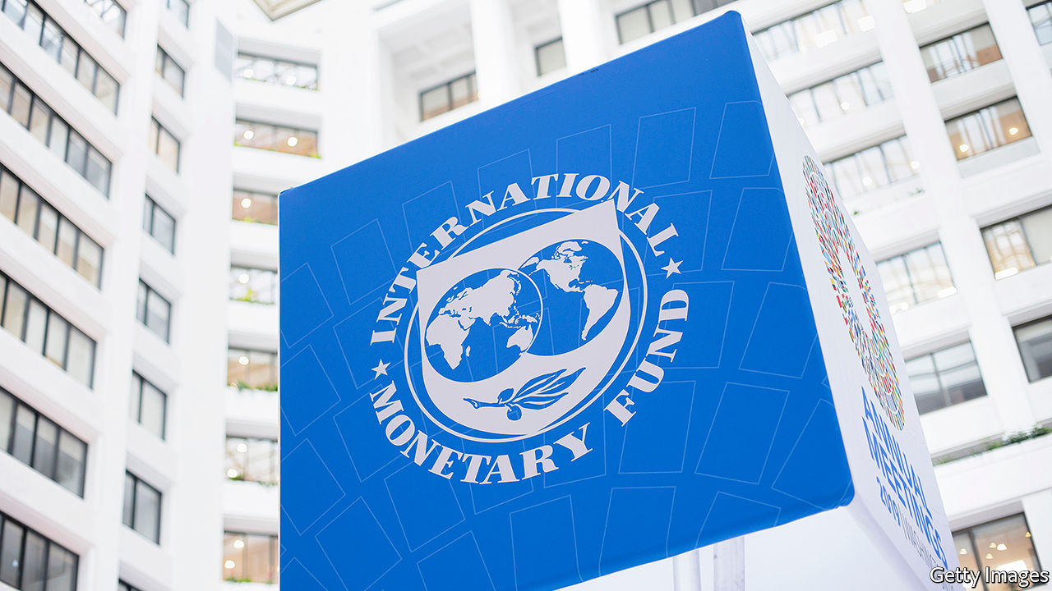

Editor’s note: The Economist is making some of its most important coverage of the covid-19 pandemic freely available to readers of The Economist Today, our daily newsletter. To receive it, register [here](https://www.economist.com/newslettersignup). For our coronavirus tracker and more coverage, see our [hub](https://www.economist.com/coronavirus)

EMERGING MARKETS are battling a financial crisis as well as a public-health emergency. Since late January foreign investors, desperate to shed risk, have been withdrawing their cash from poor countries. At the same time falling global trade, depressed commodities prices and vanishing tourists have put export revenues, and hence the supply of foreign currency, into free fall. This has left many countries struggling to pay for imports and to service their dollar-denominated debts, let alone fund emergency health or economic programmes. Over 90 countries have approached the IMF, the lender of last resort for governments, to ask for help.

The fund will need to respond on an unprecedented scale. The $96bn investors have already withdrawn from emerging-market stocks and bonds dwarfs past capital outflows, according to the Institute of International Finance, an industry group. So far this year the Brazilian real, the Mexican peso and the South African rand have lost nearly a quarter of their value against the dollar. Though few countries have sounded the alarm in public, the fund estimates that emerging markets will need at least $2.5trn over the course of the pandemic.

Some of that help is coming from America’s Federal Reserve. It is running “swap lines” with a select few central banks, which have so far borrowed about $400bn while posting their own currencies as collateral. The Fed is also allowing most central banks to temporarily exchange any Treasuries that they hold for dollars. But among emerging-market central banks only Brazil, Mexico, Singapore and South Korea are included in the swap lines, and few poor countries have a ready supply of Treasuries. So most of the burden will fall on the IMF which, unlike the Fed, cannot create dollars at will. The fund says it has about $1trn on tap, about a fifth of which is already committed. Even this may not be enough for the job if large economies like Nigeria, South Africa or Turkey join the legions of small countries seeking help. Another problem is that a big chunk of the fund’s resources is borrowing from its members that must be reauthorised this year, creating uncertainty.

These funds must be secured. America, to its credit, has already approved its share, but the biggest, richest members need to provide still more. The IMF should then follow a three-pronged approach to fighting the crisis.

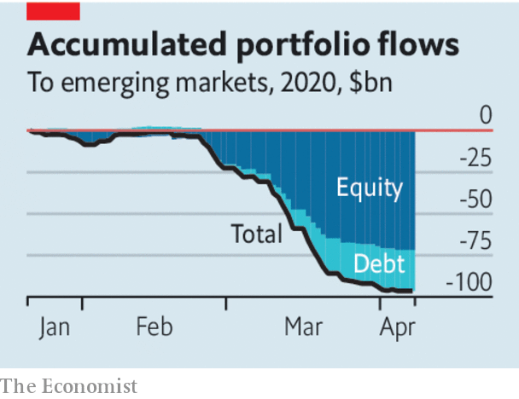

First, it ought to create new special drawing rights (SDRs), a currency of sorts which is convertible into dollars but whose quantity the fund controls (see article). This is a bit like printing money to finance a cheap perpetual credit line for every IMF member. In 2009, after the global financial crisis, the fund created $250bn in new SDRs; today it could create more than twice that amount before having to ask America’s Congress for permission to continue. Creating SDRs would provide indiscriminate, unconditional aid without draining the IMF’S reserves. However, it is controversial. The fund’s core mission is making conditional loans that are repaid, not printing money. It could take time to build the necessary support. In the meantime, rich countries should lend their SDRs to countries that are short of reserves. This may be more politically palatable than lending dollars.

Second, the IMF must alleviate the dollar liquidity shortage in solvent countries that have good institutions but which cannot borrow from the Fed. In 2017 the fund’s board rejected a proposal to provide its own swap-like funding to countries with strong institutions. It should revisit that decision. It should also explore ways of getting existing dollar reserves, which are ample at the global level, to where they are needed. For example, the fund could act as a clearing house for currency swaps, guaranteeing participating central banks against losses by graduating any debts that turn sour into a conventional IMF programme.

Third, the fund must persuade the world that many of the poorest countries, especially in Africa, are insolvent and need debt relief (see article). Researchers at the fund and the World Bank judged in February that half of low-income countries had shaky finances even before the pandemic. In these countries there is a danger that emergency loans are used to pay off existing creditors, leaving the IMF holding the bag. (This is awkward given that, by one estimate, China lent $146bn to African governments and state-owned enterprises between 2000 and 2017.) Better to write down debts collectively. Doing this in an orderly manner takes time, but public-sector creditors should immediately suspend both principal and interest payments. And if possible, the world should co-operate to shield the poorest countries from payments to private creditors, too.

These actions will be needed in addition to the IMF’s regular lending programmes, which will be called upon at a scale hitherto unseen. The fund has not faced a crisis like this before. It must fight it with every available tool.■

Dig deeper:  
For our latest coverage of the covid-19 pandemic, register for The Economist Today, our daily [newsletter](https://www.economist.com/newslettersignup), or visit our [coronavirus tracker and story hub](https://www.economist.com/coronavirus)

Read also on: <https://www.economist.com/leaders/2020/04/11/emerging-markets-are-in-turmoil-the-imf-must-step-in-to-help-heres-how>

|  |  |  |  |
| --- | --- | --- | --- |
| Previous | Articles | Sections | Next |

|  |  |  |  |
| --- | --- | --- | --- |
| Previous | Articles | Sections | Next |

#### 5Geopolitics

# Open standards, not sanctions, are America’s best weapon against Huawei

America needs a new way to deal with the Chinese telecoms giant. Its own tech industry points the way

Apr 8th 2020 |

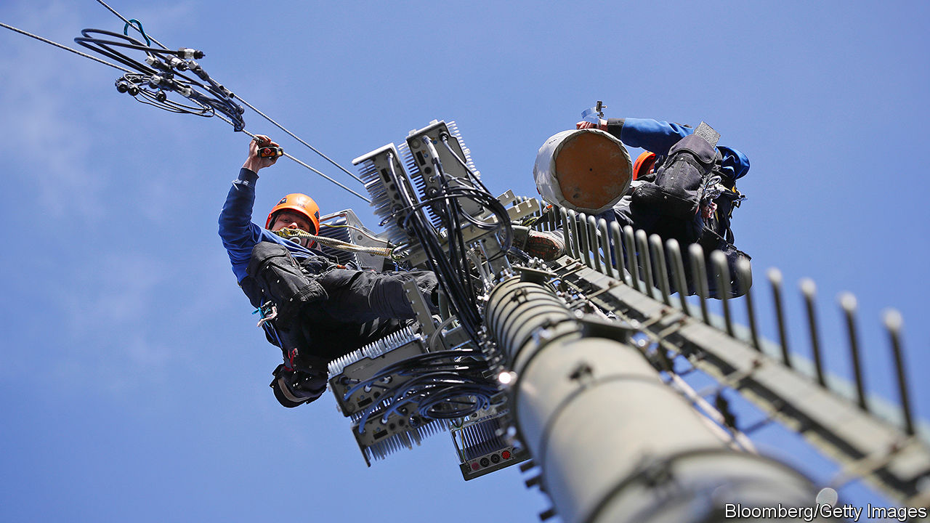

TECHNOLOGY IS POWER. Whoever controls the global digital infrastructure controls the world. That is why America is so worried about China’s rise as a technological superpower. It also explains why it is going to such lengths, even using European-style industrial policy, to rein in Huawei, China’s leading maker of telecoms equipment. The company leads the world in 5G, the next generation of mobile networks, which are expected to become the central nervous system of the global economy.

Yet by any measure America is losing the fight against Huawei, along with what President Donald Trump, steeped in zero-sum thinking, calls the “race to 5G”. The Chinese firm keeps on growing; the rollout of 5G in China continues apace; and most of America’s allies have so far ignored its entreaties to ban Huawei gear entirely from their national 5G networks on security grounds. Even so, the Trump administration seems intent on doubling down on its strategy. If hawks have their way, any chipmaker that uses American technology, which nearly all do, will soon have to ask for permission in Washington, DC, to sell its wares to Huawei.

The problem with America’s strategy is that it is trying to win today’s “tech cold war”, as some call it, with yesterday’s arsenal. In effect it is trying to build an impenetrable wall around Huawei by any means necessary. This is a fool’s errand in a hyper-connected world in which technology and talent can flow freely. It only provides extra incentives for Huawei—and China—to become technologically self-sufficient. If America wants to win the race to 5G and, more generally, the battle for digital supremacy, it needs a new approach. Happily, the country’s own technology industry points the way: it has thrived on openness, software and a healthy balance of competition and co-operation. And that approach is at last now being applied in telecoms.

Mobile networks, long dominated by specialised hardware, are becoming defined by software. On April 8th Rakuten, a Japanese online giant, launched the world’s first fully “virtualised” mobile network, built using general-purpose hardware and lots of software (see [article](https://www.economist.com/business/2020/04/11/america-does-not-want-china-to-dominate-5g-mobile-networks)). Other mobile carriers will follow suit. Such networks would go a long way towards dealing with America’s concern about Huawei: that using the firm’s gear in 5G networks could let the Chinese government intercept data or sabotage rival economies.

Virtualised networks need not rely on one vendor, but can be built with components from many, allowing carriers to pick and choose—and, if necessary, to steer clear of those made in China. They also create an opening for American tech firms, which play only a small role in the mobile-telecoms networks of today. (Many of the components of Rakuten’s network are made in America.) Moreover, such networks are cheaper to develop, make and maintain than conventional ones, because they are made mostly from off-the-shelf hardware, controlled by software—doing away with the argument of many mobile operators, that banning Huawei would force them to buy more expensive kit from Ericsson and Nokia, its main competitors.

Admittedly, virtualised networks will not solve all security problems, and the underlying standard, called OpenRAN, is not yet mature. But it is early days for all 5G networks. It will take years to roll them out fully and the covid-19 crisis has done nothing to speed up the process. So there is time.

The Trump administration and other governments should do all they can to accelerate the development of virtualised networks by subsidising research and perhaps even mandating the use of technical standards that allow mobile networks to be virtualised. All this may sound far-fetched at a time when America’s government appears stuck in the past and incapable of coming up with a coherent strategy. But as in many other domains, covid-19 creates room for new thinking. America will either pursue a tech cold war with an uncertain outcome, or help create an industry of the kind that American tech firms understand and have thrived in—letting Chinese companies join in only if they follow the rules. Sometimes establishing a robust, safe technology is not about concentrating power so much as diffusing it. ■

Read also on: <https://www.economist.com/leaders/2020/04/08/open-standards-not-sanctions-are-americas-best-weapon-against-huawei>

|  |  |  |  |
| --- | --- | --- | --- |
| Previous | Articles | Sections | Next |

|  |  |  |
| --- | --- | --- |
| Leaders | Sections | Briefing |

Letters

Letters to the editor: On covid-19, China, digital payments, cats, Sinn Fein, Jamie Dimon, Tahiti

.

|  |  |  |
| --- | --- | --- |
| Leaders | Sections | Briefing |

|  |  |  |  |
| --- | --- | --- | --- |
|  | Articles | Sections | Next |

#### On covid-19, China, digital payments, cats, Sinn Fein, Jamie Dimon, Tahiti

# Letters to the editor

A selection of correspondence

Apr 8th 2020 |

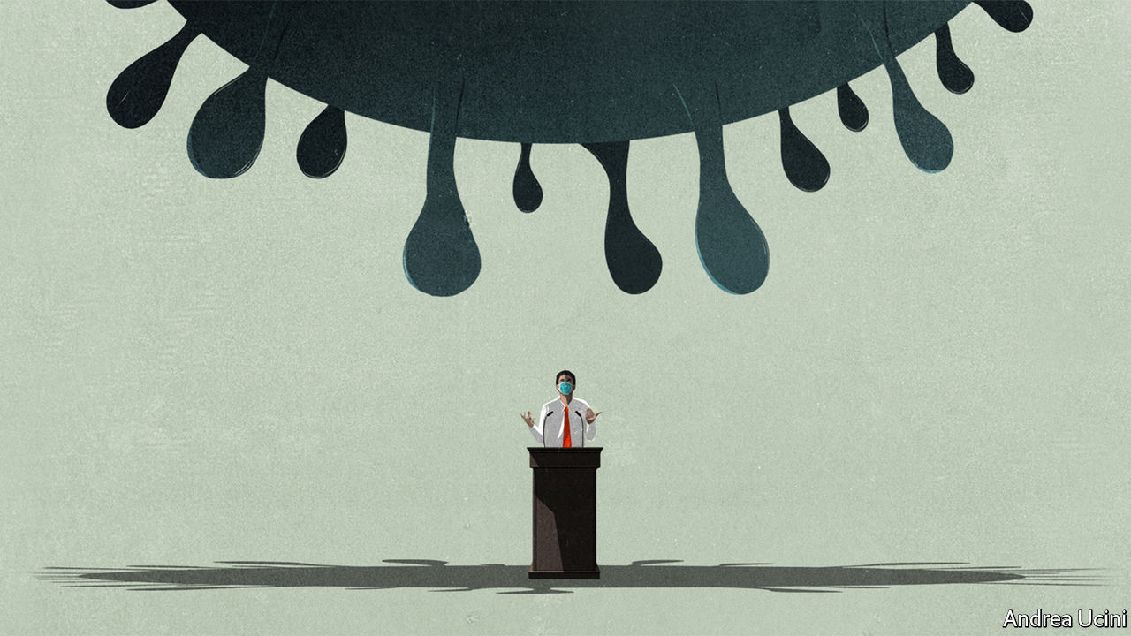

## China’s response to covid-19

Regarding the letter from Taiwan’s representative about the response to covid-19 ([March 28th](https://www.economist.com/letters/2020/03/26/letters-to-the-editor)), no one cares more about the health of our compatriots in Taiwan than China’s government. The National Health Commission promptly notified the Taiwan region about the outbreak in Wuhan. In mid-January, as requested by the relevant authorities on the island, experts from Taiwan visited Wuhan for first-hand experience of disease prevention and control, medical treatment and pathogen detection. They also held discussions with experts on the mainland and expressed heartfelt appreciation for their reception and the information obtained during their visit.

Membership of the World Health Organisation is based on sovereign statehood. The participation of Taiwan in the activities of international organisations is and must be arranged properly under the one-China principle. Based on the arrangement agreed between China and the WHO, medical experts from Taiwan can attend technical meetings at the WHO, and the WHO can send experts to the island for inspection or assistance. Such arrangements ensure that the island’s response to public health emergencies is effective regardless of wherever they may take place.

Since the outbreak of covid-19, China has been open, swift and responsible in sharing information and the latest progress with the WHO and the wider international community, and is co-operating with other countries and regions. By taking swift and decisive measures to slow down the spread of the virus, China has done its utmost to protect not only its own people but also people beyond its borders. These important facts, and China’s efforts and sacrifice, need to be understood and appreciated.

ZENG RONG  
Spokesperson of the Chinese Embassy  
London

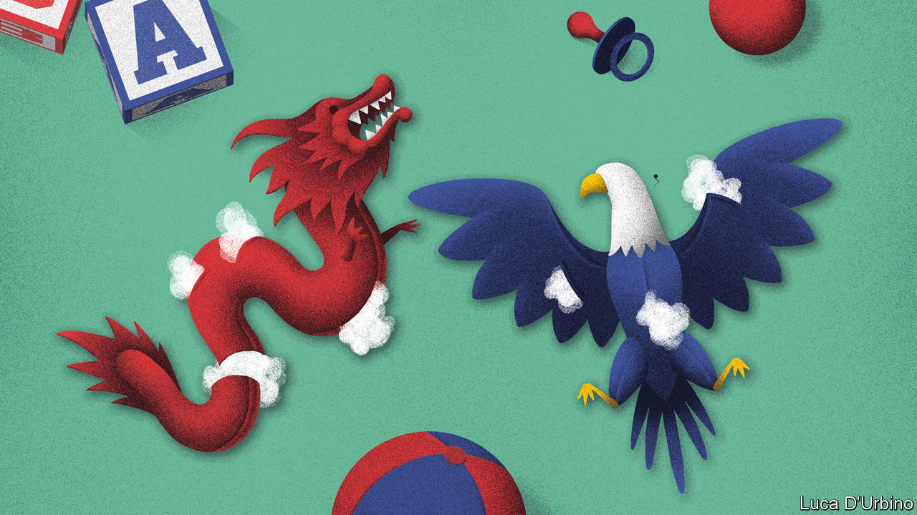

## How China sees the world

For all its high-mindedness, your leader dishing out equal blame to America and China in their dispute over journalists was wrong (“[Stop deporting reporters](https://www.economist.com/leaders/2020/03/21/expelling-journalists-is-no-way-to-fight-a-pandemic)”, March 21st). Would you run a similar line if it was not China that had thrown American journalists out of the country, but apartheid South Africa or fascist Italy instead? Your position is not how the West prevailed in two world wars or the cold war. And if you imagine that China’s party bosses see the present contest with the West in any other way, I invite you to read what they say to each other in their public literature in their own language.

For Stalin, weakness was a provocation. The Chinese Communist Party sees the West’s willingness to indulge it—to hope economic development strengthens the case for liberalisation and co-operation—as just that, weakness. Whatever pragmatic and liberalising voices were left in China fell silent with the triumph of Xi Jinping.

The West will prevail only by showing strength. China should be welcome to develop and grow rich, but on the terms that have served the world best over the past two centuries, on a rules-based, open and transparent basis. Enforcing reciprocity is a peaceful means to work towards that end. China’s party leaders gain much more from having their propaganda agents overseas than the West gains from having journalists in China. America was right to enforce tit-for-tat expulsions.

PETER ROWE  
Australian ambassador to South and North Korea, 2006-09  
Sydney

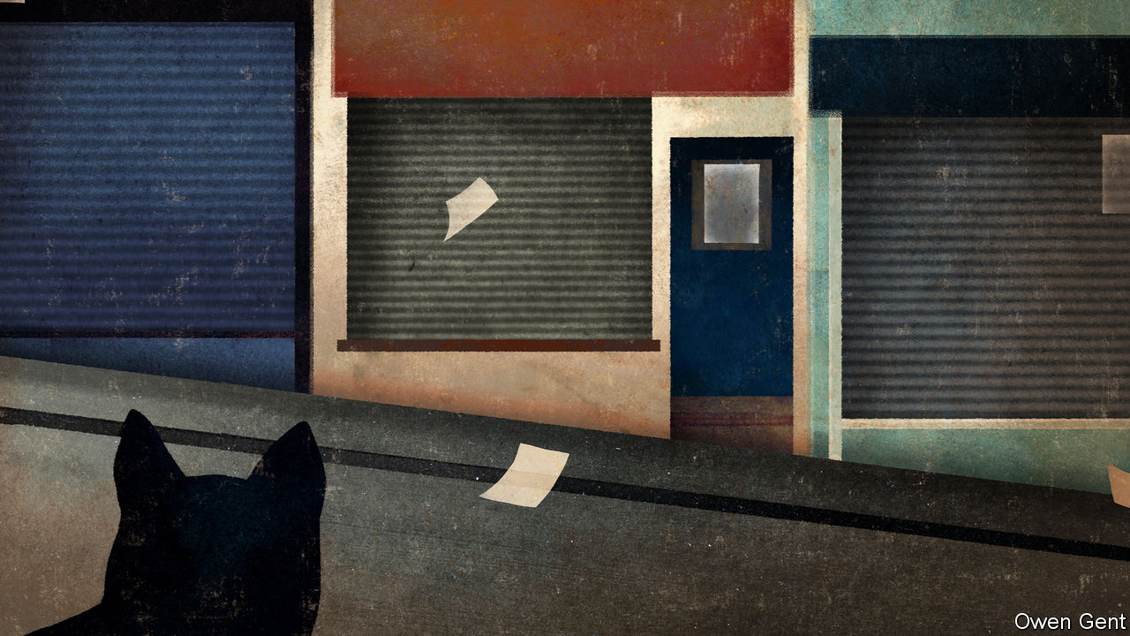

## Behind the digital curve

Past experience has indeed shown us that one problem with mailing cheques to workers, as is happening in America under the emergency covid-19 measures, is that most people will save this cash rather than spend it (“[Experimental treatment](https://www.economist.com/briefing/2020/03/19/governments-are-spending-big-to-keep-the-world-economy-from-getting-dangerously-sick)”, March 21st). Hopefully, America can catch up with the rest of the world and deliver these payments digitally in future. There are already digital MasterCard and Visa solutions that are, in effect, a virtual pre-paid card that must be spent: there is no way to save the money. Digital funding also provides us with a wealth of data on spending habits that are traceable with a pre-paid card. This data can be mined non-intrusively to ensure supply chains run efficiently.

J.P. CARROLL  
Payment Innovations  
Blackhawk Network  
San Diego

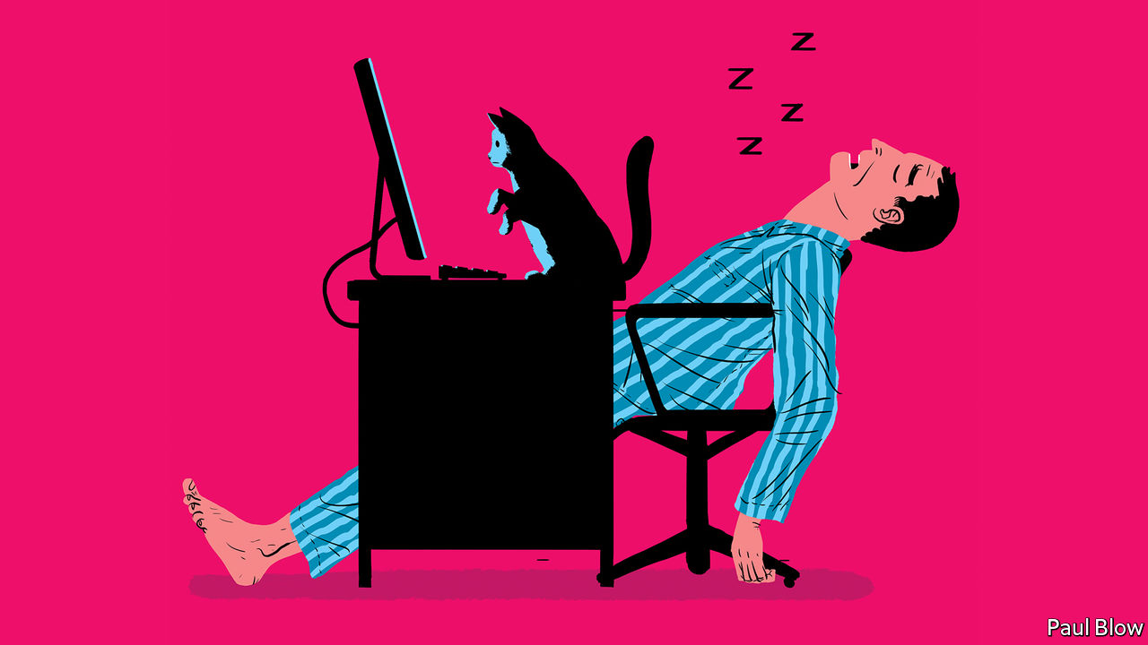

## Feline foul-up

I would like to give [Bartleby](https://www.economist.com/business/2020/03/26/diary-of-a-home-worker) a most sincere “thank you” for making me laugh out loud, something I have not done in weeks, after reading his diary of a home worker (March 28th). I, too, have a cat and am now tutoring students online instead of in person. My tuxedo cat, Wicked, has made some interesting alterations to my teaching documents, some of which I found only after emailing said documents to my charges.

FRANKIE STRACCIA  
Amherst, New Hampshire

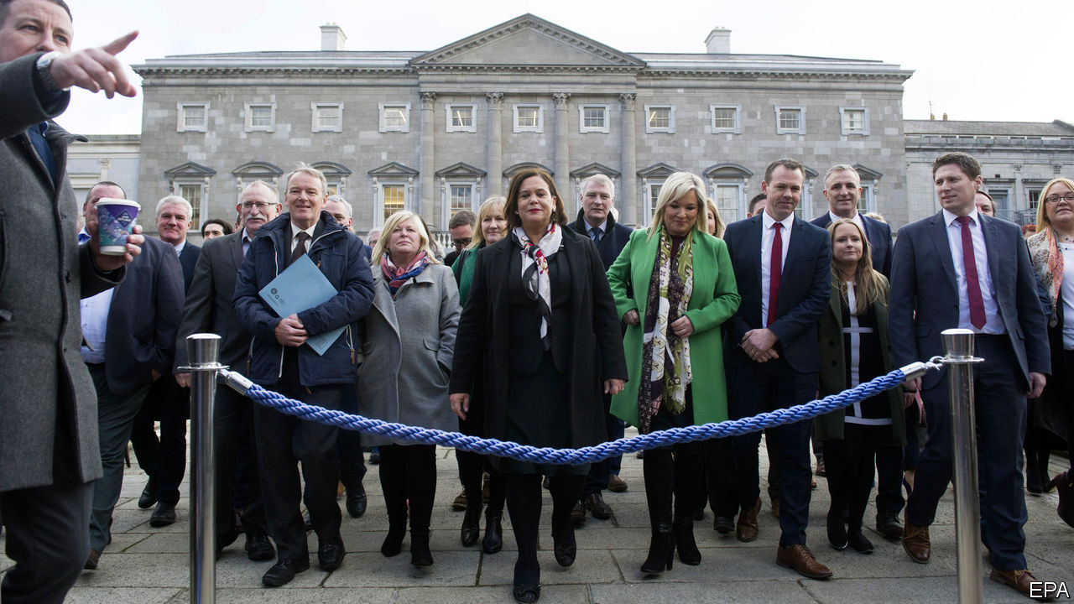

## The descendants of Sinn Fein

It is a common misconception to think that the Sinn Fein of today is the same as the Sinn Fein of 1905 (“[Shape-shifters](https://www.economist.com/europe/2020/03/05/is-sinn-fein-now-a-normal-political-party)”, March 7th). The two large centre-right parties that have dominated Irish politics since independence, the pro-treaty Fine Gael and the anti-treaty Fianna Fail, both claim to be the descendants of the old Sinn Fein. The fact that they have espoused peaceful political means since the end of the Irish civil war certainly gives them a right to say they follow in the footsteps of Arthur Griffith, Sinn Fein’s founder.

On its party website, Sinn Fein’s take on its past simply states that it emerged “as a party of resistance of the nationalist people” in 1969 without laying claim to Griffith’s Sinn Fein of 1905. If this story tells us anything it is that no one party has a claim on Ireland’s history.

JAMES GREEN  
Wicklow, Ireland

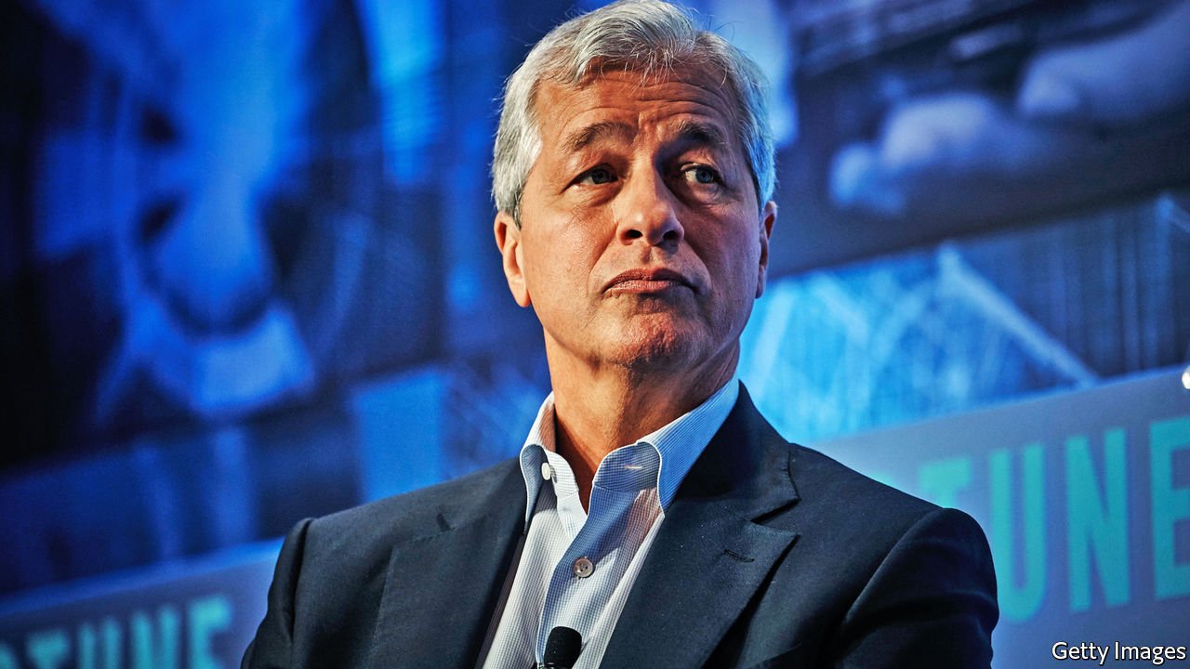

## Corporate man

Your briefing on JPMorgan Chase (“[The house that Jamie built](https://www.economist.com/briefing/2020/03/12/is-dimons-work-done-at-jpmorgan-chase)”, March 14th) reminded me of a quote from Ralph Waldo Emerson: “An institution is the lengthened shadow of one man.” Jamie Dimon has certainly cast a long and illustrious shadow over JPMorgan Chase and the global financial industry.

JAMES MCSHERRY  
Creemore, Canada

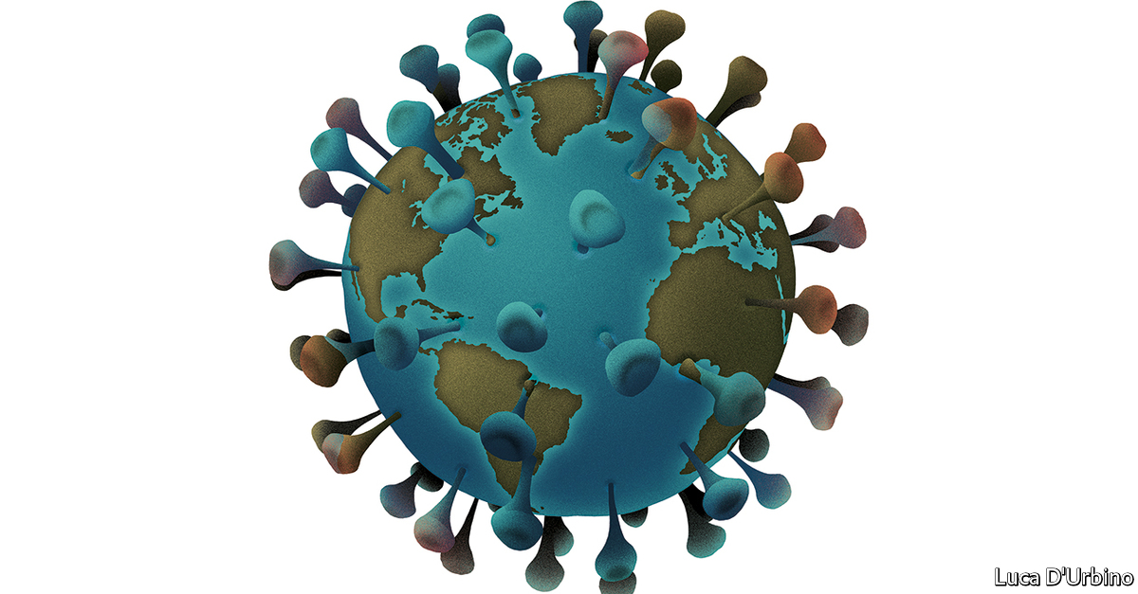

## The connected world

Thank you for the email update to subscribers about your [covid-19 coverage](https://www.economist.com/news/2020/03/11/the-economists-coverage-of-the-coronavirus). As you say, to be well informed is particularly important during these strange times. I spend most of my time in Tahiti. Although we are not, as yet, struck too badly by the pandemic, we are confined, like most of humanity. For a small territory, far from the rest of the world, that imports a lot of food, equipment and fuel, there is a feeling of going backwards, to a time when there were few ships docking here (regular flights have been suspended). We don’t know whether shipping lines in the Pacific will return as normal, so maybe we should resume planting sweet potatoes or taro.

MICHEL PAOLETTI  
Tahiti

Editor’s note: We invite our readers to share their experiences of covid-19, by writing to letters@economist.com. We will choose a selection of the most interesting for publication in print and online.

Read also on: <https://www.economist.com/letters/2020/04/08/letters-to-the-editor>

|  |  |  |  |
| --- | --- | --- | --- |
|  | Articles | Sections | Next |

|  |  |  |
| --- | --- | --- |
| Letters | Sections | United States |

Briefing

Covid and the company: Sinking, swimming and surfing

.

Manufacturing at a distance: Still made in China

.

Ructions in the oil market: Upside down

.

|  |  |  |
| --- | --- | --- |
| Letters | Sections | United States |

|  |  |  |  |
| --- | --- | --- | --- |
|  | Articles | Sections | Next |

#### Less globalisation, more tech

# The changes covid-19 is forcing on to business

The big ones are oddly familiar

Apr 11th 2020 |

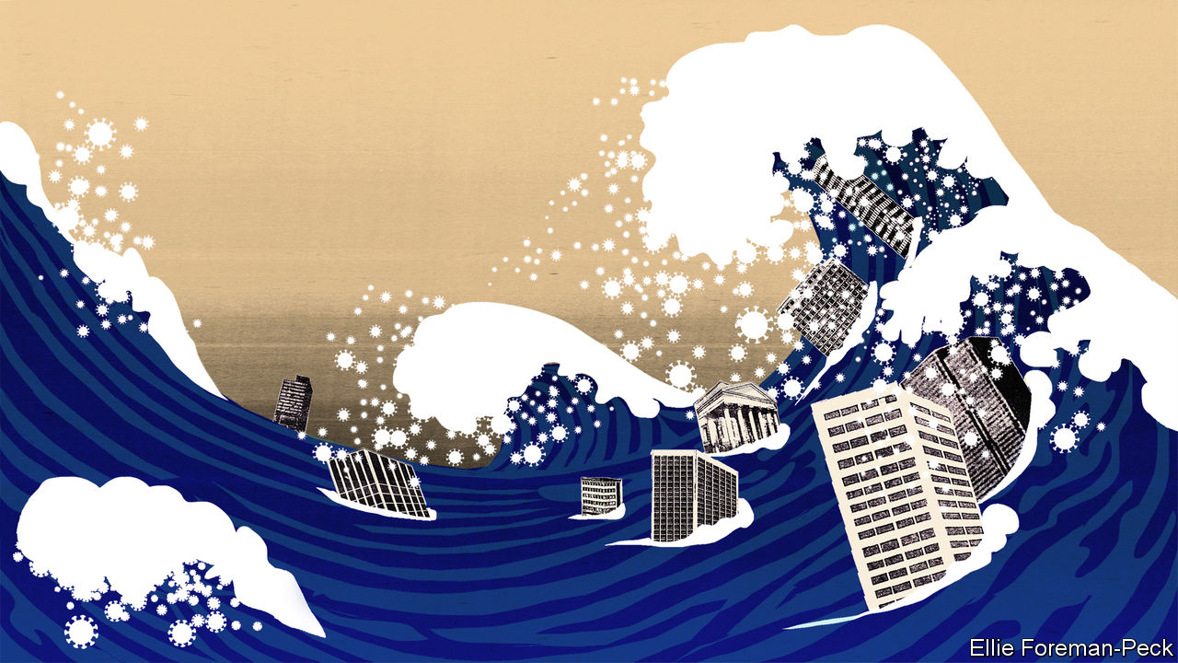

Editor’s note: The Economist is making some of its most important coverage of the covid-19 pandemic freely available to readers of The Economist Today, our daily newsletter. To receive it, register [here](https://www.economist.com/newslettersignup). For our coronavirus tracker and more coverage, see our [hub](https://www.economist.com/coronavirus)

SOMETIMES CHANGE is so vast and dislocating that it is hard to tell disaster from opportunity. In March Ocado, a British online grocer, saw its servers so overloaded that it suspected hackers. “We thought that we were under a denial-of-service attack,” says Tim Steiner, the company’s boss. In fact, Britons were desperately trying to arrange to get food and drink deliveries for the weeks ahead. After Boris Johnson, the prime minister, announced a national lockdown the site filled three weeks’ worth of delivery slots in an hour.

Companies for which the ill wind of covid-19 has blown some good have been very much in the minority. In February, even as stockmarkets began to crash, business leaders could console themselves with three observations. First, they bore no blame for the crisis. Some downturns, such as the dotcom bust of 2000-01 and the financial crisis of 2007-09 are seen through a quasi-biblical lens of retribution—just deserts for orgies of speculation. This was more like a tsunami, or a war; its casualties had some hope of being treated as innocent victims deserving of support, rather than the authors of their own fate.

Second, most companies—particularly in America—went into the crisis in pretty solid shape; employment was booming, order books were relatively full and the easing of America’s trade war with China augured well. Third, within days of global markets melting down China was tentatively reopening some factories and lifting some of its draconian lockdowns. This suggested a V-shaped recovery, or at worst a U-shaped one, something requiring not life-and-death measures but a battened-down Sufi stoicism: “This, too, shall pass.” As Dara Khosrowshahi, who runs Uber, said confidently as late as early March, “At least from what we’ve seen the bounceback can be pretty quick.”

Unfortunately, many European countries and some American states immediately began to impose social-distancing measures and, soon thereafter, lockdowns. Businesses found themselves looking into the abyss of a largely moribund economy. According to the International Labour Organisation sectors now facing a severe decline in output, and thus a high risk of lay-offs and furloughs, employ almost 38% of the global workforce: some 1.25bn workers (see chart 1).

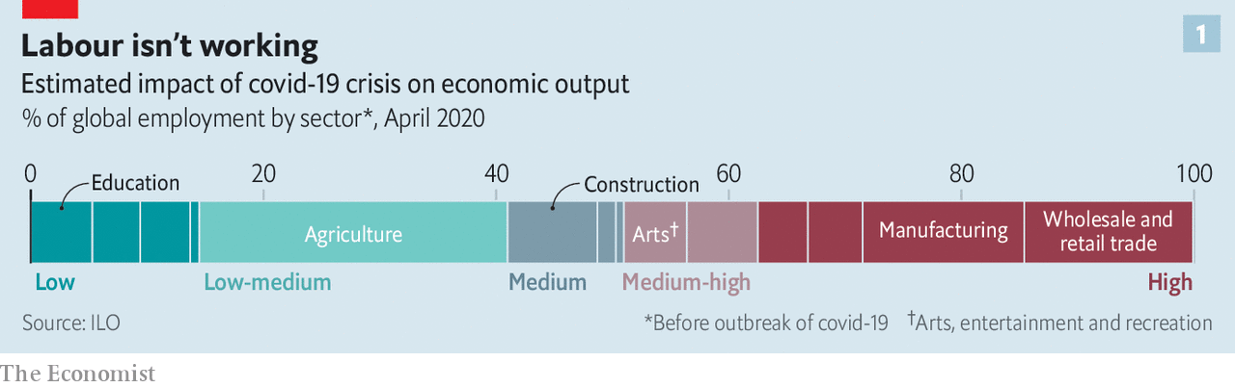

Government handouts in America and Europe should ease the pain of some of that unemployment—if fully implemented and if the benefit systems work. But many of the proposed beneficiaries, such as florists, gyms and bakeries, will still go short. Whether they scrape by or go under, that will prolong the slump in consumer confidence—as will the possibility of a second wave of illness after restrictions are lifted. One pessimistic Wall Street banker talks of a future neither V-shaped, U-shaped or even W-shaped, but “more like a bathtub”.

Yet even as they walk through the valley of the shadow of death, chief executives and corporate strategists are beginning to look to the post-covid world to come. What they think they see, for good or ill, is an acceleration. Three existing trends—the deglobalisation unpicking the business world that grew up in the 2000s; the infusion of data-enabled services into ever more aspects of life; a consolidation of economic power into the hands of giant corporations—look likely to proceed at a faster rate than before, and perhaps to go further, too. Optimists—and business folk tend to look on the bright side—see this acceleration as offering new possibilities for reinvention, even resurrection. Pessimists see inefficiencies and insularity weighing on profitability for many years to come.

## Seasick

Whether or not such doldrums lurk in the future, the present is a mad swell of chop and change in which the fortunes of different regions and sectors vary wildly.

China’s economy shows distinct signs of recovery. Bernstein, an investment firm, notes that many of the swanky metropolitan restaurants it tracks there were full by the first weekend in April. That said, many migrant workers have yet to return to work. Air and rail traffic remain severely curtailed, as do car sales. The Chinese, though, are at least making cars to sell. European and American plants are shuttered.

Neither is the gloom within countries evenly spread. Some sectors are doing worse than others, and in all the fortunes of the most and least resilient are far apart (see chart 2). Should the coming recession not kill off animal spirits entirely, there will be lots of opportunities for corporate upheaval, takeovers and strategic shifts.

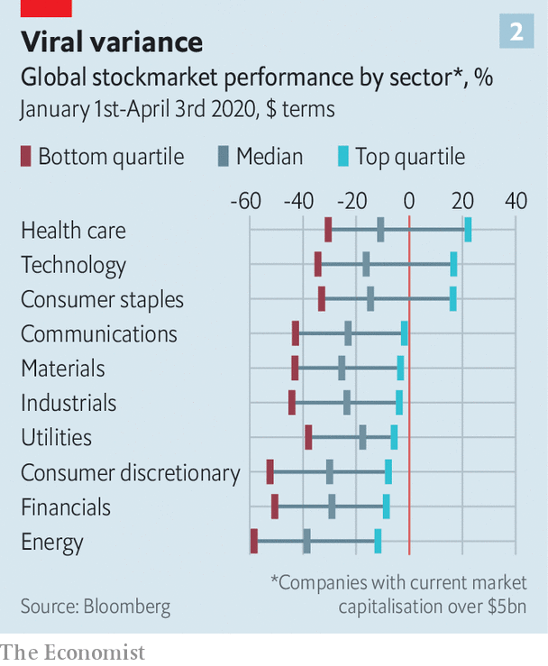

China’s government may encourage its state-owned firms to go global by buying distressed car companies in Europe. The share price of Daimler is less than half what it was when Geely, a Chinese carmaker, bought a 10% stake in 2018. Car companies may also see offers from technology giants keen to improve co-operation between metal bashers and the engineers of autonomy—currently wary at best. The healthier airlines, such as Qantas and IAG, owner of British Airways, will snap up airport slots from their bankrupt rivals and may try to acquire others only just staying aloft. Private-equity firms, which have mountains of committed investor cash, may start buying up fundamentally sound but impecunious suppliers in various industries, aware that when demand returns such companies will see its first fruits. Anand Mahindra, chairman of the Mahindra group, one of India’s largest conglomerates, says that as well as big corporations buying smaller ones, many smaller firms will look to merge with peers.

Around the world, small and medium-sized firms are particularly exposed. In America, a survey published on April 3rd by MetLife, an insurer, and the US Chamber of Commerce found that 54% of non-sole-proprietor firms with fewer than 500 employees were either closed or expected to close in coming weeks. It has been a similar story in China. As well as driving unemployment, this has systemic implications. Though such firms are often relatively inefficient, the nimbler ones can play a role in supply chains that would be hard to duplicate. Aware of this, some big firms, such as Unilever, are attempting to buoy up suppliers by paying them more quickly.

Much of this activity will happen on the fly, as disasters and opportunities present themselves. As time goes by, though, the currents of the great acceleration will begin to assert themselves. For companies enmeshed in the comparatively freewheeling, Anglo-American model of business that has been in competition with Chinese-style state capitalism in recent years it will be a distinct shock.

Take China and its supply-chain primacy first. By 2017, when average Chinese manufacturing wages had become as high as those in the poorer parts of Europe, it was clear that the logic which saw a large fraction of the world’s supply chains pass through the country needed re-examining. The former boss of a big American company’s Chinese operations says that in the past few years the trade war and other risks of business disruption saw many global firms seek to reduce their dependency on China. One of their favoured strategies was to put more business into factories elsewhere in Asia.

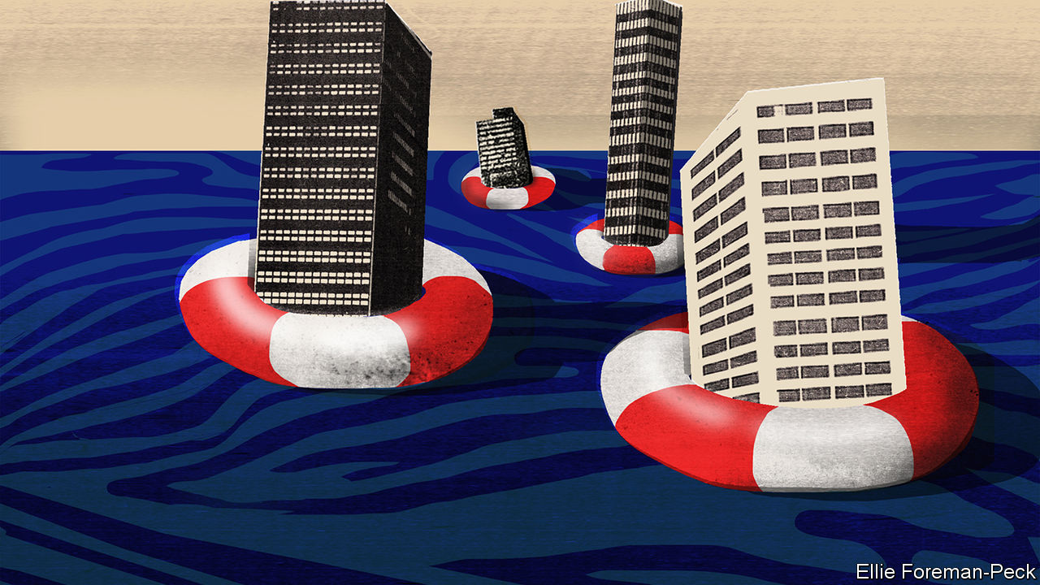

But the acute stage of China’s covid-19 crisis made it clear how essential China remains as a provider of inputs to such factories elsewhere in Asia and around the world. “What people thought was a global supply chain was a Chinese supply chain,” says Mr Mahindra. The quest for supply chains independent of Beijing needs to go further, and deeper.

Joerg Wuttke, president of the EU Chamber of Commerce in China, says that if there is one lesson people are drawing from the pandemic in this regard it is that “single source is out and diversification is in.” In other words, companies do not just need suppliers outside China. They need to build out their choice of suppliers, even if doing so raises costs and reduces efficiency. Mr Mahindra expects to see new demand for production in Vietnam, Myanmar and possibly, if it can grasp the opportunity, India.

For some, the need to have more suppliers looks like an opportunity to promote possibilities at home. The government-owned Development Bank of Japan plans to subsidise relocation costs of companies that bring production facilities back to the country. Rich Lesser, the CEO of Boston Consulting Group (BCG), which advises big global firms, says that robotics and other new approaches to manufacturing make the case for moving factories closer to home more compelling, because they reduce the cost difference. Just as previous information technology was put to work underpinning the spread of supply chains, so today’s can be used to shorten them—potentially making companies more responsive to local tastes.

And the range of the changes information technology makes possible will only increase: that is the essence of the second current of post-covid acceleration. The growth of firms built on digital connections with and between hundreds of millions, or billions, of people, and which collect reams of cloud-based data in the process, was central to the bull market that met its end in February. That growth still has plenty of room to run.

Responding to covid-19 has seen many people and companies realise that IT had more to offer them than they had realised. Zoom, an online videoconferencing service, was serving 10m customers a day at the beginning of the year, most of them in business meetings. Now it is providing 200m people a day not just with meetings, but with Tai Chi classes and “quarantinis”. Slack, which provides a medium by which far-flung colleagues can co-ordinate things, has become part of dinner-table conversation. It is not only young tech-companies, and tech companies that were previously mostly used by the young, that have prospered. Microsoft’s Teams product is gaining many converts. No one expects the amount of distance working ever again to be as low as it was before the virus hit.

Restrictions put in place during the SARS outbreak of 2003 helped accelerate China’s embrace of e-commerce. Covid-19 is having a similar effect, even in economies where e-commerce is already common. Chris Grigg, boss of British Land, one of Britain’s biggest retail and office landlords, says that as a result of covid-19 his company has brought forward by several years the time when it expects the share of shopping done online in Britain to double from its current 20%—already among the highest levels in the world. The pandemic may not just highlight the convenience of online life; it may also make some of its drawbacks less disturbing. Germans, who have historically well-founded privacy concerns, are resistant to anything that looks like “surveillance capitalism”. But Karl Haeusgen, chairman of HAWE, a maker of hydraulic pumps, says an app that helped maintain public health by tracing covid-19 infections could make them less protective of their data. If that were the case, they might become converts to other data-driven business, too.

This trend will be good news for giants of the tech scene such as Alphabet, Amazon and Apple. So will other factors. The need for economic resilience will be added to the arguments against breaking up the biggest tech companies. If the tech world splinters into rival Chinese and Western camps each side will want its champions.

If things look pretty good for big tech, though, they look none too shabby for big everything else. As the world gets back on its feet, big firms will have better access to capital markets, giving them an extra edge over smaller competitors. And across the world there will be one increasingly big customer, too—the state. As Mr Mahindra says, “the only engine of consumption for the next 12 to 24 months will be government.” Big companies fit well with big government: they make its life simpler; they lobby it more assiduously.

These trends will inevitably have pernicious side-effects. Less dependence on China will mean less access to the rapid-fire innovation that takes place there. The bigger the tech firms, the harder it will be for startups to gain sufficient scale to challenge them. Not impossible; Zoom has done well in a world where bigger companies offer services along similar lines. But more difficult.

But though innovative businesses may face challenges in the post-covid world, they may also help bring it into being. This is not just because pharmaceutical and biotech companies are feverishly searching for drugs and vaccines. It is because business can knit people together. Mr Lesser of BCG argues that companies which build a bond with “emotionally vulnerable” consumers during the crisis may help reduce their anxieties on the other side—anxieties which might otherwise linger. Businesses will need to encourage people back to restaurants, bars and boutiques when lockdowns end but fears persist. And because small companies are being badly hit, recovery in these sectors will need to see new relationships formed.

Mr Lesser recalls the anxiety he used to feel walking through Grand Central Station after September 11th 2001. He would look at the throngs and queues for coffee and quicken his step at the thought of another catastrophic attack. Eventually, though, that fear subsided and the cavernous space regained its appeal. This, too, shall pass. ■

Dig deeper:  
For our latest coverage of the covid-19 pandemic, register for The Economist Today, our daily [newsletter](https://www.economist.com/newslettersignup), or visit our [coronavirus tracker and story hub](https://www.economist.com/coronavirus)

Read also on: <https://www.economist.com/briefing/2020/04/11/the-changes-covid-19-is-forcing-on-to-business>

|  |  |  |  |
| --- | --- | --- | --- |
|  | Articles | Sections | Next |

|  |  |  |  |
| --- | --- | --- | --- |
| Previous | Articles | Sections | Next |

#### Still made in China

# How to reopen factories after covid-19

Handgel and nanotechnology

Apr 8th 2020 | HONG KONG

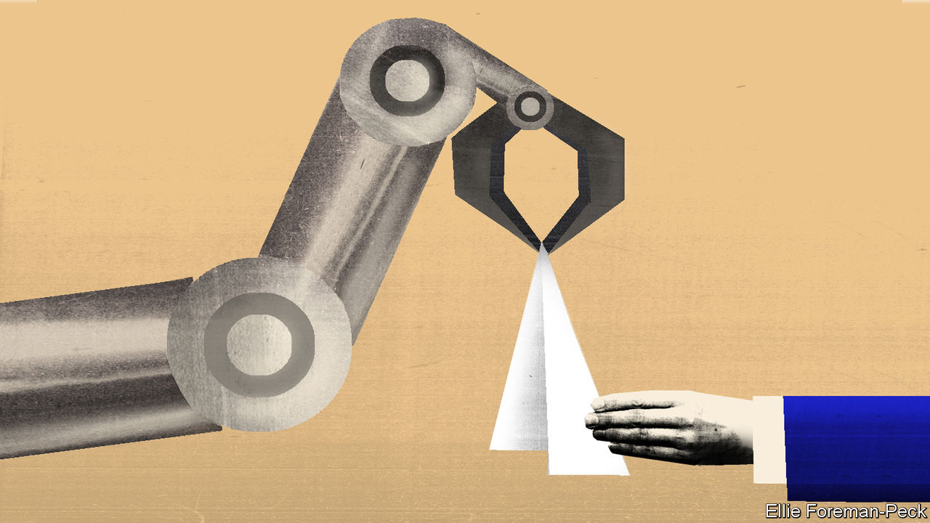

Editor’s note: The Economist is making some of its most important coverage of the covid-19 pandemic freely available to readers of The Economist Today, our daily newsletter. To receive it, register [here](https://www.economist.com/newslettersignup). For our coronavirus tracker and more coverage, see our [hub](https://www.economist.com/coronavirus)

MANY OF THE robots on factory floors operate in cages, fenced off from their human colleagues. The separation prevents the machines, in the routine and mindless pursuit of a bolt, from crushing the leg, hand or chest of a worker who happens to get in the way.

Now factory operators do not just need to keep human workers at a safe distance from robots; they have to keep them at a safe distance from each other, too. In China, fences between workers are among the measures bringing factories back to life.

Most Chinese factories are now back to operating at around 80% of capacity. Some are pushing 100%. Foxconn, the Taiwanese contract manufacturer which assembles the majority of Apple’s iPhones in China, says that with the help of tests for the virus and chest x-rays it has been able to get all its operations on the mainland back up and running with no risk to the health of its workers. In a call to investors on April 1st it reported that it was on target to provide Apple with all the 5G iPhones it needs for the launch of the device this autumn.

Many of the measures that made China’s great reopening possible were boring-but-important changes to existing protocols; more hygiene measures, more separation between workers, and screening (companies in China and elsewhere are trying to get their hands on a lot of tests for SARS-CoV-2 infection).

But there has also been investment in automation and remote operation that has brought forward improvements not expected for some time to come. Anna Shedletsky, the boss of Instrumental, a firm which uses machine learning to help manufacturers improve their processes, says that in electronics manufacturing “We’re going to do five years of innovating in the next 18 months.”

Modern high-tech factories already have systems in place to control who comes in or out and what they have on their person. The procedures which identify workers now take their temperatures, too. Many factories are also relying on a variety of “health code” apps developed by provincial Chinese governments. These run through portals inside WeChat and AliPay, two payment apps, to determine the worker’s health status and travel history. Willy Shih of Harvard Business School, who studies Chinese factories and supply chains, says such techniques were developed during the outbreaks of SARS and H1N1, in 2003 and in 2009, respectively. “Normally you change out of street clothes and go through a security check,” he says. “In many respects the [new protocols] are a small incremental addition.”

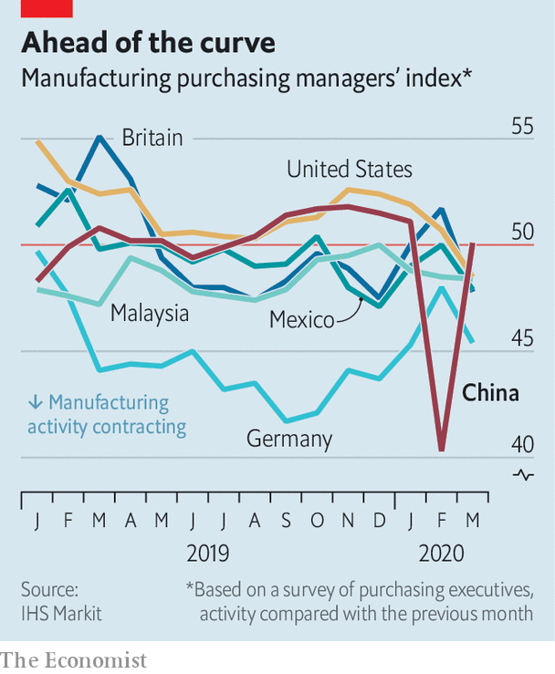

Once inside the factory, the changes required depend on what the workers are making. Those in car factories are already spread out and do not need much repositioning—though some manufacturers are using fences to enforce separation. The parts the workers handle are regularly disinfected as they pass through the assembly process, says Tu Le, a consultant. At a phone factory in Guangdong province, though, changes in layout are immediately apparent. Workers no longer cluster around each step of the assembly process in dense U-shaped cells; instead they are spread out, increasing their safety at the expense of some speed.

## Making it better

The obsessive and precise standards of modern global production make it comparatively easy for factories to adapt in such ways. However well a production process is adapted, though, things can still all go to pot if less cautious suppliers have to shut down and the parts the factory needs from them run out. As a result factories around the world have been stockpiling ferociously since news of the outbreak broke in January, going against the nature of modern just-in-time supply chains.

Another problem is new product introduction (NPI), a vital part of the business cycle in the electronics industry which is roughly 10% of Chinese manufacturing by value. During NPI, engineers from companies abroad fly in to tweak and tune the development of new products—something which today’s all-but-closed Chinese border makes impossible.

This has afforded Ms Shedletsky’s company a nice opportunity. The firm sells a system which uses machine learning to examine images of every single item a factory makes at every single stage of its assembly. It lets users explore the causes of any flaws, thereby increasing yields and reducing wasted time, money and materials. The amount of detail captured by the system also lets engineers from client companies inspect and manage production from halfway around the world—which under covid-19 has become a primary selling-point.

Engineers at P2i, a client of Instrumental’s which makes nanotechnology coatings for electronic devices, can sit at their headquarters in Oxford inspecting work at factories in China at a level of detail previously only accessible to someone on the spot. (Some of them have done the same while quarantined in hotels just down the road from the plant in question.) Neal Harkrider, the firm’s chief operating officer, says it has started connecting its manufacturing equipment to the internet, so that it can make the adjustments that Instrumental’s system recommends remotely, closing the developmental loop.

There is a near miraculous irony to the idea that the nanotechnology embodied in the protuberant proteins and RNA programming of SARS-CoV-2 is changing, through its decidedly macroscopic effects on human health and the world economy, the processes of a company like P2i that fashions its own wares back down on the virus’s own scale. But in truth it is merely accelerating a transformation that the world’s manufacturers were undergoing already. As products become more complex and their components more minute, there comes a point when human hands and eyes cease to be useful instruments for their assembly.

For a glimpse of that future, look at the world’s most complex manufacturing operations, those that produce semiconductors. Chip factories have hardly felt the impact of covid-19 at all. This is because laying down nanometre-scale transistors by the billion is far too complex for human minds to contemplate, let alone human hands to achieve, and so humans do not need to gather together on a shop floor to do it.

The world’s leading contract manufacturer of semiconductors, Taiwan’s TSMC, runs its most advanced facilities from central control rooms in which humans manage machines that move the silicon being engineered around in a hyperclean environment that human workers rarely visit. In Wuhan, ground zero for the pandemic, Yangtze Memory Technologies, a Chinese chip company that is a darling of Beijing, kept operating throughout the months of lockdown which ended in April 8th, its controlling engineers shuttled in on special trains.

For the manufacture of chips and screens, all-but-complete automation is unavoidable. In other contexts, the cost of re-engineering systems and buying new kit has kept people in the loop and on the floor. They will not vanish overnight. But covid-19 has provided a new spur for more factories to approach the machinic perfection of chip foundries. That new distancing between human and machine is likely to long outlive the disease itself. ■

Dig deeper:  
For our latest coverage of the covid-19 pandemic, register for The Economist Today, our daily [newsletter](https://www.economist.com/newslettersignup), or visit our [coronavirus tracker and story hub](https://www.economist.com/coronavirus)

Read also on: <https://www.economist.com/briefing/2020/04/08/how-to-reopen-factories-after-covid-19>

|  |  |  |  |
| --- | --- | --- | --- |
| Previous | Articles | Sections | Next |

|  |  |  |  |
| --- | --- | --- | --- |
| Previous | Articles | Sections | Next |

#### The collapse

# An unprecedented plunge in oil demand will turn the industry upside down

Many producers will not survive the pandemic’s aftershock

Apr 8th 2020 | NEW YORK

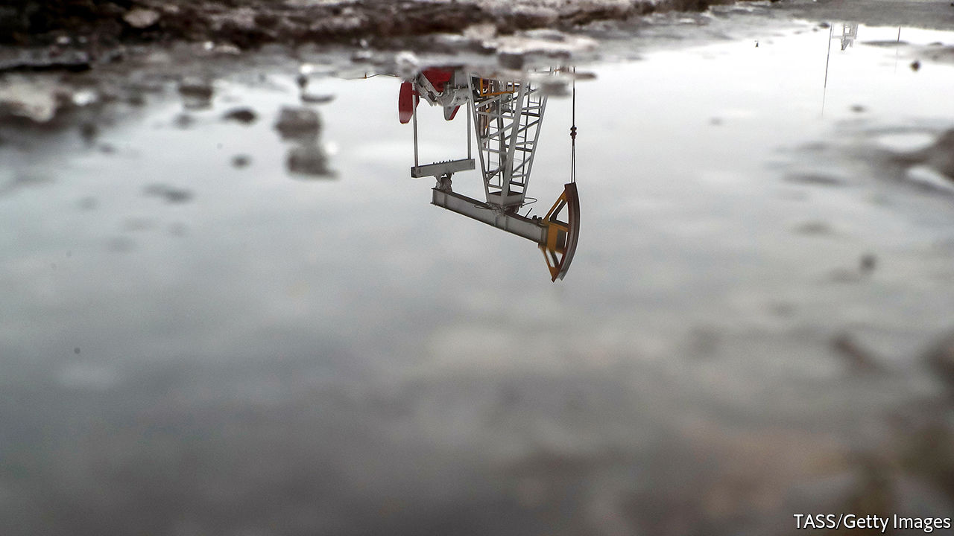

Editor’s note: The Economist is making some of its most important coverage of the covid-19 pandemic freely available to readers of The Economist Today, our daily newsletter. To receive it, register [here](https://www.economist.com/newslettersignup). For our coronavirus tracker and more coverage, see our [hub](https://www.economist.com/coronavirus)

EACH DAY about 100m barrels of oil rise from reservoirs deep below Earth’s surface. A ship called Liza Destiny sits off the coast of Guyana, collecting the black stuff from wells on the seabed nearly 2km below. On Norway’s continental shelf the Johan Sverdrup project is ramping up faster than expected. In Texas some 174,000 wells are at work, from big shale operations to solitary pumpjacks nodding as cattle graze nearby. Last month Saudi Arabia said it would ship a staggering 12.3m barrels a day to customers in April. From the Niger delta to Siberia, oil continues to flow. The rest of the world, meanwhile, is standing still.

In recent years oil producers have faced a spectre of depressed demand that could up-end the industry. All of a sudden the wraith has materialised—not out of concern for the climate, as oilmen feared, but because of covid-19. Crude fuels the movement of people and goods around the world. A lot of this has stopped as governments limit travel and other economic activity to contain the pandemic. Oil demand has dipped in only two years of the past 35. In the first six months of 2020 it may plunge by more than 20%.

If that weren’t enough, a brawl between Saudi Arabia and Russia has led to a price war. The price of Brent crude, the global benchmark, fell by more than half in March, below $23 a barrel. The last time it was this cheap, in 1999, Britney Spears topped the charts and the dotcom bubble had not burst. As for the drop, “nothing like this has ever happened before,” says Daniel Yergin, a historian and vice-chairman of IHS Markit, a consultancy.

## …Baby, one more time

Saudi Arabia and Russia were expected to discuss production cuts with other petrostates on April 9th, after The Economist went to press, then again at a G20 meeting the next day. Any deal is unlikely to end oversupply. Covid-19 is already exposing vulnerabilities of petrostates and oil firms. With prices poised to sink lower, the entire industry may be forever transformed.

A few months ago demand was expected to rise modestly this year. But trouble festered. Surging production in Guyana, Norway and Brazil seemed sure to weigh on prices. More worrisome, the world’s energy powers were increasingly at odds. In 2016 Russia teamed up with the Organisation of the Petroleum Exporting Countries (OPEC), led by Saudi Arabia, in an attempt to offset booming American shale production. This OPEC+ alliance proved both fractious and ineffectual. Russia regularly ignored the group’s self-imposed production limits, forcing Saudi Arabia to curb its own output more sharply. That pushed oil prices high enough to shore up investment in American shale but too low to balance the budgets of Saudi Arabia and other petrostates.

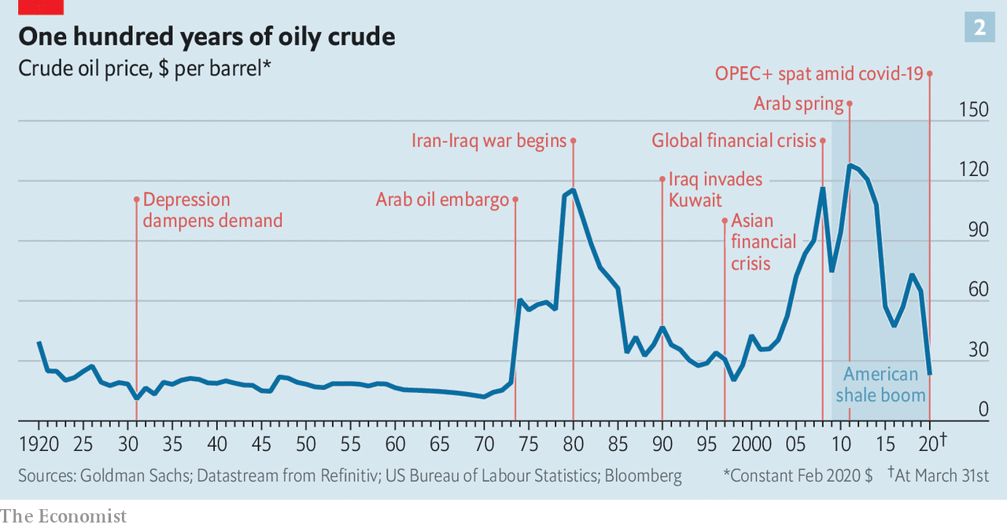

America, which in 2018 eclipsed Saudi Arabia and Russia as the world’s top oil producer (see chart 1), indeed looks like the main beneficiary of OPEC+. In an effort to snuff out shale Russia shocked OPEC in March by refusing further production cuts. Furious Saudis declared the price war in response.

American frackers and international oil giants had problems of their own. Even as shale production surged, shale firms’ valuations sank, with more investors sceptical of their ability to produce steady profits. Worries over climate change clouded the long-term prospects of supermajors such as ExxonMobil and Royal Dutch Shell while other industries offered better short-term returns. Energy was the worst-performing sector in the S&P 500 index in four of the past six years.

The oil market has witnessed big shocks before (see chart 2). In the late 1990s supply rose while a demand-sapping financial crisis rocked Asia. In 2014 the Saudis opened the taps in an attempt to drown American shale. But never before has anyone seen anything like covid-19. In the coming weeks crude will come perilously close to filling the capacity to store it. Citigroup, a bank, says that global supply needs to fall by 10m barrels a day, 12% of the total, for tanks not to spill over. Prices in parts of the world may fall below $10, says Goldman Sachs, another bank—or turn negative, as producers pay to have their oil taken away rather than shut in wells.

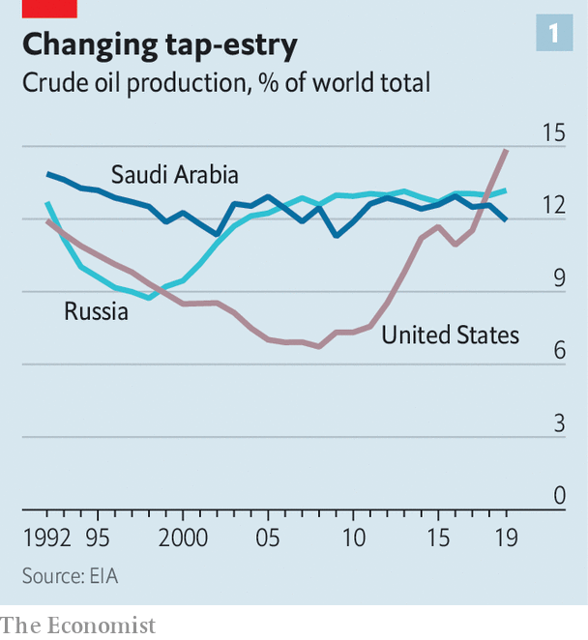

With OPEC+ in tatters and America’s shalemen clamouring for help, on April 2nd Donald Trump, who two days earlier welcomed cheap oil as a tax cut for American consumers, tweeted that a production deal between Russia and Saudi Arabia was imminent. This pushed Brent up by 20%, the biggest one-day gain since 1986.

Mr Trump wanted to support American oil companies further by buying their crude and storing it in the government’s strategic reserves. But he is not an autocrat presiding over a petrostate and his idea was rejected by Congress. Another of his suggestions, to levy a tariff on imported oil, might benefit some of America’s 9,000 or so oil and gas producers. But it would harm integrated giants such as ExxonMobil, which use heavier overseas crudes in their American refineries. Large companies also resist national production caps that would prop up smaller, less profitable rivals.

Some petrostates have trouble grasping that Mr Trump cannot call oil bosses and tell them to do this or that, says Mr Yergin. But, he adds, the president does have “an enormous amount of influence”. If the government’s power over oil firms is limited, its control of aid is plainer. A group of American senators from oil-producing states have threatened to withhold military support for Saudi Arabia if it refuses to limit output.

Mr Trump may therefore help broker an agreement, particularly if armed with data showing that American companies are already cutting spending. However, continued animosity between Russia and Saudi Arabia, combined with instability within OPEC’s smaller members, will lead at best to temporary production deals of limited impact. Output cuts agreed now would take time to be felt in the physical market. Even a cut of 15m barrels a day—around ten times what the Saudis sought in March—would be dwarfed by covid-19’s obliteration of demand, of as much as 20m barrels a day in April. “We are not going to fully recover until we are through corona,” says Mike Sommers of the American Petroleum Institute, a powerful lobby group.

Even then, it is unclear that the industry, in its current form, recovers at all. Russia is in a position of relative strength. It can balance its budget with oil at $42 a barrel and has more than $500bn in foreign reserves. Saudi Arabia has low operating costs of just $3.20 a barrel, about one-third of America’s, according to Rystad Energy, a consultancy. That would help it in a drawn-out battle for market share, though the current crisis has hit about a decade too soon for comfort—economic reforms to diversify the Saudi economy away from oil are a work in progress and the country still needs $84 a barrel to finance its budget.

Other producers look more vulnerable. Low oil prices will tighten the vise on Iran and Venezuela, each already squeezed by American sanctions. In Iran deteriorating finances will make it even harder to deal with high rates of coronavirus transmission. Cheap oil will exacerbate strife in Libya and may feed unrest in Iraq, as well as Algeria. A few big projects in Africa require an oil price of $45 or more just to break even, reckons Rystad; many may now be put on hold. Listed oil giants are paring spending in an effort to protect dividends. ConocoPhillips has delayed drilling in Alaska. Chevron has cut its capital budget for this year by 20%.

More damage will come as low prices compel firms and governments not just to cancel new projects but mothball existing wells. That may hurt countries with high production costs, like Brazil and Britain.

The sudden plunge in demand means that shut-ins will depend as much on logistics as on production cost, argues Damien Courvalin of Goldman Sachs. As inland tanks fill, landlocked wells with limited access to storage and transport will suffer. Canadian crude has the double misfortune of being costly and hard to ship—on April 7th a barrel of Western Canadian Select fetched about $10, a third as much as Brent. Some inland American and Russian production may stop, too.

## Oops…I did it again

When the world economy begins to open up after the pandemic, it will find the oil industry looking different. In America less productive shale beds may be gone, finally “flushing out production that was never really warranted”, says Ed Morse of Citigroup. The number of shale bankruptcies jumped by 50% last year. In 2020 more inefficient companies will vanish. Some wells, once closed, are too costly to reopen. And with oil at $35 a barrel, the return on renewable projects—which most energy firms have largely ignored—can rival that of a new oilfield, notes Valentina Kretzschmar of Wood Mackenzie, a consultancy.

A sudden loss of production could, if demand picks up quickly, create an opportunity for more drilling. But investors may now be warier of oil companies’ spending plans. Especially if they suspect covid-19 fundamentally alters oil demand: more people may work remotely, a lot of international travel could come to be seen as unnecessary and companies may bring supply chains closer to home to avert disruptions. “Are we about to see a structural change in oil consumption?” wonders Mr Courvalin. “It is a very valid question.” Oilmen used to take comfort that it was an abstract one. No longer. ■

Dig deeper:  
For our latest coverage of the covid-19 pandemic, register for The Economist Today, our daily [newsletter](https://www.economist.com/newslettersignup), or visit our [coronavirus tracker and story hub](https://www.economist.com/coronavirus)

Read also on: <https://www.economist.com/briefing/2020/04/08/an-unprecedented-plunge-in-oil-demand-will-turn-the-industry-upside-down>

|  |  |  |  |
| --- | --- | --- | --- |
| Previous | Articles | Sections | Next |

|  |  |  |
| --- | --- | --- |
| Briefing | Sections | The Americas |

United States

White House v virus: Bigger than Trump

.

Race and covid-19: Woes compounded

.

The intelligence community: The spooky state

.

The navy: Seasickness

.

Living spaces: Please shower on entry

.

Prison gerrymandering: Ghost constituents

.

Lexington: A river runs through it

.

|  |  |  |
| --- | --- | --- |
| Briefing | Sections | The Americas |

|  |  |  |  |
| --- | --- | --- | --- |
|  | Articles | Sections | Next |

#### Bigger than Trump

# The White House v covid-19

Now that the Trump administration has taken charge of the government’s pandemic response, how is it doing?

Apr 11th 2020 |

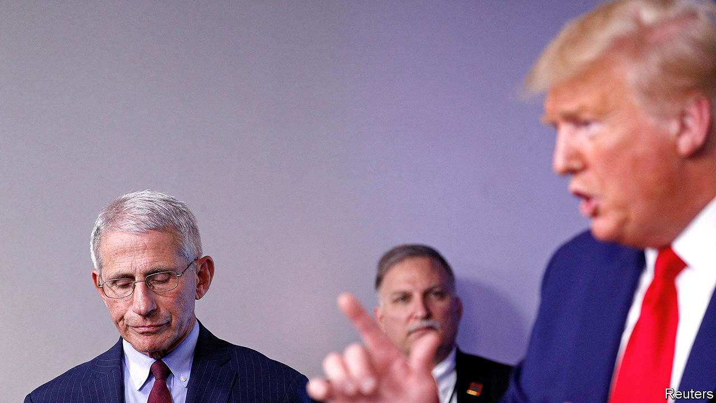

Editor’s note: The Economist is making some of its most important coverage of the covid-19 pandemic freely available to readers of The Economist Today, our daily newsletter. To receive it, register [here](https://www.economist.com/newslettersignup). For our coronavirus tracker and more coverage, see our [hub](https://www.economist.com/coronavirus)

WHEN THE Trump administration took office in January 2017 it inherited, among other things, plans to make cheaper ventilators and 20m reusable face masks, should the country need them. Nobody followed up. In 2018 John Bolton, the national-security adviser, “streamlined” the National Security Council and, in the process, closed its pandemic preparedness office. The following year, the administration decided to no longer embed an epidemiologist from the Centres for Disease Control and Prevention (CDC) with China’s CDC.

The consequences of these decisions, like the consequences of President Donald Trump’s insistence up until four weeks ago that covid-19 was less serious than seasonal flu, can only be guessed at for now. It seems likely that covid-19 would always have hit America hard, as it has most other rich countries that did not feel the impact of SARS. It also seems possible that America will suffer more than other rich Western democracies. If so, some portion of this exceptional excess mortality will be attributable to the president’s public-health advice and to decisions he avoided until too late.

That accounting will come later, though. Right now, the White House is running a response focused on getting material to the states being hit first by the virus. Though the CDC has not held a public briefing for a month, it is sending Epi-Aids, teams of epidemiologists, around the country to find new outbreaks. The Federal Emergency Management Agency (FEMA) is flying in kit from China. The president’s son-in-law, fresh from an attempt to bring peace to the Middle East, has again been handed the keys to the West Wing.

This is an improvement on the torpor that continued until the middle of March. Yet several criticisms of how the White House is responding persist. The first comes from state governors, who say they are bidding against each other and against the federal government for supplies. The governors of Kentucky, Ohio, Louisiana, Washington, Michigan, Illinois, New York and Arkansas have all said this is the case. Before the federal government stepped in, a handful of states went as far as arranging their own flights carrying protective equipment. While states were waiting for the federal government to do something, governors were banding together to place a large order of gear from China.

Since FEMA began flying medical equipment in from abroad, the competition has not gone away. Distribution of supplies, according to Rear Admiral John Polowczyk, who is in charge of the White House’s logistics effort, is still being done by private companies rather than by the feds, following the template used during Hurricane Katrina. The problem this time is that the emergency is not confined to one or two states, so everyone is bidding against each other for the same stuff. J.B. Pritzker, the governor of Illinois, says that once equipment brought in on FEMA flights arrives in America, governors are still placing bids with private distributors for it.

They are not the only ones: cities, hospital systems and care homes are all trying to secure their own supplies. “It’s a cage match,” says an employee of one of the country’s largest hospitals. State procurement officers swap tales of middlemen calling up with offers of millions of face masks at a few bucks over their retail price.

A second accusation is that the federal government is doling out scarce equipment to reward friendly governors. “How can it be that Kentucky and Florida get 100 percent or 100 percent-plus of what they need while Massachusetts doesn’t?” Elizabeth Warren asked Vox, a news website. “I think anyone would look at that and say it’s Donald Trump playing politics once again.” The president has encouraged this impression, too. “If they [state governors] don’t treat you right, I don’t call,” he told the White House press corps on March 27th.

This does not seem to be true of how FEMA is working. The agency is largely staffed by career civil servants who served the last president and, in many cases, the one before him. FEMA allocates medical kit according to a formula that considers need and the likelihood of an outbreak, insulating the process a bit from political considerations. If Florida has received what it asked for, that might be because it has a large population in care homes and is at high risk. There is, though, a cost to the impression that the president is distributing supplies in a haphazard and political way.

What is harder to quantify is the extent to which this administration’s trade war has slowed the current supply of equipment to hospitals. At the same time as Mr Trump issued an executive order banning the export of certain categories of medical equipment from America, the federal government was trying to secure supplies of the same gear made abroad. According to various people who worked with state governors to secure supplies, shipments were held up in China. Exports to America have become politically sensitive for party bosses in a way they used not to be.

Firms making gear in China are also concerned about being sued in American courts for equipment that does not protect the wearer. Chinese exporters of medical gear now require a new licence. That has created another layer of bureaucracy for suppliers with scruples, and a trade in fake permits for those without. The constraint on supplies from China does seem to have eased a bit after the president sent a tweet at 1am, when MAGA hat-wearers were tucked up in bed, praising Xi Jinping and calling the virus by the name most other people use, rather than the “Wuhan virus” or the “Chinese virus” which he had preferred, though that may be a coincidence.

Some of the president’s critics can only see the virus through a Trump lens. This suits the president, who has boasted wishfully about the great ratings his daily press briefings are getting. Mr Trump has indeed been incompetent and irresponsible. He continues both to offer unfounded medical advice, most recently on the use of an anti-malarial drug, and to shush any expert who might contradict him in public. He has blamed the World Health Organisation for mistakes his own administration made, and threatened to cut its funding.

The White House is as bizarre as ever. The president had no chief-of-staff for much of March. In less than a week he has got rid of the inspectors-general of the intelligence community and the watchdog overseeing the $2 trn federal stimulus. The Navy fired the captain of an aircraft-carrier for reasons that seem to have more to do with politics than with carrying aircraft. The Navy secretary then had to resign. But the virus is bigger than Trump.■

Dig deeper:  
For our latest coverage of the covid-19 pandemic, register for The Economist Today, our daily [newsletter](https://www.economist.com/newslettersignup), or visit our [coronavirus tracker and story hub](https://www.economist.com/coronavirus)

Read also on: <https://www.economist.com/united-states/2020/04/11/the-white-house-v-covid-19>

|  |  |  |  |
| --- | --- | --- | --- |
|  | Articles | Sections | Next |

|  |  |  |  |
| --- | --- | --- | --- |
| Previous | Articles | Sections | Next |

#### Woes compounded

# Covid-19 exposes America’s racial health gap

African-Americans appear more vulnerable to the virus

Apr 11th 2020 | CHICAGO AND NEW ORLEANS

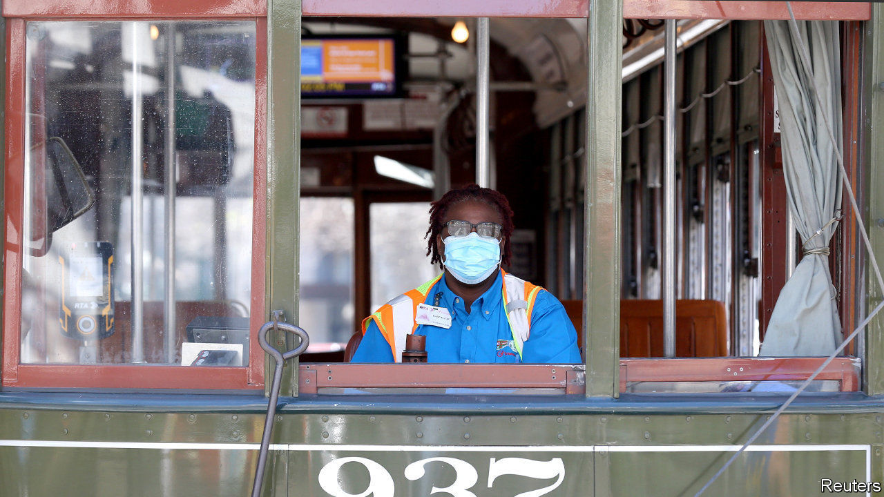

Editor’s note: The Economist is making some of its most important coverage of the covid-19 pandemic freely available to readers of The Economist Today, our daily newsletter. To receive it, register [here](https://www.economist.com/newslettersignup). For our coronavirus tracker and more coverage, see our [hub](https://www.economist.com/coronavirus)

AS COVID-19 extends its deadly reach into new hotspots such as Detroit and New Orleans, its proliferation has been accompanied by a disturbing trend. The disease appears to be taking a greater toll on black Americans. African-Americans make up 14% of Michigan’s population. Yet as of April 6th they accounted for some 33% of confirmed coronavirus cases and 40% of the state’s 617 deaths. Louisiana, which has the second-highest share of African-Americans among states, was home this week to ten of the 20 worst-hit counties in the country, ranked by deaths per 100,000 residents, according to Gary Wagner of the University of Louisiana at Lafayette. He says one county had a mortality rate more than double that of New York City.

One possibility is that the higher death rate so far for black Americans may follow from the disease’s tendency to strike cities early. Michigan’s biggest city is Detroit, which is 80% black. The state’s governor, Gretchen Whitmer, says Detroit’s large airport probably made it vulnerable to importing contagion. New Orleans also gets plenty of visitors. The city held its two-week-long Mardi Gras in mid-February before carriers of the virus—many being asymptomatic—worried much about mingling. Mr Wagner calls that a “super-spreader event” as 1m or so people partied at close quarters. Some participants’ costumes were even coronavirus-themed. Now, officials fear cases are rising so fast they will soon overwhelm hospitals. The city’s population is below 400,000, but it has already seen 171 deaths.

In addition to living in cities that covid-19 struck early, African-Americans share several other vulnerabilities to the disease. Black Americans are, on average, poorer than other ethnic groups. Those who live in overcrowded homes or who work in blue-collar jobs and must keep toiling outside their houses cannot isolate themselves as easily as better-off folk. The poor and uninsured—African-Americans are likeliest to go without coverage—may also seek medical care too late.

The long-standing residential segregation of some black communities makes things worse. People in places with high levels of violence may make different calculations about the risk posed by a mere virus. A counsellor who works with violent men in parts of Chicago says “shooting goes on” despite the virus. Public-health lockdowns are hard to enforce.

More important, though, is the link between race and chronic ill-health. Chicago’s mayor, Lori Lightfoot, recently noted that before the pandemic white residents were expected to live nearly nine years longer than black ones, who are likelier to suffer from chronic health problems such as respiratory illness, high blood pressure, diabetes and obesity.

In Detroit chronic conditions are depressingly common. About 45% of adults were obese in 2017 (the figure for New Orleanians was 36%). America’s national rate of obesity was 30%, according to one measure by the Centres for Disease Control and Prevention. Those with existing problems risk deadly complications once infected with the virus. Officials in Louisiana said that 97% of those who died with the virus to March 29th had an underlying condition.

Covid-19’s spread may further expose this racial health gap. Ms Lightfoot says that Chicago’s black residents—who make up less than 30% of the city’s population—live lives that are so much shorter that they account for 72% of its deaths. “Those numbers take your breath away.” ■

Dig deeper:  
For our latest coverage of the covid-19 pandemic, register for The Economist Today, our daily [newsletter](https://www.economist.com/newslettersignup), or visit our [coronavirus tracker and story hub](https://www.economist.com/coronavirus)

Read also on: <https://www.economist.com/united-states/2020/04/11/covid-19-exposes-americas-racial-health-gap>

|  |  |  |  |
| --- | --- | --- | --- |
| Previous | Articles | Sections | Next |

|  |  |  |  |
| --- | --- | --- | --- |
| Previous | Articles | Sections | Next |

#### The spooky state

# What does Donald Trump want from America’s intelligence services?

The sacking of Michael Atkinson highlights the president’s push for personal loyalty

Apr 11th 2020 | WASHINGTON, DC

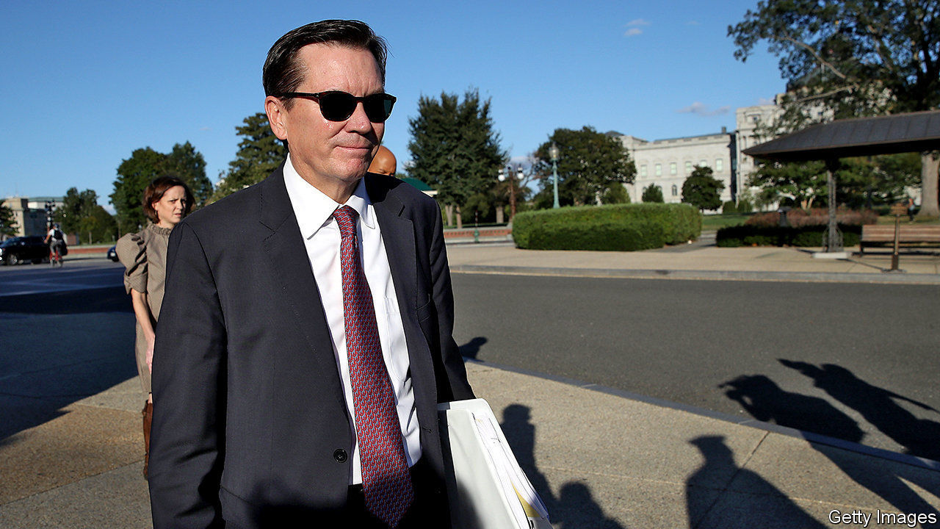

ON APRIL 3RD Donald Trump fired Michael Atkinson, the inspector-general for America’s intelligence community (IC). Mr Atkinson’s sin seems to have been following the law. He told Congress, as he was legally bound to do, about a whistleblower’s complaint regarding Mr Trump’s phone call with Ukraine’s president, over which Mr Trump was impeached last year. Mr Atkinson’s sacking highlights, obviously, Mr Trump’s vindictiveness. But it also reveals, more interestingly, what he wants from the IC.

The phrase “intelligence community” refers to a long list of America’s federal intelligence-gathering services. There are no fewer than 17, including the Central Intelligence Agency, the Federal Bureau of Investigation and the map-making National Geospatial Intelligence Agency, as well as the intelligence arms of the armed forces and several cabinet departments. Overseeing them is the Office of the Director of National Intelligence, a cabinet-level co-ordinating position created after the attacks of September 11th 2001.

Tension is inherent to the relationship between any president and the IC. Presidents are politicians. Intelligence analysis ought to be apolitical and dispassionate. Analysts must sometimes deliver information that presidents do not want to hear. Some presidents have mistrusted the IC: Richard Nixon believed it was filled with Ivy Leaguers who looked down on him. Some sidelined it: when a small plane crashed on the White House lawn two years into Bill Clinton’s presidency, some in the IC joked that it was the head of the CIA trying to get a meeting with the domestically focused president. Some have challenged it: Barack Obama, one analyst recalled, used to listen to his daily brief, and then ask “the hardest question—the one you hoped he wouldn’t ask you.”

Mr Trump, by contrast, seems to want an IC that is personally loyal to him, and therefore politicised, rather than analytical and independent. He came into office primed to distrust the IC, which first raised concerns over his campaign’s links with Russia. That mistrust—intensified by his suspicion for civil servants who have served under multiple administrations, as opposed to political appointees whose careers he controls—has only deepened over the course of his tenure.

James Comey, a former director of the FBI, got the axe after declining to say that Mr Trump was not personally under investigation for his campaign’s links with Russia, and, reportedly, for failing to promise Mr Trump “loyalty” at a private dinner. In February Joseph Maguire was forced out as acting Director of National Intelligence (DNI) after a subordinate told Congress that Russia is intervening to help Mr Trump win this year’s election. He replaced Mr Maguire with Ric Grenell, a caustic political operative with no intelligence background.

The president uses opprobrium to intimidate those he does not fire. He has publicly derided IC officials who disagree with him as “extremely passive and naive”, accused the IC of using its powers to “surveil and abuse the Trump campaign”, compared American intelligence professionals to Nazis and, according to Andrew McCabe, a former FBI acting director, taken the word of Vladimir Putin over American analysts’.

Mr Trump has similarly scant regard for the intelligence product. Ideally, presidents do not ask their analysts for advice; presidents tell them what they want to do, and ask them to forecast what is likely to happen depending on how they decide to do it. Douglas London, a 34-year veteran of the CIA’s clandestine service, explains that Mr Trump “just wants to see intelligence that aligns with his beliefs, as opposed to information he can ponder to inform his decision-making”.

The president can be dismissive of intelligence that fails to confirm his views. He recently mocked the IC’s findings on current Russian electoral interference as “rumour” and “disinformation”. He can also be cavalier. Soon after taking office, he revealed classified information provided by an American ally to Russia’s foreign minister. In August 2019, after an Iranian rocket launch failed, Mr Trump tweeted an image of the launch site that probably came from a spy satellite or drone.

Some harms from this behaviour are clear. Revealing sensitive information makes others warier of sharing it with America, which risks leaving America less informed about its adversaries. A president with more respect for the IC might not have ignored its warnings about covid-19 and sprung into action sooner. Senior IC officials seem less likely, with Mr Grenell as DNI, to warn of election interference—at least in Mr Trump’s favour.

Other harms are more nebulous and harder to forecast. Because the IC works in the shadows, its successes tend to be secret and its failures evident only in retrospect. Perhaps Mr Trump will be lucky. Perhaps IC professionals’ habits of clear-eyed analysis and co-operation with allies will persist, despite ructions at the top. But analytical independence is an essential part of a functioning intelligence service, and any actions that weaken it risk weakening the service—particularly as senior professionals leave, and those who remain learn to toe the line in order to survive.

This may reverse under a different president. So could, with enough time and reassurances, other countries’ wariness to share their secrets. But a second Trump term could leave the IC less a collection of independent analysts than an institution with broad powers to operate in secret for the president’s personal and political benefit—without, as Mr Atkinson’s sacking warns, any real oversight.■

Dig deeper:

* Sign up and listen to Checks and Balance, our new [newsletter](https://www.economist.com/checksandbalance/) and [podcast](https://www.economist.com/podcasts/2020/02/21/checks-and-balance-our-new-weekly-podcast-on-american-politics) on American politics
* [Explore our guide](https://www.economist.com/united-states/2020/02/26/the-economists-guide-to-the-us-2020-elections) to the US 2020 elections
* For more coverage of covid-19 see our [coronavirus hub](https://www.economist.com/news/2020/03/11/the-economists-coverage-of-the-coronavirus)

Read also on: <https://www.economist.com/united-states/2020/04/11/what-does-donald-trump-want-from-americas-intelligence-services>

|  |  |  |  |
| --- | --- | --- | --- |
| Previous | Articles | Sections | Next |

|  |  |  |  |
| --- | --- | --- | --- |
| Previous | Articles | Sections | Next |

#### Seasickness

# Covid-19 takes out an aircraft-carrier, and a navy secretary

Thomas Modly, America’s acting secretary of the navy, offered to resign after a coronavirus controversy

Apr 8th 2020 |



Editor’s note: The Economist is making some of its most important coverage of the covid-19 pandemic freely available to readers of The Economist Today, our daily newsletter. To receive it, register [here](https://www.economist.com/newslettersignup). For more coverage, see our coronavirus [hub](https://www.economist.com/coronavirus)

SEVERAL HUNDRED sailors thronged the cavernous belly of the USS Theodore Roosevelt, a 100,000-tonne nuclear-powered aircraft-carrier. “Captain Crozier! Captain Crozier!” they chanted, as the commanding officer, Brett Crozier, walked forlornly down the gangway into a warm Guam evening on April 3rd, bidding farewell to his warship. “Now that’s how you send out one of the greatest captains you ever had,” remarked a sailor in the crowd. The result is the latest civil-military calamity of this administration, culminating in the departure of Donald Trump’s second navy secretary in five months.

In mid-March the Roosevelt was exercising in the South China Sea, fresh from a visit to Vietnam. Then covid-19 struck, forcing the ship to Guam. On March 30th, as the virus raged through a crew of over 5,000, Captain Crozier sent an imploring four-page letter to his colleagues. The spread of the disease was “ongoing and accelerating”, he warned, and sailors had to be evacuated from the confined quarters. “We are not at war,” he urged. “Sailors do not need to die.”

At first navy leaders expressed support, insisting that Captain Crozier would not face retaliation for sounding the alarm. A day later he was removed. Thomas Modly, America’s acting secretary of the navy, offered a jumble of reasons. The captain had “undermined the chain of command” and “created…panic on the ship” by copying 20-30 people on his letter. He had created “the perception that the Navy is not on the job, the government’s not on the job.” And he might also have “emboldened our adversaries to seek advantage”.

Then, in an intemperate speech aboard the Roosevelt on April 6th, Mr Modly told its incredulous crew that Captain Crozier had either deliberately leaked the letter to the media, or was “too naive or too stupid to be a commanding officer”. Mr Modly mockingly called the captain—who had tested positive for covid-19 a day earlier—a “martyr” and accused him of “betrayal”. Worst of all, he said, the letter had caused “a big controversy in Washington, DC”.

Mr Modly later apologised for his remarks, but they reinforced the sense that Captain Crozier’s offence was to have embarrassed the administration rather than violated protocol or undermined readiness. On April 7th, under pressure from lawmakers, and largely disowned by the Pentagon, Mr Modly resigned.

Even before this episode, it was clear that America’s globe-girdling navy was not in tip-top shape. In January the Pentagon’s inspector-general scrutinised a dozen destroyers and found deficiencies with training. In one case it concluded that “the ship will not be able to conduct gunnery support”—including trifling matters “such as identifying where the ship is shooting”. Shoddy seamanship in the Seventh Fleet, based in Japan, resulted in two warship collisions that killed 17 people in 2017. The fleet was also rocked by a separate corruption scandal, leading to reprimands for at least ten captains and admirals, and the first-ever conviction of a serving admiral for a federal crime.

American warships are ageing—57% are more than 20 years old. Crumbling shipyards and relentless operations have made it harder to maintain them. The navy is also short of more than 6,000 sailors, though recruitment, retention and morale are unlikely to be helped by Mr Modly’s instruction to sailors that “you’re under no obligation to like your job, only to do it”.

Then came covid-19, which has spread across several vessels. Tight quarters make warships “a Petri dish of virus”, says a former carrier strike group commander. Sailors aboard the uss Ronald Reagan, a carrier moored in Japan, have also tested positive. That does not mean America’s fleet would be paralysed in a crisis—warships can lose much of their crew and remain viable—but it may keep many in port.

Mr Modly’s own brief tenure only came about because of the last mess. In November his predecessor, Richard Spencer, was fired after resisting what he called Mr Trump’s “shocking and unprecedented intervention” in the case of a Navy Seal who had been accused of war crimes. In a parting letter to the president, Mr Spencer said that this meddling had put at risk “good order and discipline”. The navy now looks more rudderless than ever.■

Dig deeper:  
For our latest coverage of the covid-19 pandemic, register for The Economist Today, our daily [newsletter](https://www.economist.com/newslettersignup), or visit our [coronavirus hub](https://www.economist.com/coronavirus)

Read also on: <https://www.economist.com/united-states/2020/04/08/covid-19-takes-out-an-aircraft-carrier-and-a-navy-secretary>

|  |  |  |  |
| --- | --- | --- | --- |
| Previous | Articles | Sections | Next |

|  |  |  |  |
| --- | --- | --- | --- |
| Previous | Articles | Sections | Next |

#### Please shower on entry

# House-sharers find covid-19 restrictions especially hard to deal with

More American adults now share living spaces, but not necessarily the same understandings of orders to stay at home

Apr 11th 2020 |

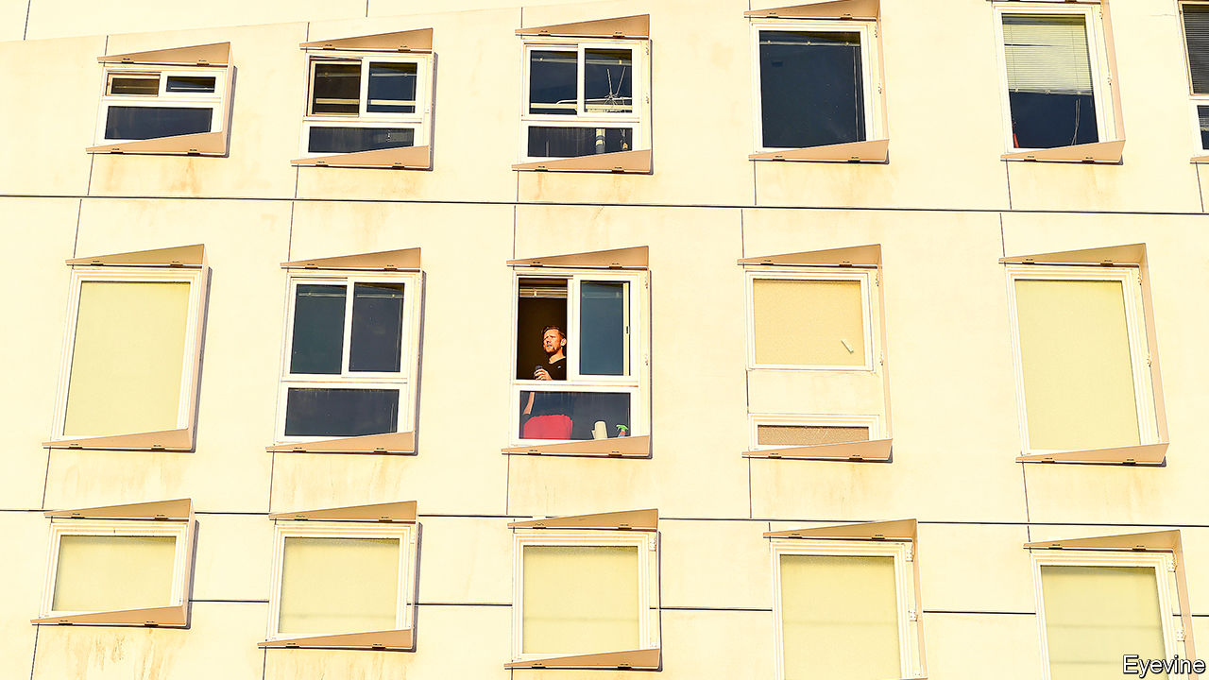

Editor’s note: The Economist is making some of its most important coverage of the covid-19 pandemic freely available to readers of The Economist Today, our daily newsletter. To receive it, register [here](https://www.economist.com/newslettersignup). For our coronavirus tracker and more coverage, see our [hub](https://www.economist.com/coronavirus)

IN LATE MARCH, a text message appeared on Twitter from a student at Brigham Young University in Salt Lake City. She asked her flatmate not to invite guests to their shared space during the coronavirus epidemic, since her immune system was compromised. “I’m glad that you are seeking to stay safe,” came the reply, “however, you can’t prevent me from having people over. So you can expect to see Brett over often, and if that’s an issue for you, you can stay in your room.” Not surprisingly, this was retweeted everywhere, the Salt Lake City health department weighed in (“Brett could do his part in flattening the curve by visiting virtually,” it scolded) and by the next day #StayHomeBrett was one of the top ten trending hashtags nationally.

This small episode caught people’s attention because it highlights the broader problems that a swathe of Americans have in coping with the coronavirus. These are house-sharers. According to the Pew Research Centre, in 2017 just under a third of adults lived in households with other adults who are not their spouses or partners, up from just over a quarter in 2004.

Over the past 15 years, household sharing—think of the sitcom “Friends”—has soared with the rising cost of housing and rent. According to Pew, 30% of those under 35 are house-sharers, compared with 12% of people aged 35 to 54. They are concentrated in the largest cities. Zillow, a property-database company, estimated in 2018 that 40-50% of adults in southern California’s large cities as well as New York lived in shared households, compared with less than 20% in North Dakota and Iowa. Coastal cities also have by far the highest number of coronavirus cases, so the reaction of urban house-sharers will play a vital role in how America copes with the disease.

Which is worrying because they face special difficulties. In families, parents can (in theory) persuade children into good behaviour. But house-sharers are independent adults. As the Salt Lake student put it, “you can’t prevent me.” Yet one roommate can put a whole household at risk.

So house-sharers have suddenly been forced to start thinking about questions like: are visitors allowed? Partners? What happens if someone gets the virus?

Most households are answering such questions piecemeal. “Each of us had slightly different ideas about how to abide by the stay-at-home order,” says Sarah Fredrick, who shares a house in Washington, DC, with five other professional women. They have come to an arrangement based on trust, rather than rules. Partners are allowed, visitors aren’t. But there are no protocols about (for example) shopping.

Others rely on explicit rules. Everyone who enters the house must change clothes and shower, says Brad Marriner. He shares an apartment in New York with another man; both have partners in other two-person apartments, making a circle of six people in three houses, all of whom have signed up to common rules. “There’s a lot of laundry and showering,” he says.

A communal house in Oakland, California, has gone further, drawing up a 12-page list of rules for what Jeremy Blanchard, a house member, describes as “gold-standard quarantine”: no one can be closer than six feet to any outsider for 22 days; everyone must wear a mask outside; no one has covid-like symptoms and so on. If the household reaches the gold standard, its members may visit other households that have achieved it, too. There are also rules for domestic chores, though not as stringent as in another Oakland house, which requires five people to do the shopping: two to buy goods (they wear two layers of clothing, taking off the outer layer after leaving the store); two to disinfect purchases outside the house; one to clean the fruit and vegetables. It takes hours.

That is extreme. But the big public-health problem lies not in shared households that go too far but in irresponsible ones that do not go far enough. How sharers respond will determine not only how quickly covid-19 passes, but also whether, afterwards, millions will continue to live in households that are an infection risk. ■

Editor’s note: The Economist is making some of its most important coverage of the covid-19 pandemic freely available to readers of The Economist Today, our daily newsletter. To receive it, register [here](https://www.economist.com/newslettersignup). For our coronavirus tracker and more coverage, see our [hub](https://www.economist.com/coronavirus)

Read also on: <https://www.economist.com/united-states/2020/04/11/house-sharers-find-covid-19-restrictions-especially-hard-to-deal-with>

|  |  |  |  |
| --- | --- | --- | --- |
| Previous | Articles | Sections | Next |

|  |  |  |  |
| --- | --- | --- | --- |
| Previous | Articles | Sections | Next |

#### Ghost constituents

# The United States census has an inmate problem

Critics say registering the incarcerated as residents of their prisons’ counties leads to gerrymandering

Apr 11th 2020 | NEW YORK

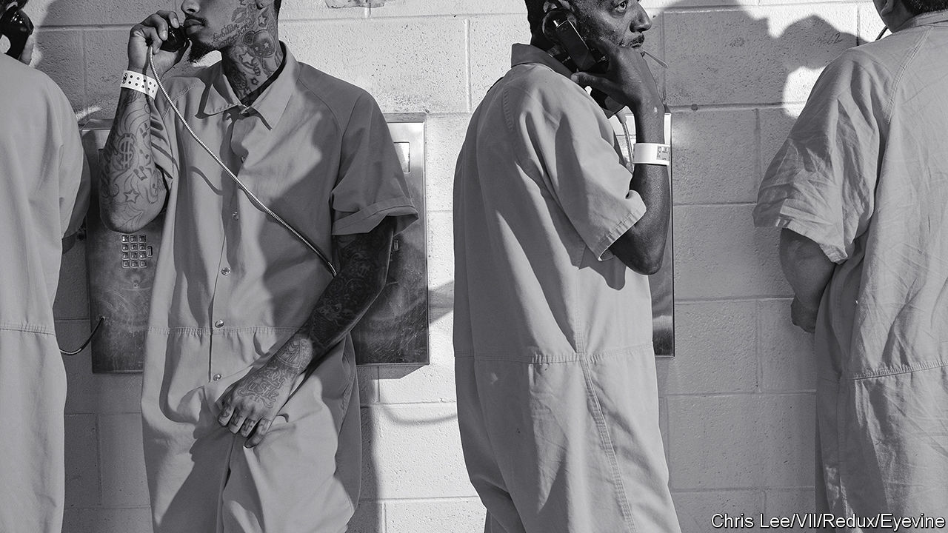

ROBERT HOLBROOK was 17 years old when he went to prison in 1991. For the next 27 years he was incarcerated in several state prisons in Pennsylvania. He was imprisoned at SCI Greene, a supermax prison in the south-western corner of the state, during the 2010 census. Since 1790, the Census Bureau—which began its decennial count on April 1st—has registered incarcerated people as residents of the counties where their prisons are located, not the last address before their arrest. This is important because states then use the census data to draw legislative maps. A prison can bump up a state legislative district’s population, even in places where prisoners cannot vote, which in America means everywhere apart from Maine and Vermont.

Critics call this practice prison-based gerrymandering. Mr Holbrook, an African-American man from the outskirts of Philadelphia, was counted as a resident of Greene County, a mostly white rural area. He, two other formerly incarcerated people and the NAACP Legal Defense Fund filed a lawsuit in February in a Pennsylvania state court over this practice.

The lawsuit asserts that prison gerrymandering has two unconstitutional effects. First, it inflates the political power of the voters in counties with prisons, mainly in rural, mostly white districts. Second, it dilutes the political power of voters in the incarcerated person’s urban home district. Pennsylvania’s prison population is predominantly black or Latino and comes from Philadelphia and Pittsburgh.

Prisons can also lower the income per person for the county while the home district could lose government funding. Mr Holbrook, who had been locked up 300 miles away from home, reckons that “no one should benefit or profit from people in cages. However, if anyone wants the benefit from my incarceration, it should have been the community I harmed.”

A 2018 study by Brianna Remster and Rory Kramer, two Villanova University sociologists, found that if prison-based gerrymandering were done away with and the incarcerated were counted where they lived before they went to prison, several districts with prisons would lose representation and several urban districts would gain it. Their research showed a “substantial likelihood” that Philadelphia would gain an additional majority-minority district in the state house.

The Census Bureau does not intend to change its policy for the 2020 count. So states are taking matters into their own hands. In 2019 a state lawmaker proposed a bill to end the practice in Pennsylvania. It has not made much headway but momentum is building elsewhere. At least eight other states have legislation on the table. Last month Colorado’s governor signed a bill ending the practice. Seven other states, including New York and California, have passed bills ending the practice. Anamosa, a small city in Iowa, changed its law in 2009 after a candidate was elected with just two votes; one was his wife and the other a neighbour. Most of the district residents were prison inmates who could not vote.

Wanda Bertram of the Prison Policy Initiative, a research group, says that as more people focus on gerrymandering in general, it is becoming “easier for folks to understand how taking people out of their home communities and reallocating to their prison cells, for the purposes of redistricting can really change how political power is allocated.”

Mr Holbrook was released in 2018. He is now a registered voter and paralegal but according to the census is still technically considered a resident of Greene County.■

Dig deeper:

* Sign up and listen to Checks and Balance, our new [newsletter](https://www.economist.com/checksandbalance/) and [podcast](https://www.economist.com/podcasts/2020/02/21/checks-and-balance-our-new-weekly-podcast-on-american-politics) on American politics
* [Explore our guide](https://www.economist.com/united-states/2020/02/26/the-economists-guide-to-the-us-2020-elections) to the US 2020 elections
* For more coverage of covid-19 see our [coronavirus hub](https://www.economist.com/news/2020/03/11/the-economists-coverage-of-the-coronavirus)

Read also on: <https://www.economist.com/united-states/2020/04/11/the-united-states-census-has-an-inmate-problem>

|  |  |  |  |
| --- | --- | --- | --- |
| Previous | Articles | Sections | Next |

|  |  |  |  |
| --- | --- | --- | --- |
| Previous | Articles | Sections | Next |

#### Lexington

# A river runs through it

Fly-fishing is compatible with social distancing—and a lesson in American strengths and strains

Apr 11th 2020 |

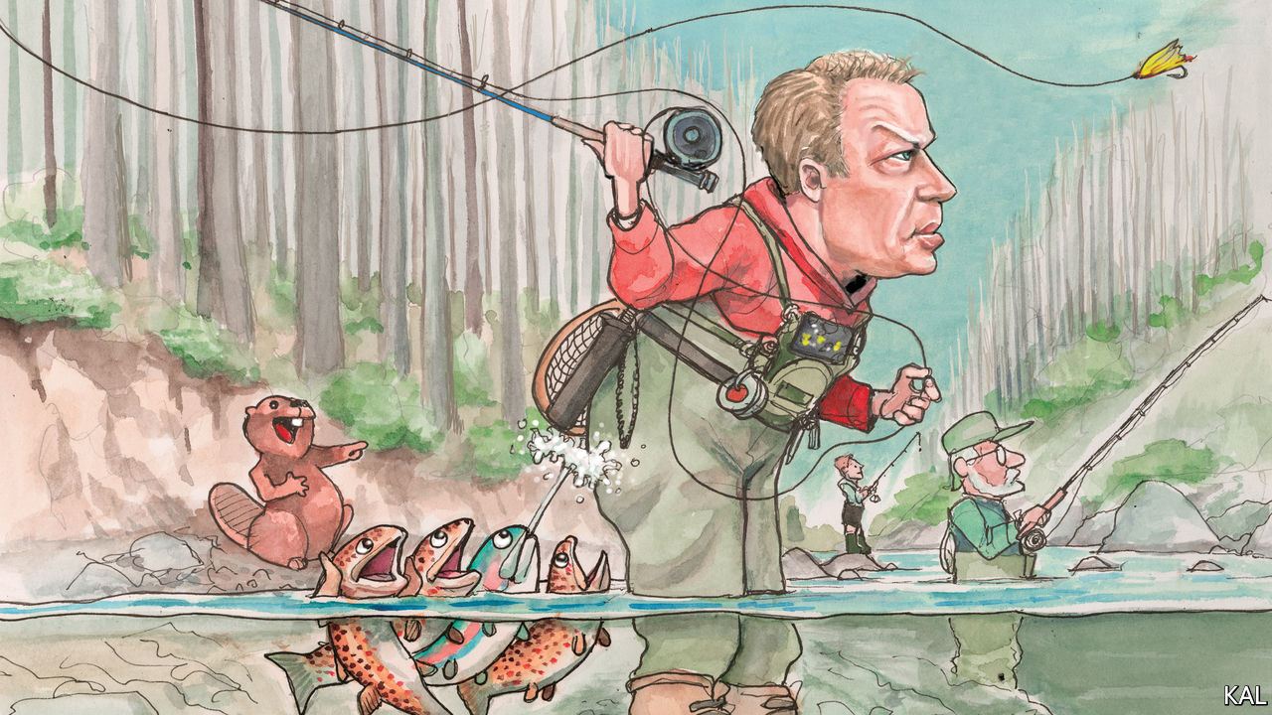

Editor’s note: The Economist is making some of its most important coverage of the covid-19 pandemic freely available to readers of The Economist Today, our daily newsletter. To receive it, register [here](https://www.economist.com/newslettersignup). For our coronavirus tracker and more coverage, see our [hub](https://www.economist.com/coronavirus)

THE NORTHERN CENTRAL RAILROAD, running up from Baltimore, has long been synonymous with great deeds. It was a route for escaped slaves, heading for Pennsylvania. It carried Abraham Lincoln to Gettysburg in 1863, and bore his body, 17 months later, on a leg of its journey home to Illinois. It is a hiking trail now, shaded by sycamore and willow. But for the pen-and-brush duo behind this column, the old railroad remains auspicious, as the access-point to a deep pool of the Gunpowder river, where trout lie.

It is not the best fishing spot on the Gunpowder. That is a couple of miles upstream, near the reservoir which, thanks to a decades-old agreement between the local anglers and city of Baltimore, releases a steady flow of water into the river. But any fish caught in that stretch must be put back. And the dispensation for angling in Maryland’s coronavirus lockdown rules applies only to fishing for food. So that is what Lexington, his nine-year-old son, and “Kal”, this newspaper’s cartoonist-in-chief, were set upon, one glorious recent afternoon, with an eagerness whetted by days cooped up.

They kept 12 feet apart, mind, while chatting and scrambling down the riverbank. This seemed not only sensible but representative of what fly-fishing is. It is a solo activity. Yet the technical demands of casting a long line to deliver a feathered hook to the water with, ideally, the delicacy of an insect alighting make its practitioners prone to lively exchanges of information: on rods, water, flies and so forth. An American master angler, Lee Wulff, called fly-fishing “the most social of all the solitary sports”. Pondering this, your columnist took his place on a sandbar dotted with beaver tracks, and began casting across the bottom of the pool, to where a jumble of rocks rose promisingly from its gravelly depths.

Maryland’s dispensation reflects the exalted place angling occupies in America. Around 50m Americans go fishing each year; not far off as many as voted for Donald Trump. A minority of them fly-fish. Yet the sport’s elite reputation, which came with it from 18th-century Britain, and the commitment of its devotees, have made it especially influential and revealing. Presidents from Grover Cleveland to George H.W. Bush have been devoted to it. Three have written books on fly-fishing: including Herbert Hoover and Jimmy Carter, who spent the day after his crushing electoral defeat in 1980 building an ingenious contraption to dry his fly-lines.

Fly-fishing’s success in America reflects above all the country’s natural bounty. Within a few decades of the technique being mainly practised by British officers, homesick for their own chalk streams, Americans were fly-fishing in diverse conditions for bass and many species of salmon and trout. This led them to innovate; some American fly patterns were based on native American lures. Yet the fly-fishing establishment remained concentrated on the Anglocentric east coast. This encouraged an unwarranted inferiority complex, which was compounded by the fact that early American fishing scribblers and fly-tiers tended to be British. The first great writer, Theodore Gordon, initially wrote for a British journal.

But even then America was showing its genius for popularising elite culture. This was partly a reaction to the snooty Anglos. “Our fish are too Republican, or too shrewd, or too stupid, to understand the science of English trout fishing,” wrote a peeved angler in 1830. A similar urge drove baseball to supplant American cricket around this time. Yet the growth of a New World fly-fishing tradition, more capacious than the British one, reflected above all America’s vast socioeconomic, as well as piscatorial, possibilities.

An exploding rail network opened up new angling paradises to thousands of first-generation fishers. The connection between infrastructure and wilderness was sometimes overt; the owners of the Denver and Rio Grande Railroad offered a $20 gold piece to anyone who caught a 10lb trout alongside its tracks. Other entrepreneurs also seized the opportunity fly-fishing presented. Wisconsin’s fly-tying industry would soon produce over 10m lures a year. While the east-coast elite maintained an exclusive idea of fly-fishing, it had become a mass hobby.

The inevitable downside of this growth, overfishing and pollution, led to a pushback in the late 19th century. In the name of conservation, private fishing clubs grabbed areas that had previously been open to the public. Such enclosures at least led to better management—which was then applied nationally in the emerging conservation movement that fly-fishers had thereby helped launch. America’s angling lobby has sometimes erred from its strong environmental record. To maintain bipartisanship, it has said little about the ominous threat of climate change to America’s rivers. And rainbow and brown trout—which the Lexington team was after—are two of America’s most invasive species. But as the Gunpowder, once a stagnant trickle, goes to show, the billion-dollar angling industry remains a powerful force for conservation.

## An angle on fishing

American fly-fishing is still evolving. Recent decades have seen a big expansion in saltwater fly-fishing, pioneered by Lefty Kreh, a Marylander who helped broker the Gunpowder agreement. It has also become fashionable, due to interest from Hollywood and social media. Apparently, it does well on Instagram. Fly-fishing has been America’s fastest-growing category of fishing in recent years.

Anchored in local topography, hydrology and culture, it has meanwhile retained local differences amid such national trends. According to Walter Wiese, a fishing guide in Montana, east-coast anglers, being accustomed to small rivers and trees, tend to be nimble but not big casters; west-coasters tend to be the opposite. Fly-fishing is a story of oscillating tensions between the masses and elite; tradition and innovation; regional against national concerns: it is an American parable.

It can be frustrating, too. After several hours flogging the river, Lexington had caught nothing. His son had meanwhile landed a plump brown trout. Fishing always sorts the men from the boys.■

Dig deeper:  
For our latest coverage of the covid-19 pandemic, register for The Economist Today, our daily [newsletter](https://www.economist.com/newslettersignup), or visit our [coronavirus tracker and story hub](https://www.economist.com/coronavirus)

Read also on: <https://www.economist.com/united-states/2020/04/11/a-river-runs-through-it>

|  |  |  |  |
| --- | --- | --- | --- |
| Previous | Articles | Sections | Next |

|  |  |  |
| --- | --- | --- |
| United States | Sections | Asia |

The Americas

Latin America and covid-19: Bracing for a battering

.

A battle in the Caribbean: Bolivarian farce

.

Bello: A president who is isolating himself

.

|  |  |  |
| --- | --- | --- |
| United States | Sections | Asia |

|  |  |  |  |
| --- | --- | --- | --- |
|  | Articles | Sections | Next |

#### Pandemic preparedness

# Latin America’s health systems brace for a battering

Despite recent improvement, the region’s health care is not ready

Apr 11th 2020 | MEXICO CITY AND QUITO

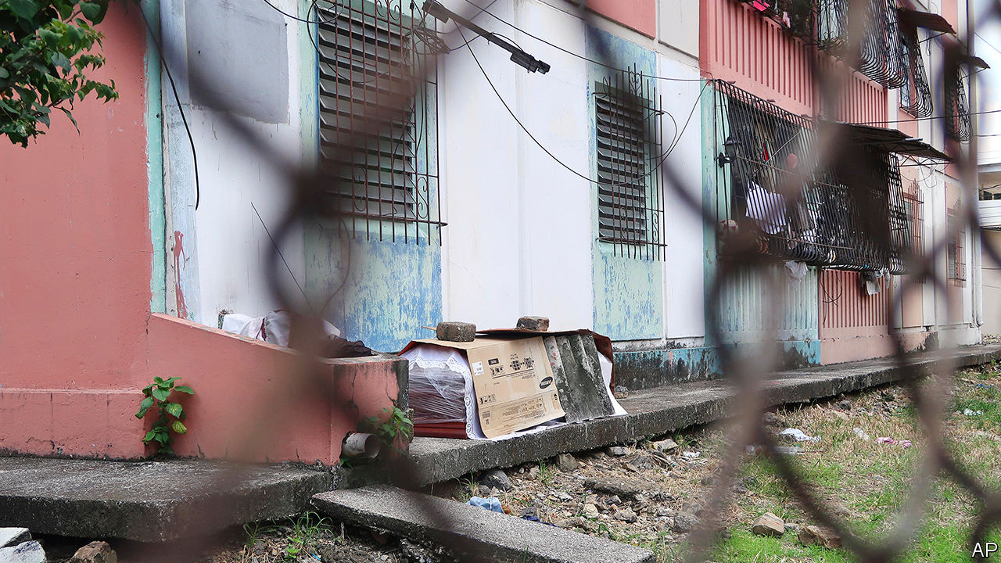

Editor’s note: The Economist is making some of its most important coverage of the covid-19 pandemic freely available to readers of The Economist Today, our daily newsletter. To receive it, register [here](https://www.economist.com/newslettersignup). For our coronavirus tracker and more coverage, see our [hub](https://www.economist.com/coronavirus)

A PROCESSION OF disappointments awaits residents of Guayaquil, Ecuador’s largest city, when illness strikes. Those who report symptoms of covid-19 to the health-care hotline get appointments scheduled for several weeks later, by which time they will probably have recovered or died. With ambulance services overwhelmed, stricken people arrive at hospitals in pickup trucks, only to find there are no empty beds. When somebody dies at home, the corpse joins a long waiting list for removal. The city has run out of wooden coffins. Some relatives dump loved ones’ bodies in the sweltering streets.

Guayaquil is the first place in Ecuador where covid-19 has struck with force. That is probably because the country’s Pacific coast takes a long school holiday starting in early February, five months before the Andean region, including Quito, the capital. Guayaquileños flew to and from Europe after the novel coronavirus began spreading but before cancelling trips became the norm. The hospitals and bureaucracy could not cope with the disease they brought back. In desperation the city’s mayor, Cynthia Viteri, told municipal vehicles to park on runways to block incoming flights. She contracted the virus.

Other parts of Latin America wonder whether Guayaquil’s horrors will soon be theirs. “No health system in the world” can cope with covid-19 once the rate of transmission gets beyond a certain point, notes the director of a public hospital in Mexico. Northern Italians have discovered the truth of that. But the capacity and competence of health-care systems matter a lot, and in Latin America they vary greatly, both between countries and within them. “You have Europe and Africa on the same continent,” says Alejandro Gaviria, a former Colombian health minister.

In general Latin American health systems, though still smaller and less well managed than those of Europe, have matured greatly. Colombia, which introduced universal, taxpayer-financed health care in 1993, has ten times the number of intensive-care beds it did before then. This year Peru’s health budget as a share of GDP—3.3%—is two-thirds higher than in 2015. Across Latin America and the Caribbean, public and private health spending is about 8.5% of GDP, compared with an average of 12.5% in the OECD, a club of mainly rich countries. The region has recent experience of fighting outbreaks of infectious disease, including cholera in 1991, swine flu in 2009 and the Zika virus in 2016. Most countries have competent health-care technocrats. The Pan American Health Organisation, the world’s oldest international health body, founded in 1902, helps governments learn from each other.

But Latin America’s safety net has shortcomings, which covid-19 will expose. Fragmentation, red tape and corruption will enfeeble its response in some areas. Government budgets support world-class urban hospitals and crumbling rural clinics. In several countries, bare-bones publicly financed health care operates alongside plush private provision for the rich. The course of the pandemic may sharpen grievances about inequality that drew millions of protesters onto the streets of many Latin American countries late last year.

The delay in the arrival of the pandemic from Europe and Asia has given the region valuable time, which some governments have taken advantage of. El Salvador announced a national lockdown when it had three covid-19 cases. With 15 confirmed cases on March 12th, Ecuador suspended large events and shut schools a day later. Peru’s government locked down the country on March 15th. On the same day, with 75 confirmed cases, Chile announced the closure of schools and universities.

Other countries have responded more sluggishly. In Brazil governors and mayors have stopped commerce even as the country’s president underplays the crisis (see Bello). Mexico, keen to protect the incomes of informal workers, merely exhorts its citizens to stay home. Nicaragua is in a class of its own. Schools remain open. European sports channels are in talks to broadcast games from the country’s football league, which plays on. This month the authoritarian government sponsored bikini pageants and food festivals.

Countries that took early action have no doubt slowed the disease’s progress, but the region’s relatively low numbers of confirmed cases are deceptive. As Ecuador counted 98 deaths nationwide on April 1st, Guayaquil’s civil registry was processing 40 death certificates per day more than usual. Brazil counted 2,369 hospitalisations of covid-19 patients in the four weeks to April 4th. But in the same period the health ministry reported 18,000 more admissions for respiratory illnesses than during the same period last year. Chile’s relatively high number of confirmed cases—5,116 as The Economist went to press—reflects a high level of testing.

## Young, but not fit

The resilience of Latin America’s health systems depends partly on whether its young population will need less care than ageing Europe’s citizens. But its youth are not as healthy as Europe’s. The “monstrous burden” among young Mexicans of diabetes, hypertension and obesity—all of which could worsen covid-19 cases—may wipe out the age advantage over countries like Italy, says Hugo López-Gatell, Mexico’s coronavirus tsar. In Rio de Janeiro a quarter of coronavirus-positive patients in hospital have been under 40.

Health systems are racing to equip themselves for caseloads on a European scale. As in other regions they are building field hospitals and graduating medical students early. Chile has suspended its requirement that migrant doctors requalify. In Colombia private health insurers, which provide most health care, have been agile. They offer online consultations and have rolled out home delivery of remedies to non-covid-19 patients, largely through Rappi, an app-based service. This relieves pressure on the health system. Peru’s president, Martín Vizcarra, set up a central command to co-ordinate management of the pandemic and plan long-term reforms. Peru’s Congress has given the government powers for 45 days to issue pandemic-related decrees. Chile’s president, Sebastián Piñera, has invoked a constitutional clause that lets him spend money equivalent to 2% of the budget to deal with a calamity. Mexico’s army has taken charge of procurement, logistics and 35 hospitals.

But such urgency will not compensate for long-standing failings. Several countries, including Mexico, Argentina and Ecuador, have fragmented public-health systems, which leads to inefficiency and confusion among patients. Mexico, for instance, has separate federally run hospital networks for private-sector workers, government workers, veterans, oil workers and another for workers in the informal economy and the poor. In Peru hospitals are run by the health ministry, social-security institutes, regional governments, the police and the army.

Corruption and mismanagement make things worse. Ecuador’s social-security agency paid $12 per mask for face-masks, which led to the sacking of a senior official. Directors of some public hospitals in Colombia have stolen millions of dollars and starved their organisations of investment. Rural areas are underserved because the private sector sees little prospect of profit there and neither national nor local governments have stepped in.

Such failings have left the region short of ventilators and intensive-care beds (see chart). Tumaco, a Colombian town with 250,000 people, has one public hospital and no ventilators. In late March Ecuador’s government commandeered two ventilators from Lago Agrio, in northern Amazonia, for use in a regional capital, but failed to deliver 1,400 testing kits it had promised. A baby with covid-19 died.

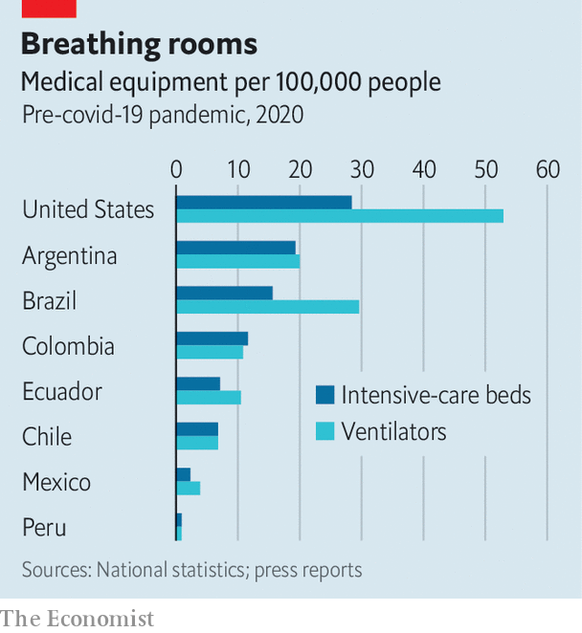

One disadvantage caused by the late arrival of the pandemic is that Latin America was slow to join the international scramble for N95 masks and ventilators. Many governments, including those in the European Union, have banned their export. “We have suffered many difficulties finding [ventilators], to the degree that we have had to obtain them in small quantities,” says Mexico’s Mr López-Gatell. Brazil and Mexico, which have large manufacturing sectors, are repurposing factories to repair old machines and test new ones.

Scarcity raises the risk that the poor will suffer far more from the pandemic than the rich. Brazil’s private health system, which serves mainly the richest quarter of the population, has half the ventilators and intensive-care beds. Perhaps made sensitive by last year’s protests, some governments are taking steps to narrow the gap. In Chile, Mexico and Colombia they have declared states of emergency that give them the power to tell private hospitals how to allocate beds. Argentina’s health minister backed off from his claim that “all beds are public, whether they are public or private.” But he has taken control of all purchases of equipment. A debate on the public takeover of private hospitals “is coming to Latin America pretty soon”, says Mr Gaviria.

In such expedients may lie the seeds of change. Every government in the region is learning a hard lesson about the value of investing in public health. The problem is, covid-19 is destroying the prosperity that would help make it happen. ■

Dig deeper:  
For our latest coverage of the covid-19 pandemic, register for The Economist Today, our daily [newsletter](https://www.economist.com/newslettersignup), or visit our [coronavirus tracker and story hub](https://www.economist.com/coronavirus)

Read also on: <https://www.economist.com/the-americas/2020/04/11/latin-americas-health-systems-brace-for-a-battering>

|  |  |  |  |
| --- | --- | --- | --- |
|  | Articles | Sections | Next |

|  |  |  |  |
| --- | --- | --- | --- |
| Previous | Articles | Sections | Next |

#### A farcical sea battle

# Venezuela’s navy battles a cruise ship, and loses

The sailors had guns, but the unarmed pleasure boat had a thick hull

Apr 8th 2020 |



IT WAS, ON the face of it, a mismatched contest. The ANBV Naiguatá, a Venezuelan patrol vessel, was armed with a 76mm naval gun, a German-built anti-aircraft system that sprays a cloud of tungsten bullets and a pair of deck-mounted machine guns, among other weaponry. The RCGS Resolute, a Portuguese-flagged cruise ship with an 80-seat theatre, had the top speed of an oil tanker. But in the early hours of March 30th it was Venezuela’s Bolivarian navy whose ship ended up on the seabed—in the first decisive naval skirmish in the Caribbean for 75 years.

The Resolute, en route to Curaçao, a Dutch island in the Caribbean, had been drifting for a day in international waters near La Tortuga, a Venezuelan island, as it tinkered with its starboard engine. At midnight it was approached by the Naiguatá and ordered to come into port. As the Resolute contacted its head office for instructions, the Naiguatá opened fire—a video released by the Venezuelan navy shows a sailor firing an AK-47 in the howling wind and darkness with Rambo-like enthusiasm—and rammed the cruise ship, according to its parent company.

Unfortunately for the Naiguatá, the Resolute’s placid appearance belies the fact that its strengthened hull, built for polar cruising, can smash through metre-thick ice—and, it turns out, puny patrol boats. The Resolute brushed off the collision with “minor damages”, whereas the Naiguatá rapidly took on water and sank, leaving 44 sheepish sailors to be rescued.

Venezuela disputes this account. Its armed forces accused the Resolute of “cowardly and criminal behaviour” by initiating the collision in Venezuela’s national waters. The Bolivarian navy insisted that its gallant sailors put in an “impeccable performance” against the unarmed cruise ship, presumably by sinking with particular panache. The navy darkly added that the Resolute, which boasts a jacuzzi and sauna, might have been carrying mercenary commandos to attack Venezuelan bases. As evidence, it pointed to nefarious inflatable boats on its deck.

Venezuela’s thuggish regime may be especially touchy now. In January the uss Detroit, an American warship, conducted “freedom-of-navigation” operations close to Venezuela’s coastline. On March 26th the United States indicted Nicolás Maduro, the dictator, and his inner circle for drug-running and “narco-terrorism”.

On April 1st Donald Trump announced that the United States was launching an “enhanced counter-narcotics operation” in the eastern Pacific and Caribbean, involving an impressive array of warships and spy planes. The operation would “choke off the funds that go to that corrupt regime”, said Robert O’Brien, Mr Trump’s national security adviser. The Bolivarian navy will be ready to repel any invaders—just as soon as its sailors dry off.■

Read also on: <https://www.economist.com/the-americas/2020/04/08/venezuelas-navy-battles-a-cruise-ship-and-loses>

|  |  |  |  |
| --- | --- | --- | --- |
| Previous | Articles | Sections | Next |

|  |  |  |  |
| --- | --- | --- | --- |
| Previous | Articles | Sections | Next |

#### Bello

# Jair Bolsonaro isolates himself, in the wrong way

The Brazilian president’s reckless handling of covid-19 will come back to haunt him

Apr 11th 2020 |

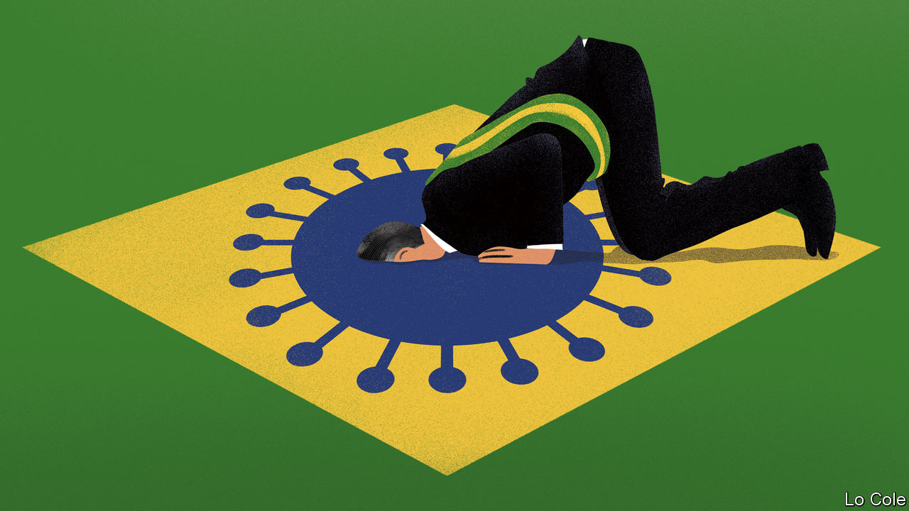

Editor’s note: The Economist is making some of its most important coverage of the covid-19 pandemic freely available to readers of The Economist Today, our daily newsletter. To receive it, register [here](https://www.economist.com/newslettersignup). For our coronavirus tracker and more coverage, see our [hub](https://www.economist.com/coronavirus)

ONE BY ONE the doubters have made their peace with medical science. Only four rulers in the world continue to deny the threat to public health posed by covid-19. Two are flotsam from the former Soviet Union, the despots of Belarus and Turkmenistan. A third is Daniel Ortega, the tropical dictator of Nicaragua. The other is the elected president of a great, if battered, democracy. Jair Bolsonaro’s undermining of his own government’s efforts to contain the virus may mark the beginning of the end of his presidency.

Since the new coronavirus was first detected in Brazil in late February Mr Bolsonaro, a former army captain with a fondness for military rulers, has made light of it. Dismissing its effects as “just a little dose of flu”, he said “we’re going to face the virus like a man, dammit, not like a little boy.” He added, helpfully: “we’re all going to die one day.” In the 15 months since he became president, Brazilians have become accustomed to his macho bravado and ignorance on issues ranging from the conservation of the Amazon rainforest to education and policing. But this time the damage is immediate and obvious: Mr Bolsonaro has coupled defiant rhetoric with active sabotage of public health.

He claims to believe in “vertical isolation”, in the quarantining only of Brazilians aged over 60 in order to limit damage to the economy. There are two problems with this. Young people die of covid-19 (10% of those it has killed in Brazil are under 60), and enforcement of such a quarantine would be impossible.

The governors of Brazil’s most important states have gone ahead and imposed lockdowns using their own powers. Mr Bolsonaro has encouraged Brazilians to ignore them. A man who fears betrayal and has a perpetual need to provoke, he greeted with hugs and selfies supporters who attended a rally against Congress on March 15th. He launched a campaign urging businesses to re-open and called for a religious “fast and demonstration” to take place in churches on April 5th. He has mused about decreeing, illegally, an end to the lockdowns. He has twice come close to sacking his own health minister, Luiz Henrique Mandetta, a conservative doctor who publicly opposed the president’s call to loosen restrictions. Mr Bolsonaro is seemingly jealous of the rising profile of a minister he claims “lacks humility”.

Even by his own standards, Mr Bolsonaro’s breach of his primary duty to protect lives has gone too far. Much of the government is treating him like a difficult relative who shows signs of insanity. Key ministers, including the cohort of generals in the cabinet, as well as the speakers of both houses of Congress, have given sometimes ostentatious support to Mr Mandetta, who has the public on his side. A poll this month by Datafolha found 76% approval for the health ministry’s handling of the virus, compared with 33% for Mr Bolsonaro’s management of the crisis.

Calls for Mr Bolsonaro’s resignation have mounted. They have come not just from the left but also from some of his erstwhile supporters such as Janaina Paschoal, a São Paulo state legislator whom he once considered as his running mate. Saying he was guilty of “a crime against public health”, she added: “we don’t have time for impeachment.”

There can be little doubt that the president’s conduct constitutionally merits impeachment, a fate that befell two of his predecessors, Fernando Collor in 1992 and Dilma Rousseff in 2016. But for now Mr Bolsonaro retains sufficient public support to survive. While polls found a majority favouring Ms Rousseff’s ousting (for breaking the fiscal-responsibility law to win re-election), 59% told Datafolha they don’t want Mr Bolsonaro to resign. Her approval rating fell to around 10%; he retains the support of a third of voters. Few in Brasília believe that the country wants or can afford the distraction of impeachment while it is under siege from covid-19.

Mr Bolsonaro is sustained by a small coterie of ideological zealots who include his three sons, by the faith of many evangelical Protestants and by lack of information about covid-19 among some Brazilians. The last two factors may change as the virus ploughs its fatal furrow in the coming months. By April 8th Brazil had suffered 14,049 confirmed cases and 688 dead. And the president may not be able to quarantine himself from blame for the economic impact. By his recklessness with the lives of Brazilians, Mr Bolsonaro has forced the possibility of his own departure onto the political agenda. It is likely to remain there after the epidemic fades.

Dig deeper:  
For our latest coverage of the covid-19 pandemic, register for The Economist Today, our daily [newsletter](https://www.economist.com/newslettersignup), or visit our [coronavirus tracker and story hub](https://www.economist.com/coronavirus)

Read also on: <https://www.economist.com/the-americas/2020/04/11/jair-bolsonaro-isolates-himself-in-the-wrong-way>

|  |  |  |  |
| --- | --- | --- | --- |
| Previous | Articles | Sections | Next |

|  |  |  |
| --- | --- | --- |
| The Americas | Sections | China |

Asia

Singapore and covid-19: No way out

.

Justice in Uzbekistan: Blind obedience

.

Taiwan on alert: Strait and harrow

.

Sexism in Japan: Heels at high water

.

Criminal justice in Australia: Judges v jury

.

Politics in South Korea: Voting amid the virus

.

Banyan: Locked out of the bolthole

.

|  |  |  |
| --- | --- | --- |
| The Americas | Sections | China |

|  |  |  |  |
| --- | --- | --- | --- |
|  | Articles | Sections | Next |

#### No way out

# Not even Singapore has been able to avoid a lockdown

The efficient city-state’s contact-tracing has not stopped the virus

Apr 11th 2020 | SINGAPORE

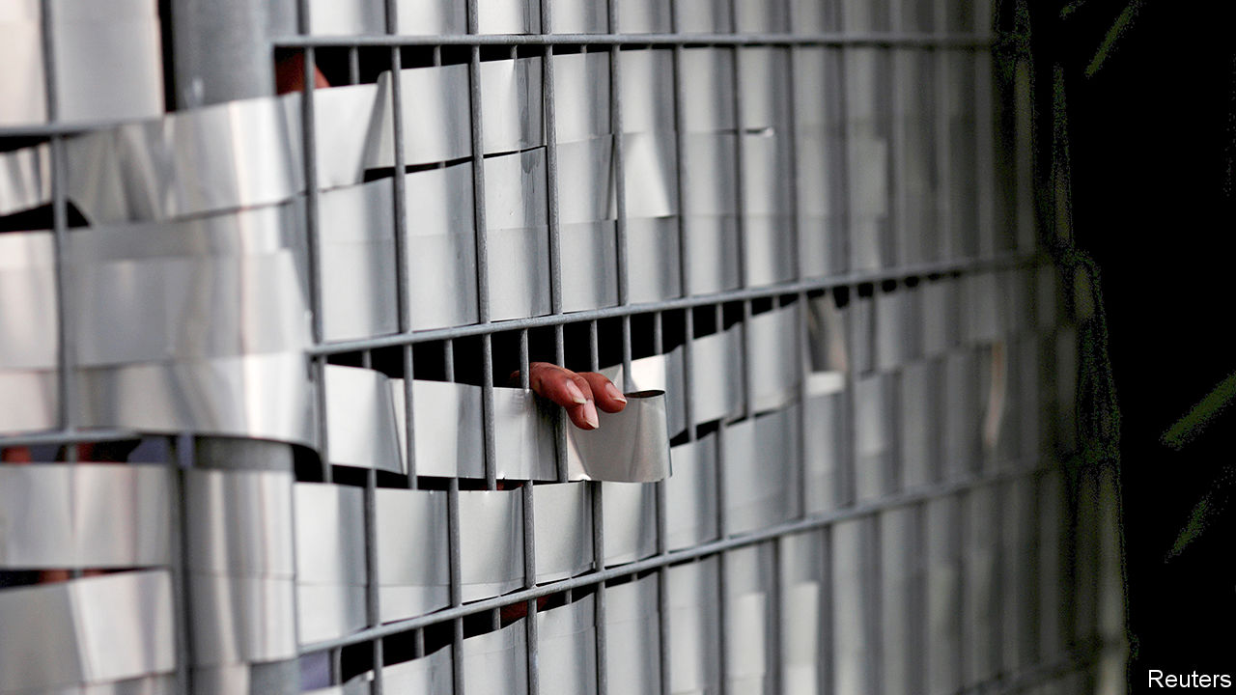

Editor’s note: The Economist is making some of its most important coverage of the covid-19 pandemic freely available to readers of The Economist Today, our daily newsletter. To receive it, register [here](https://www.economist.com/newslettersignup). For our coronavirus tracker and more coverage, see our [hub](https://www.economist.com/coronavirus)

“NO ESCAPE,” READS the pest-control van parked near the entrance to S11 Dormitory @ Punggol, a residence for migrant workers in Singapore. Its warren of low-slung metal-clad buildings houses some 13,000 male labourers, 63 of whom have been moved to hospital after catching covid-19. The rest are among the 20,000 migrant workers ordered to remain in compounds like S11 for two weeks to stop the spread of the coronavirus. Faced with a sudden spike in new cases, almost all of them contracted locally (see chart), the government has decided to adopt much more stringent measures to slow the spread of the virus.

For most Singaporeans, the new regime, instituted on April 7th, will not be quite as strict. They will be allowed out of their homes to buy food and medicine and to exercise. This “circuit-breaker”, as the government calls it, will remain in place for at least a month. Previously, shops and restaurants had remained open, although patrons were supposed to remain a metre apart and no more than ten people were supposed to gather in one place. Even bars had been able to keep going, as long as they served food. Schools, too, had continued to operate. All will now be closed. Anyone meeting people with whom they do not live risks six months in prison, a fine of S$10,000 ($7,000) or both. Singapore, which had won praise from the World Health Organisation (WHO), among others, for its measured but effective approach to the coronavirus, is no longer able to preserve a semblance of normality.

Singapore had been able to take a less draconian approach because of its initial success in containing the disease. On January 22nd it began taking the temperatures of air passengers arriving from China, the day before the Chinese government stopped travel into and out of Wuhan. Soon afterwards it began banning visitors from areas badly affected by the virus. By the end of March the government had advised against all non-essential journeys abroad, closed its borders to non-residents and suspended all religious services.

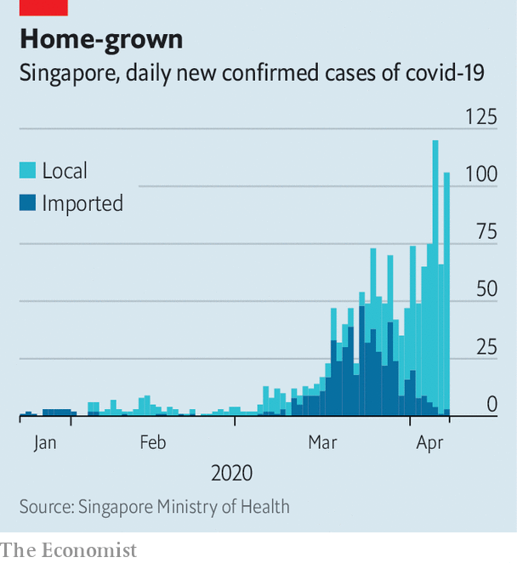

All the while efficient contact-tracing teams—including members of the police and the army—identified and isolated thousands of people possibly infected with the virus. Members of the armed forces have been making up to 2,000 calls a day to hunt for potential carriers. Those told to stay at home for 14 days have been monitored assiduously to ensure compliance. (Uncooperative types face prosecution or the loss of their residency rights, if they are not citizens.)

Yet in spite of everything, the virus continues to spread. The effort to find and isolate cases linked to the initial outbreak in Wuhan was successful. But from March, as many Singaporeans returned home because of the proliferating coronavirus restrictions in other countries, some infections clearly slipped through the net. Hence the new restrictions. “One important objective is to apply brakes from time to time to slow down the momentum of this transmission,” explains the health minister, Gan Kim Yong.

Singapore’s approach continues to evolve. Take face masks. Initially Singaporeans were advised that they did not need to wear them unless unwell. Then on April 3rd, in his third televised address on covid-19, Lee Hsien Loong, the prime minister, said that the government would no longer discourage their use and would, in fact, distribute reusable ones to every household. Singapore’s testing regime may alter too. Currently people’s travel history and symptoms are among the factors considered before they are tested for the coronavirus. But health officials say the approach is reviewed regularly and that wider testing might be adopted in future.

The government has not said much about how it thinks the pandemic will play out in Singapore. Unlike Britain’s, for example, it has not shared the models it is using to predict the number of cases or deaths. Singapore has a relatively vulnerable population by the standards of the region, since the virus poses a greater risk to elderly people and some 10% of residents are over 65. The migrant workers quarantined in crowded dormitories are another group to watch. And as the number of cases rises it becomes harder to trace the contacts of the sick, hampering one of the most effective elements of Singapore’s response.

Planning is under way for a long campaign against covid-19. Officials intend to turn parts of Singapore Expo, a convention centre with some 100,000 square metres of floor space, into a quarantine facility for recovering patients. One of Changi airport’s four terminals will suspend operations for 18 months to save running costs, suggesting that the government does not expect air travel to recover fully for a long time.

A good indicator of how confident the authorities are about their handling of the epidemic will be provided by the timing of the next election. It is due within a year, and the government had been rumoured to be on the verge of calling a snap poll before the virus put such considerations on hold. The publication of new electoral boundaries last month set tongues wagging again. So too did the introduction of a bill in parliament on April 7th to ensure a safe election in spite of covid-19. Among other measures, the legislation would allow citizens whose movements have been restricted for reasons of public health to vote from wherever they have been told to stay. With the election, as with the virus, Singapore’s government is leaving little to chance. ■

Dig deeper:  
For our latest coverage of the covid-19 pandemic, register for The Economist Today, our daily [newsletter](https://www.economist.com/newslettersignup), or visit our [coronavirus tracker and story hub](https://www.economist.com/coronavirus)

Read also on: <https://www.economist.com/asia/2020/04/11/not-even-singapore-has-been-able-to-avoid-a-lockdown>

|  |  |  |  |
| --- | --- | --- | --- |
|  | Articles | Sections | Next |

|  |  |  |  |
| --- | --- | --- | --- |
| Previous | Articles | Sections | Next |

#### Blind obedience

# Uzbekistan is reforming its judicial system—up to a point

The courts are becoming fairer, except in a few prominent cases

Apr 8th 2020 | TASHKENT

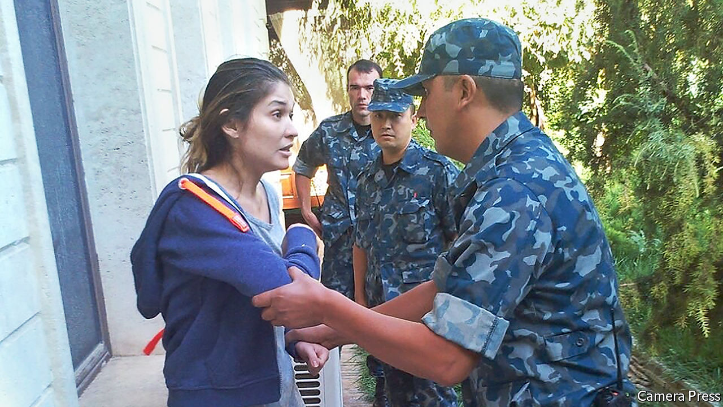

“IF JUSTICE PERISHES, human life on Earth has lost its meaning,” intoned Shavkat Mirziyoyev, Uzbekistan’s president, quoting Immanuel Kant, a philosopher. Mr Mirziyoyev was explaining to parliament his plans for reform of the justice system. Anyone entering an Uzbek courtroom, he said, should be “fully confident that the principles of legality and justice are unfailingly upheld”. That is a tall order in a country in which, until he came to power in 2016, the courts served a dictatorship. And although the courts are indeed being overhauled, there are limits.

Mr Mirziyoyev has appointed a young British-educated justice minister, Ruslanbek Davletov. Fully 80% of prosecutors were replaced after Mr Mirziyoyev condemned their rampant bribe-taking. The government has decreed that evidence obtained by torture (common under Mr Mirziyoyev’s predecessor, Islam Karimov) is inadmissible. A special council has been set up to boost judicial independence.

These reforms may be paying off: the number of acquittals, previously near zero, has risen. Remarkably, a court recently overturned the conviction of Chuyan Mamatkulov, one of dozens of Karimov-era political prisoners released under Mr Mirziyoyev. The Justice Ministry has also permitted the establishment of Huquqiy Tayanch (Legal Support), a rights group that campaigns for the rehabilitation of former political prisoners. It is headed by Azam Farmonov, an activist who was once jailed in the notorious Jaslyk prison camp, which Mr Mirziyoyev has closed.

Mr Farmonov wants a proper airing of the abuses that took place in Jaslyk and in the justice system more broadly under Karimov, who died in 2016. “Karimov’s repressions repeated Stalin’s repressions,” he says. If they are not exposed, “no one can say something like this won’t happen again.” Human Rights Watch, a watchdog, estimates that 10,000 people were jailed for political reasons; many remain behind bars. Mr Farmonov expects resistance to any reckoning from the police, jailers and judges who took part. Examining the misdeeds of the past could also be awkward for Mr Mirziyoyev, who served as Karimov’s prime minister for 13 years.

The case that most clearly embodies these tensions is that of Gulnara Karimova, Karimov’s daughter. In March a court jailed her for 13 years after a closed trial. Her sentence, on charges of running crime rings, extortion and money-laundering, will run concurrently with a term she was already serving for extortion, embezzlement and tax evasion. The Justice Ministry insists Ms Karimova’s rights were respected, but has not explained why her trial was not public. Ms Karimova, a former singer and socialite, received several plum diplomatic postings from her father. She fell from grace in 2014, while he was still president, and was detained without trial. She has been indicted in America over an “extensive corrupt bribery scheme”.

Conducting Ms Karimova’s trial “behind closed doors, and in violation of due-process norms, does a disservice to the Uzbek government’s efforts to show that the court system has fundamentally improved”, argues Steve Swerdlow, a lawyer. Advocates of reform also worry about two other recent closed trials. In January Kadyr Yusupov, an ex-diplomat who suffers from schizophrenia and who was arrested after a suicide attempt, was jailed on espionage charges. In March, Vladimir Kaloshin, a journalist for a military newspaper, received a 12-year sentence for treason after proceedings that featured no defence witnesses. His daughter, Anastasiya Episheva, says it was “not a trial but a travesty”.

These investigations were led by the State Security Service, a feared intelligence agency which Karimov used to silence dissidents, but which Mr Mirziyoyev has reined in. Some observers suspect that these secret policemen, whom the president once labelled “mad dogs”, are trying to prove their worth by uncovering phantom plots. Whatever their motivation, the intelligence services’ continued clout creates a “climate of fear” and “adversely affects” judicial independence, a UN rapporteur concluded last year. ■

Read also on: <https://www.economist.com/asia/2020/04/08/uzbekistan-is-reforming-its-judicial-system-up-to-a-point>

|  |  |  |  |
| --- | --- | --- | --- |
| Previous | Articles | Sections | Next |

|  |  |  |  |
| --- | --- | --- | --- |
| Previous | Articles | Sections | Next |

#### Strait and harrow

# With the world distracted, China intimidates Taiwan

Chinese warships and fighter jets are testing Taiwan’s defences

Apr 8th 2020 |

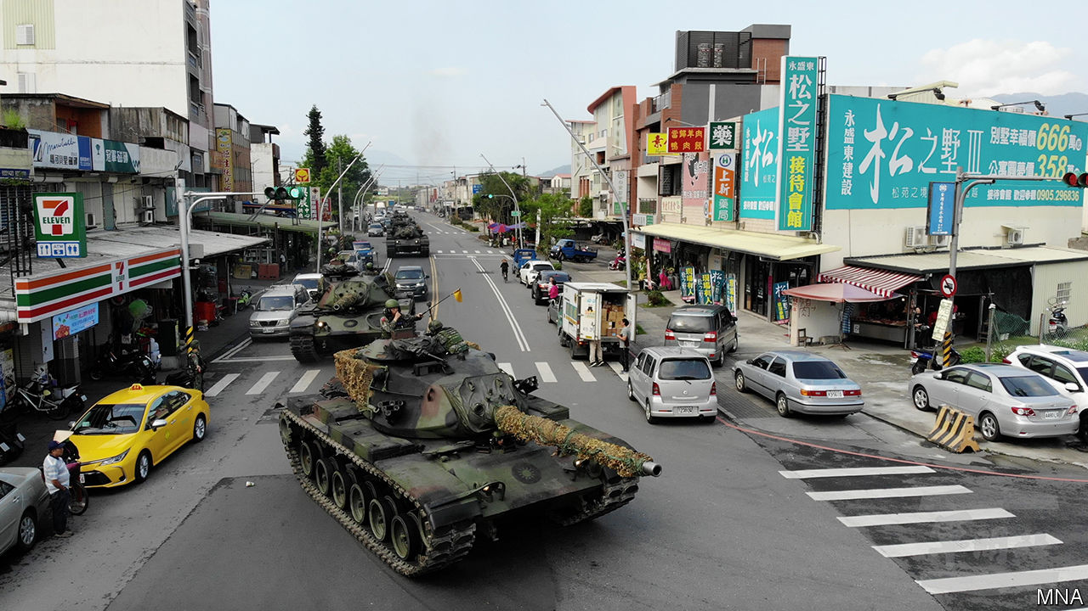

THE TANKS queued patiently with the cars, delivery trucks and bright yellow taxis before rolling serenely through the traffic lights. The drill, in Yuanshan, a town south-east of Taipei, was intended as practice at repelling a Chinese invasion. Some of the tanks, covered in webbing, hid in a copse, about as inconspicuously as is possible for a 50-tonne vehicle. The unit had good reason to be rehearsing. In recent months China has been rattling more sabres than usual at Taiwan, which it considers part of its territory. With covid-19 subsiding in China but consuming America, some in Taiwan feel vulnerable.

China sends around 2,000 bomber patrols a year into the Taiwan Strait, which separates the two countries, according to Taiwan’s defence minister. These are taking increasingly menacing routes. In 2016, when Tsai Ing-wen, an opponent of reunification with China, was first elected Taiwan’s president, China began sending bombers to circumnavigate the island as a show of force. Last year it deliberately sent fighters across the mid-point of the strait for the first time in two decades. In December China’s first domestically built aircraft carrier, the Shandong, was sent through the strait two weeks before Taiwan’s presidential election, in which Ms Tsai won a second four-year term.

China has not let the coronavirus get in the way of this muscle-flexing. “Our air operation command centre has had alarms on a daily basis since February,” says Alexander Huang of Tamkang University. That month, even as the epidemic raged in Hubei province, Chinese jets probed Taiwanese airspace several times, prompting Taiwan to scramble its own planes.

On March 16th China conducted its first night-time exercise near Taiwan, sending a clutch of fighter jets and surveillance aircraft, which can peer farther than ground-based radar, well past the mid-point of the strait. The same day Taiwan’s coastguard said that Chinese speedboats—probably part of the maritime militia, a paramilitary force that sometimes uses fishing vessels—had rammed one of its cutters near the Kinmen islands, a part of Taiwan barely 5km from the mainland.

“At the height of outbreak of the pandemic worldwide, if the Chinese Communists attempted to make any military adventure leading to regional conflict, they would be condemned by the world,” warned Taiwan’s deputy defence minister on March 30th. “We are all ready and have made the best preparation.”

It helps that America has been underlining its support for Taiwan. On February 12th America sent two B-52 bombers up Taiwan’s east coast, two days after Chinese jets had crossed the median line. An American warship has also sailed through the Taiwan Strait in each of the past three months—an expression, the navy says, of America’s “commitment to a free and open Indo-Pacific”. Last year America agreed to sell Taiwan a whopping $8bn-worth of weapons, including 66 F-16 fighter jets.

But the uss Theodore Roosevelt, an American aircraft-carrier that was exercising near China weeks ago, is stuck in Guam thanks to a coronavirus outbreak among its crew (see article). In March the Chinese army held two weeks of exercises with Cambodia, even as America and its allies were cancelling drills. The effects of the virus aside, the military balance is shifting. “Based on current trends, and barring …technological breakthrough, America will probably have lost the ability to defend Taiwan within the decade,” says Brendan Taylor of the Australian National University. “Policymakers should be worried about the growing risk of strategic crisis during this window.” ■

Read also on: <https://www.economist.com/asia/2020/04/08/with-the-world-distracted-china-intimidates-taiwan>

|  |  |  |  |
| --- | --- | --- | --- |
| Previous | Articles | Sections | Next |

|  |  |  |  |
| --- | --- | --- | --- |
| Previous | Articles | Sections | Next |

#### Heels at high water

# Japanese women rebel against painful dress codes

Some employers care more about how they look than how they feel

Apr 8th 2020 | TOKYO

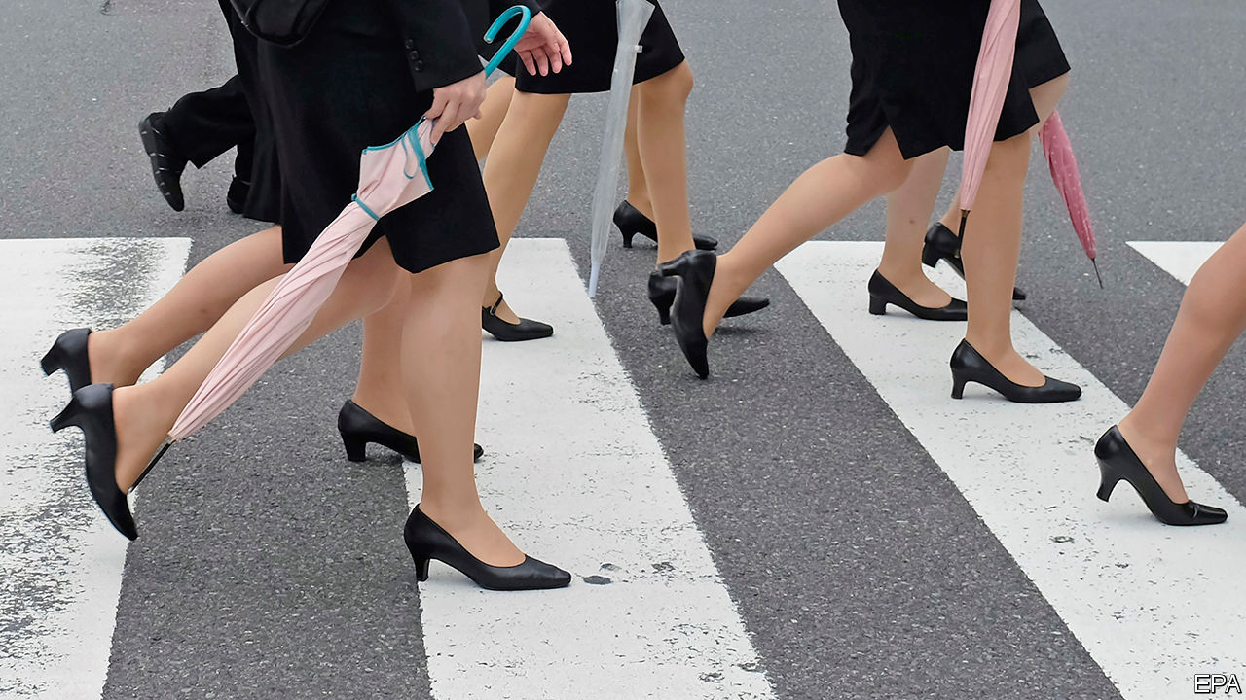

ISHIKAWA YUMI worked eight-hour shifts as an usher in a funeral parlour, always in heels. Her employer insisted. Her toes bled. “Why do we have to hurt our feet at work, when men can wear flat shoes?” she complained on Twitter. The tweet exploded.

Encouraged, she gathered 18,800 signatures on a petition calling for a ban on employers requiring women to wear high heels, which she submitted to the government last June. Ms Ishikawa became the face of the #KuToo campaign—a pun on Japanese words for shoes (kutsu) and pain (kutsuu), with a nod to the #MeToo movement.

More than 60% of Japanese women with jobs have been forced to squeeze their feet into heels at work or have witnessed colleagues having to, according to a survey. Female staff at Takashimaya, a department store, must parade around the shop in 5cm heels. The former defence minister, Inada Tomomi, felt obliged to totter about in heels even on the deck of a visiting American aircraft carrier.

Dress codes at many Japanese firms are rigid. Some ban glasses for women (but not men), on the grounds that they are unflattering. This is especially unreasonable for those who find contact lenses uncomfortable. “Women have always been told to follow the dress code, even if it causes pain,” says Ms Ishikawa. Japanese bosses, who tend to be older men, often expect their female underlings to gaman (endure it).

The government has dug in its heels. A former labour minister, who received Ms Ishikawa’s petition last year, insists that wearing high heels at work is “necessary and appropriate”. The petition itself has received no official response to date. Japan ranks the second lowest out of the 29 rich countries in The Economist’s glass-ceiling index, which measures equality for women in the workplace.

But corporate Japan is slowly responding to #KuToo. In late March Japan Airlines announced that its female flight attendants can kick off their heels and swap skirts for trousers if they choose. All three big mobile-phone operators have relaxed their rules on heels. Ms Ishikawa is collaborating with a shoe company to produce chic heel-less shoes. “Society is changing,” says Ms Ishikawa. “We can’t be ignored.” Pointless rules about footwear may soon be given the boot.

Read also on: <https://www.economist.com/asia/2020/04/08/japanese-women-rebel-against-painful-dress-codes>

|  |  |  |  |
| --- | --- | --- | --- |
| Previous | Articles | Sections | Next |

|  |  |  |  |
| --- | --- | --- | --- |
| Previous | Articles | Sections | Next |

#### Judges v jury

# An Australian court overturns a cardinal’s conviction for sexual abuse

George Pell, once the Vatican’s main financial manager, was accused of molesting two choirboys

Apr 8th 2020 | SYDNEY

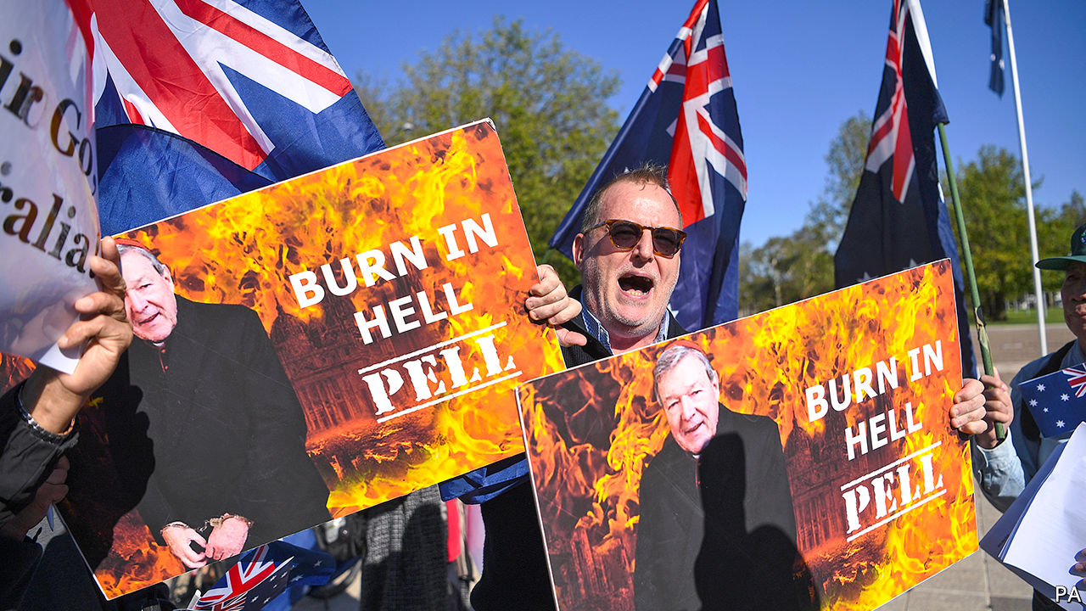

THE JURY that in 2018 found George Pell guilty of sexually assaulting two choirboys deliberated about its verdict for five days. But it did not think about the evidence carefully enough, Australia’s High Court ruled on April 7th. It overturned the conviction and ordered Mr Pell, a cardinal who used to be the Vatican’s top financial manager, released. If the jury had been “acting rationally on the whole of the evidence”, the seven judges ruled unanimously, it “ought to have entertained a reasonable doubt” about his guilt.

The charges date to 1996, when Mr Pell was Archbishop of Melbourne. He was accused of molesting the boys in the cathedral’s sacristy, or dressing-room, after a Sunday mass. The guilty verdict was initially subject to a gagging order, in order not to prejudice possible future proceedings. Only months later were the media allowed to report on it. A little over a year ago the prelate began his six-year jail sentence, which was upheld by an appeals court in the state of Victoria last year.

The High Court was troubled, however, by the other courts’ reliance on the testimony of a single witness. One of the two choristers died in 2014, so the conviction was “wholly dependent upon the acceptance of truthfulness and reliability” of the surviving one, the High Court’s judges observed. Even though the witness was “credible and reliable”, they said, the jury should have had its doubts.

Cardinal Pell’s lawyer had pointed to the “sheer unlikelihood” that he would have found himself alone with the boys amid the “hive of activity” in the cathedral. Indeed, evidence from other witnesses should have raised logistical questions about whether he could have committed the crimes of which he was accused, the court said. As a result, the ruling concluded, there was “a significant possibility that an innocent person has been convicted”.

Australian judges do not like to overturn their juries’ decisions, for fear of denting faith in criminal justice, says Rick Sarre of the University of South Australia. Rulings like this are fairly uncommon. To some, the acquittal is a sign of a system working. But it has rattled many Australians. As the cardinal walked free, vandals emblazoned the words “no justice” over the cathedral in Melbourne.

It is hard to “satisfy a criminal court that the offending has occurred beyond the shadow of a doubt”, acknowledged the surviving choirboy, as he accepted the court’s decision. But the Survivors Network of those Abused by Priests, a support group, took the decision as a sign that “the powerful have won.” Victims may lose their faith in the criminal justice system, argues the group’s coordinator for Australia, Steve Spaner. If fewer of them come forward as a result, he fears, crimes will go unpunished.

Australia has long wrestled with claims of sexual abuse of minors. In 2018 the prime minister, Scott Morrison, issued a lengthy apology to survivors. After the High Court’s ruling, Daniel Andrews, the premier of Victoria, issued a statement telling victims: “I believe you.” Yet some of the cardinal’s supporters feel that justice has eluded them, as well. An innocent man was imprisoned by a biased jury, they say, and the judges who heard the initial appeal upheld its decision. “Nobody is safe” in such a system, one pundit railed.

While some consider it unseemly for judges to overrule a jury, others would like to entrust them with more authority. Victoria is the only state in Australia that does not allow well-known defendants to be tried by a judge alone, if they fear that the public mood is against them, notes Matthew Collins, a barrister. Nick Papas, Victoria’s former chief magistrate, would like the state to adopt the same procedure. ■

Read also on: <https://www.economist.com/asia/2020/04/08/an-australian-court-overturns-a-cardinals-conviction-for-sexual-abuse>

|  |  |  |  |
| --- | --- | --- | --- |
| Previous | Articles | Sections | Next |

|  |  |  |  |
| --- | --- | --- | --- |
| Previous | Articles | Sections | Next |

#### Voting amid the virus

# South Korea presses on with an election

The big parties are trying to game the electoral system

Apr 11th 2020 | SEOUL

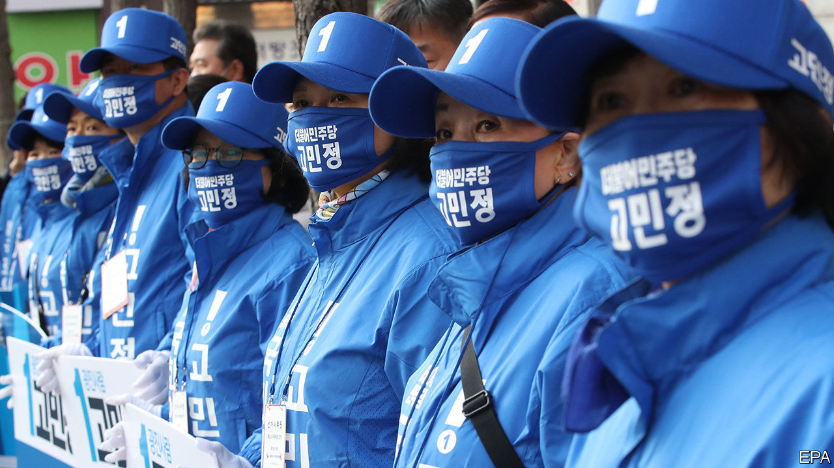

Editor’s note: The Economist is making some of its most important coverage of the covid-19 pandemic freely available to readers of The Economist Today, our daily newsletter. To receive it, register [here](https://www.economist.com/newslettersignup). For our coronavirus tracker and more coverage, see our [hub](https://www.economist.com/coronavirus)

AT FIRST GLANCE it looked like any old campaign event. A crowd thronged around a stage in a narrow street in central Seoul. Dancers in bright pink hoodies performed a lacklustre routine to a K-pop tune. But the dancers wore face masks that matched their hoodies. Spectators, though hard-pressed to keep the officially recommended two-metre distance from each other, had covered their faces, too. And when the candidate, Hwang Kyo-ahn, took to the stage, he sported a clear perspex shield over his mouth and nose.

Last weekend marked the start of campaigning for South Korea’s legislative elections, which will go ahead as planned on April 15th despite the covid-19 pandemic. The prospect of queues at polling stations and of sharing booths, pencils and ballot boxes has prompted several other countries, including Britain, France and some American states, to cancel or postpone elections. But the South Korean authorities believe the outbreak is at bay. On April 6th the country recorded fewer than 50 new cases for the first time since late February.

Nonetheless, to minimise the risk of infection for voters and poll workers, the National Election Commission has instituted elaborate safeguards. All voters will have their temperature taken before entering their polling station (those found to have a fever or other symptoms will be directed to a separate polling booth). They will also have to wear a face mask, sanitise their hands and put on vinyl gloves before picking up a ballot paper and entering the booth. Election stewards will ensure people keep away from each other while queuing and voting. Door knobs, pencils and ballot boxes will be sterilised often.

These measures seem to have reassured citizens sufficiently to persuade them to show up: in a poll on April 2nd 73% expressed their intention to vote, more than in the run-up to the previous legislative election, in 2016. There are some grumbles: more than half the 170,000 voters who live abroad will not be able to cast their ballots at the South Korean embassy in their country of residence, owing to pandemic-related restrictions. Koreans in Canada and Germany are mulling a constitutional appeal.

Back home, the grumbling is less about the complications of the pandemic and more about the machinations of politicians. The election will be the first since the National Assembly amended the electoral law to strengthen the proportional element of the hybrid electoral system. Of the 300 seats in the unicameral assembly, 253 are filled on a first-past-the-post basis. The remaining 47 are allocated based on a second vote, for a party. The formula for awarding them used to favour the two main parties, which won 59% of the party-list vote in 2016, but ended up with 82% of the seats in the assembly. But now the rules have been tweaked to help smaller parties.

The reform has prompted the formation of several new parties. Thirty-five will be competing for seats, 14 more than in the previous election. The Revolutionary Dividends Party, for instance, wants to run the country like a corporation, dismantling the parliamentary apparatus to save money and giving cash handouts to encourage people to go on dates and get married.

The big parties, including the ruling Minjoo (Democratic) party, which came up with the reform, are doing their best to undermine it by creating “satellite parties”, which will compete only for party-list seats. After the election, these will co-operate, or even merge, with their big sibling. To hammer the point home, Minjoo’s satellite is distributing posters depicting it and Minjoo as bride and groom.

“These decisions undermine the very idea of the reform,” complains Kim Jong-cheol of Yonsei University. “They shouldn’t be allowed to do that.” But the electoral commission says no rules are being broken. The constitutional court can only get involved if the government asks for a ruling, which seems unlikely given Minjoo’s eager embrace of the satellite-party scheme. South Koreans may be beating covid-19, but they have not yet worked out how to tame wily politicians. ■

Dig deeper:  
For our latest coverage of the covid-19 pandemic, register for The Economist Today, our daily [newsletter](https://www.economist.com/newslettersignup), or visit our [coronavirus tracker and story hub](https://www.economist.com/coronavirus)

Read also on: <https://www.economist.com/asia/2020/04/11/south-korea-presses-on-with-an-election>

|  |  |  |  |
| --- | --- | --- | --- |
| Previous | Articles | Sections | Next |

|  |  |  |  |
| --- | --- | --- | --- |
| Previous | Articles | Sections | Next |

#### Banyan

# The eternal, fanciful allure of the South Pacific

It turns out tropical boltholes can be hard to reach in a crisis

Apr 11th 2020 |



Editor’s note: The Economist is making some of its most important coverage of the covid-19 pandemic freely available to readers of The Economist Today, our daily newsletter. To receive it, register [here](https://www.economist.com/newslettersignup). For our coronavirus tracker and more coverage, see our [hub](https://www.economist.com/coronavirus)

AS A DISTRACTING sidebar to much grimmer stories, newspapers around the world have been publishing tales of tourists stranded in palm-fringed places, unable to catch a flight home. A 19-year-old Briton trapped on a tropical island after a stint volunteering for a charity told the BBC, “I think people assume, ‘You’re in Fiji, you’re on the beach sipping cocktails, it’s just a holiday.’ Everything is in lockdown and we spend our days looking for ways to get home.” Some hapless travellers have been told by their governments that the only way to get back to their families is to charter a private jet at their own expense.

That is exactly what some much richer people have been doing, albeit heading in the opposite direction. Scrutineers of flight-tracking websites report an increase in private jets leaving America, in particular, for the vast, remote South Pacific. They include two Gulfstream jets that left Los Angeles earlier this month and landed in Tonga. The Polynesian kingdom is supposedly closed to air traffic. In Fiji, the rumour that Nicole Kidman was holed up on Wakaya Island, where Keith Richards once fell head first out of a coconut tree, proved unfounded. But others have gone to ground there. Agents report a rise in superyacht charters, too, by billionaires and their families looking for “remote” locations in which to self-isolate.

The South Pacific’s allure is fuelled by fantasy: that of a pure, even erotic, innocence, compared with the disease, pollution and corruption of Western civilisation. The trope dates to the West’s first encounters with the Pacific. “Poedua”, the first portrait in oil of a Pacific islander, by John Webber, an artist on Captain James Cook’s Endeavour in the late 1770s, is less ethnographic than pornographic in its representation of the young princess. It is but a short hop to Paul Gauguin’s paintings of Tahitian girls over a century later, today among the world’s most expensive paintings. Tourism brochures depicting island women with frangipani blooms behind their ears play to the same idea.

The fantasy has in fact been lethal, bringing infectious disease with it. The English and French captains who were the first Europeans to visit Tahiti bickered over which crew had introduced syphilis (probably the English). It was a killer. Tahiti later suffered devastating epidemics of smallpox, dysentery, scarlet fever and measles in quick succession. Gauguin infected three child brides and a string of adolescents with syphilis. Missionaries carried death too. When Robert Louis Stevenson visited the Marquesas in 1888, so many had died no one remembered the old songs and dances, and coffins had become prestige items. The population of Hawaii fell from perhaps 250,000 in Cook’s time to less than 40,000 by the end of the 19th century. Bear this history in mind when you hear Fiji’s strongman, Frank Bainimarama, warning those tempted to break the current curfew: “It doesn’t matter how famous you are, it doesn’t matter how rich you are... No one is immune to our laws.” With weak health systems and many vulnerable citizens, South Pacific countries cannot risk an outbreak of covid-19.

But what about New Zealand? One-percenters who have long prepped for the apocalypse—whether caused by disease, nuclear war or the breakdown of society—have always seen it as the place to ride out the end of days. The devastation Cyclone Harold inflicted this week on Vanuatu only highlights smaller countries’ vulnerability. New Zealand, in contrast, is far from global tensions, has a clean environment and a phlegmatic folk not inclined to sharpen their pitchforks. Peter Thiel, a Silicon Valley mogul with land on South Island, has long praised the country’s survivalist attributes. Rising S, a Texan maker of doomsday bunkers, has sold several 150-ton models to American tycoons and shipped them to New Zealand to be buried underground.

Too bad if you’re among the filthy rich who thought of New Zealand only recently: it has tightened its laws to restrict foreign ownership of property. But even if you already own a bolthole, you need to get ahead of the looming catastrophe. Few anticipated Jacinda Ardern, the prime minister, closing borders so promptly last month. And how on earth do you decide which of your family and staff to bring? And—oh lord—which pets? No exceptions: the pets must spend at least ten days in government quarantine. A converted nuclear-missile silo in Kansas, whose prices are reported to be rising, starts to look more appealing.

Dig deeper:  
For our latest coverage of the covid-19 pandemic, register for The Economist Today, our daily [newsletter](https://www.economist.com/newslettersignup), or visit our [coronavirus tracker and story hub](https://www.economist.com/coronavirus)

Read also on: <https://www.economist.com/asia/2020/04/11/the-eternal-fanciful-allure-of-the-south-pacific>

|  |  |  |  |
| --- | --- | --- | --- |
| Previous | Articles | Sections | Next |

|  |  |  |
| --- | --- | --- |
| Asia | Sections | Middle East and ... |

China

Traditional medicine: Fighting it the Chinese way

.

Beekeeping: The honey trap

.

Chaguan: A window almost closed

.

|  |  |  |
| --- | --- | --- |
| Asia | Sections | Middle East and ... |

|  |  |  |  |
| --- | --- | --- | --- |
|  | Articles | Sections | Next |

#### Fighting it the Chinese way

# China backs unproven treatments for covid-19

Traditional medicine is not just a placebo, claims the government

Apr 11th 2020 | BEIJING

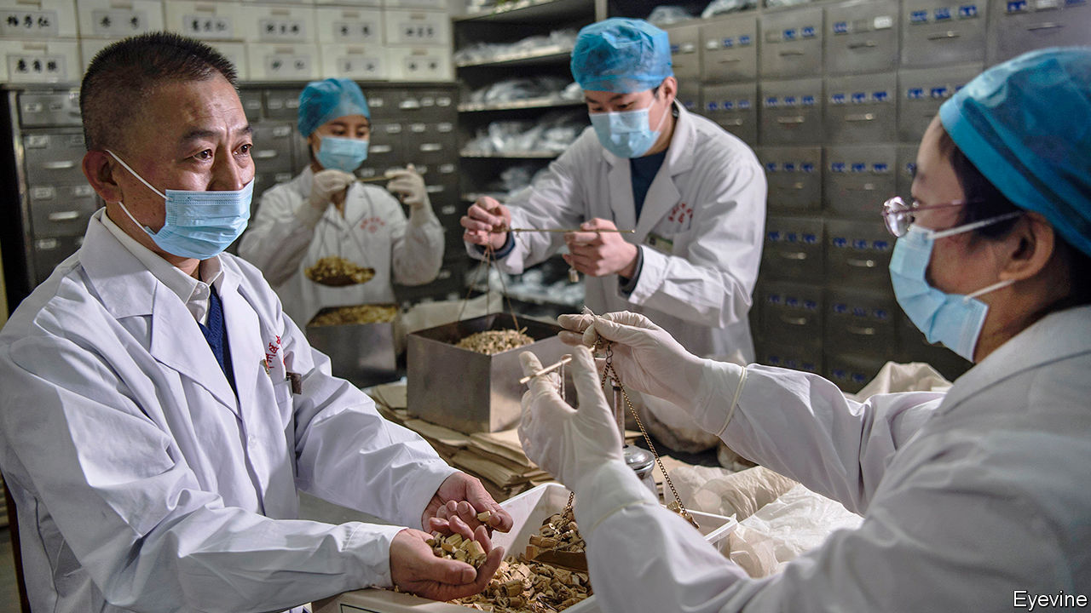

Editor’s note: The Economist is making some of its most important coverage of the covid-19 pandemic freely available to readers of The Economist Today, our daily newsletter. To receive it, register [here](https://www.economist.com/newslettersignup). For our coronavirus tracker and more coverage, see our [hub](https://www.economist.com/coronavirus)

WANG DASHAN (not his real name), a bus driver from Hubei province, thinks a herbal broth may have saved his life. The yellow-brown tonic, made by a large state-owned company, was one of several traditional remedies that doctors used to treat Mr Wang during the two weeks that he spent with covid-19 at a makeshift hospital in Wuhan, the provincial capital. He says his cough and fever subsided a few days after he started drinking it. He does not think he would have got better on his own, though most patients with the coronavirus recover.

Around the world officials are advising people to be wary of alternative treatments for covid-19. The opposite is true in China, where remedies known as traditional Chinese medicine, or commonly, TCM, are being heavily promoted by the state. In January, as the crisis escalated, the health ministry listed TCM treatments among those it recommended for the disease. It sent nearly 5,000 specialists to Hubei to administer them to patients (including sufferers at a sports centre in Wuhan that was turned into a TCM hospital for people with mild symptoms). On March 23rd a senior official from the government’s TCM administration said more than 90% of all sufferers of covid-19 had received traditional therapies, and these had been “effective” 90% of the time. She offered no data to support this claim.

The epidemic has subsided in China. On April 8th Wuhan, the worst-affected city where the covid-19 outbreak took off, lifted its cordon sanitaire (it closed its 16 field hospitals, including the TCM one, in March). Now China is keen to promote its remedies abroad. TCM practitioners have joined Chinese medical teams sent to help manage outbreaks in Cambodia, Iraq and Italy. The government says it has donated traditional medicines to other countries, too. Global Times, a newspaper in Beijing, says 90,000 people from 64 countries joined a recent conference-call to learn from Chinese TCM specialists how they battled the virus. In mid-March state media quoted a Tanzanian health official saying that China’s use of TCM for covid-19 may be “a model” for Africa to follow.

China’s government does not promote using only TCM. Those with serious symptoms of covid-19 are given conventional treatment. TCM practitioners seldom deny that what they call “Western medicine” is useful, especially for acute illness. But the government does claim that TCM is more than just a palliative or placebo. In a white paper issued in 2016, it called TCM a “medical science” and said the time had come for it to “experience a renaissance”.

TCM is about far more than herbal remedies such as Mr Wang’s soup (among its ingredients are betel nuts, almonds and Ephedra sinica, a plant used in China for centuries to treat flu). It includes acupuncture and moxibustion (the burning of dried plant materials near the skin). It can also apply to slow-motion kung-fu-like exercise known as qigong, which is supposed to cultivate a mystic energy in the body known as qi—TCM blends into the occult. Patients at Wuhan’s TCM field hospital performed mass qigong routines.

For most people, all this is harmless. But the government’s hard sell of TCM presents two main dangers. One is that some people prefer it to conventional treatments that, unlike TCM therapies, are proven to save lives. The other is of a threat to wildlife. Animal parts are often considered vital components of TCM. The government bans the use of endangered species, but there remains a widespread belief that tiger penis, rhinoceros horn and other parts of rare animals have powerful medicinal properties.

The use of animals sometimes involves appalling cruelty. One of the TCM remedies that the health ministry has recommended for use in the treatment of covid-19 patients includes powdered bear bile. In China this is often extracted from live bears kept in grim farms even though its active ingredient can be created synthetically. In February China banned the sale of wild animals as food—close contact in markets between live specimens and merchants may have helped the coronavirus to leap from animal to human. But the new rules do not prevent trappers and breeders from selling animal parts for use in TCM.

There is huge demand for it, fuelled by the government’s health-insurance schemes which cover some TCM remedies. Spending on TCM accounts for 40% of China’s drug market, according to analysts at Jefferies, a bank. Nearly 15% of China’s hospitals specialise in traditional treatments. Of more than 8.4m hospital beds in 2018, 1.2m were in such facilities. There are more than 700,000 people who practise traditional medicine or dispense it.

China’s leaders support this partly for reasons of national and cultural pride. TCM has ancient origins, drawing on treatises dating back 2,000 years or more. President Xi Jinping has been particularly keen to promote such pride and redefine the Communist Party as an embodiment of ancient wisdom. China must “adhere to using Chinese medicine alongside Western medicine” in the fight against the coronavirus, he said last month.

Officials do not say that traditional remedies can cure covid-19. But they do claim that TCM can reduce death rates by preventing patients with mild or moderate symptoms from developing more serious ones. They also say that TCM can speed up recovery. A website set up by China Daily, a state newspaper, called “Fighting covid-19 the Chinese way”, says that TCM can “remove the trash which causes illness”, leaving the virus “no room to survive”.

TCM enjoys some cover from the World Health Organisation. Last month the WHO deleted advice it had posted on its website saying that herbal remedies were not effective against the coronavirus and might be harmful. It said the statement it had issued was too “broad”. In a report published in 2014 it said that traditional medicine was “an important and often underestimated” resource and that such remedies, if of “proven quality, safety and efficacy”, could help plug gaps in health-care provision. That, however, would rule out much TCM. ■

Dig deeper:  
For our latest coverage of the covid-19 pandemic, register for The Economist Today, our daily [newsletter](https://www.economist.com/newslettersignup), or visit our [coronavirus tracker and story hub](https://www.economist.com/coronavirus)

Read also on: <https://www.economist.com/china/2020/04/11/china-backs-unproven-treatments-for-covid-19>

|  |  |  |  |
| --- | --- | --- | --- |
|  | Articles | Sections | Next |

|  |  |  |  |
| --- | --- | --- | --- |
| Previous | Articles | Sections | Next |

#### The honey trap

# China’s beekeepers feel the sting of covid-19

Lockdown can be fatal for apiarists’ colonies

Apr 11th 2020 |

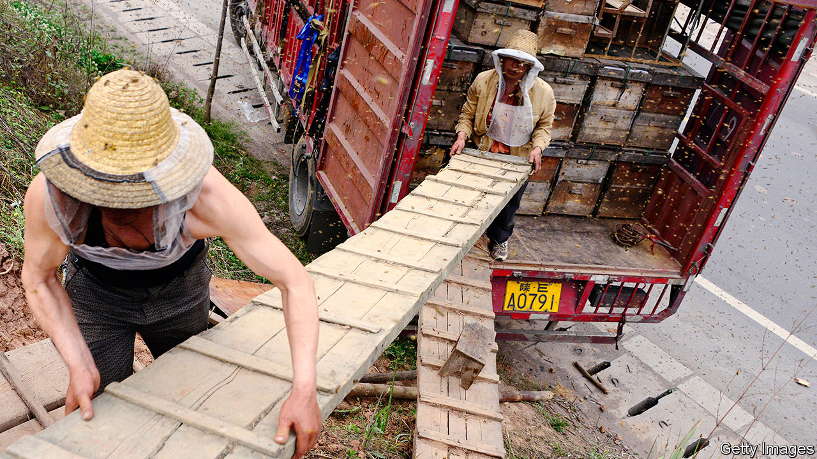

Editor’s note: The Economist is making some of its most important coverage of the covid-19 pandemic freely available to readers of The Economist Today, our daily newsletter. To receive it, register [here](https://www.economist.com/newslettersignup). For our coronavirus tracker and more coverage, see our [hub](https://www.economist.com/coronavirus)

ZHANG YALI remembers the pains of living in the Chinese countryside when she was growing up. On the mountainside in rural Shanxi, the northern province where her family lived, snakes and scorpions lurked. If they did not bite, the mosquitos certainly would. But the Zhangs could not move their isolated home to the safety of a village, because only the mountain was free of pesticides. What worried the Zhangs more than the odd sting were chemicals that might kill their bees.

Pesticides have long plagued China’s honey-making industry, which is by far the world’s largest. This year, however, covid-19 has been a bigger headache for the country’s 250,000 beekeepers, who produce around one-quarter of the global supply. Many of them are itinerant, moving their colonies around the country on lorries in search of pollen and nectar. For many days, restrictions imposed to curb the epidemic made this difficult.

The average honey bee flies for more than 1,500km in her lifetime. Many of China’s beekeepers travel about twice that distance in a season, criss-crossing the western and southern plains. But late in January local governments began to limit people’s movements. Many keepers who had taken advantage of the cold weather, when bees huddle in their hives, to leave their colonies and visit relatives, found themselves stuck. They were unable to return to take their bees on the road. Those united with their hives could not set off either. Many of the insects died of starvation. “In previous years, our relatives would go south for spring flowers and rapeseed. But no one can go this year,” says Ms Zhang.

In mid-February the central government announced measures to make it easier for agricultural workers and goods to move around. But there are still obstacles of various kinds, including frequent health checks. Woe betide the beekeeper required to self-quarantine—that can mean separation from bees. Even those who manage to go about their business normally will struggle to make up their losses. Margins are thin at the best of times. Wang Baorong, a beekeeper in Yunnan, normally makes about 1,000 yuan ($140) a month, about average for a rural household in the poor southern province. “Beekeepers have to rely on heaven to eat,” he says.

Some may be able to supplement their income by turning to a growth industry for owners of bees: pollinating farmers’ crops. In parts of China wild bee populations have been falling because of pesticide use, climate change and diseases such as deformed-wing virus, forcing farmers to pollinate by hand. It is a labour-intensive process and results in lower yields. (Around one-third of China’s pear trees are pollinated in this way.) But Ms Zhang says that regions where demand for these services is highest, such as Xinjiang in the far west and Inner Mongolia in the far north, are too far away to make it worthwhile for her family to travel there.

The economy is slowly recovering. Travel is getting easier. But for itinerant beekeepers it is too late to catch the early blooms of spring. Ms Zhang grumbles that life even before covid-19 was “mediocre”—not helped by her father’s poor health. “We must practise the spirit of the bees, live and learn, keep busy and grow old,” she says. ■

Dig deeper:  
For our latest coverage of the covid-19 pandemic, register for The Economist Today, our daily [newsletter](https://www.economist.com/newslettersignup), or visit our [coronavirus tracker and story hub](https://www.economist.com/coronavirus)

Read also on: <https://www.economist.com/china/2020/04/11/chinas-beekeepers-feel-the-sting-of-covid-19>

|  |  |  |  |
| --- | --- | --- | --- |
| Previous | Articles | Sections | Next |

|  |  |  |  |
| --- | --- | --- | --- |
| Previous | Articles | Sections | Next |

#### Chaguan

# China stifles documentary-makers, but their art still shines

A director makes personal appeals to strangers to download his hard-hitting film

Apr 11th 2020 |

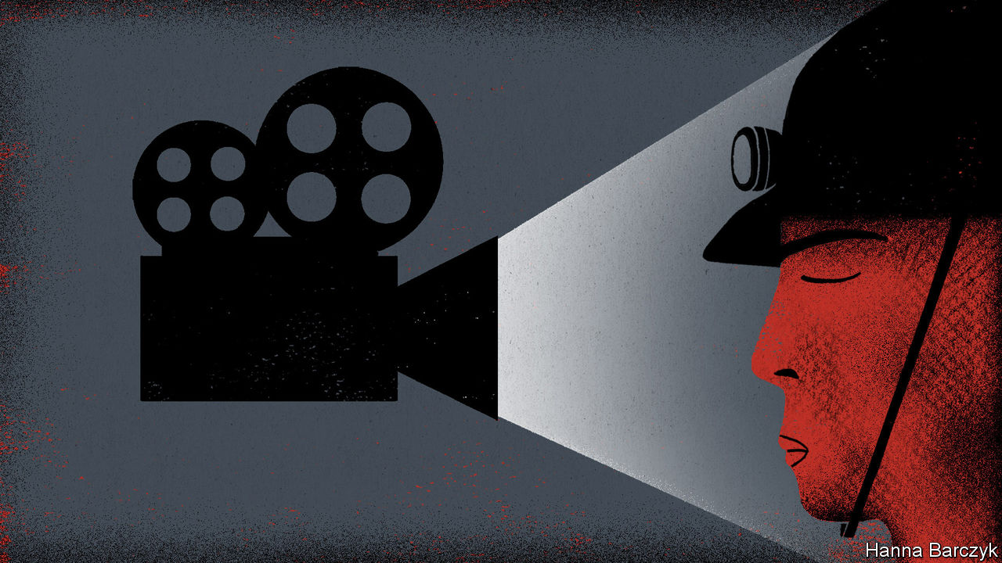

IF INDEPENDENT documentary-makers in China are squeezed much harder by the authorities, their plight will soon be a question fit for philosophers. Namely, if a film has no viewers, in what meaningful sense does it exist?

For some years now, the makers of non-fiction films have understood that, without the letter of approval from censors that they call a “dragon seal”, their work will reach only a handful of hardy Chinese fans—perhaps via a semi-underground film screening at a bar near a university, or in a small festival sponsored by a foreign diplomatic mission. Losing money is taken for granted.

Even so, documentary enthusiasts were shocked to realise in late March that a respected film-maker was quietly distributing his latest work by sending individual strangers instructions on how to get it from the internet, without paying. These download links arrived as private messages from the director, Jiang Nengjie, to film-lovers who clicked a button marked “Want to watch” when reading about his new project on Douban, a leading review site. Mr Jiang’s documentary* is called “Miners, the Horsekeeper and Pneumoconiosis”. It is about coal workers afflicted with a fatal lung disease. Shot over eight years, the film takes viewers down illegal mine shafts in the central province of Hunan, inside shabby rural clinics and, finally, into a village home where children watch their father fighting to breathe, like a man drowning on dry land. The work has sparked a revealing debate. There have been scattered attacks from nationalists on Weibo, a microblog platform, one of whom demanded Mr Jiang’s arrest for his “enraging” refusal to show China’s good side. Overall the film has a high rating from Douban’s users. A supporter earned 40,000 likes and 2,000 comments with a post on Weibo expressing shock that Mr Jiang was giving work away free. “Shit, independent film-makers have it so rough!” it said. Some users sent Mr Jiang the cash equivalent of a cinema ticket.

This is not dissident art. The documentary offers no political opinions about the Communist Party. It eavesdrops on miners who talk of the authorities with wary cynicism and resignation, rather than love or conspicuous dislike. The state is mostly conspicuous by its absence. To avoid unseen inspectors, miners move at night and dig illegal pits on mountain tops in weather too cold for any official to brave. “Corruption cannot be solved,” a villager sighs. “There are still many corrupt officials.” Mr Jiang’s film has no voice-over. The contrast is striking with state television documentaries featuring bossy, relentless narrators declaiming upbeat slogans. This is film-making that is content to show, not tell.

Reached by telephone, Mr Jiang insists that he has cautious, limited ambitions for his work. Many of those who appear in his new film are his own relatives, for he was born in the mountains of rural Hunan in 1985. China’s millions of pneumoconiosis sufferers need more help from health officials, he says. “I want more people to know about them. To see them.” A film-maker since 2009, he supports his documentary projects by videoing weddings and commercial events. He did not consider entering this film for a foreign festival, as too much attention can be troublesome. Mr Jiang did not ask censors to approve the work, knowing that they would either say no, or demand a long list of edits. “I’d have to turn my film upside down, and I don’t want that.”

Some Chinese film-promoters have given up all ambitions, as political controls tighten remorselessly under President Xi Jinping. In January the China International Film Festival, an influential event first staged in the eastern city of Nanjing in 2003, announced it was suspending operations indefinitely. Organisers called it impossible to hold a truly independent film festival, after 20 years of relative openness.

Karin Chien co-founded dGenerate, a film-distribution company, to bring uncensored Chinese works to worldwide audiences. “That was in 2008, and we didn’t know then it was a golden age,” explains Ms Chien. Technology helped. She watched hundreds of independent films emerge from China as artists, poets and other writers picked up digital video-cameras. She recalls the ingenuity of the Beijing Queer Film Festival which in 2014 staged a screening-on-rails by telling festival-goers to take a specific train, to bring laptops and sit in the same carriage. There, memory sticks were handed out so all could watch the opening film together. Since about 2014, alas, she has seen a steady stream of film-makers emigrate from China. Some others surrender to commercial forces.

## Letting the invisible be seen, and the voiceless be heard

The power of documentaries to shake public opinion in modern China has been shown more than once. In 1988 state television broadcast “River Elegy”, a six-part call to embrace outside influences and break with stifling traditions. The questions it raised were echoed by the protesters in Tiananmen Square the next year. In 2015 “Under the Dome”, a scathing documentary about air pollution, was viewed online hundreds of millions of times and praised by China’s new environment minister, before censors swooped. It is hard to imagine either work being screened today.

Independent documentaries offer a sense of immediacy and of bearing witness “on the spot”, says Kiki Tianqi Yu, a Chinese film-maker who is a lecturer in London. Film–makers document history that the government will not, she adds. Those Chinese who are likely to hear about and see non-approved documentaries are a rather privileged bunch: university students, intellectuals, art-lovers, urban professionals and the like. Mr Jiang’s new film lets them hear a gruff ex-miner lament: “My poor little boy. I can’t die. His life will be difficult if I die.” Soon after his 50th birthday though, sensing that his end is near, he tells the camera, “I spat out blood yesterday. Damn it.” Perhaps only a few thousand people in China will see the film. But just for a moment, a father’s pain and fear bridges the gulf that separates urbanites from poor villagers in China, a horribly unequal society. Reason enough for art to exist. ■

* Editor's note: the documentary described in this column may be seen via this [link](https://www.youtube.com/watch?v=Tq0PHPF0U50&feature=youtu.be)

Read also on: <https://www.economist.com/china/2020/04/11/china-stifles-documentary-makers-but-their-art-still-shines>

|  |  |  |  |
| --- | --- | --- | --- |
| Previous | Articles | Sections | Next |

|  |  |  |
| --- | --- | --- |
| China | Sections | Europe |

Middle East and Africa

Iraq: Dark times ahead

.

Covid couture: Lebanon gets comfortable

.

Fiscal ill-health: Debt and disease

.

Kenya: Tall tales of the city

.

African agriculture: Dummy farms

.

|  |  |  |
| --- | --- | --- |
| China | Sections | Europe |

|  |  |  |  |
| --- | --- | --- | --- |
|  | Articles | Sections | Next |

#### Dark times ahead

# The risk that Iraq might fall apart

Covid-19, militias and a cratering economy all threaten the central state

Apr 11th 2020 |

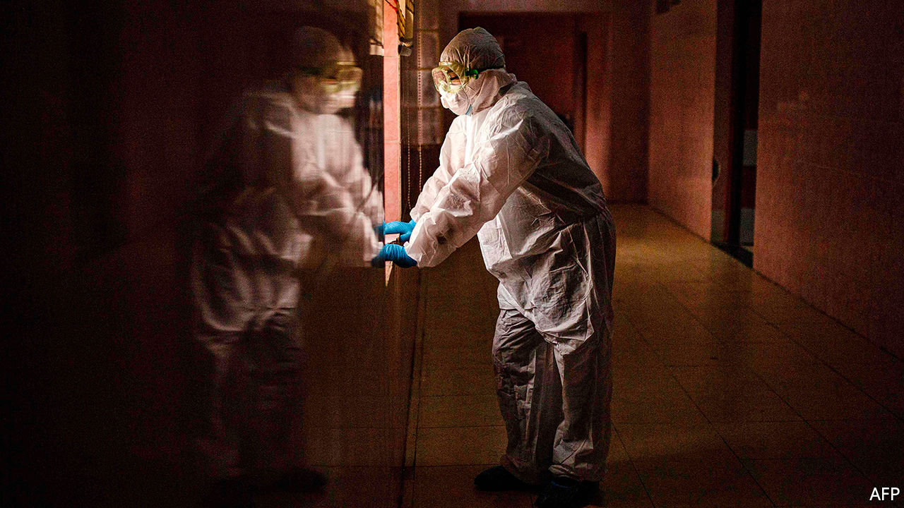

Editor’s note: The Economist is making some of its most important coverage of the covid-19 pandemic freely available to readers of The Economist Today, our daily newsletter. To receive it, register [here](https://www.economist.com/newslettersignup). For our coronavirus tracker and more coverage, see our [hub](https://www.economist.com/coronavirus)

IN SADR CITY, the vast shantytown east of Baghdad, cars still pack the roads, pilgrims still pray at shrines and people still gather in shops. Many see covid-19 as either a Zionist hoax or a fast track to paradise, so they feel no obligation to comply with the government’s order to stay inside. The government itself seems unprepared. Iraq claims to have just 1,122 cases of the virus, but it is accused of minimising the number. Its public hospitals are not equipped to handle a big outbreak.

If the virus were Iraq’s only problem, that would be enough. Alas, the country is nearly bankrupt—the result of a precipitous decline in the price of oil, which supplies more than 90% of government revenue. Its politics are also a mess, with parties unable to agree on a new prime minister. Iraq’s militias are running amok, while the jihadists of Islamic State (IS) regroup. America and Iran, which helped Iraq muddle through past crises, are focused on fighting each other. Fears are growing that the state will collapse, says an Iraqi official.

Saudi Arabia and Russia are in talks over oil-production cuts, which would provide some relief to Iraq by raising prices. But even if the price of oil jumps by half, Iraq would still be looking at a sizeable budget deficit. As it is, the government cannot afford to pay salaries in the ever-expanding public sector (see chart). It has around $60bn in cash reserves, but that could run out by the end of the year, leaving it dependent on a loan from the IMF, which may not be forthcoming. The state’s 7m employees and pensioners are worried. “Without salaries, that’s the end of Iraq,” says Mowaffak al-Rubaie, a former national-security chief.

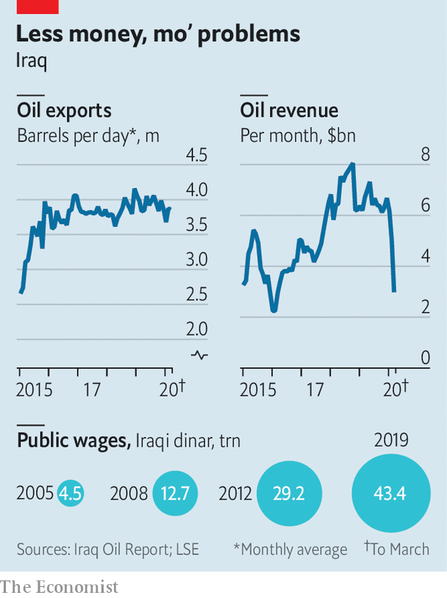

That may sound alarmist, but Iraq does not have much of a private sector to fall back on. Many firms rely on government contracts. Much of the sector is informal. With a curfew in place, travel restricted and the borders closed, commerce has slowed considerably. Even before the virus, many Iraqis struggled to get by. Such hardship, along with blatant corruption, sparked big protests, beginning last year.

Those have largely subsided as people keep their distance from each other. But Iraq’s politicians are not taking advantage of the calm. Since the prime minister, Adel Abdul-Mahdi, resigned in November, two men have been put forward to take his place. The first, Muhammad Allawi, failed to gain the backing of important Shia parties and their associated militias. The second, Adnan Zurfi, is trying to win over parliament, but he is opposed by Iran and is also unpopular with Shia politicians, who cannot agree on a successor. Many are happy to leave the pliable Mr Abdul-Mahdi in office as a caretaker.

Meanwhile, the militias that once fought against IS as part of the Hashd al-Shaabi, or popular mobilisation forces (PMF), are fragmenting. Two men who held them together—Abu Mahdi al-Mohandis, the PMF’s commander, and Qassem Suleimani, the head of Iran’s Quds Force, its foreign legion—were killed by America in January. Now some militias want to integrate with the army. More militant ones are going their own way. There are also signs of trouble within the militias, with splinter groups acting like criminal gangs.

Iran continues to use militias to wield influence in Iraq and try to push out America. A rocket attack by militia forces on March 11th killed two American soldiers and a British medic at an Iraqi military base. America responded with strikes on an Iranian-backed militia, Kataib Hizbullah. On March 16th militia forces attacked another Iraqi base used by American soldiers (causing no casualties). An unknown group called Usbat al-Thayireen claimed both attacks and issued threats against America, “suggesting that the [Quds Force] had assembled its proxy militias into a new coalition,” says the Soufan Centre, a New York-based research body.

President Donald Trump says Iran “will pay a very heavy price” if its proxies keep up their attacks. He has been consolidating America’s position in Iraq. Of the 5,200 American soldiers who were in the country at the start of the year, most have been gathered into a few large bases, mainly in Kurdish and Sunni areas. Some have been withdrawn. European and Canadian soldiers, part of the anti-IS coalition, have left, citing the outbreak of covid-19. IS, meanwhile, is active again. “It has a bit of a free pass right now,” says Michael Knights of the Washington Institute, a think-tank. “They’re better prepared for the virus than any fighting force. They’re doomsday preppers.”

With no leader and outside powers preoccupied with their own interests, it is not clear who will hold Iraq together. Grand Ayatollah Ali al-Sistani, Iraq’s spiritual arbiter, has receded from politics. The Kurds, who have sought independence before, may do so again if the central government cannot produce the cash promised to their region. Sunni leaders are discussing carving out their own state, too. And the protests are likely to resume once the outbreak subsides. Politicians and analysts differ over how Iraq might collapse, but many think it is only a matter of time. ■

Dig deeper:  
For our latest coverage of the covid-19 pandemic, register for The Economist Today, our daily [newsletter](https://www.economist.com/newslettersignup), or visit our [coronavirus tracker and story hub](https://www.economist.com/coronavirus)

Read also on: <https://www.economist.com/middle-east-and-africa/2020/04/11/the-risk-that-iraq-might-fall-apart>

|  |  |  |  |
| --- | --- | --- | --- |
|  | Articles | Sections | Next |

|  |  |  |  |
| --- | --- | --- | --- |
| Previous | Articles | Sections | Next |

#### Covid couture

# Lebanon embraces sweatpants during the outbreak

A stylish nation lets standards slip

Apr 11th 2020 | BEIRUT

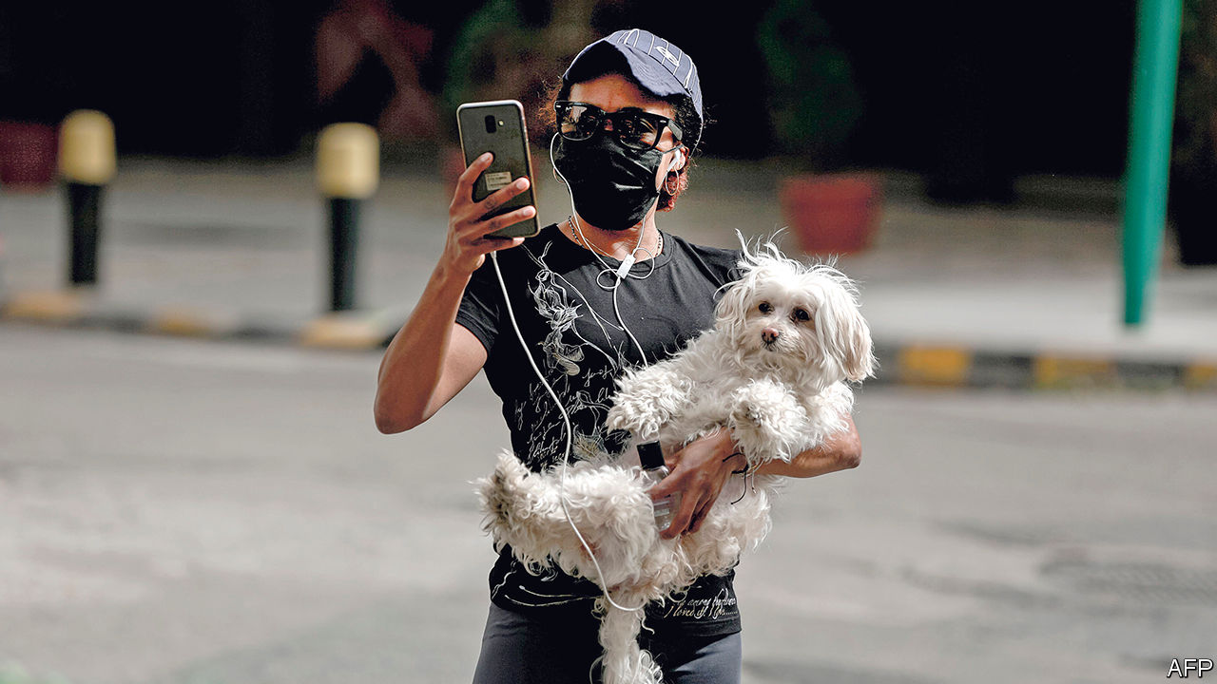

Editor’s note: The Economist is making some of its most important coverage of the covid-19 pandemic freely available to readers of The Economist Today, our daily newsletter. To receive it, register [here](https://www.economist.com/newslettersignup). For our coronavirus tracker and more coverage, see our [hub](https://www.economist.com/coronavirus)

THE ODDITIES begin the moment you step outside in Lebanon, now in its fourth week of near-total lockdown. Streets once choked with traffic are empty. At the entrance to a supermarket shoppers don masks and plastic gloves, while staff check their temperatures. But the strangest sight is inside. Customers stroll the aisles in sweatpants, pyjamas, even flip-flops. Asked about this unusually dégagé fashion, one shopper observed, with mock horror, that the Lebanese were starting to dress like Americans. Her tracksuit top, coincidentally, had the stars and stripes sewn on one arm, a relic of more casual days studying in America.

Depending on whom you ask, Lebanon’s 4m citizens are stereotyped as either stylish or vain, bon vivants or parvenus. It is a stereotype, they admit, rooted in some truth. A quick trip to the bakery might require a dab of make-up or a splash of cologne. Banks used to offer loans for plastic surgery. Cars, clothes, champagne in clubs—public life was a stage on which to show off.

Until the curtain fell. Nightclubs were first to close, then bars and restaurants. Even the Sunday lunch, a regular gathering of family and friends, has been curtailed: a government decree issued on April 5th limited car travel six days a week and forbade it entirely on Sundays. With nowhere to go but the supermarket, no one can be bothered to dress up. Drive into the mountains outside the capital, Beirut, and the deserted roads are full of tracksuit-clad families out for a stroll, another oddity in a country notorious for its lack of public space.

The glamorous Lebanon of tourism ads and diaspora fantasies was always a veneer. A clubgoer wearing designer labels tosses her Mercedes keys to a valet earning a few hundred dollars a month. A diner at a fancy restaurant steps outside for a cigarette and draws a crowd of beggars, some of them only children. An estimated 45% of Lebanese live on less than $3,100 a year. More than 60% of the 2.8m accounts in local banks contain under 5m Lebanese pounds ($3,300).

The virus has not erased these distinctions, but rather inverted them. Whereas the well-off huddle invisibly at home, the poor must flaunt their desperation. Scores of people in Tripoli defied curfew last month to protest about their living conditions. A taxi driver in Beirut set his car on fire after being fined for violating rules that limit him to one passenger. A Syrian refugee tried to self-immolate on April 5th. The cabinet has belatedly asked the army to distribute 400,000 pounds to every needy family, but it does not even know which families need help.

For those old enough to remember the civil war, lockdown feels familiar: long hours spent at home, quick sprints out for supplies. The country’s joie de vivre was a reaction against hardship.

But this shock is different. Even before the coronavirus arrived, Lebanon was mired in a monetary crisis. Thousands of businesses had closed; more are now quietly going under. When the pandemic passes, there may be less demand for designer clothes.■

Dig deeper:  
For our latest coverage of the covid-19 pandemic, register for The Economist Today, our daily [newsletter](https://www.economist.com/newslettersignup), or visit our [coronavirus tracker and story hub](https://www.economist.com/coronavirus)

Read also on: <https://www.economist.com/middle-east-and-africa/2020/04/11/lebanon-embraces-sweatpants-during-the-outbreak>

|  |  |  |  |
| --- | --- | --- | --- |
| Previous | Articles | Sections | Next |

|  |  |  |  |
| --- | --- | --- | --- |
| Previous | Articles | Sections | Next |

#### Double burden

# Africa’s debt crisis hampers its fight against covid-19

Governments must choose between paying creditors or saving lives

Apr 11th 2020 |

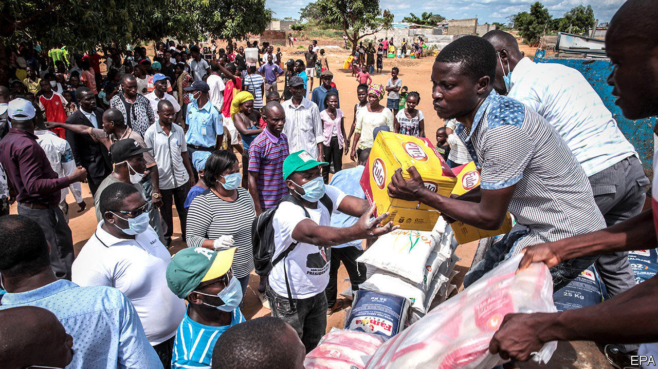

Editor’s note: The Economist is making some of its most important coverage of the covid-19 pandemic freely available to readers of The Economist Today, our daily newsletter. To receive it, register [here](https://www.economist.com/newslettersignup). For our coronavirus tracker and more coverage, see our [hub](https://www.economist.com/coronavirus)

ECONOMIC CRISIS and covid-19 are forcing hard choices on most of the world. But the dilemma facing indebted poor countries is particularly acute. They can either pay foreign creditors or allow more of their citizens to die, say experts.

This dilemma is not new. In 2016 Angola spent nearly six times as much servicing its external debt as it did on public health care. Fifteen countries in sub-Saharan Africa spent more money paying creditors abroad than they did on doctors and clinics at home. But now, faced with a slump in revenues and skyrocketing borrowing costs as investors seek relative safety, many African governments are struggling to find the money to fight the pandemic and shore up their economies. Whereas rich countries are borrowing to spend about 8% of GDP on stimulus measures, African ones are spending just 0.8% of GDP.

This is because the virus has thrown petrol onto a slow-burning debt crisis. The countries most at risk of default—and, by definition, the least able to borrow affordably—are those with limited domestic savings and large external debts, such as Angola, Ethiopia, Ghana and Zambia. But they are not the only ones in trouble. Since 2010 average public debt in sub-Saharan Africa has risen faster than in any other developing region, from 40% to 59% of GDP in 2018. Most African countries have borrowed more than is prudent, said the IMF last year; 18 were classed as being in debt distress, or at high risk of it.

Many homeowners in Western countries are getting a mortgage holiday because of the pandemic. Might governments in Africa get the equivalent? The previous big round of debt relief for the continent came via the Heavily Indebted Poor Countries Initiative, which reduced foreign public debt of recipient countries from about 100% of GDP in 2005 to 40% by 2012. At the time Western governments and multilateral organisations, such as the IMF and World Bank, were the biggest lenders to Africa. Now, though, China is the continent’s biggest bilateral creditor. Having signed loans worth more than $146bn to African governments since 2000, it may not be as forgiving.

Africa’s debt burden does more than divert spending from health care and stimulus to loan payments. It also discourages rich countries from helping out. Europe and America, in particular, worry that any aid they provide to African countries would eventually end up in the pockets of Chinese lenders.

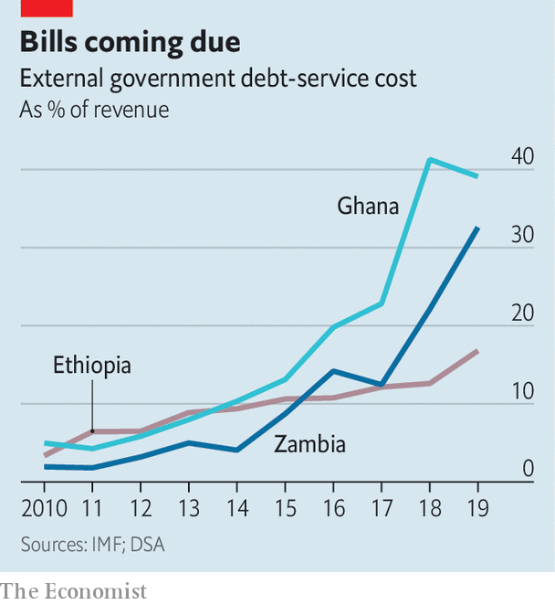

The World Bank and IMF have asked bilateral lenders to suspend debt payments from the world’s 76 poorest countries. That would be a start, but would cover only a quarter of sub-Saharan Africa’s total debt-service costs. Nevertheless, the appeal seems to have fallen on deaf ears in China, where officials say they will deal with African debt on a case-by-case basis. Analysts think China is loth to give up the political leverage that comes with being owed so much money. But, like other creditors, it may have to choose between orderly debt relief or chaotic defaults.

Even if China and other government lenders agreed to a pause on payments, states in sub-Saharan Africa might still use emergency funds to pay private creditors. The states owe bond investors $115bn. (Commodity traders and domestic investors are owed, too.) Few commercial bonds are due for repayment before 2022, but interest must still be paid. If it is not, bondholders could demand full repayment. African finance ministers, hoping to protect their countries’ creditworthiness, want donors to help pay the interest while negotiations take place.

More than 100 international NGOs have called for a cancellation of all debt payments in 2020. But multilateral banks are reluctant to risk their own credit ratings and private bondholders are hard to corral. Lee Buchheit, a law professor at the University of Edinburgh, suggests changing American and British codes to stop lawsuits by angry bondholders against countries hit hard by covid-19.

Even if lenders listen to the NGOs and suspend all debt payments this year, there is still trouble ahead for African countries. Most collect relatively little tax. Low commodity prices have led to decreased revenues. And the countries that borrow the most also tend to be irresponsible spenders. Once this crisis is over, a wall of payments awaits them. ■

Dig deeper:  
For our latest coverage of the covid-19 pandemic, register for The Economist Today, our daily [newsletter](https://www.economist.com/newslettersignup), or visit our [coronavirus tracker and story hub](https://www.economist.com/coronavirus)

Read also on: <https://www.economist.com/middle-east-and-africa/2020/04/11/africas-debt-crisis-hampers-its-fight-against-covid-19>

|  |  |  |  |
| --- | --- | --- | --- |
| Previous | Articles | Sections | Next |

|  |  |  |  |
| --- | --- | --- | --- |
| Previous | Articles | Sections | Next |

#### Tall tales of the city

# Why urban migrants understate how much they earn

And why this harms rural folk

Apr 8th 2020 | KAMPALA

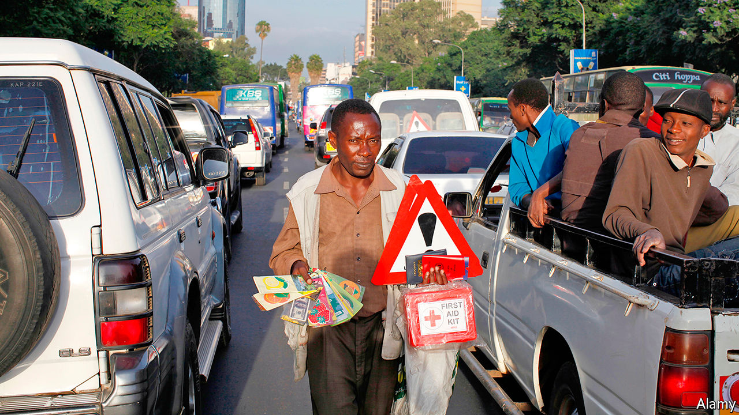

SOME COUNTRY folk do not understand what life is like in town, says Roda Radido, who lives in Nairobi, the Kenyan capital. She is right. Rural Kenyans typically have no idea how much better off they would be if they moved to a city. A survey by Travis Baseler of the University of Rochester found that people in western Kenya guessed that the average worker in Nairobi earns about twice as much as the average worker in Bungoma, a small town near the border with Uganda. In fact, the Nairobian makes four times as much. Urban Kenyan incomes are higher even after accounting for costlier rent and rood, and even when comparing wages in similar jobs.

Why do rural folk underestimate the rewards of working in a city? Many respondents had relatives who had worked in Nairobi, who could easily have told them. Yet for some reason they did not. When Mr Baseler surveyed migrants in the capital, nine out of ten said their loved ones back home did not know how much they were earning.

Ms Radido understands why. She and her husband moved to Nairobi when he found work on a poultry farm on the city’s outskirts. Now the relatives she left behind in western Kenya pester her whenever they need a bit of cash. It is a common problem, and makes urban migrants cagey about their wages. “People in the city do not want to expose the kind of money they have,” she says, for fear they will be overwhelmed by requests for help.

In Mr Baseler’s survey, 61% of urban migrants strongly agreed that they would be asked to send back more money if their real incomes were known. Mr Baseler also spoke to the family and friends of migrants. Parents thought that their children in the city were only making half as much as they actually were.

In a working paper Mr Baseler suggests ways in which this economy with the truth is harmful. Because villagers never hear the true benefits of migration, they stay at home and forgo a big pay rise. In an experiment to test this idea, he presented rural households with true information about the average income in cities, food prices and wages in typical jobs. Two years later migration to Nairobi from these households was 33% higher than from a control group, which was told nothing.

City streets are not paved with gold, of course. Newcomers often huddle in overcrowded slums. Linda Adhiambo Oucho of the African Migration and Development Policy Centre, a think-tank in Nairobi, says that many migrants are surprised by the hardships of urban life, including the high costs of rent, transport and electricity. Some families even send food from the village to struggling relatives in town.

However, only a quarter of the migrants whom Mr Baseler surveyed said that their quality of life was lower in the city than at home. Over half said that it had improved. Moving to the city brings fresh opportunities, as well as guilt-inducing phone calls from needy relatives.■

Read also on: <https://www.economist.com/middle-east-and-africa/2020/04/08/why-urban-migrants-understate-how-much-they-earn>

|  |  |  |  |
| --- | --- | --- | --- |
| Previous | Articles | Sections | Next |

|  |  |  |  |
| --- | --- | --- | --- |
| Previous | Articles | Sections | Next |

#### Bucolic botch

# Why big farms flopped in Ethiopia

Too few investors knew the land; too many deals were crooked

Apr 8th 2020 | OMORATE

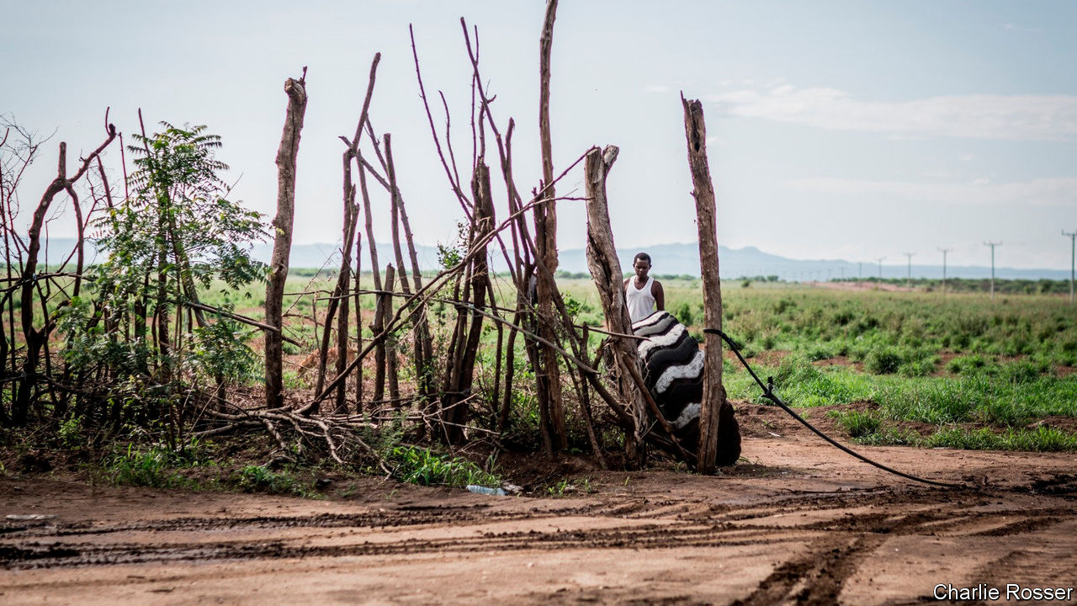

THE PLAN was to transform farming in southern Ethiopia. Twelve years ago Fri-El, an Italian conglomerate, signed a lease with the state government for 30,000 hectares of farmland in South Omo to make palm oil. But the palms needed more water than the copper-coloured Omo river could supply and production was so disappointing that in 2011 its lease was cut by a third in size. Even a switch to cotton production did not help. Many bolls are left unpicked owing to labour shortages. A ginnery lies idle for want of electricity.

A decade ago rising food prices spurred investors to get land across Africa. In Ethiopia, where the government offered tax breaks, low rents and vast tracts of allegedly empty farmland, more was leased than almost anywhere else. One study calculated that around 1m hectares were allocated between 2005 and 2012; others suggested two or even three times that. The idea was that poor, remote places like South Omo, near Ethiopia’s south-western border, would become paragons of development. Mechanised cotton estates would feed Ethiopia’s burgeoning textile factories. Nomads would ditch their cattle for jobs as labourers on commercial farms.

Instead South Omo has become a cautionary tale. No cotton farm in the local area is operating anywhere near capacity, reckons Benedikt Kamski, who studies such matters for the Arnold-Bergstraesser Institute, a German think-tank. In 2018 less than 3% of the 90,000 hectares leased to investors in three of South Omo’s districts was being farmed, he found.

Many of the farms created in Ethiopia’s sparsely populated lowlands were simply too big, and those leasing them lacked the capital to develop them. Karuturi Global, an Indian firm, signed a deal for 100,000 hectares in 2010, only for it to be cancelled five years later. By that point less than 2% of its tract had been developed. In 2015, the last year for which estimated data are available, less than a fifth of the total land leased in Ethiopia by local and international companies was being farmed.

Some investors were incompetent. “We didn’t know what to do, we’re not farmers,” admits an estate manager in South Omo. Others were crooked. In the region of Gambella 335 out of 420 land deals were signed in just three years after 2008, according to a paper from 2016 by Fana Gebresenbet, an Ethiopian academic. Most involved individuals linked to the ruling party. Many such ventures may be what Mr Kamski calls “dummy farms”: idle assets acquired to get generous government loans.

The neglect of Ethiopia’s lowland areas by those living in its highlands, long the country’s power centre, worsened the situation. Bigwigs dismissed the concerns of local people. The government often deems rangelands “unused”, ignoring the claims of nomads who use them for grazing and light agriculture. This brings farmers and cattle herders into conflict in South Omo and areas like it.

South Omo has also been deprived of resources it needs for development, which makes farming even more difficult. The valley did not contain a sizeable bridge until 2010. Shoddy construction meant it collapsed before it was finished the following year. Scant infrastructure is a headache for companies such as Fri-El. The lack of local petrol stations means it must transport the tens of thousands of litres of diesel it needs each month more than 350km to its farm.

In recent years the government has tried to improve matters. Since 2013 it has cancelled several big contracts, drawn up stricter requirements for investors and introduced maximum landholdings. In 2016 the state development bank temporarily suspended lending to commercial agriculture, after years of handing out questionable loans. The following year some responsibility for leasing land was returned from the federal government to the states to give locals more say.

Yet officials have hinted that the government wants to promote huge farms once more, this time by expanding wheat production to boost food security. The lesson they should remember is that the details matter more than scale or haste. ■

Read also on: <https://www.economist.com/middle-east-and-africa/2020/04/08/why-big-farms-flopped-in-ethiopia>

|  |  |  |  |
| --- | --- | --- | --- |
| Previous | Articles | Sections | Next |

|  |  |  |
| --- | --- | --- |
| Middle East and ... | Sections | Britain |

Europe

Europe’s response to covid-19: Paying for it

.

Greece’s vulnerable economy: A terrible toll on tourism

.

Turkey and covid-19: Perfumed guardian

.

Russia: The invisible leader

.

Charlemagne: Zoom diplomacy

.

|  |  |  |
| --- | --- | --- |
| Middle East and ... | Sections | Britain |

|  |  |  |  |
| --- | --- | --- | --- |
|  | Articles | Sections | Next |

#### Paying for it

# European finance ministers ponder coronabonds

Once again, the euro zone is consumed by rows over debt

Apr 9th 2020 | BERLIN

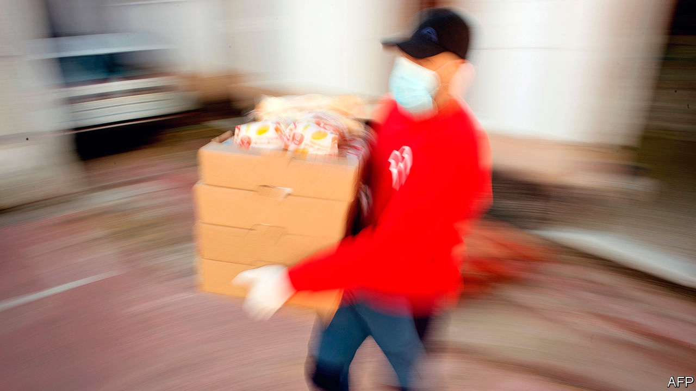

Editor’s note: The Economist is making some of its most important coverage of the covid-19 pandemic freely available to readers of The Economist Today, our daily newsletter. To receive it, register [here](https://www.economist.com/newslettersignup). For our coronavirus tracker and more coverage, see our [hub](https://www.economist.com/coronavirus)

IT IS “impossible to be more optimistic than [António] Costa,” Portugal’s president once said about his country’s irrepressible prime minister. Yet on March 26th Mr Costa’s bonhomie was nowhere to be seen. After EU leaders had held a fractious video-conference on the covid-19 crisis he stood before cameras, his face like thunder, to declare: “If we don’t respect one another…no one has understood anything about the EU.” Attacks by Wopke Hoekstra, the Dutch finance minister, on southern Europeans’ overspending were “disgusting” and “mean-spirited”. Things have not got much better since then.

Some analysts forecast a slump of nearly 10% in euro-zone GDP this year. But though rich countries like Germany have marshalled huge domestic responses, solidarity has been lacking. Border checks were imposed and medical supplies hoarded. The EU has at least relaxed fiscal and state-aid constraints to give afflicted countries room to respond. And on March 18th, with bond yields in Italy and Spain creeping up, the European Central Bank announced a €750bn ($810bn) asset-purchase plan and relaxed its rules over what it can buy. Christine Lagarde, its president, said there were “no limits” to its commitment.

That was enough to calm the markets. But like her predecessor, Mario Draghi, whose “whatever it takes” intervention kept the euro together in 2012, Ms Lagarde wants governments to do more. Specifically, she urges the euro zone to consider issuing a jointly guaranteed, one-off “coronabond”. Nine governments, led by France, Italy and Spain, have made a similar plea.

Yet the euro zone remains divided along familiar lines. An all-night session of finance ministers on April 7th-8th failed to reach agreement after the Italians and Dutch squabbled over debt mutualisation and other matters. A smaller suite of measures may yet be signed off. These include an expansion of European Investment Bank private-sector loans, EU financial support for national wage-subsidy schemes, and perhaps credit lines from the European Stability Mechanism (ESM), the euro zone’s bail-out fund. But these amount to a “nothingburger”, says Mujtaba Rahman of the Eurasia Group consultancy.

By pitting frugal northerners, like the Germans, Dutch and Austrians, against supplicant southerners, the row recalls elements of the 2010-12 euro crisis. Yet the differences are at least as salient. During the euro crisis the ECB waited until 2012 to act decisively; this time Ms Lagarde moved quickly (after an early misstep), ensuring governments did not have to battle market and health-care meltdowns at the same time. Moreover, most coronabond proposals envisage a one-off issuance to pay for specific aims like health capacity or wage subsidies, rather than an ongoing commitment or the mutualisation of old debt. “You don’t win the debate with the same old arguments about Eurobonds, because this is a shock that hit everyone without being anyone’s fault,” says Lucas Guttenberg of the Jacques Delors Centre in Berlin.

A more worrying difference is political. In Italy, which sits on a debt pile of over €2.5trn, Euroscepticism had emerged as a powerful force even before the corona crisis—channelled largely through Matteo Salvini, a former deputy prime minister who leads the hard-right Northern League. In early April one poll found that 53% of Italians were ready to leave the euro or EU. This has forced Giuseppe Conte, the non-partisan prime minister, to toughen his line, describing the ESM as “utterly inadequate”. Recalling the austerity forced on euro-zone wards like Greece by foreign creditors, many Italians fear that ESM loans will bring impossibly exacting conditions—even though Germany has promised leniency. The loans also stack up on national balance-sheets. As the Italian government negotiated on April 7th Mr Salvini appeared on television to denounce the “loan sharks” of Berlin and Brussels.

Spain’s Socialist prime minister, Pedro Sánchez, is less hostile than Mr Conte to the ESM. But he has also abandoned Spain’s typical Euro-quietism, warning that ruling out coronabonds would risk the credibility of the EU in countries like his. During the euro crisis, in which Spain’s banks had to be bailed out by the ESM, Spaniards knew they were paying the price of their own irresponsibility in inflating a property bubble. This time they have simply been hit by bad luck. Rejection will spur Eurosceptic sentiment that populist parties on the left and right would be happy to harness.

Neither Italy nor Spain is on the precipice. But the weakness of their fiscal positions—debt-to-GDP ratios of 136% and 97% respectively last year—is showing. Their responses to covid-19 have been more timid than Germany’s (see chart), despite the havoc it has wrought in their countries. More worryingly, growing debt may inhibit their ability to pay for recovery. The ECB is no panacea: its bond-buying could be indirectly undermined in May, when Germany’s constitutional court rules on the legality of its quantitative-easing programme; and anyway it cannot last forever. “At some point, markets will question Italy’s debts,” says Nicola Nobile at the Oxford Economics consultancy.

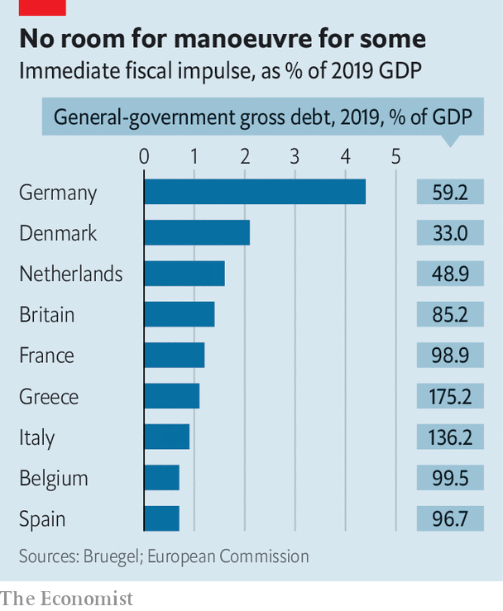

That calls for a “second line of defence”, says Grégory Claeys at Bruegel, a think-tank. Yet Germany continues to rule out coronabonds, and the Dutch appear even more immovable (although Mr Hoekstra eventually apologised for his tone). The sceptics’ old arguments about moral hazard and the risks of common borrowing without centralised supervision have been supplemented with new ones: a coronabond would take too long to establish, and institutions like the ESM and EIB involve some mutualisation anyway. And like their southern counterparts, northern governments must also deal with restive parliaments and troublemaking populists.

Countless proposals aim to square the difference. There is talk of turning the EU’s small seven-year budget into a new “Marshall Plan”. The Dutch have proposed a small fund that would dispense no-strings aid. Perhaps most prominent is a plan of Bruno Le Maire, France’s finance minister, to establish a temporary post-crisis rescue fund that would issue common bonds worth several billion euros, perhaps to be repaid by a European “solidarity tax”. Mr Le Maire carefully avoids the word “coronabond” while echoing Mr Sánchez’s apocalyptic talk about the risks of failure. But so far he has failed to win over Germany.

Even Angela Merkel, Germany’s chancellor, calls the corona crisis the biggest test the EU has ever faced. Yet her government’s diagnosis of the problem remains fundamentally at odds with much of the rest of the euro zone. The debate is not over, but Costa-style optimism is thin on the ground. “Whatever they do magic up is unlikely to meet the scale of the need,” says Mr Rahman. “Something may break.” ■

Dig deeper:  
For our latest coverage of the covid-19 pandemic, register for The Economist Today, our daily [newsletter](https://www.economist.com/newslettersignup), or visit our [coronavirus tracker and story hub](https://www.economist.com/coronavirus)

Read also on: <https://www.economist.com/europe/2020/04/09/european-finance-ministers-ponder-coronabonds>

|  |  |  |  |
| --- | --- | --- | --- |
|  | Articles | Sections | Next |

|  |  |  |  |
| --- | --- | --- | --- |
| Previous | Articles | Sections | Next |

#### A terrible toll on tourism

# Covid-19 hits Greece even harder than the rest of the euro zone

Just as it was beginning to turn a corner

Apr 11th 2020 | BERLIN

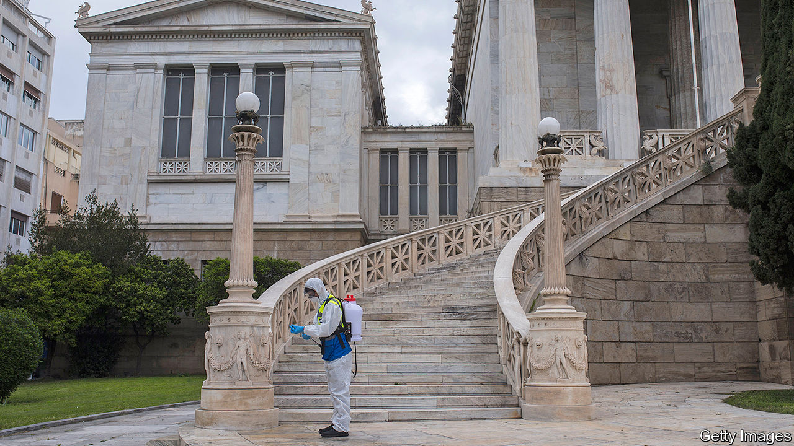

Editor’s note: The Economist is making some of its most important coverage of the covid-19 pandemic freely available to readers of The Economist Today, our daily newsletter. To receive it, register [here](https://www.economist.com/newslettersignup). For our coronavirus tracker and more coverage, see our [hub](https://www.economist.com/coronavirus)

AT THE START of this year it seemed as if Greece might have turned a corner. After a downturn that lasted longer than America’s Great Depression, its economy was growing again. Market capitalisation at the Athens Stock Exchange rose by 47% in 2019, the sharpest increase in the world. Tourism was booming, consumers were spending and Greek banks were reducing their burden of non-performing loans.

Business confidence at the start of this year was at an all-time high, bolstered by the election last July of a pro-business conservative prime minister, Kyriakos Mitsotakis, who promised to sweep away obstacles to business. The Harvard-trained former banker started well. He cut Greece’s labyrinthine red tape to make it easier to start a new business. He reformed labour laws, reducing the cost of firing an employee. He lowered taxes on corporations from 28% to 24%. Last September he fully lifted capital controls for individuals and companies. In November he signed off on a €600m ($650m) investment by China Ocean Shipping Company in Piraeus, Greece’s largest port.

That cheery mood seems like ancient history. Greece faces some of the severest disruption of any euro-zone economy, says Jakob Suwalski of Scope, a credit-rating agency, who predicts a fall of anything from 7% to 18% in GDP this year. No country in the euro zone other than Cyprus depends more than Greece on tourism, which has practically ceased to exist. The sector accounted for half of economic growth in 2018, more than 20% of GDP (90% in some parts of the southern Aegean) and a quarter of the country’s jobs. Now the tourists have stopped coming. On March 19th the government ordered hotels across Greece to close from March 23rd until April 30th, a date that will surely be extended. The Hellenic Chamber of Hotels estimates that the loss of profits thanks to cancellations has already exceeded half a billion euros.

In mid-March the Greek government restricted public gatherings to ten people. It also banned arrivals of non-European Union residents and travel to and from Albania, Italy, North Macedonia and Spain. And it ordered the closure of all retail businesses other than supermarkets, pharmacies, petrol stations, pet shops, food-delivery companies, groceries, bakeries, kiosks and banks. Greece is a nation of small businesses, most of which have scant resources to weather hard times. On March 23rd the government further tightened restrictions by imposing a national lockdown.

On top of an emergency boost of €10bn, Mr Mitsotakis insists that the country has “more weapons” to protect the economy, after around €12bn of its paper was declared eligible for inclusion in a €750bn bond-purchasing programme that has been launched by the European Central Bank. That should help to hold down the risk premium on Greek government debt. It is also, perhaps, a signal that the EU is prepared to believe in Greece’s recovery—once the virus is tamed. ■

Dig deeper:  
For our latest coverage of the covid-19 pandemic, register for The Economist Today, our daily [newsletter](https://www.economist.com/newslettersignup), or visit our [coronavirus tracker and story hub](https://www.economist.com/coronavirus)

Read also on: <https://www.economist.com/europe/2020/04/11/covid-19-hits-greece-even-harder-than-the-rest-of-the-euro-zone>

|  |  |  |  |
| --- | --- | --- | --- |
| Previous | Articles | Sections | Next |

|  |  |  |  |
| --- | --- | --- | --- |
| Previous | Articles | Sections | Next |

#### Perfumed guardian

# Turks try to ward off covid-19 with eau de cologne

Soap is cheaper, but kolonya is a national obsesssion

Apr 11th 2020 | ISTANBUL

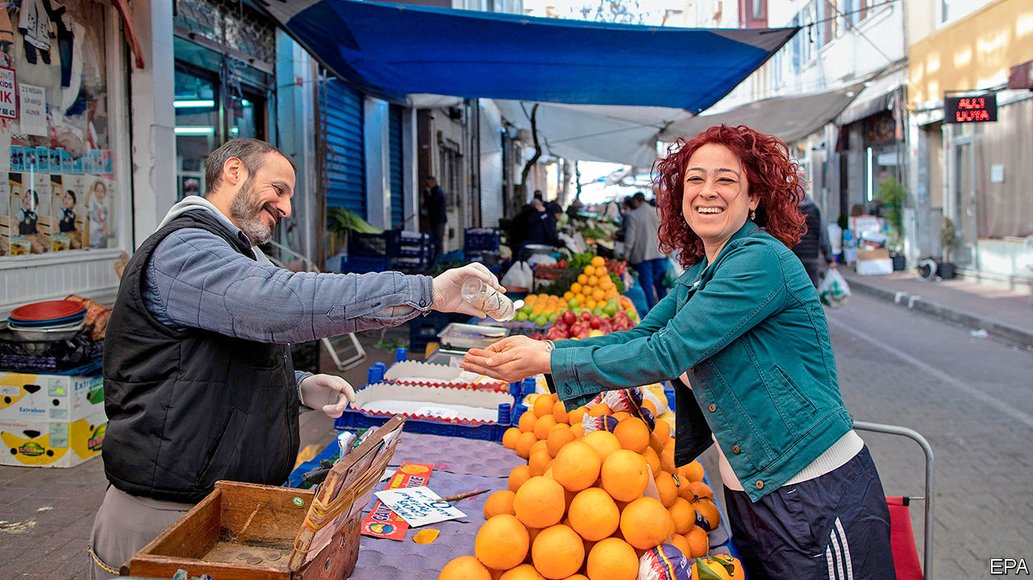

Editor’s note: The Economist is making some of its most important coverage of the covid-19 pandemic freely available to readers of The Economist Today, our daily newsletter. To receive it, register [here](https://www.economist.com/newslettersignup). For our coronavirus tracker and more coverage, see our [hub](https://www.economist.com/coronavirus)

IN MOST REGARDS, Turkey’s response to the covid-19 outbreak has not been out of the ordinary. The government has cancelled all international flights, sports events, and communal prayers at the country’s 90,000 mosques. Schools, universities and restaurants have been closed. People over 65 and under 20 have been ordered to stay at home.

Unlike other countries, however, Turkey has also made it a matter of policy to keep its citizens supplied with cologne. On March 18th President Recep Tayyip Erdogan promised to distribute the stuff to the elderly. Days later, local producers pledged they would not raise prices during the pandemic. Officials vowed that stocks would never run low.

Turkey is a land of germophobes. Food vendors hand out wet-wipes. The secular and pious alike wash their hands religiously. Asked how often they do so after a trip to the toilet in a 2015 survey, Turks scored higher (94%) than any country in Europe save Bosnia and Herzegovina, trouncing France (62%), Italy (57%) and the Netherlands (50%).

But nothing quite matches Turkey’s love for cologne. Named after the German city in which it was invented, cologne arrived in the Ottoman empire in the 19th century. It found a brand ambassador in Sultan Abdulhamid II, who carried Atkinsons cologne wherever he went and could get through a bottle in a matter of hours. The habit caught on, and cologne made its way into Turkish vocabulary, initially as odikolon (from eau de Cologne) and eventually as kolonya.

To this day, in homes across Anatolia, hosts sprinkle kolonya on their guests’ hands to kill bacteria (and body odour), before stuffing them with sweets and tea. Waiters do the same for patrons at restaurants, and bus attendants for passengers on long-distance routes.

Since the outbreak, kolonya has been flying off the shelves. One online retailer has reported a 3,400% increase in sales. Since kolonya is mostly alcohol, it may indeed destroy the virus. Granted, soap is cheaper. But kolonya smells nicer.

Dig deeper:  
For our latest coverage of the covid-19 pandemic, register for The Economist Today, our daily [newsletter](https://www.economist.com/newslettersignup), or visit our [coronavirus tracker and story hub](https://www.economist.com/coronavirus)

Read also on: <https://www.economist.com/europe/2020/04/11/turks-try-to-ward-off-covid-19-with-eau-de-cologne>

|  |  |  |  |
| --- | --- | --- | --- |
| Previous | Articles | Sections | Next |

|  |  |  |  |
| --- | --- | --- | --- |
| Previous | Articles | Sections | Next |

#### Washing his hands of it

# As covid-19 spreads, Vladimir Putin is invisible

Russia’s indispensable leader is strangely absent from the fight against the pandemic

Apr 8th 2020 |

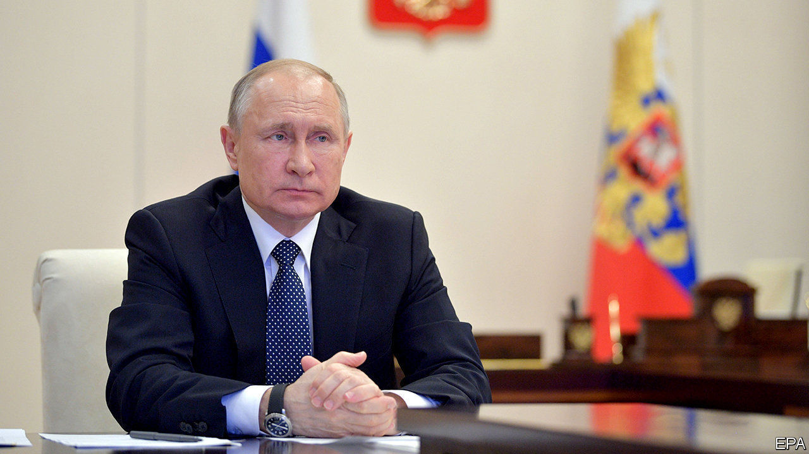

FOR THE past 20 years Russians have been told they could not survive without their superhero president, Vladimir Putin. Only a month ago, a Soviet-era cosmonaut-turned-politician urged parliament to lift constitutional restrictions that require him to step down as president in 2024. He was the only one who could save the country from crisis, she said, and should be allowed to run again and again.

The public was also told over the past few months that the threat of the new coronavirus was greatly exaggerated, that the Americans had invented it to harm China, and that Russia was well protected. Now, Moscow and many other cities are in lockdown, while the number of cases is rising exponentially. Yet Mr Putin has all but vanished from public view, hunkered down in his residence. If there is blame in the air, he does not want to catch it.

To be sure, Mr Putin did perform one of his trademark publicity stunts for the television cameras, donning a bright yellow hazmat suit and a respirator and visiting a hospital treating covid-19 patients. But such stunts have only made the absence of empathy and leadership he has exhibited all the more apparent.

Mr Putin has avoided personally imposing or even mentioning such words as “quarantine” or “lockdown”. Nor has he announced a state of emergency, fearing that this would hurt his approval ratings, which have been sliding for months. He did, however, extend “non-working days” until the end of April.

Conspicuously, he has said nothing about how the government plans to support the economy. Public-sector employees, who are 40% of Russia’s labour force, will continue to get paid. But private firms have been left high and dry. Mr Putin has not spelled out a national plan for fighting the epidemic. (Some Russian commentators recall how Stalin retreated to his distant dacha in the first few days after Germany attacked the Soviet Union in 1941.)

Unpopular measures will no doubt have to be taken. Mr Putin has pushed the responsibility for them down to the regional governors. This might have made sense had he not spent the past 20 years dismantling Russian federalism, centralising power and depriving the regions of political autonomy and financial resources.

One notable exception is Moscow, whose mayor, Sergei Sobyanin, sits on top of one of the largest municipal budgets in the world. Mr Sobyanin has emerged as a tough, decisive leader not only fighting the crisis hands-on in Moscow but also co-ordinating the work of other regions. Mr Putin, meanwhile, seems preoccupied with propaganda. He has sent Russian military planes loaded with medical kit to America and Italy, perhaps to remind domestic voters that Russia is a superpower.

The crisis has presented a new opportunity for Alexei Navalny, Russia’s best-known opposition leader. His regular YouTube broadcasts about “Putin’s betrayal of his people” are getting about 2m views, as people search for alternatives to official “news”. A close ally, Anastasia Vasilyeva, the formidable leader of an independent doctors’ union, has waged her own campaign against the inadequacy of Russia’s medical system. She has gained enough attention to make her a target of Russia’s repressive state. On April 2nd, as she tried to deliver masks and gloves to a small hospital outside Moscow, the police roughly detained her. Amnesty International, a watchdog, commented that “It is staggering that the Russian authorities appear to fear criticism more than the deadly covid-19 pandemic.” ■

Read also on: <https://www.economist.com/europe/2020/04/08/as-covid-19-spreads-vladimir-putin-is-invisible>

|  |  |  |  |
| --- | --- | --- | --- |
| Previous | Articles | Sections | Next |

|  |  |  |  |
| --- | --- | --- | --- |
| Previous | Articles | Sections | Next |

#### Charlemagne

# How to run a continent via videolink

Covid-19 torpedoes the EU’s surprisingly personal way of doing politics

Apr 11th 2020 |

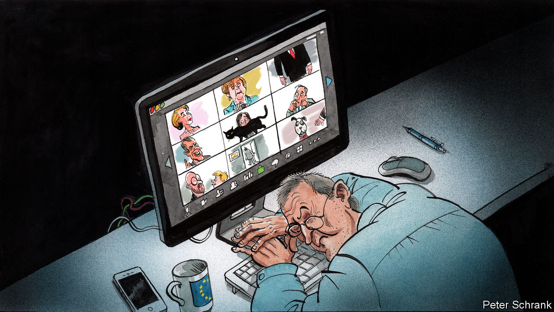

Editor’s note: The Economist is making some of its most important coverage of the covid-19 pandemic freely available to readers of The Economist Today, our daily newsletter. To receive it, register [here](https://www.economist.com/newslettersignup). For our coronavirus tracker and more coverage, see our [hub](https://www.economist.com/coronavirus)

“PLEASE, MUTE your microphone,” begged the message splashed across the video-conference screen. That the meeting contained the French president and the German chancellor, along with the other 25 heads of government in the EU, proved no shield against the banal horrors of remote working. Dodgy connections, muttering off-mic and unflattering camera angles are now a fact of life at the top of European politics just as they are in any office grappling with life in a time of coronavirus. A Europe-wide lockdown has wrecked the EU’s way of working, at precisely the moment the continent is struggling to grapple with a pandemic and stave off economic depression.

If you were to design a body to spread the new coronavirus, then you would come up with something akin to the EU. A constant stream of diplomats heads into Brussels, where they lock themselves in airless rooms to hammer out agreements, before flying back home. Every month, thousands make the absurd trip between Brussels and Strasbourg—about 270 miles (430km)—for the European Parliament’s plenary sessions. Lobbyists and hangers-on from across the globe visit to pay fealty to whichever commission official or parliamentary committee chair dictates the regulatory fate of their industry. Covid-19 has jolted this carousel to a halt, throwing into confusion the social mores and practicalities of life in the Brussels bubble.

Nowhere is this more true than at the head of the organisation. The European Council is where the EU’s 27 leaders gather to solve the continent’s trickiest political questions. Originally envisaged as an opportunity for a fireside chat between the men (it was the 1970s) who ran Europe, it still retains the features of a cosy dining club, argues Luuk van Middelaar, author of “Alarums and Excursions”, which looks at how the EU operates in a crisis. In normal times, leaders use summits to speak frankly in near-total privacy, with just a handful of civil servants for company. In person, European summits are a cross between a psychiatrist’s couch, where leaders pour out their political angst to the few people qualified to empathise, and a bullring, where they try to gore each other.

All this has changed. Now the regular meetings resemble the interminable results section of the Eurovision Song Contest, with national leaders rather than D-list celebrities, grumbles one observer. Monologues have replaced dialogues. Compromise is tricky on a conference call. Normally, retreats and U-turns happen outside the main room, in even greater seclusion. It is in these smaller meetings that texts are fiddled with and egos stroked. (Meanwhile any leaders who care little about the outcome catch up on reading or sleep.) These side meetings have witnessed the most dramatic recent moments in the EU. At the height of the Greek crisis, in the summer of 2015, Donald Tusk refused to let Angela Merkel and the then Greek prime minister Alexis Tsipras leave such a meeting without an agreement. In an era of “Zoom diplomacy”—named after the video-conferencing software—such breakouts are now much harder, moan diplomats, making progress slower.

Now is obviously a terrible time for sluggish diplomacy. In the coming weeks, European leaders must compose an economic rescue package, sifting through a soup of acronyms with billions of euros at stake. This cocktail of high politics and tiny details is dangerous. A leader’s mistake could foreshadow the break-up of the euro zone. Even a smaller error could swiftly guillotine a politician’s career. Such negotiations are difficult enough in person, never mind sat opposite a disembodied face on a screen, with—in the case of Luxembourg’s prime minister—a large painting of a can of Pringles behind his head.

Proximity is a weapon in Brussels, where meetings run on until the early hours in the hope of a breakthrough. Such late finishes are a feature rather than a bug of European gatherings, with lack of sleep acting as a form of benign torture. Even bog-standard legislation is signed off in this way, with officials from member states and MEPs scrapping over every line in the final stage of the lawmaking process well into the night in so-called “trilogue” meetings. A windowless meeting room can feel like a temporary prison cell in a way a video conference never will. Likewise, national concerns appear distant when meeting face-to-face in Brussels, argues Mr van Middelaar. European leaders have the space to think of a world beyond their home country. It is hard to lose oneself on a video call.

## The political is personal

At the lower altitude of power, a form of Potemkin politics has taken over Brussels. Daily press conferences at the European Commission still take place, with its chief spokesperson on stage in an otherwise empty auditorium. Journalists email in questions, giving it the air of a peculiar call-in television show for people obsessed with state-aid rules. A nearly empty European Parliament plays host to a handful of MEPs and visiting dignitaries. Daily business is logistically tricky. Getting hold of interpreters, who translate meetings into the 24 official languages of the EU, has proved difficult. The language of Europe may still be translation, as Umberto Eco argued, but in a video conference it tends to be English. If arranging a meeting featuring 27 leaders is tricky, try doing the same for 705 MEPs.

Yet the legislative gears still turn, albeit with the occasional grinding noise. The European Parliament has held the first remote vote in its 62-year history, with MEPs emailing in their ballots. The restaurants surrounding the EU’s institution may sit empty, but mischievous ambassadors and officials from the institutions still gossip with journalists, offering the same mix of accurate analysis and blatant spin, over Zoom rather than over lunch. Few relish the thought of keeping the new way of doing things. A reliance on the personal side of politics belies Brussels’ technocratic reputation. But the EU can still function. As long as people remember to mute their microphones. ■

Dig deeper:  
For our latest coverage of the covid-19 pandemic, register for The Economist Today, our daily [newsletter](https://www.economist.com/newslettersignup), or visit our [coronavirus tracker and story hub](https://www.economist.com/coronavirus)

Read also on: <https://www.economist.com/europe/2020/04/11/how-to-run-a-continent-via-videolink>

|  |  |  |  |
| --- | --- | --- | --- |
| Previous | Articles | Sections | Next |

|  |  |  |
| --- | --- | --- |
| Europe | Sections | International |

Britain

Covid-19: Patient number one

.

Labour’s new leader: Socialism with a barrister’s face

.

Lockdown compliance: For queen and country

.

Misinformation and mobile networks: Dodgy signal

.

The other sick: Stay home, protect the NHS, unless...

.

Funerals: Ashes to ashes

.

The economy: Over the cliff edge

.

Bagehot: Missing Boris

.

|  |  |  |
| --- | --- | --- |
| Europe | Sections | International |

|  |  |  |  |
| --- | --- | --- | --- |
|  | Articles | Sections | Next |

#### Britain’s shaky government

# Boris Johnson’s illness will test Britain’s constitution

It makes no provision for a prime minister’s long-term absence

Apr 8th 2020 |

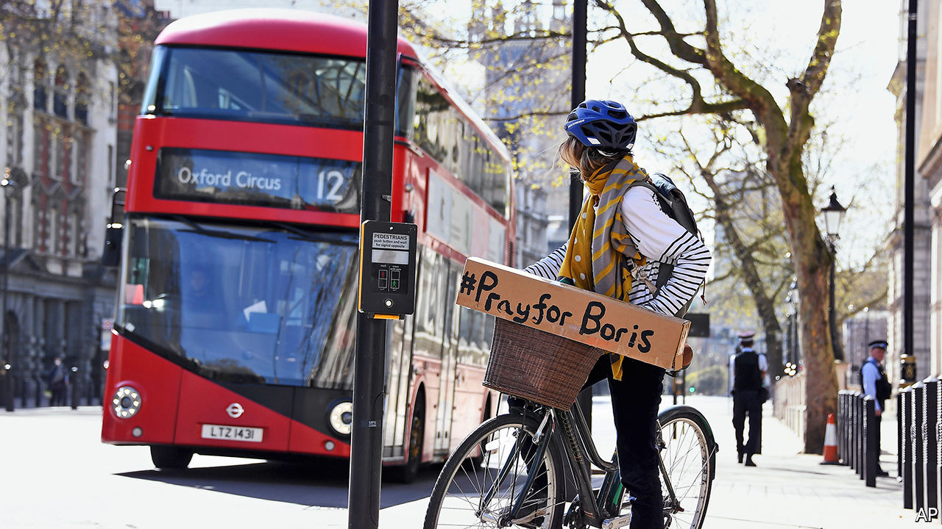

Editor’s note: The Economist is making some of its most important coverage of the covid-19 pandemic freely available to readers of The Economist Today, our daily newsletter. To receive it, register [here](https://www.economist.com/newslettersignup). For our coronavirus tracker and more coverage, see our [hub](https://www.economist.com/coronavirus)

AFTER A WEEK or so of sickness, during which they seemed to stabilise, patients suffering from covid-19 often then take a turn for the worse. So it has been with British politics. On April 5th, 13 days into a new life of strict lockdown and a daily rhythm of crisis meetings and press conferences, Downing Street announced that Boris Johnson had been hospitalised. The virus was attacking government itself.

The prime minister worked from his bed, but the following afternoon his condition deteriorated. He was given oxygen treatment, and taken into an intensive care unit “as a precaution”. He relayed a message that Dominic Raab, the foreign secretary and first secretary of state, should deputise for him “where necessary”.

As The Economist went to press, his office said he was “stable overnight and remains in good spirits”. He has not been put on a ventilator. Donald Trump said he had directed American drugs companies to provide the prime minister’s doctors with experimental treatments. Downing Street’s polite rejection of the offer allowed it to reiterate its support for the institution at the centre of the effort to combat the disease: “We’re confident the prime minister is receiving the best possible care from the National Health Service.”

For every covid-19 patient who has so far been discharged alive from critical care, another is dead. Those who, like Mr Johnson, don’t require ventilation in their first 24 hours have a much better chance of survival. And Mr Johnson is somewhat younger than the average patient: 55 compared with 60, and, though overweight, with no underlying health problems. Yet as Derek Hill, professor of medical imaging science at University College London, says, “There is no doubt this turn of events means Boris Johnson is extremely sick.”

Mr Raab now runs a war government from his desk in the Foreign Office. He said the prime minister has left “very clear plans” for running the government in his absence. He is chairing a daily meeting of the “c-19” cabinet, which, aside from the prime minister and senior officials, is made up of Rishi Sunak, the chancellor of the exchequer, Michael Gove, the cabinet office minister, Matt Hancock, the health secretary, and Mr Raab. Those four run the subcommittees on the economy, the wider public sector and critical infrastructure, health and foreign relations. Much business is done over Zoom, a videoconferencing app, as Mr Gove is self-isolating at home after a member of his family fell ill. So is Dominic Cummings, Mr Johnson’s senior aide, who has symptoms of the virus.

Up to now, the government’s performance has been mixed. Mr Johnson’s approval ratings soared as the crisis hit Britain, in common with other leaders, in evidence of the “rally round the flag” phenomenon that often occurs during crises. Some aspects of the management of the crisis are going well—the NHS has, for instance, rapidly expanded places in intensive care units, and the lockdown has worked better than many had feared. But the government has faced criticism for moving too slowly in imposing social-distancing measures and over its failure to implement a widespread testing regime to track the spread of the virus.

Divisions have appeared within the cabinet. There has been rivalry between Mr Gove and Mr Hancock over who takes precedence in the campaign to combat covid-19, and on April 7th Mr Raab distanced himself from a promise by Mr Hancock to reach a target of 100,000 tests every day by the end of the month, implying that Mr Hancock would be held accountable if the target is not met.

Disunity in government is never a good thing; in a time of crisis, when the leader is absent, it can be disastrous. And the government has a critical decision coming up.

By April 13th, ministers will need to decide whether to extend or relax the initial three-week lockdown. Chris Whitty, the chief medical officer, said there should be no talk of relaxation until Britain is beyond the peak of the outbreak, but Mr Sunak is known to be deeply worried about the speed with which the economy is shrinking. Gus O’Donnell, a former cabinet secretary, says the civil service will hanker for the prime minister to return and wield his authority.

Should Mr Johnson’s health worsen, the constitution could prove to be a problem. It makes no provision for a prime minister’s long-term absence or death. The Cabinet Manual, a handbook for government last updated in 2011, is silent on the issue.

Britain’s security state has sought to fill the gaps left by the constitution. During the cold war, the prime minister would appoint “nuclear deputies” responsible for retaliation if London were vaporised. The practice was revived by Tony Blair after 9/11. Mr Raab will chair the National Security Council in the prime minister’s absence. Mr Johnson’s instructions to Britain’s nuclear submarine fleet in case Britain is wiped from the map—known as the letters of last resort—will remain in force.

But the death of a prime minister in office, which has not happened since 1865, would cause serious problems, according Vernon Bogdanor, professor of history at King’s College London. Mr Raab’s title of first secretary of state is a largely honorific indication of seniority and does not entitle him to claim the top job. A man with a reputation for coldness in a parliamentary party that favours collegiality, he would not be a popular choice.

The queen appoints as prime minister whoever can carry the support of the House of Commons—normally the leader of the largest party. Conservative Party rules require that the leader is elected by the membership. That would take too long, so a decision would need to be made on whether the new prime minister should be chosen by the cabinet or by a ballot of Conservative MPs, which is how the party got its leaders before 2001. Speed is of the essence, and the cabinet would be faster, but given the rivalries within it, hostilities might break out into the open. MPs, along with the entire nation, will be fervently hoping that it does not come to that.■

Dig deeper:  
For our latest coverage of the covid-19 pandemic, register for The Economist Today, our daily [newsletter](https://www.economist.com/newslettersignup), or visit our [coronavirus tracker and story hub](https://www.economist.com/coronavirus)

Read also on: <https://www.economist.com/britain/2020/04/08/boris-johnsons-illness-will-test-britains-constitution>

|  |  |  |  |
| --- | --- | --- | --- |
|  | Articles | Sections | Next |

|  |  |  |  |
| --- | --- | --- | --- |
| Previous | Articles | Sections | Next |

#### The Labour Party

# Keir Starmer: Labour’s electable new leader

Socialism with a barrister’s face

Apr 8th 2020 |

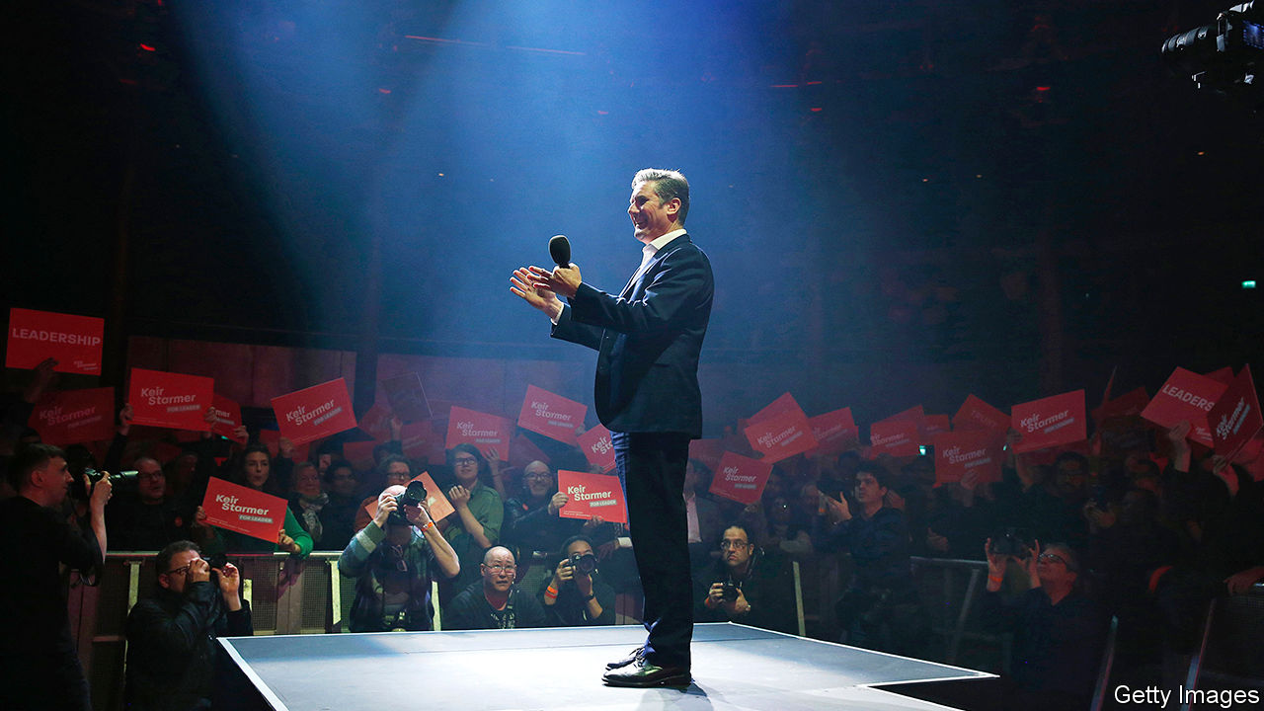

GEORGE ORWELL’S lament in 1937 that socialism is a magnet for “sandal-wearers and bearded fruit-juice drinkers” has held up well in recent years. Tony Blair, who avoided mentioning the word, dragged an unwilling Labour Party rightwards while wearing good suits; Michael Foot and Jeremy Corbyn, the furthest-left leaders in the past half-century, put the least effort into looking electable.

Sir Keir Starmer, who succeeded Mr Corbyn on April 4th, may be a rare experiment in recent history: a self-described socialist whom voters can picture in office. He has credible executive experience as Britain’s former public prosecutor. His dispatch-box interrogations as shadow Brexit secretary outshone Mr Corbyn’s ramblings. He has good suits.

Voters can imagine Sir Keir as prime minister by a margin of 42% to 27%, according to Opinium, a pollster. The comparable figures for Mr Corbyn in the 2019 election were 29% to 59%.

His task, says Neil Kinnock, Foot’s successor, is to prove the party is in “decent and sensible hands” by making a rapid break with Mr Corbyn’s regime. He has already made two moves designed to do that. He has apologised to Jewish groups for the anti-Semitism that thrived under his predecessor, and he has purged Mr Corbyn’s allies from the shadow cabinet and drafted in sensible, more moderate types.

Anneliese Dodds, the new shadow chancellor, is a former academic and MEP. Ed Miliband, a former party leader, is back as shadow business secretary. Charlie Falconer, Mr Blair’s justice secretary, is the shadow attorney-general. Lisa Nandy, one of Sir Keir’s leadership rivals, is the new shadow foreign secretary; unlike Mr Corbyn, she is a strong critic of Vladimir Putin. Angela Rayner, who left school without qualifications, is the new deputy leader; she is on the left but never fit in with Mr Corbyn’s gang. Rebecca Long-Bailey, Mr Corbyn’s favoured candidate, is shadow education secretary.

Yet Sir Keir’s policies are well to the left. He will retain manifesto pledges to renationalise railways and utilities, to end private contracting in the public sector and to increase taxes on top earners and companies. He also wants to abolish university tuition fees, scrap the current welfare regime and place new constraints on military intervention to prevent “illegal wars”.

The challenge for Sir Keir is enormous. The party’s performance in last year’s election was its worst since 1935. To get a working majority, it would need a swing of around 10% at the next election, similar to Mr Blair’s landslide victory in 1997. The campaign will be a tricky one because the targets include a wide variety of seats—professional and manufacturing, north and south, renters and homeowners, notes Alan Wager of Kings College London.

The pandemic may heighten voters’ enthusiasm for public services, which will be good for Labour. But it will also leave Britain indebted, and thus present hard choices on public spending. “Since 2010 Labour has struggled to rebuild its reputation for economic competence, and the crisis clearly doesn’t remove the need for us to convince voters we can once again be trusted to manage the economy,” says Spencer Livermore, who ran the party’s election campaign in 2015.

The party must take care not to appear opportunistic, warns Peter Mandelson, an architect of Mr Blair’s centrist New Labour. Voters’ support for a more protective state “should not be mistaken for a headlong embrace of big-state socialism”, he cautions. Sir Keir’s arrival may clarify whether British voters shunned socialism because of the policies, or their advocates.■

Read also on: <https://www.economist.com/britain/2020/04/08/keir-starmer-labours-electable-new-leader>

|  |  |  |  |
| --- | --- | --- | --- |
| Previous | Articles | Sections | Next |

|  |  |  |  |
| --- | --- | --- | --- |
| Previous | Articles | Sections | Next |

#### Public order

# How to build social consensus around lockdown

Having a queen and a National Health Service helps

Apr 11th 2020 |

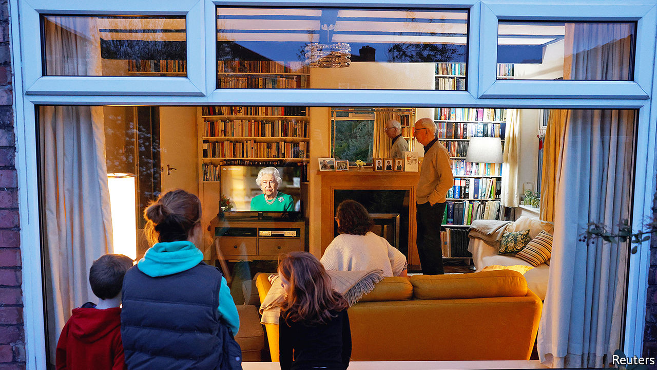

Editor’s note: The Economist is making some of its most important coverage of the covid-19 pandemic freely available to readers of The Economist Today, our daily newsletter. To receive it, register [here](https://www.economist.com/newslettersignup). For our coronavirus tracker and more coverage, see our [hub](https://www.economist.com/coronavirus)

THE QUEEN does not give interviews. Nor, indeed, does she say much in public at all, apart from her annual Christmas address. So it speaks to the gravity of the moment that she gave a special broadcast—only the fifth of her 68-year reign—on April 5th. Wearing the pearl necklace that came out for previous such broadcasts, during the Gulf war, to mark her Diamond Jubilee and on the deaths of her mother and Princess Diana, she reminded the 24m compatriots who tuned in to hear her of the country’s wartime resolve. “We will succeed,” she insisted.

This was her answer to a central question confronting the government: how to ensure compliance with a lockdown without resorting to force? Other countries face a similar challenge, but it is more acute in Britain, which has a long tradition of individual liberty and policing by consent. Identity cards are the norm in Europe, but opposition from civil-liberties groups in Britain has prevented their adoption.

The lockdown in Britain is looser than elsewhere. In Paris, daytime exercise is banned, and in Madrid, residents resort to working out on balconies. Even relatively gentle attempts by the police to halt the spread of the pandemic have prompted ridicule and accusations of overreach. “This is essentially voluntary,” says Gus O’Donnell, a former head of the civil service. “We know we couldn’t enforce it.” As sunshine and the looming Easter holidays tempt people outdoors, ministers are relying mainly on co-operation to keep the country under voluntary house arrest.

One tactic is shame. Tabloid newspapers rage at “covidiots” for such sins as sunbathing in parks, setting up barbecues and visiting tourist spots. Catherine Calderwood, Scotland’s chief medical officer, made a televised apology for contravening her own advice by twice visiting her second home; she later resigned. Some councils have closed parks, citing the misbehaviour of a minority. Matt Hancock, the health secretary, has hinted that such rule-breaking might lead to a ban on outdoor exercise.

The evidence suggests that guilt can be a useful public-health tool. But ministers risk alienating people who may just be doing their best to follow the guidance. Shoppers who have emptied supermarket shelves, for instance, do not think of their actions as hoarding but as stocking up on essentials during a crisis, points out John Drury of Sussex University.

Efforts to shame those who do not follow the rules could also prove counterproductive. Psychologists reckon people are likely to copy others’ behaviour in times of crisis. So reports of gatherings may encourage citizens to break the rules. “If you show images of people crowded on Brighton beach, people will think the done thing is to go out and do that,” says Hanna Zagefka, a social psychologist at Royal Holloway, University of London. Footage of deserted town centres would, she believes, be more effective in encouraging compliance. Jeremy Hunt, a former health secretary, says communications should play to people’s desire to be seen doing the right thing. “The best way to get people not to drop litter is to say, ‘Most decent people pick up their litter’,” he says.

Another approach is to emphasise that this is a national effort in which everybody plays a part. The queen made several references to the second world war, invoking tropes of collective sacrifice and “quiet good-humoured resolve”. A scheme to recruit volunteers to the National Health Service was oversubscribed threefold, suggesting it might be as useful in boosting morale and letting folk feel they are contributing as in supplying manpower. The wartime Home Guard, made up of platoons of men too old to fight, was intended to keep up spirits as much as to create a back-up defence force. As Edward Grigg, a minister, recognised at the time, “action raises morale.”

The NHS, long beloved of Britons, has assumed totemic status. Cabinet ministers, celebrities and members of the royal family join a nationwide “clap for carers” every Thursday evening. Even from his hospital bed, Boris Johnson tweeted that NHS staff are “the best of Britain”. The breadth of this veneration ensures that public-health messages are not dependent on support for a particular politician or party. “Britain has got an advantage in that the NHS is so important for British self-definition,” says Ms Zagefka. Government advertisements urge Britons to stay at home to “protect the NHS”.

A final way to boost compliance is to stress the benefit to others. The broad range of outcomes of those who contract covid-19 risks exacerbating optimism bias, notably among the young, who are less likely to die from the virus. Communicating the message that even asymptomatic people can spread it, with disastrous results, is important. In a recent article in the Lancet, a medical journal, several psychologists concluded that such a message would mitigate the damage quarantine might do to mental health as well as improving adherence.

For now, the lockdown seems to be holding. Polls by Ipsos MORI suggest compliance with official advice is increasing week by week. In mid-March, about a quarter of Britons said they were avoiding leaving the house more often because of covid-19. A week later, that share had risen to half, and by the end of the month to nearly four-fifths. “The story of this is just how high the compliance has been,” says Lord O’Donnell. “Who would have thought that in a liberal democracy so many people would do what they are told?” Ministers will be anxious to keep it that way.■

Dig deeper:  
For our latest coverage of the covid-19 pandemic, register for The Economist Today, our daily [newsletter](https://www.economist.com/newslettersignup), or visit our [coronavirus tracker and story hub](https://www.economist.com/coronavirus)

Read also on: <https://www.economist.com/britain/2020/04/11/how-to-build-social-consensus-around-lockdown>

|  |  |  |  |
| --- | --- | --- | --- |
| Previous | Articles | Sections | Next |

|  |  |  |  |
| --- | --- | --- | --- |
| Previous | Articles | Sections | Next |

#### Misinformation and mobile networks

# How 5G conspiracy theories used covid-19 to go viral

Paranoid Britons are burning down mobile towers

Apr 8th 2020 |

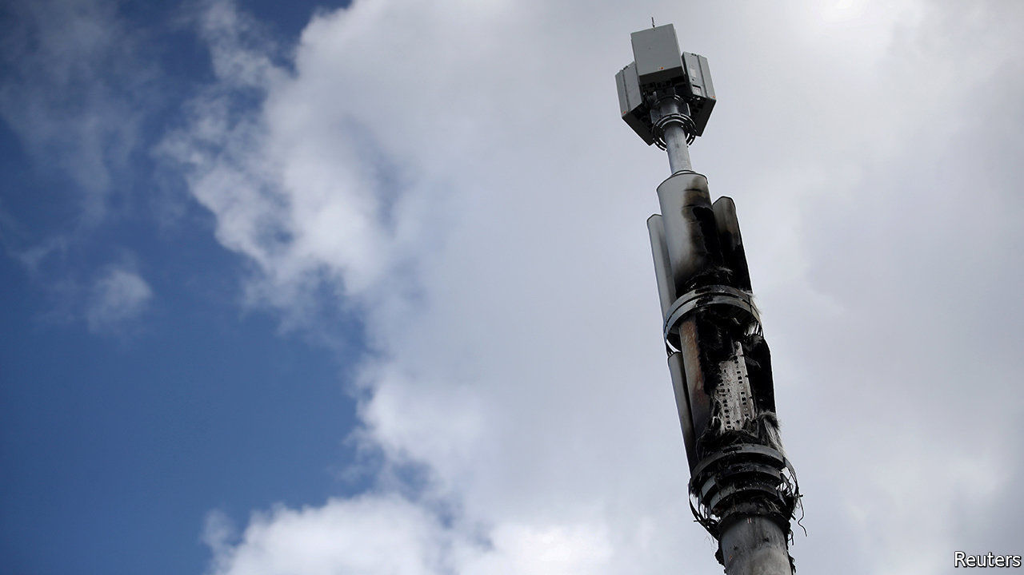

FOR AS LONG as there have been mobile networks, there have been health concerns about the radiation they emit. At first, people worried they would cause cancer. The fifth generation of networks, or 5G, aroused fears of headaches, rashes and severe skin burns.

Lack of evidence has not put paid to these suspicions. Last year councils in Frome, Glastonbury and Totnes banned the rollout of the technology, backbenchers in Parliament debated the matter, and EE, a mobile network, had so many concerned calls that it dedicated a team to dealing with them.

Covid-19 has given conspiracy theorists a new angle. Some pointed out that Wuhan, where the virus originated, was also one of the first cities in China to get 5G coverage. That was where their relationship with reality came to an end.

Several strains of the theory have emerged. One is that 5G weakens immune systems, another that it inhibits oxygen intake, exacerbating the disease, a third that covid-19 does not exist but is a cover for 5G-related diseases that governments are trying to hush up. Amanda Holden, a TV personality, tweeted a (now-deleted) petition linking 5G with coronavirus. On April 7th, YouTube removed an interview with David Icke, a conspiracy theorist, repeating the story, and said it would ban all such content.

The theories have spread like wildfire in Africa, America and Europe, says Hanna Linderstal of Earhart, a security and risk-management firm, with Europeans the most enthusiastic proponents. Last week, they led to literal fires: mobile networks’ tower masts were set alight in Birmingham and Merseyside. Workers laying fibre-optic cable have been harassed in the street.

Ms Linderstal analysed dozens of videos on social-media platforms. Many of them contain “expert advice” on “how you cure the virus with cold air and move away from 5G antenna or even destroy the 5G antenna to save your family”. Though the videos’ origins are unclear, the people spreading them are mostly worried rather than malign, she says. Yet at a time when Britons are stuck at home and unusually reliant on mobile networks and broadband to connect to the outside world, the actions of a small group of scared citizens risk causing real harm—unlike the tower masts they are burning down.

Read also on: <https://www.economist.com/britain/2020/04/08/how-5g-conspiracy-theories-used-covid-19-to-go-viral>

|  |  |  |  |
| --- | --- | --- | --- |
| Previous | Articles | Sections | Next |

|  |  |  |  |
| --- | --- | --- | --- |
| Previous | Articles | Sections | Next |

#### Stay home, protect the NHS, unless...

# A sharp drop in accident-and-emergency admissions worries medics

More hand-washing could explain fewer stomach bugs. It is unlikely to explain fewer heart attacks

Apr 8th 2020 |

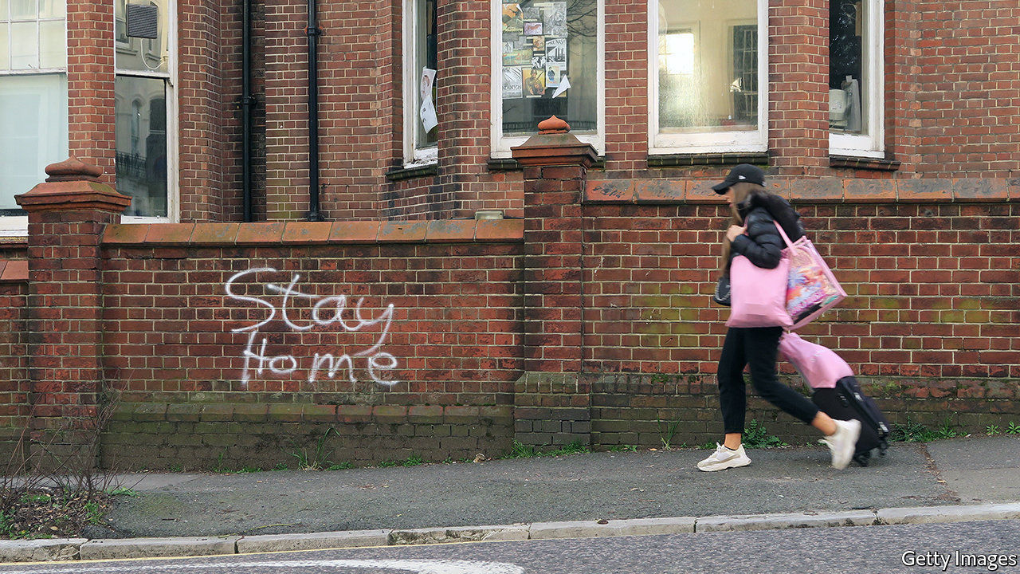

IT IS A curious feature of this pandemic that hospital emergency departments are unusually empty. An uptick in the number of pneumonia admissions has been more than balanced out by an enormous fall in the number of people coming in with other problems. “It is eerily quiet,” reports one emergency doctor. “You almost want it to be busy, so you feel all those preparations are useful.”

The government’s mantra, repeated at every opportunity, instructs people to “stay home, protect the NHS, save lives”. But the message is intended for healthy folk, so that they should not transmit the virus, not for those who need treatment for non-covid illnesses. Doctors are concerned that people are staying away from hospitals so as not to add to the pressure on the health service or because they fear catching the virus. Although intensive-care units are stuffed with people suffering from the coronavirus, early data suggests attendance in emergency departments is down by nearly half in England and by more than half in Wales.

This is not entirely bad. For one thing, the quiet has made reorganisation easier. And it is likely that some of the drop-off reflects a genuine decline in need. Many of the so-called “worried well” are now probably more worried by a trip to hospital than by their supposed illness. With more handwashing, it is little surprise that admissions for gastrointestinal illnesses have dropped. With pubs closed and roads empty, there are fewer accidents. Greater use of online and telephone consultations means that fewer people need to come into hospital to receive care.

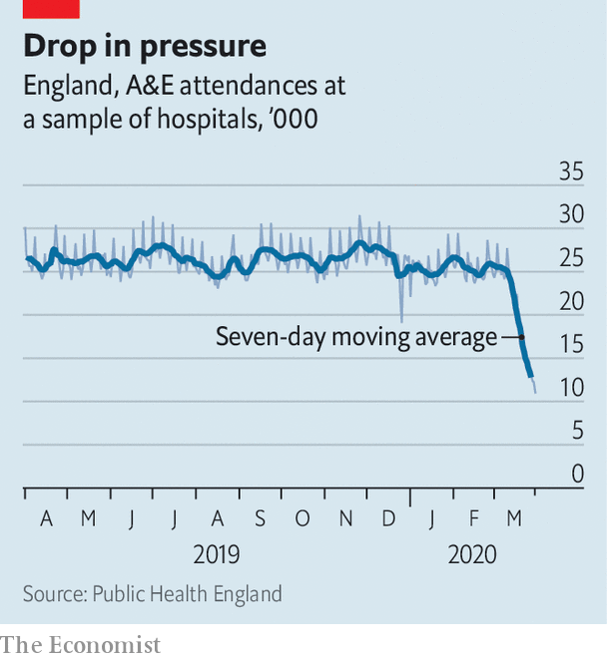

Yet the scale of the drop in admissions has alarmed medics. Before the crisis, the health service estimated that just one in ten emergency attendances were “non-urgent”, meaning treatment could have been provided by a general practitioner outside of hospital. Emergency departments are not just seeing fewer stomach bugs. There has been a sharp fall in the number of emergency admissions with cardiac problems. Forthcoming data will show that referrals for cancer diagnosis have plunged. And one hospital even reports a 70% fall in admissions for detached retinas. None of these things is likely to be the result of cleaner hands.

The NHS is scrabbling to find out what other treatment people may be missing out on. Once these gaps have been identified, it will try to get in touch with people potentially at risk, telling them to seek treatment. As Carrie MacEwan, chair of the Academy of Medical Royal Colleges, notes, the worry is that the health service is storing up problems for once the first wave of the virus has passed. Having encouraged people to protect the NHS, the government now needs to encourage them to protect themselves.■

Read also on: <https://www.economist.com/britain/2020/04/08/a-sharp-drop-in-accident-and-emergency-admissions-worries-medics>

|  |  |  |  |
| --- | --- | --- | --- |
| Previous | Articles | Sections | Next |

|  |  |  |  |
| --- | --- | --- | --- |
| Previous | Articles | Sections | Next |

#### Funerals

# How covid-19 is changing funerals

There’s a tension between the demands of a crisis and people’s spiritual needs

Apr 11th 2020 |

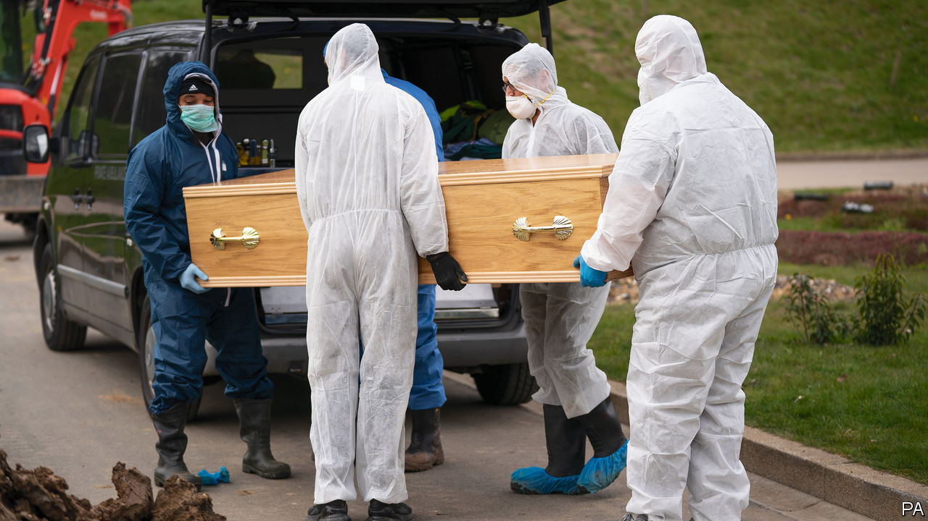

Editor’s note: The Economist is making some of its most important coverage of the covid-19 pandemic freely available to readers of The Economist Today, our daily newsletter. To receive it, register [here](https://www.economist.com/newslettersignup). For our coronavirus tracker and more coverage, see our [hub](https://www.economist.com/coronavirus)

LAURA FOSTER’S mother, Hilary Heath, wanted to be buried in a red flowery dress, but the current crisis does not permit people to choose the style of their departure. Ms Heath, who died of covid-19, will be cremated as soon as her daughter’s self-isolation is over. The vicar will be the only other person present.

Funerals these days are even sadder than in normal times. Public Health England has ruled that only close family members may attend, anyone with coronavirus symptoms is banned, and social distancing must be enforced. Some councils, like Bradford and Leeds, have banned mourners altogether; others have put limits on attendance. In Birmingham, where six are permitted, Tahir Ali, a Labour MP, was scolded by police after going to a constituent’s funeral as an observer.

Even tighter rules were originally envisaged. The Coronavirus Act, passed into law on March 25th, gave local authorities the power to order compulsory cremations. But after some pushback from Jewish and Muslim groups, for whom a ritualised burial is essential, the act was amended to take into account people’s religious beliefs.

The act reflects concerns about the funeral industry’s capacity. In normal times, weekly death rates vary from 8,500 to 14,800. Neil Ferguson, an epidemiologist from Imperial College London, suggests that between 7,000 and 20,000 Britons will die from coronavirus, increasing demands on a sector already under pressure.

The Crown Commercial Service, the government’s purchasing agency, has increased mortuaries’ capacity by extending them through the use of refrigerated tents. Mortuary storage is up by 25,000. Refrigerated lorries are on standby as a last resort.

Making cremations compulsory nationwide would have relieved pressure on burial sites. In 2013, a BBC study found that a quarter of England’s local authorities expected their graveyards to be full by 2023. Even though fewer than a quarter of Britons choose to be buried, covid-19 will bring this date forward.

That is of particular concern in London, where covid-19 is concentrated. Hackney and Tower Hamlets have already run out of graves. Tower Hamlets also has the highest proportion of Muslim residents in the country; Hackney has the largest group of Charedi Jewish people in Europe.

Religious groups have been organising their own sites. Gardens of Peace, a dedicated Muslim cemetery in East London, opened in 2002. Within 15 years its 10,000 plots were full. It opened a second graveyard in 2018, and has purchased a third.

Pandemics change burial traditions. The Spanish flu, which killed over 200,000 Britons a century ago, brought an end to the horse-drawn funeral processions that were popular in Victorian times. Whatever impact covid-19 has in the long run, for now its victims’ mourners are looking forward to proper commemorations when the lockdown is lifted. “When this is all over we can have the hymns, the readings, the party that Mum wanted,” says Ms Foster. “I just see this cremation as a way to get her home. I just want her home.”■

Dig deeper:  
For our latest coverage of the covid-19 pandemic, register for The Economist Today, our daily [newsletter](https://www.economist.com/newslettersignup), or visit our [coronavirus tracker and story hub](https://www.economist.com/coronavirus)

Read also on: <https://www.economist.com/britain/2020/04/11/how-covid-19-is-changing-funerals>

|  |  |  |  |
| --- | --- | --- | --- |
| Previous | Articles | Sections | Next |

|  |  |  |  |
| --- | --- | --- | --- |
| Previous | Articles | Sections | Next |

#### Recession looms

# Covid-19 causes Britain’s fastest economic contraction on record

Government borrowing is rocketing, undoing a decade’s work to shrink the deficit

Apr 11th 2020 |

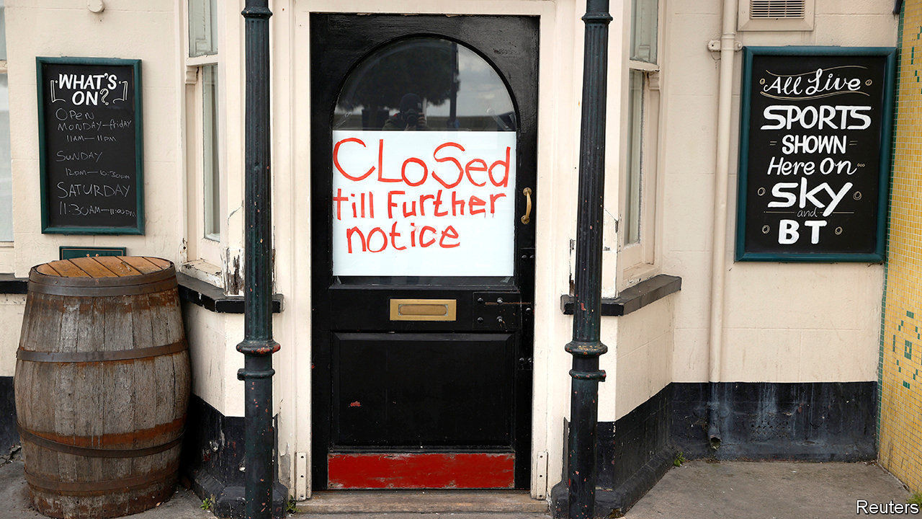

Editor’s note: The Economist is making some of its most important coverage of the covid-19 pandemic freely available to readers of The Economist Today, our daily newsletter. To receive it, register [here](https://www.economist.com/newslettersignup). For our coronavirus tracker and more coverage, see our [hub](https://www.economist.com/coronavirus)

LENIN WAS probably thinking about the Communist revolution in Russia when he said that “there are decades in which nothing happens, and there are weeks in which decades happen”, but the observation fits Conservative economic policy just as well. In his budget on March 11th, Rishi Sunak, the chancellor, unveiled a response to covid-19 that added up to some £12bn ($15bn). Just over a week later, with much of the economy shut by government decree, the direct fiscal response was increased to more than £30bn and the government sought to guarantee £330bn (around 15% of GDP) of private sector lending.

The severity of the decline and its pace look to be without modern precedent. According to Samuel Tombs of Pantheon Macroeconomics, a consultancy, “In a normal recession, if it was very bad, you might see a quarter-on-quarter drop of 2% in GDP. The second quarter this year will probably be down closer to 20%.”

Official data from the Office for National Statistics will take time to catch up to the new reality, but survey data are startling. The composite purchasing managers’ index (PMI) fell from 53 in February to 37.1 in March, a record low for the series and the largest monthly decline on record. Any number below 50 signals contraction. Elsewhere in Europe, PMIs have fallen to even lower levels, but this reflects the timing of lockdown measures. Britain locked down on March 23rd, later than most of Europe. Other data paint a similarly grim picture; car registrations fell by 44% in the year to March, while claims for Universal Credit, the main out-of-work benefit, rose by around 950,000 in the two weeks after the lockdown began.

The scale of the economic damage and the cost of the policy response will in months undo a decade of effort to reduce the fiscal deficit. The take-up of support schemes appears to be running well ahead of what was anticipated. The jobs-retention scheme, for example, allows firms to furlough staff on 80% of their wages up to £2,500 a month with the taxpayer picking up the bill. At first the Treasury estimated that around 3m private-sector employees, just over 10% of the workforce, would be furloughed, at a cost to the exchequer of around £10bn. But a survey conducted by the British Chambers of Commerce found that three-quarters of respondents planned to use the scheme, and almost four in ten intended to furlough more than three-quarters of their staff.

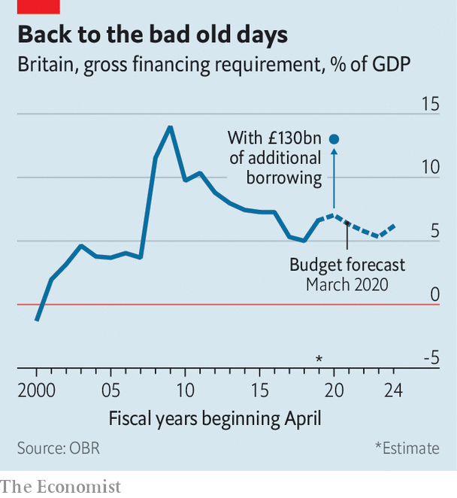

In his budget, Mr Sunak estimated that government borrowing would rise to 2.4% of GDP. The Institute for Fiscal Studies, a think-tank, now estimates that it could increase by around an additional £130bn this year, to around 10% of GDP. That would take the government’s total financing needs back to levels last seen in the financial crisis (see chart).

The best hope is that the recession and recovery will be V-shaped, with the steep decline matched by an equally rapid bounce-back once the lockdown is ended. But despite help from the government, unemployment is rising and firms are failing, causing damage that may scar the economy and slow the recovery. ■

Dig deeper:  
For our latest coverage of the covid-19 pandemic, register for The Economist Today, our daily [newsletter](https://www.economist.com/newslettersignup), or visit our [coronavirus tracker and story hub](https://www.economist.com/coronavirus)

Read also on: <https://www.economist.com/britain/2020/04/11/covid-19-causes-britains-fastest-economic-contraction-on-record>

|  |  |  |  |
| --- | --- | --- | --- |
| Previous | Articles | Sections | Next |

|  |  |  |  |
| --- | --- | --- | --- |
| Previous | Articles | Sections | Next |

#### Bagehot

# Boris Johnson’s illness has darkened Britain’s mood

The illness of a man who once divided the nation has united it

Apr 11th 2020 |

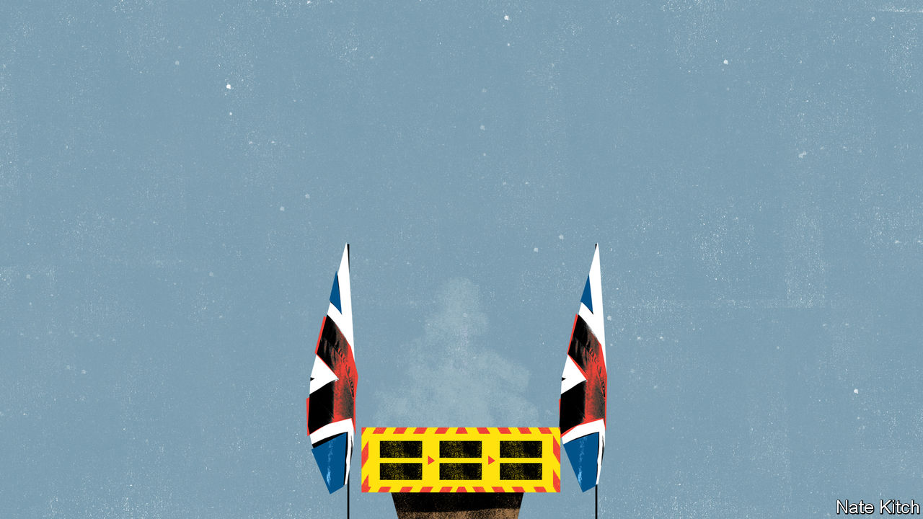

Editor’s note: The Economist is making some of its most important coverage of the covid-19 pandemic freely available to readers of The Economist Today, our daily newsletter. To receive it, register [here](https://www.economist.com/newslettersignup). For our coronavirus tracker and more coverage, see our [hub](https://www.economist.com/coronavirus)

BORIS JOHNSON has always believed that history was not made just by vast impersonal forces but by great men and women who change its course through their sheer talent and willpower. His admiration for Winston Churchill and Margaret Thatcher springs from this worldview; so did his decision to reject the belief widespread in the establishment that Britain’s destiny lay in the European Union and to lead the country out of it.

Just as Mr Johnson was fulfilling his ambition, with a recently acquired 87-seat majority in Parliament and grand plans to build a new one-nation Conservatism that might yet win him membership of the great-men club, the vast impersonal forces hit back. On March 27th Mr Johnson revealed that he had covid-19. On April 6th he went into intensive care. The government is in the hands of his cabinet and the first secretary of state, Dominic Raab. Mr Johnson’s Brexit plans have been sidelined in order to fight a rearguard action against a disease that is locking down the country and tanking the economy. The prime minister who wanted to be defined by Brexit will be defined by covid-19.

Mr Johnson’s condition is all the more shocking because he is normally such a force of nature. He has been blessed (or cursed) with Falstaffian appetites: witness his two marriages and a third in the offing; his five acknowledged children and another on the way; his string of mistresses; his enthusiasm for food, wine and, of course, cake; the mound of books and articles that he has produced while also pursuing his political career; and his extraordinary ability to light up a room. He has also been an omnipresent figure in British public life for several decades: editor of the Spectator, star columnist on the Daily Telegraph, mayor of London, principal Brexiteer, foreign secretary and tormentor-in-chief of his predecessor, Theresa May, until he finally got the job he always wanted.

He had thrown himself into the role of wartime prime minister with his usual brio. He has been broadcasting to keep up morale, driving the government machine and taking the big decisions. He led daily press briefings, visited hospitals and worked 15-hour days fuelled by vegan food. Even after he succumbed to the virus, and was forced to retreat into the flat above Number 11 Downing Street to self-isolate, he continued to work long hours, chairing the daily Cobra meetings (named after one of the Cabinet Office Briefing Rooms) and the weekly cabinet meeting.

His visibility has had the desired effect. Despite the lockdown that has put Britons in effect under house arrest, in the past few weeks they have rallied not just around the flag but around the person of the prime minister, with more than 70% agreeing that he is doing a good job. The news that he has been brought down by the virus, at least for the moment, has had an even more powerful unifying effect. Neighbourhood social-media groups were full of messages praying for his life. That the illness of a man who once so divided the country has brought it together is a measure of how vulnerable Britons feel.

Mr Johnson’s illness is powerful evidence that nobody is safe: not the young, the middle-aged nor the healthy. The prime minister belongs to a group well represented in critical care: men who are over 50 and overweight (his promise to his girlfriend to lose a few pounds and practise yoga seems to have been abandoned). But he has always prided himself on his robustness and endurance. He is rarely ill; indeed people who have worked closely with him say he regards illness as a sign of personal weakness. He is built like a rugby player and enjoys the rough-and-tumble of physical sports; he invented an idiosyncratic version of tug-of-war that involves pulling the other team into a swimming pool. He is a vigorous if eccentric tennis player and when mayor, would cycle around the city, though being prime minister put paid to that.

His illness is also an alarming proof of how vulnerable the machinery of government is. Mr Raab is struggling to project his authority. There are long-simmering rivalries between cabinet ministers and tensions between the Department of Health and the Treasury about how much longer Britain can keep the lockdown in place. The decision by Michael Gove, the cabinet-office minister, to self-isolate because a member of his family has come down with the virus is yet another blow to the government: he is an experienced and competent minister who is central to the campaign against covid-19.

Number 10 is struggling to cope with the effects of the virus and the difficulty of running government by video. Mr Johnson’s two leading advisers, Dominic Cummings and Eddie Lister, are both working from home. And although Mr Raab has responsibility to take decisions while Mr Johnson is ill, if the prime minister dies, it is not clear how another one is to be appointed. The Cabinet Office manual sets out what the procedure should be if the monarch dies, but has nothing to say about the demise of the prime minister. When, God willing, Mr Johnson is back in the job, that gaping omission will need to be remedied.

## Together, afraid

Sometimes nations are brought together by joyful moments, like the 2012 Olympics or the queen’s Diamond Jubilee, when Britain united around a common sense of patriotism and hope. Sometimes they are frightening ones, when the country is gripped by a common sense of vulnerability and anxiety. The second world war, to which the queen referred in a speech to the nation on April 5th, was one of those. So is this.

The sense of despondency that currently hangs over the nation may soon be dispelled. Mr Johnson was probably transferred to intensive care earlier than another patient would have been out of an abundance of caution. He has not, according to Number 10, been put on a ventilator. News that he is improving, if it comes, will lighten the public mood just as news of his illness has darkened it. Britons are praying that it comes quickly. ■

Dig deeper:  
For our latest coverage of the covid-19 pandemic, register for The Economist Today, our daily [newsletter](https://www.economist.com/newslettersignup), or visit our [coronavirus tracker and story hub](https://www.economist.com/coronavirus)

Read also on: <https://www.economist.com/britain/2020/04/11/boris-johnsons-illness-has-darkened-britains-mood>

|  |  |  |  |
| --- | --- | --- | --- |
| Previous | Articles | Sections | Next |

|  |  |  |
| --- | --- | --- |
| Britain | Sections | Special report |

International

Religious divides: Living on a prayer

.

Virtual worship: Our Father, who art in cyberspace

.

|  |  |  |
| --- | --- | --- |
| Britain | Sections | Special report |

|  |  |  |  |
| --- | --- | --- | --- |
|  | Articles | Sections | Next |

#### Living on a prayer

# The pandemic has exposed fissures within religions

Worshippers are suspending rites hitherto regarded as vital

Apr 11th 2020 | CAIRO AND ROME

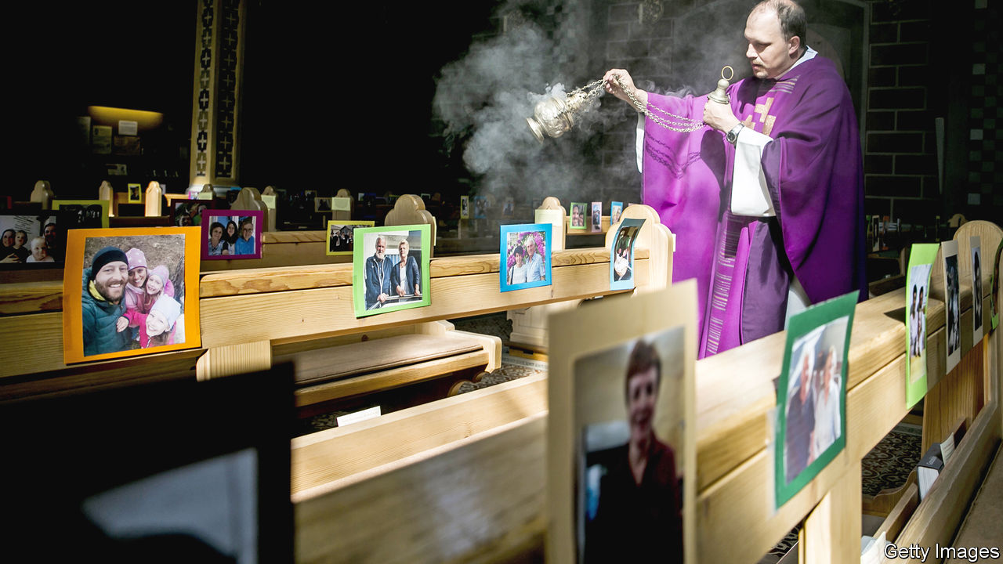

Editor’s note: The Economist is making some of its most important coverage of the covid-19 pandemic freely available to readers of The Economist Today, our daily newsletter. To receive it, register [here](https://www.economist.com/newslettersignup). For our coronavirus tracker and more coverage, see our [hub](https://www.economist.com/coronavirus)

IN THE 2,000 years since the story of Jesus was first told in Rome, his followers have never seen an Easter like this. In Catholicism’s home, the most poignant moment in the Paschal drama comes on Good Friday when the pope leads worshippers on a walk, with 14 stops, enacting the progress of Jesus towards his execution.

This year that has proved impossible. It was announced that instead, Pope Francis would move about in an empty St Peter’s square. Two days later, on April 12th, instead of proclaiming the resurrection of Jesus to a multitude, he would officiate almost alone in its vast basilica. Millions could observe, but only electronically.

Past emergencies, from recessions to wars, have galvanised people to find new meaning in old rituals. But nothing prepared believers for the world of covid-19, in which those rituals, the gestures and gatherings at the heart of their identity, have become a public danger. For innovative religious types who already use technology with confidence (see article), the crisis will accelerate a trend. But for more established faiths, reactions have ranged from meek compliance to truculent defiance.

Covid-19 has not generally widened fissures between faiths. Rather, it has widened those within the ranks of all great religions. They were already squabbling over how far old beliefs could live with modern views of Earth’s origin. The pandemic exacerbates the rift between science-defiers and those who respect the laboratory.

For some, the bafflement is palpable. Russian Orthodoxy’s Patriarch Kirill declared on March 29th: “I have been preaching for 51 years...I hope you understand how difficult it is for me to say today, refrain from visiting churches.” Among eastern Christianity’s followers, many will not: clerics in Georgia, for example, continued to offer the faithful consecrated bread and wine, by which it is impossible, they insist, to be harmed.

Pope Francis has sounded surer: “Thick darkness has gathered over our squares, our streets and our cities; it has taken over our lives, filling everything with a deafening silence and a distressing void.” But the broader response of Western faith has been unimpressive, argues Marco Ventura of Siena University. “Even for many believers, medical officers are the new prophets.”

Not all Christians agree. Some American evangelicals, including vocal supporters of Donald Trump, have been reckless denialists of covid-19. A preacher in Florida, Rodney Howard-Browne, was briefly arrested on March 30th after busing people to worship, insisting he could neutralise the virus. Some politicians seem half-sympathetic. Two days later the state’s governor, Ron DeSantis, listed religious activities among “essential services” that could continue (without crowds) despite a lockdown. In at least a dozen other states, such activities were left unimpeded.

Secularist rage has been rising since early surges in the epidemic were traced to religious recklessness. In South Korea hundreds of members of the secretive Shincheonji Church of Jesus contracted the virus at packed services and spread it. The government complained that the church was not co-operating in tracing them. Its leader later apologised. An Islamic gathering in Malaysia in February helped spread the virus to neighbouring countries.

Elsewhere, liberal clergymen, rabbis and imams have heeded calls to suspend gatherings. But among ordinary people, the order to stop their cherished rituals feels like a dark conspiracy. “Not even the communists completely forbade Easter services” is a refrain in eastern Europe.

Within Judaism, many have reacted creatively, accepting, for instance, that a minyan, the ten-strong quorum for worship, might assemble electronically. The ultra-Orthodox, or Haredim, however, have dug their heels in. In Israel the Haredi stronghold of Bnei Brak has been a covid-19 hotspot. People have insisted on gathering for prayers, weddings and funerals, defying a lockdown and exacerbating chronic tensions between the Haredim and the state.

Elsewhere zealots already at odds with the state or with established religious powers have found in the virus a fresh battleground. In Iraq Muqtada al-Sadr, a fiery cleric, has challenged Grand Ayatollah Ali al-Sistani, a Shia leader who has denounced those who spread the virus as murderers. On March 5th Mr Sadr prayed at the entrance to the Imam Ali shrine in Najaf until caretakers opened the teak doors. It remained open, and mourners carry their dead around the shrine in coffins. The radical preacher has called coronavirus a punishment for gay marriage, as have some fundamentalist Christians.

Where the state broadly controls Islam, as it does in the Gulf monarchies, orders to suspend Friday prayers have been obeyed. The Saudis have told pilgrims to defer any plans to make the haj in July. But when Ramadan begins around April 23rd, authorities in all Islamic lands will struggle to restrain communal meals to break the fast.

In Iran, one of the first- and worst-hit countries, the religious authorities wield ultimate power. Their decision on March 16th to suspend pilgrimages to holy places, including those in the city of Qom from which infection had spread to other countries, was criticised as too late by secular liberals, too harsh by the ultra-devout.

India is one of many places where politicians must collaborate with religious forces. In Ayodhya, claimed as the birthplace of Rama, officials tried with mixed results to limit celebrations of the Hindu god. It was left up to the Hindu organisers to encourage restraint; they obeyed reluctantly.

On the spectrum of reactions, the Catholic one stands out as respectful of science. Today’s Holy See differs from the one which in centuries past persecuted astronomers. But some critics, including conservative American Catholics, see in its meek response the church’s broader weakness.

The contrast between cautious Catholics and gung-ho evangelicals has been sharp in Brazil. Catholic bishops and politicians have co-operated with the suspension of services, while President Jair Bolsonaro, an evangelical who has called the virus “just a sniffle”, has joined co-religionists in legal battles to keep churches open.

In the end, the survival of religions may depend on their finding a way of explaining to followers, in their own terms, why their spiritual duty now lies in suspending rites hitherto regarded as vital. As Shadi Hamid of the Brookings Institution, a think-tank, notes, Muslim jurisprudence has accepted that human survival can trump other norms: a Muslim can eat forbidden pork rather than starve. For liberal-minded Jews, the ideal of tikkun olam, or repairing the world, is higher than rules governing prayer or diet.

Communion, during which Christians consume bread and wine which some believe to have been transformed into the body and blood of Jesus, throws up particular challenges. Rule-minded Christians find an electronic Eucharist untenable: the ritual has to be physical.

And yet traditional Christian teaching may also have hygienically helpful things to say. It affirms that the entire world is mysteriously blessed every time bread and wine are sanctified, regardless of how many are present. That helps explain the determination of Greece’s bishops to celebrate “behind closed doors” this month the services leading to Orthodox Easter.

James Alison, a radical Catholic priest, proposes a solution both revolutionary and traditionalist. He is encouraging households to practise “Eucharistic worship” at home: to bless bread and wine and invoke the presence of Jesus. His approach, he says, affirms the intimacy and mystery of classical worship but challenges the idea of a caste of celebrants. As he points out, a lack of manpower in some parts of Christendom is already prompting a rethink of the role of priests: the virus could be the coup de grâce. Pope Francis has called the pandemic “a time to separate that which is necessary from that which is not”. Some may take him at his word. ■

Dig deeper:  
For our latest coverage of the covid-19 pandemic, register for The Economist Today, our daily [newsletter](https://www.economist.com/newslettersignup), or visit our [coronavirus tracker and story hub](https://www.economist.com/coronavirus)

Read also on: <https://www.economist.com/international/2020/04/11/the-pandemic-has-exposed-fissures-within-religions>

|  |  |  |  |
| --- | --- | --- | --- |
|  | Articles | Sections | Next |

|  |  |  |  |
| --- | --- | --- | --- |
| Previous | Articles | Sections | Next |

#### Our father, who art in cyberspace

# Churches turn to the internet to reach their flocks

Digital worship goes beyond just broadcasting sermons

Apr 11th 2020 | NEW YORK

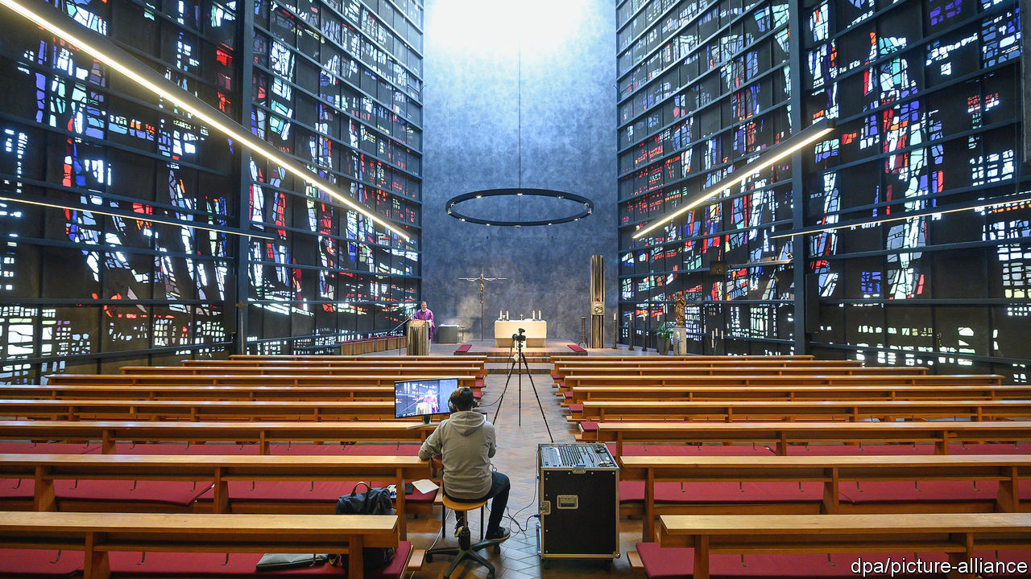

Editor’s note: The Economist is making some of its most important coverage of the covid-19 pandemic freely available to readers of The Economist Today, our daily newsletter. To receive it, register [here](https://www.economist.com/newslettersignup). For our coronavirus tracker and more coverage, see our [hub](https://www.economist.com/coronavirus)

ENTER THE Reverend Albert Bogle’s coffee shop and you might see a menu listing espressos, enticing cakes and a bell waiting to be rung. It never will be. Mr Bogle resides in Scotland, but his coffee shop exists only online. A parishioner can “enter” the virtual café by clicking a link to that day’s Zoom meeting. Mr Bogle started the virtual coffee shop as a way for people to connect while observing social distancing. But his Sanctuary First church started offering digital worship resources long before covid-19 confined people to their homes—and it is not the only one.

Streaming church services is actually rather old hat. American preachers began experimenting with radio in the 1920s and televangelism was in full swing as early as the 1950s. African Pentecostal churches, among the most successful of Christian brands, stream services to migrant diasporas. Nowadays pastors do not just broadcast to their quarantined flocks, says Heidi Campbell, a scholar of religion and digital media at Texas A&M University. They expect them to participate too, using apps and social media to make virtual services interactive.

Religions whose declared aims include the preservation of ancient revelations have always had an ambivalent but ultimately pragmatic attitude to technology. When printing transformed communication in the 15th century, the Catholic clergy saw both opportunities and dangers. In the end it was the Protestant Reformers who benefited.

When the coronavirus retreats, will digital worship go with it? Not likely. Life.Church, a mega-church based in Oklahoma that helps other parishes navigate the online world, says the number of communities using its Church Online Platform surged from 25,000 to 47,000 in March alone. Other outfits, such as Virtual Reality Church and Sanctuary First, expect to grow. In the meantime, Mr Bogle hopes to start running his virtual coffee shop 24 hours a day. He is considering starting one for Spanish-speakers: “I think that could be real fun.”

Dig deeper:  
For our latest coverage of the covid-19 pandemic, register for The Economist Today, our daily [newsletter](https://www.economist.com/newslettersignup), or visit our [coronavirus tracker and story hub](https://www.economist.com/coronavirus)

Read also on: <https://www.economist.com/international/2020/04/11/churches-turn-to-the-internet-to-reach-their-flocks>

|  |  |  |  |
| --- | --- | --- | --- |
| Previous | Articles | Sections | Next |

|  |  |  |
| --- | --- | --- |
| International | Sections | Business |

Special report

South Korea: Loosening up

.

New economic models: Another way to work

.

Men and women: Battle lines

.

Beyond K-pop: K-pop’s intellectuals

.

Politics: A flickering legacy

.

North Korea: A god-king with nukes

.

The future: The limits of loosening

.

|  |  |  |
| --- | --- | --- |
| International | Sections | Business |

|  |  |  |  |
| --- | --- | --- | --- |
|  | Articles | Sections | Next |

#### South Korea

# South Korea is going through deep social, economic change

But the transformation is still fragile, and covid-19 is not helping, says Lena Schipper

Apr 8th 2020 |



THE TENSION between traditional top-down economic and social decision-making and a more individualistic, bottom-up approach has been apparent in South Korea since it democratised more than three decades ago. In the past two months, however, two things have happened that have highlighted this tension.

On February 10th, in what feels now like a different era, the world looked on in amazement as “Parasite”, a rip-roaring, iconoclastic South Korean film, won the Oscar for best picture. It was the first non-English-language movie ever to capture that honour. The director, Bong Joon-ho, won best director, too. The success of “Parasite” is a sign of a flourishing arts scene in South Korea, and a potent symbol more broadly of the loosening of social and economic norms there. It is a brutal and darkly comic farce about class war. Daggers and dingy basements feature prominently. Asked after the ceremony how he was able to make such a film, Mr Bong replied, in English: “Because I’m a fucking weirdo.”

Yet even as Mr Bong, the weirdo who was until recently on a government blacklist, was being invited to the presidential palace to celebrate, the novel coronavirus was working its way through South Korea. Suddenly, the country’s impassioned debate about the clash between individual freedom and social obligation was put on hold. The pandemic clearly demanded a strong, competent state response. It also required individuals to sacrifice for the common good. Both Koreans and their government responded well to the crisis. Testing was widespread. The contacts of infected people were aggressively traced. Official recommendations to wash hands and practise social distancing were followed. Governments around the world now seek to learn from the South Korean approach to curbing covid-19.

On the face of it these two episodes tell two very different stories about the country. The remarkable response to the virus looks like a lesson in the benefits of the old Korea—a strong, bossy state combined with individual willingness to compromise and show self-discipline for the benefit of society as a whole. When the government suggested that people stay at home, there was widespread compliance from the start and little grumbling—unlike in America and in many European countries. Though the government never mandated social isolation, it made use of expansive powers in tracing infections, sifting through people’s mobile-phone data and credit-card records without a warrant, something it was allowed to do following legal changes prompted by the outbreak of MERS, another coronavirus, that killed 38 people in 2015.

But even here, it feels like something has changed. People were happy to follow the government’s plan to beat the pandemic partly because of the transparency with which it was communicated. That marks a sharp contrast even with 2014, when a ferry full of schoolchildren sank and a bungled official response infuriated the public. The government then sought to muzzle those who complained. The protests that followed, now known as the “candlelight movement”, prompted South Koreans to question their relationship with authority and forced officials to become more responsive. The president at the time, Park Geun-hye, was impeached in 2016 and imprisoned for corruption in 2018. When Moon Jae-in took over from Ms Park, he promised to create a “fair” and “just” society, to make government more accountable and to end the corrupt practices which had contributed to her downfall.

Parliamentary elections on April 15th, in which 300 seats in the National Assembly are up for grabs, will show if South Koreans think that Mr Moon has lived up to his promises, in fighting the pandemic and in other areas. His administration has had its own share of scandals and he has come under fire for initially downplaying the virus. Responding to a poll early in the outbreak, South Koreans professed much more faith in the centre for disease control than in the president’s office.

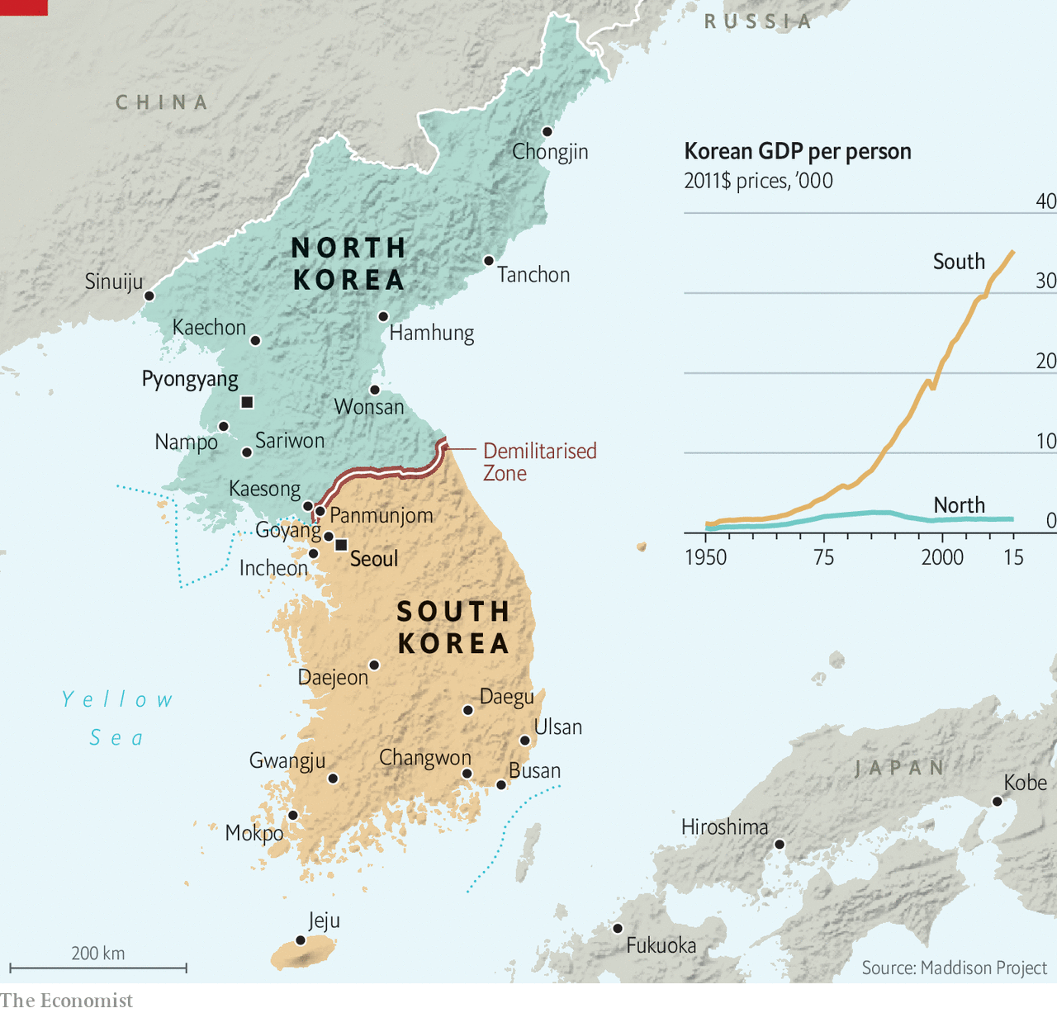

Yet South Korea’s social transformation cuts deeper than politics, and covid-19 is unlikely to halt it. The country’s arts scene and pop culture are just the most visible examples of the new model Koreans are devising for themselves. In 2018 the country exported more “cultural products” (which include music, television dramas and films) than home appliances (such as televisions) for the first time (see chart). The nature of those cultural exports is changing, too. BTS, the country’s—and the world’s—biggest boy band, are much more interesting than many of their equally pretty peers. One recent album is based on the psychoanalysis of Carl Jung. “Parasite” itself is no cheesy K-drama; its plot cuts to the heart of social divisions and inequality in South Korea and beyond.

When covid-19 has receded, South Koreans will go back to challenging old structures and rigid expectations. Women are leading the way. They have plenty to complain about. Among rich countries, South Korea is arguably the worst place to be a working woman. Women still earn less than two-thirds of what men do. Their participation rate in the paid workforce lags that of men by 20 points. And they shoulder the vast bulk of unpaid labour in the home—not only cooking but also tirelessly coaxing their children to study for exams. Sexism is a huge problem. In 2018 two-fifths of young women surveyed by the city of Seoul said they had suffered violence from a partner. In another survey, 70% of the women polled said they had been sexually harassed at work. The gulf between what Korean men and women want from a marriage is so great that many women refuse to get hitched or have children. South Korea has the world’s lowest fertility rate: the average number of children a woman can expect to have in her lifetime is 0.92. That probably will not change until men do.

Social transformation is not easy. When it happens fast, conflicts erupt, says Kim Joong-baeck of Kyung-hee University. “My father still believes in patriarchy and Confucianism and remembers poverty. I barely do, and my teenage son doesn’t at all. How are we supposed to understand each other?” He believes that the country is going through a stage of what sociologists call “anomie”, a mismatch between individual expectations and the guidance they receive from society. “We’re living through this process of transformation, and nobody quite knows where it will lead.”

Economic change can be wrenching, too. Even before covid-19 hit, the export-led model that powered South Korea’s economic rise had come under scrutiny. Growth has slowed markedly: in 2019 the economy grew at a rate of just 2%, the lowest in a decade. Competition from China and the stalling of globalisation have hurt the chaebol, South Korea’s big conglomerates, which have long been the engines of its economy.

The pandemic has already pummelled South Korea’s open economy. In the short term, it will be crucial to try to minimise the damage from the inevitable recession. But once South Korea emerges from the virus-induced slump, it needs to get back to looking for new sources of growth. One place to look is its burgeoning startup scene. ■

Read also on: <https://www.economist.com/special-report/2020/04/08/south-korea-is-going-through-deep-social-economic-change>

|  |  |  |  |
| --- | --- | --- | --- |
|  | Articles | Sections | Next |

|  |  |  |  |
| --- | --- | --- | --- |
| Previous | Articles | Sections | Next |

#### New economic models

# Startups offer a different future for South Korea’s economy

But chaebol still dominate

Apr 8th 2020 |

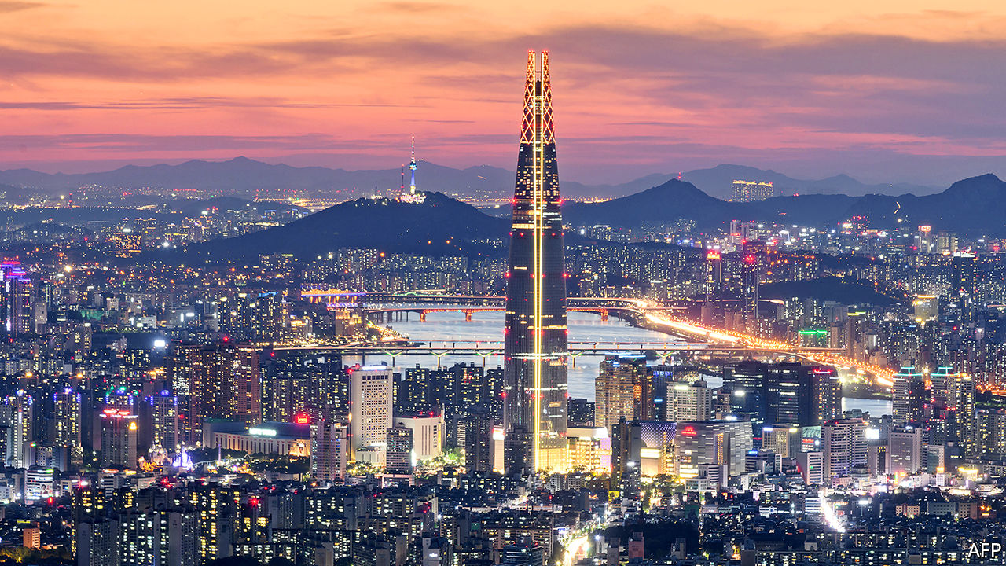

Editor’s note: The Economist is making some of its most important coverage of the covid-19 pandemic freely available to readers of The Economist Today, our daily newsletter. To receive it, register [here](https://www.economist.com/newslettersignup). For our coronavirus tracker and more coverage, see our [hub](https://www.economist.com/coronavirus)

COUPANG, AN E-COMMERCE firm and South Korea’s most valuable startup, occupies the upper 20 floors of a skyscraper in Jamsil, a district in southern Seoul. The lower floors are still used by affiliates of Hyundai, the country’s second-biggest conglomerate, whose engineering arm built and operates the building. Coupang employees joke that it is easy to spot anyone who works for Hyundai in the weekday-morning jostle for the lifts. Most workers in the building are in classic startup attire of jeans and expensive trainers: “The Hyundai guys are the ones in suits.”

The government hopes that companies such as Coupang will eventually change more than just dress codes. Starting with the “creative economy” initiative launched by the Park Geun-hye administration in 2013, it has been pouring money into seed capital, incubators and networking opportunities for budding entrepreneurs. Last year it announced an extra 12trn won ($9.9bn) of venture-capital support by 2022. It is encouraging banks and other large firms to do the same in a bid to diversify the economy away from its reliance on the chaebol. It has also co-opted those conglomerates into the strategy, encouraging them to invest their own money, resulting in big chaebol such as Samsung and Hyundai launching their own startup incubators. The government also makes it easy for small businesses to borrow money, guaranteeing a large portion of bank loans. The interest differential for smaller and larger companies is one of the smallest in the OECD.

Behind all this is an urgent need to preserve long-term growth. South Korea grew rich thanks to an export-led model that prioritised large conglomerates and a handful of key manufacturing industries. But growth in exports and overall GDP has slowed towards the OECD average over the past decade, even though income per person is still a third below the richest half of OECD countries. Productivity in the service sector, which is 60% of the economy, is only half that in manufacturing. Small and medium-sized firms are much less productive than large ones. Fixing that will require structural changes. “The chaebol-led growth model is broken,” says Randall Jones of Columbia University. “Improving productivity means moving towards a more startuppy, digitalised model.”

If that is the long-term challenge, for now South Korea faces a more immediate problem. The covid-19 pandemic is ravaging the economy, domestically and around the world. The current global turmoil is extremely worrying for a country so dependent on trade. How big the impact will be will depend on how long the pandemic lasts and what governments do to counter the economic effects, says Park Sangin of Seoul National University. But there is no doubt that it will be very bad indeed.

## Won loss

The short-term fallout has already rattled the South Korean economy. In March the stockmarket and the value of the won against the dollar slumped to their lowest levels since 2009, in the tail-end of the global financial crisis. The country’s airlines had 92% fewer customers during the second week of March compared with the same period in 2019 and are unlikely to recover them soon, given tightening travel restrictions around the world. Consumer confidence has plummeted; shops, bars and restaurants are expecting a drop in sales of up to 80% for the first quarter of 2020. Many are already struggling to pay rent. A “nice landlord” movement has gathered pace across the country as building owners have lowered or waived rents for struggling shopkeepers, hoping to be reimbursed by the government. Delivery companies like Coupang, by contrast, have struggled to keep up as demand for home deliveries has soared by nearly 50%.

Factory closures in China, where industrial output fell by more than 20% in January and February following the covid-19 outbreak, have had knock-on effects on Korean firms that depend on parts from there. Hyundai, which makes more than half the country’s cars, saw a 13% drop in global sales in February compared with 2019 and disruption to the production of around 120,000 vehicles as Chinese suppliers shuttered their factories. The situation is likely to grow worse as the virus closes factories elsewhere, though the slow resumption of production in China, where the epidemic has levelled off for now, may improve things.

Supply-chain disruptions and infections have also hit the makers of semiconductors, smartphones and display panels. Samsung and LG have had to pause production on several occasions during the outbreak as cases were discovered at their plants. Since the factories are designed to run round the clock, that is likely to hit their sales volumes for the year.

What about the longer term? Much will depend on what governments do, both in South Korea and elsewhere. Historically, the country has rebounded quickly from economic shocks. After the Asian financial meltdown of 1997, it took just two years for GDP to return to its pre-crisis peak. The country also emerged more quickly than others from the global financial crisis of 2008, because its banks were in better shape than a decade before and because the government responded aggressively, with a mix of fiscal and monetary stimulus.

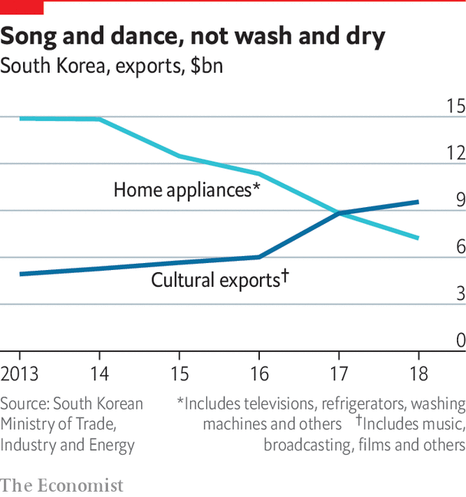

It is responding to the covid-19 outbreak equally vigorously. Among other measures, the government launched a stimulus package of 11.7trn won, a financing plan worth 100trn won to help small businesses and a fund to stabilise bond and equity markets, similar to one it set up to cope with the crisis of 2008. If these measures work, the shock from the virus may be only temporary, says Mr Park. Christophe André of the OECD reckons that South Korea could emerge more quickly from the slump than other economies because it has good economic fundamentals and the fiscal space to finance its stimulus plans. But he worries that the pandemic will strengthen existing hostility to globalisation around the world. That could spell long-term damage for its export-heavy economy.

When South Korea makes it through the pandemic, it faces daunting long-term challenges. The country is ageing rapidly. The working-age population is declining, and the government now believes that the total population may already have peaked, correcting projections made as late as 2019 that this would not happen for another ten years. South Korea has the highest rate of relative poverty among old people in the OECD, with 44% of over-65-year-olds living on less than half the median income in 2017 (the equivalent rate in Japan, which faces similar challenges, is less than 20%). At current projections, the reserves of the national pension fund, whose payouts are hardly generous as it stands, may be exhausted within the next three decades. It does not help that many firms press workers to retire in their mid-50s, long before they are ready.

To expand or even sustain existing levels of welfare provision, the country will have to find ways of improving growth rates. Unlike in previous decades, counting on the chaebol is unlikely to be enough. Exports still account for over two-fifths of GDP and are dominated by the chaebol, with semiconductors, cars and smartphones the most important products for export. However, all of these are vulnerable both to competition from China and to new trade barriers, if the world turns away from globalisation. Last year exports shrank by more than 10% on the previous year. So as well as making better use of female talent, South Korea needs in the long run to improve the productivity of the small and medium-sized firms that employ close to 90% of workers.

Can the startup economy deliver? Like everything in South Korea, its development has been swift. When Coupang was founded in 2010, the country barely had a startup industry. Just five years ago, there were only 80 startups that had raised more than $1m from investors. Today there are nearly 700, including around 200 that have raised more than $10m and ten “unicorns” valued at more than $1bn (Coupang is valued at $9bn). In 2019 investors poured more than 4trn won ($3.3bn) of venture capital into South Korean startups, triple the amount they invested in 2013.

## Startup upstarts

The rapid development of the industry has transformed Seoul, the capital, where it is concentrated. Teheran-ro in Gangnam, just down the road from Coupang’s office in Jamsil, has turned from a concrete desert into a bustle of co-working spaces and expensive coffee shops. Smaller clusters have sprung up all around town. “When I moved back from America in 2013, there was very little going on,” recalls Lim Jung-wook, a venture capitalist. “Now I bump into a founder every time I go to lunch.” The scene is still small, but it is growing. Venture-capital investment accounted for 0.36% of GDP in 2018, according to data from the Korea Venture Capital Association, higher than the estimate for China (0.26%) but trailing the United States and Israel, at 0.64% and 1.75%.

Starting your own business is increasingly seen as an alternative to a job at a chaebol or in the civil service. “Ten years ago no Korean mother would have wanted her child to set up a startup,” says Nathan Millard of G3 Partners, a consulting firm. “That has changed.” Partly, that is because there are now many prominent examples of entrepreneurs who have made serious money.

Coupang’s founder, Bom Kim, became a billionaire in 2018 despite nagging questions about the company’s profitability. The net worth of Bang Si-hyuk, the bookish founder of Big Hit Entertainment, the production company behind BTS, is estimated at nearly $800m. Such role models may encourage others who wish to do their own thing rather than spending decades scaling the hierarchy of a big company.

For now, startups are a long way from replacing the chaebol as the engine of growth. Their share of the economy remains tiny: the total of venture capital that flowed into the industry in 2019 was just over half of Samsung Electronics’ profit in the final quarter of the year (and Samsung had a bad year). But startups do not need to replace conglomerates to boost growth. Mr Jones hopes that they can spread some of their attitudes—to innovation, and to digital technology—to more traditional parts of the service sector, improving productivity across the board.

In a small way, that is already happening. Fabrictime, a startup run by two young women out of Dongdaemun fashion market in eastern Seoul, uses an online video platform to showcase fabrics produced in the market to international designers, opening up a global market to fabric wholesalers whose marketing budget would never previously have allowed expansion outside Korea.

However, the pandemic may put a dampener on the scene’s growth. Past experience suggests that economic crises tend to promote consolidation. This is because large, cash-rich businesses (such as the chaebol) are more likely to survive. Even if South Korea avoids a long slump, the pandemic may entrench the economic structure which the country was just beginning to challenge. And it is not just economic change that is under threat.

Dig deeper:  
For our latest coverage of the covid-19 pandemic, register for The Economist Today, our daily [newsletter](https://www.economist.com/newslettersignup), or visit our [coronavirus tracker and story hub](https://www.economist.com/coronavirus)

Read also on: <https://www.economist.com/special-report/2020/04/08/startups-offer-a-different-future-for-south-koreas-economy>

|  |  |  |  |
| --- | --- | --- | --- |
| Previous | Articles | Sections | Next |

|  |  |  |  |
| --- | --- | --- | --- |
| Previous | Articles | Sections | Next |

#### Men and women

# South Korean women are fighting to be heard

Women have taken their struggle against misogyny into the open

Apr 8th 2020 |

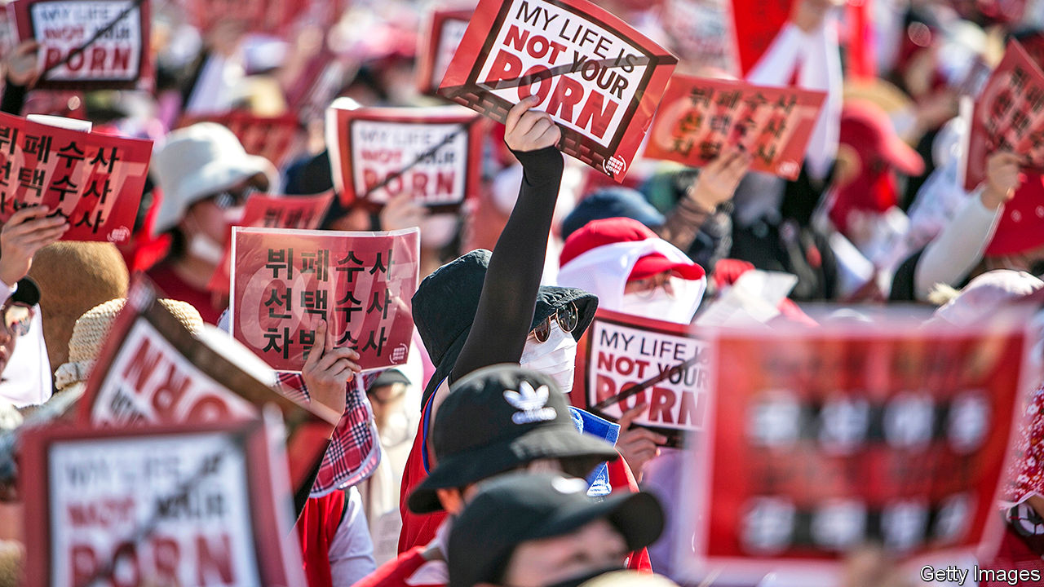

ENTERPRISING WOMEN are everywhere in South Korean film and television. In “The Handmaiden”, a film by Park Chan-wook, two women team up to take revenge on their male tormentors and eventually elope as a couple. “Crash-landing On You”, a television series that had the country glued to its screens this year, features a chaebol heiress who cuts ties with her family to set up her own business and ends up romancing a North Korean pianist. The driving force in “Parasite” is the twenty-something daughter of a poor family who is fed up with life in a dingy basement.

Enterprising women are increasingly visible in the real Korea, too. More young women are earning university degrees than men. More than 70% of women between 25 and 34 are active in the workforce. Young women are far more vocal than previous generations in challenging the conservative social mores that hold them back.

Under the post-war dictatorship, South Korea’s growth model relied on a clear division of labour: men did military service and went out to work, women raised the children and did the housework. What paid work women did tended to be subordinate to men’s, serving, for instance, to pay for their brothers’ education. Adverts often stated that applicants must have completed military service, effectively excluding women. Such rules were abolished as part of the democratisation of the late 1980s. And Korean women are now far too well-educated to submit meekly to second-class status. But they still face barriers in the labour market, and are expected to do the bulk of housework and child care. Many are extremely unhappy about this. A rising number are opting out of marriage and motherhood entirely.

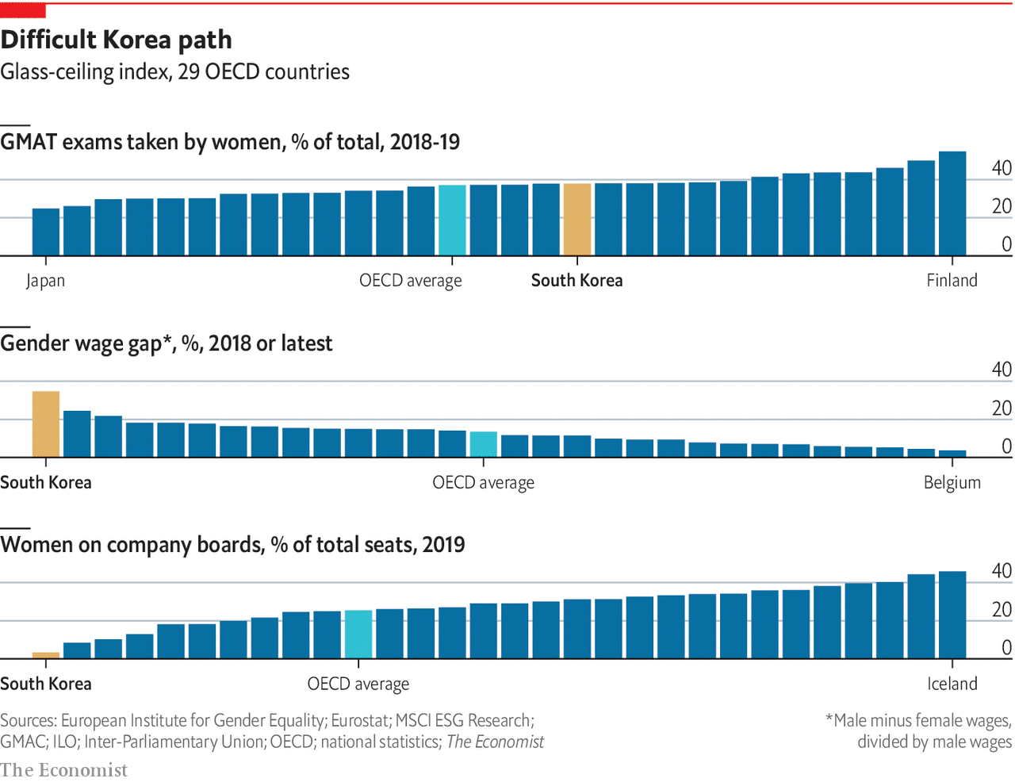

Jung Se-young and Baeck Hana, two twenty-something women who live on their own in Seoul, are a case in point. Last year they set up a YouTube channel about single living after meeting at a feminist discussion group. They regale their 40,000 subscribers and tens of thousands more casual viewers with tales of blissful holidays free of the obligation to cook for a roomful of male family members. They also offer practical advice for living a happy and successful single life, including investment advice and budgeting tips for solo living in Seoul’s expensive housing market.

Only 2% of babies are born out of wedlock, compared with 40% on average across the OECD

The two women are part of a wave of feminist activism that has swept South Korea. In early 2018 a state prosecutor, inspired by the global #MeToo movement, spoke out on national television about being sexually assaulted by one of her bosses. Others followed her lead, resulting in cases against several high-profile men, including a theatre director and a provincial governor. Since then tens of thousands of women have taken to the streets and to the internet to protest against sexual harassment, illegal spycam videos and the country’s restrictive abortion laws. More radical ones like Ms Jung and Ms Baeck have cut their hair, thrown away their make-up and sworn off relationships with men.

## Toute seule in Seoul

Ditching make-up is still a fringe position, but the reluctance to marry is not. In 2018 only 44% of women surveyed still felt that it was necessary for them to tie the knot one day, down from 68% in 1998. (Some 53% of men in 2018 still believed it necessary.) The percentage of women who are not married rose from 30% in 1995 to 77% in 2015 for those aged 25-29, and from 7% to 38% for those aged 30-34. That brings South Korea in line with many European countries and Japan.

The expectations placed on a South Korean wife are burdensome. She faces intense pressure to look after her husband’s extended family, deferring to her mother-in-law and preparing endless snacks. And it is still taboo to have a child unless married. Only 2% of Korean babies are born out of wedlock, compared with 40% on average across the OECD. “Even though people’s lives have changed a lot, the traditional idea of what marriage will be like has not,” says Lee Do-hoon of Yonsei University. “That is stopping them from getting married in the first place.” Growing up in a conservative part of the country, Ms Jung remembers being appalled as a teenager by how poorly her mother, a housewife, was treated by other relatives. “I always knew I didn’t want to end up like that,” she says.

But the battle against misogyny starts much earlier. “The problem is that nobody takes you seriously,” says Kim Na-yoon, a 17-year-old who says she was sexually abused by a group of boys at school and treated dismissively when she reported the incident. “Everyone said it was my fault because I seduced them with my mature body and sexy clothes,” she says. “The male police officer they sent to take my statement asked why I didn’t just play it cool.”

Ms Kim says she only realised she had not been at fault when she met Yang Ji-hye, a bubbly 22-year-old who heads up a group of young women battling sexism in schools. To Ms Yang, a big part of the problem is a lack of education about sex and equality. “Sex among teenagers is considered taboo, and not being able to talk freely about it gives people unrealistic expectations.” Government guidelines on sex education in high schools still suggest pupils be taught that women should focus on their appearance and men on making money to attract partners, and that a man who spends money on a date may “naturally” expect sexual favours in return. Gay sex or transgender rights are not even mentioned. Ms Kim’s middle-school sex education consisted of anti-abortion videos.

Activists focus less on the labour market. Many Korean women appreciate the government’s efforts to improve child-care provision and parental-leave arrangements. But some feminists decry the motive they say underpins such policies. “They’re still trying to push us into getting married and having babies,” says Ms Baeck.

Over the past 20 years the government has rapidly expanded child-care provision. South Korea now spends about 1% of GDP on child care for very young children. Within the OECD club of rich countries, only France and the Scandinavian countries spend more. Thanks to those generous state subsidies, the median dual-income family with two children aged two and three spends just 3% of income on child care, less than a tenth of the figure in Britain or America. Parental leave allowances have also been expanded, including for fathers (though take-up remains low).

So a lack of affordable child care is probably not the main reason why Korean women languish in the job market. The average woman still makes two-thirds of the salary of the average man and is given fewer opportunities to advance. Informal arrangements to limit the number of female employees persist in some companies; several banks were recently fined for illegally changing the test scores of job candidates to ensure more men were hired.

Most discrimination is more subtle. Many bosses believe that men’s jobs are more important than women’s because, they assume, men are the primary breadwinners. Julian Han, who manages the homewares division at Lotte Mart, the country’s biggest retailer, says a previous employer explained a decision not to promote her by saying that she could always quit and live with her husband whereas her male competitor had to support a family. Coming back to the same or a similar job after maternity leave is hard. As a result, there are still too many well-educated women whose potential is being wasted. Improving their situation is a goal in itself. It has also become vital for achieving the government’s most pressing aim: generating enough growth to sustain a rapidly ageing country.

Not everyone is happy to hear women loudly asking for more. “There were problems with gender inequality in the past but those feminists are all about getting advantages for women at the expense of men,” says Oh Serabi, a female writer and activist of an older generation. “Women should work alongside men to make society better, not fight them.” Some young men argue that it is they who get the short straw. Women are exempt from military service, which is universal and gruelling for men. Some men feel blamed for structures they did not create. “We didn’t ask for the patriarchy,” says Moon Sung-ho, who works with Ms Oh, “It’s unfair of the feminists to target us just because we are men.”

Men’s attitudes have not caught up with women’s demands. When men marry, they have more traditional expectations of gender roles than women. Even in families where both partners work, women spend more than three hours a day on housework and child care compared with only half an hour for men. Men spend nine hours a day at the office, against seven hours for women.

To many young women, change still feels frustratingly slow. But the fact that inequality is now being openly discussed is progress in itself, says Kim Ji-Yoon, a political talk-show host. “The single most important achievement of the past couple of years is that these issues are now on the agenda.” It is becoming easier to make different choices, says Ms Jung. “The influence of feminism is increasing,” she says. “Young people no longer want these conservative traditions, and women are free to reject them.” That increasing sense of possibility is not confined to gender roles. It is also making itself felt in politics. ■

Read also on: <https://www.economist.com/special-report/2020/04/08/south-korean-women-are-fighting-to-be-heard>

|  |  |  |  |
| --- | --- | --- | --- |
| Previous | Articles | Sections | Next |

|  |  |  |  |
| --- | --- | --- | --- |
| Previous | Articles | Sections | Next |

#### Beyond K-pop

# K-pop is changing, too

The world’s most successful boy band make perfect posterboys for the new Korea

Apr 8th 2020 |

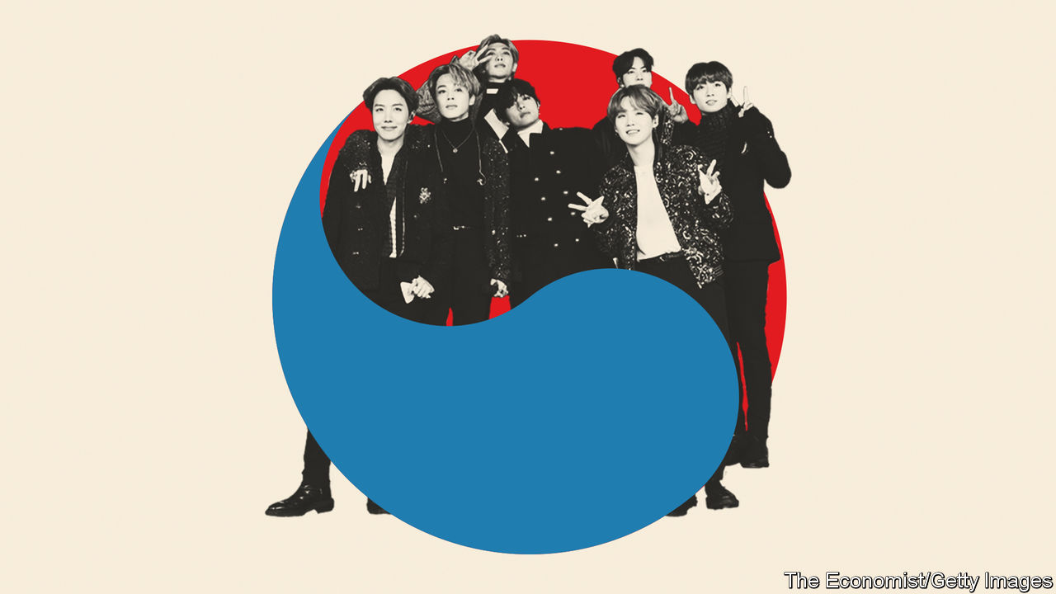

IN A SMALL restaurant in a quiet backstreet in Seoul’s Gangnam district, the walls and part of the ceiling are covered in posters, postcards and key rings. On one shelf sits an enormous pyramid of coffee-cup sleeves. All the decorations show members of BTS, South Korea’s most successful K-pop act and the highest-grossing boy band in the world. They are gifts from fans around the world for whom the restaurant, where the band used to eat before they were famous, has become a site of pilgrimage.

So far, so unsurprising. Teenagers have projected their dreams onto K-pop idols for years. But BTS are not your average K-pop band. Although their output has all the trappings of the genre—slick production, perfectly choreographed dance routines, rap interludes and ever-unconfirmed rumours about band members’ relationships—they do not conform to the stereotype of the flawless, manufactured idols who are expected to serve as blank screens for fans’ projections. Their producer, a graduate in aesthetics who set up his production company after years of working as a songwriter, has given them plenty of leeway in writing their songs and developing their own image.

That has led them down lyrical paths previously unseen in K-pop. “Dionysus”, the final track of “Map of the soul: persona”, an album inspired by the theories of Carl Jung, a Swiss psychoanalyst, which topped charts all over the world in 2019, celebrates the creative potential of intoxication. The song, named for the Greek god of wine and other sensual pleasures, cuts to the heart of current changes in South Korea. Murray Stein, whose book about Jung inspired the album, likes to think of the Greek god as a “loosener”. Dionysus forces his followers to abandon rigid patterns of thought or behaviour that threaten to thwart their development.

Rather than put fans off, the public soul-searching and the references to Greek mythology and psychoanalysis have struck a chord in a way that no previous K-pop act has ever managed. In 2019 BTS were the highest-paid boy band in the world, selling out stadiums from Seoul to São Paulo. Their latest album topped the charts not just in South Korea but also in Britain and America. “The band’s story is very compelling,” says Hong Seok-kyeong of Seoul National University. “Just these seven ordinary boys who grow together.”

Contrary to common narratives in the West, the South Korean government’s efforts to promote Korean culture have had little to do with this success, says Ms Hong. “Western observers still find it hard to accept that a small east Asian country could generate this amount of cultural influence without a five-year plan from the government.” But that is precisely what BTS appear to have done.

Read also on: <https://www.economist.com/special-report/2020/04/08/k-pop-is-changing-too>

|  |  |  |  |
| --- | --- | --- | --- |
| Previous | Articles | Sections | Next |

|  |  |  |  |
| --- | --- | --- | --- |
| Previous | Articles | Sections | Next |

#### Politics

# South Koreans are unhappy with the pace of political change

A younger generation has now been politicised

Apr 8th 2020 |

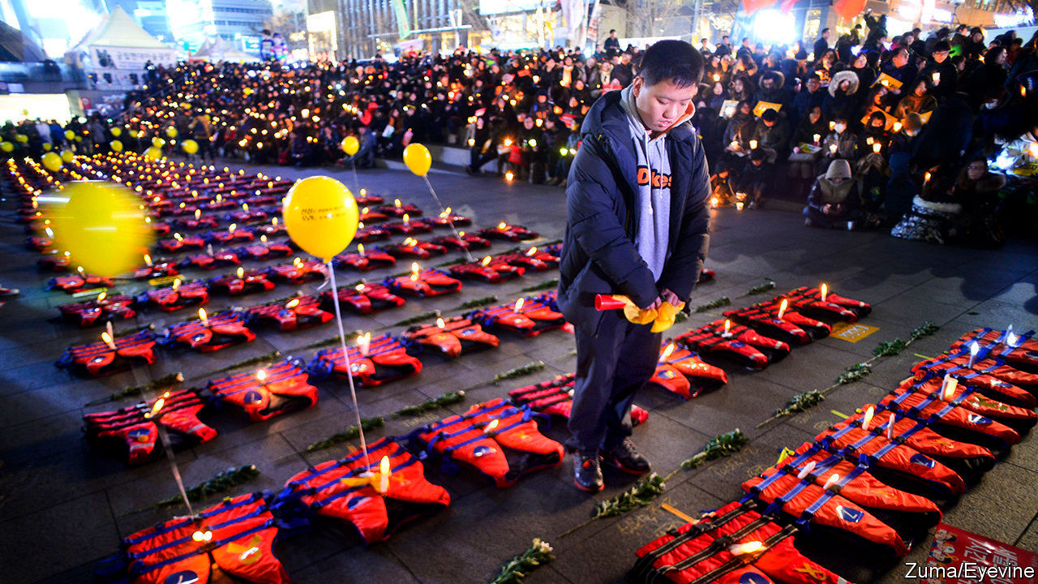

ON A WINDSWEPT pier in Mokpo on the far south-western coast of South Korea sits the rusting hull of a ferry. It is what remains of the Sewol, which sank in 2014 on its way to the island of Jeju. Yellow ribbons still cover the gates to the pier, along with pictures of the 304 people, mostly schoolchildren, who died in the disaster.

The wreck has become a symbol of how corruption and negligence by state institutions can fail citizens. The Sewol was overloaded when it sank. Dangerous modifications had affected its stability. Corrupt regulators had allowed it to sail anyway. The crew abandoned ship while most passengers were still on board. Most survivors were saved by private vessels rather than the coast guard, whose officials seemed more concerned with keeping up appearances to superiors than saving lives. The then president, Park Geun-hye, did not appear in public for hours after the ship began to sink and seemed ill-informed about what had happened. She was later found to have encouraged the national intelligence service to keep tabs on people who spoke up about the official response.

Protests which began in the wake of the tragedy eventually led to Ms Park’s impeachment, criminal prosecution and imprisonment. They became known as “the candlelight movement” and prompted a fundamental reassessment of the relationship between citizens and the state, for the first time since pro-democracy protesters brought down the military dictatorship in the 1980s. They also prompted a drive to reform the political system. Changes to the electoral law designed to improve the chances of smaller parties were passed in December and will apply for the first time in the parliamentary election on April 15th.

The tragedy of the Sewol made South Koreans question their relationship with authority. Many were particularly appalled that the good behaviour of the children, who largely followed orders from the ship’s crew and their teachers to stay put as the ferry sank, may have played a role in causing their deaths. Kim Hee-ok, who has worked with victims’ families, says the sinking was a moment of realisation. “That these parents could just lose their children, just like that—it showed how little responsibility the state actually takes for people’s lives.”

The aftermath of the Sewol sinking marked the moment of politicisation for many youngsters who are now trying to shake up South Korea’s stagnant political scene by running for parliament. Shin Min-joo, a 25-year-old with cropped hair and several ear piercings, wanted to invite victims’ families to her university for a talk. The university authorities refused on the grounds that it would be “too political”. “I realised that if I wanted politics to be different I had to become a part of it,” says Ms Shin. In the election she is running as a candidate for the Basic Income Party, a small outfit with a socially liberal agenda advocating feminism and gay rights alongside its main platform.

## Aux armes, citoyens

Son Sol of the Minjung Party, another small progressive group, has a more conservative hairstyle but similarly ambitious plans: she wants to become the youngest member of the National Assembly. “Parliament is full of kkondae,” she says, using a slang term for haughty old people. “None of them care about us, so we young people have to look out for ourselves.” The Sewol played a big role in forming her political views, too, but she says her background also motivated her. “I’m from the countryside, my parents didn’t go to college—when I got to university in Seoul I realised how unusual that was.” Young people, she says, are frustrated by privileged older politicians’ claims that all that is needed for success is hard work. “Until last year, I wouldn’t even have been allowed to run in an election because I was too young.”

In the previous election, the average age of those elected to parliament was over 55; only three candidates who were younger than 40 managed to win seats even though more than a third of eligible voters were between 19 and 39 years old. Generational change is proceeding only slowly in the two main parties. It is still not clear whether politicians like Ms Shin and Ms Sol will actually succeed in shaking up the party system from within, as young people are beginning to do in Taiwan, or whether they will continue to be sidelined like their fellow progressives in Japan, who, while tolerated, remain for ever on the outside.

The policy environment for change from below has become more favourable. The recent electoral reform strengthens proportional-representation provisions that are designed to ensure that smaller parties win seats roughly in line with their vote share. That will probably mean fewer seats for Mr Moon’s Minjoo party and United Future, the main conservative opposition party (though both are looking for ways around the rules, using “satellite parties”).

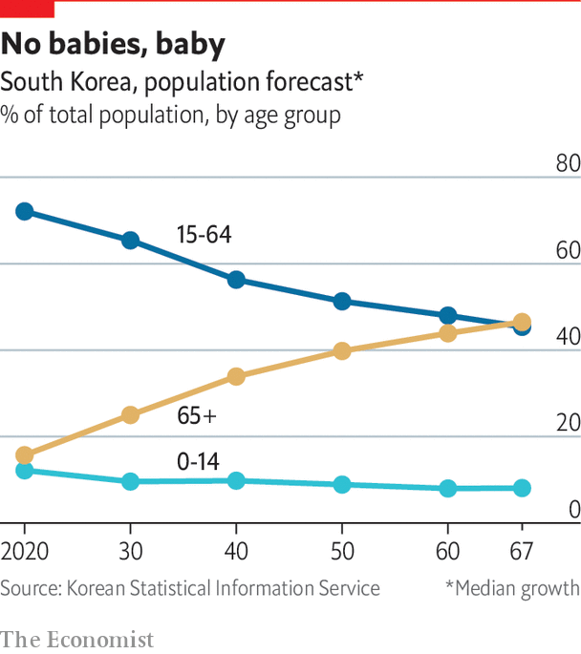

That may go some way towards breaking the deadlock between the two major parties, as they will have to include a wider variety of views to build coalitions. Though it probably won’t fix the partisan polarisation overnight, it may help.

What of the relationship between citizens and politicians? Mr Moon was swept into office on a tide of hope that the political class would become less distant from ordinary people. The former democracy activist and human-rights lawyer cultivated a down-to-earth image, eating cafeteria lunches and going for iced coffee with his aides. He promised to lead a government that was more responsive to people’s demands. He vowed to tackle corruption, inequality and the nepotism of the university admissions system, as well as aiming for de-escalation with North Korea.

Three years on, the Moon government’s plan to be less haughty than its predecessor is looking shaky. In autumn 2019 the justice minister was forced to resign after just weeks in office over a nepotism scandal. Mr Moon supported him long after the allegations became known and later only offered a mealy-mouthed apology.

To some, the president is also falling back into old patterns of dealing with the judicial authorities: prosecutors investigating his political allies, including the former justice minister and an associate accused of meddling in a mayoral election, found themselves reassigned to provincial outposts. “This kind of stuff is extremely demoralising,” says one disappointed left-wing professor. “People think you have a better chance in politics if you’re morally corrupt, and if that’s how these guys behave then why should I be a good citizen? It ruins social trust.”

The election on April 15th will show whether South Koreans consider Mr Moon’s government a disappointment by the standards the president set himself. But whoever is in charge will still have to deal with the looming problem to the north. ■

Read also on: <https://www.economist.com/special-report/2020/04/08/south-koreans-are-unhappy-with-the-pace-of-political-change>

|  |  |  |  |
| --- | --- | --- | --- |
| Previous | Articles | Sections | Next |

|  |  |  |  |
| --- | --- | --- | --- |
| Previous | Articles | Sections | Next |

#### North Korea

# North Korea is changing, but still dangerous

Attempts at reconciliation have stalled

Apr 8th 2020 |

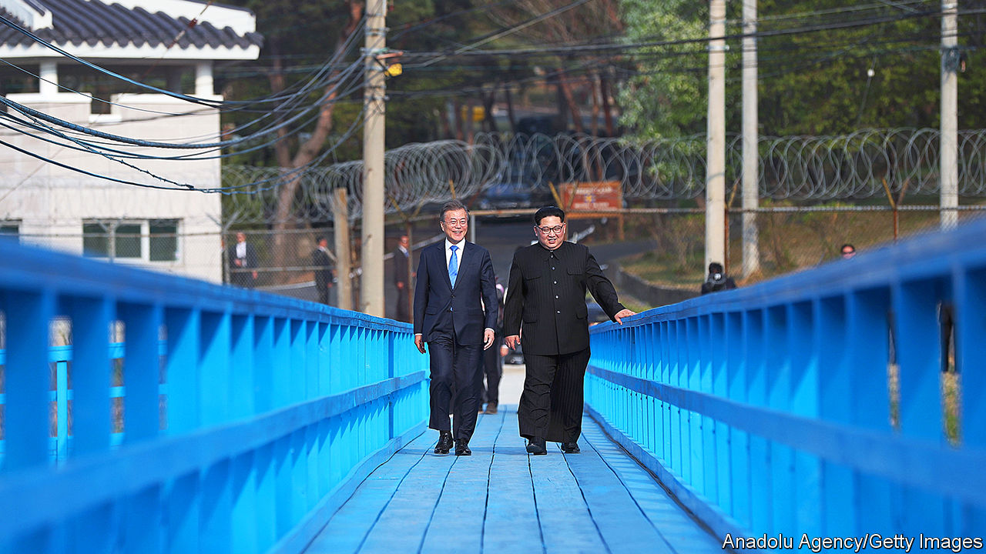

IN THE SUMMER of 2019, South Koreans were shocked by the news that a North Korean woman, who had fled her country through China a decade before, had died with her young son in her flat in Seoul. Weeks passed before a building manager found the bodies. Authorities concluded she had starved.

Though the case was unusual, it highlighted an important truth. Much is made of how Koreans have thousands of years of shared history and culture. But the split between the communist North and the capitalist South after the second world war was deep and traumatic. Today, people who flee the impoverished dictatorship of Kim Jong Un for the rich, free South find it hard to adapt to life in such a different society. This matters immensely if the two Koreas are ever to reunite.

The number of North Koreans making it to the South has declined of late. Some 33,000 have settled in total, but the 1,047 who registered for the first time in 2019 was the lowest number for nearly two decades. Tighter controls at the Chinese border with North Korea, as well as increased efforts by China to repatriate refugees, are major reasons. Another could be that the North Korean economy is going through a loosening of its own and heading in a less Marxist direction. That has raised hopes of loosening in other areas, notably the 70-year military stalemate on the peninsula.

For a few heady months in 2018, change was in the air. In April 2018 Moon Jae-in and Kim Jong Un met for the first time in Panmunjom in the demilitarised zone and stepped hand in hand across the border between their countries. South Korea (and much of the world) swooned. The two leaders vowed to accelerate efforts to reunify Korea by stepping up economic co-operation and intensifying personal exchanges. They promised to reduce military tensions and formally end the Korean war. They also said they would work towards a “nuclear-free” Korean peninsula.

The “spirit of Panmunjom” rekindled discussion about the possibility of reunification. Despite the North’s appalling regime and nuclear threats, most South Koreans favour the idea. They consider North Koreans neighbours, not foes. Many have relatives on the other side. However, interest in reunification is markedly lower among South Koreans in their 20s and 30s, especially if asked whether they would be happy to pay for it.

How might reunification play out? For years, South Koreans looked to East and West Germany as an example. An economically and politically weak North Korea would be “absorbed” by the South. Refugees would surge southwards. The cost to southern taxpayers would at first be huge. But there would be new opportunities for southern firms to build modern infrastructure up north.

Mr Moon’s government, however, favours a more gradual process. His “new northern policy” envisions a phased opening of North Korea through the rebuilding of railways, pipelines and roads, intensifying trade links across north-east Asia. Eventually, the two Koreas would move towards a federal system and reunification. His plan is tactfully silent on its political implications.

The Kim regime insists that American troops should leave the peninsula. China, the Kim regime’s patron, agrees. South Koreans, who fear China, may not. In a future united Korea, northerners would surely want the vote. That would spell the end of the Kim dynasty, and perhaps the prosecution of Mr Kim himself. Would China allow any of this to happen? To say that Mr Moon’s plan faces obstacles is an understatement.

How much would reunification cost South Korea? Estimates range from around 3% to 12% of its annual GDP over several decades. The potential economic benefits to South Korea are uncertain. In the German case, much of the fiscal aid to the East ended up on the balance-sheets of West German landlords, construction firms and consumer-goods producers. But North Koreans are much poorer than East Germans were at the time of reunification, when West Germans were only about twice as rich as their cousins in the East. South Korea’s national income per head in 2018 was 25 times that of North Korea. What’s more, North Korea currently has much stronger commercial links with China, which accounts for 90% of its trade, than with South Korea, so there is no guarantee that southern aid would actually end up back in the South.

Most trade with China is through conglomerates that are “North Korea’s version of the chaebol”

Until North Korea either dramatically reforms or collapses, reunification is hard to imagine. For now, neither seems very likely. That said, the economic changes in the North are real. The famine in the 1990s that killed more than half a million people led to a transformation of the country from below, as millions of North Koreans began buying and selling things to survive, despite such commerce being officially illegal. There are now hundreds of illicit-but-tolerated markets, known as jangmadang, in the country. Kim Byung-Yeon of Seoul National University estimates that ordinary North Koreans earn at least two-thirds of their income from such activities, possibly much more.

There is no sign of political loosening, but Marxist economics is now mostly a thing of the past in the North. Marketisation has intensified under Kim Jong Un. Most trade with China is controlled by conglomerates close to the armed forces and the party, which operate largely according to market principles. They are “North Korea’s version of the chaebol”, argues Rüdiger Frank of the University of Vienna. Those in charge pay a percentage of their profits into state coffers in return for relative operational freedom (though this is not yet called “corporation tax”). This has created a new class known as donju, “money men”, quasi-capitalists who are loyal to the state but whose wealth also gives them some leverage. Besides parking it in foreign bank accounts, they apparently invest their cash in Pyongyang’s property market, where de facto private ownership of flats and apartment buildings is now common.

An important consequence of these developments has been a diversion of citizens’ loyalties from the state to smaller social groupings such as the family, argues Hazel Smith of the School of Oriental and African Studies in London. They cannot rely on the state for their livelihood, even if they have to pretend to believe in the greatness of their leaders to avoid being thrown in a gulag.

This “obvious dissonance between rhetoric and reality” may explain the current Mr Kim’s difference in focus. His father tried to stamp out the grey economy. At one point he tried to confiscate traders’ savings by declaring old banknotes no longer to be legal tender, though this reform was swiftly reversed and the official in charge of it was shot. By contrast, the current god-king of North Korea has largely refrained from interfering with the jangmadang. His propaganda promises prosperity. Though the vast majority of North Koreans remain poor, the grey economy and the gradual marketisation of state enterprises has provided many with a measure of comfort unimaginable under Kim Jong Il. North Korea is increasingly turning into a place where there is nothing money cannot buy—as long as you have it.

From the late 1990s, lively smuggling networks between North Korea and China enabled tens of thousands of North Koreans to escape, including, via an underground railroad through China and South-East Asia, to the South. But political repression has intensified since the latest Mr Kim took power. Security along the border with China has been tightened. China has built new fences and video-surveillance systems, making it costlier to pay smugglers and to bribe officials to turn a blind eye to illegal border crossings.

## Atomic Khitan

Mr Kim sees economic growth partly as a way of keeping the masses quiet, and partly as a way to finance his nuclear-weapons programme. Under him, North Korea has conducted four nuclear tests and over a hundred missile launches, including three of intercontinental ballistic missiles in 2017. According to Siegfried Hecker and colleagues at Stanford University, it probably has around 30 nuclear weapons and sufficient fissile material for as many more, though there is still some uncertainty over the degree to which it can reduce the size of warheads to fit them onto its missiles, and whether its long-range missiles could really hit the United States.

If Mr Kim were actually to fire a nuclear weapon in anger, it would be the end of his regime (and a great deal more besides). But he appears to believe that possessing such weapons is his best guarantee against external attack. Talks about disarmament that followed the inter-Korean thaw in 2018 have not got far, despite three meetings between Mr Kim and Donald Trump. Working-level talks never got off the ground. In May 2019 Mr Kim resumed the missile tests which he had promised to abandon the year before.

His “new path” represents something more worrying than a return to the status quo. America’s response to North Korea’s resumption of missile tests has been weak and muted. That has increased the risk that Mr Kim will grow overconfident and, consequently, miscalculate, says Jenny Town of the Stimson Centre, a think-tank in Washington, DC. “It has become very unclear what the red lines are. Which kind of provocation would spark a response now?” she asks.

That uncertainty is one of several. Relations among allies in the region are more strained than they have ever been. South Korea finds the Trump administration’s transactional approach to alliances both objectionable and frightening. Previous American presidents regarded their troops in Korea (of whom there are still 28,000) as part of a broader strategy to keep the peace in Asia. Mr Trump carps about the price tag. Negotiations between the two countries over cost-sharing, which used to happen every five years, have become a painful annual ritual. South Koreans have been put out by American demands that they pay the entire cost of its troop deployment, and by America’s use of public furlough threats to South Korean staff at its bases as a negotiating tactic. Both sides repeat, in public, that the alliance is “ironclad”. But Mr Trump shows few signs of believing this.

The deteriorating relationship between America and China adds a further complication. Back in 2017 and early 2018, the two great powers looked relatively united in their desire to curb North Korea’s provocations. China assisted efforts to mitigate the threat from the North through strict enforcement of the international sanctions designed to curb Mr Kim’s nuclear ambitions. Amid the trade war between the two countries, however, such co-operation has waned.

All this means that the appropriate symbol for the inter-Korean mood over the next few years may lie not in Panmunjom, but at another spot on the DMZ. At the Imjingak Observatory, the unfinished station for a “peace gondola” towers over a vast, mostly empty car park. In the “unification pond” that was gifted by a wealthy donor just last year, a few lifeless-looking carp float around below the surface. And on the bridge that looks out over the bird-filled fields of the DMZ, an elderly visitor who was born just across the border with the North muses on the possibilities of reunification. “I still hope it’ll happen but it probably won’t.” ■

Read also on: <https://www.economist.com/special-report/2020/04/08/north-korea-is-changing-but-still-dangerous>

|  |  |  |  |
| --- | --- | --- | --- |
| Previous | Articles | Sections | Next |

|  |  |  |  |
| --- | --- | --- | --- |
| Previous | Articles | Sections | Next |

#### The future

# South Korea’s transformation is still fragile

And covid-19 could damage it even more

Apr 8th 2020 |

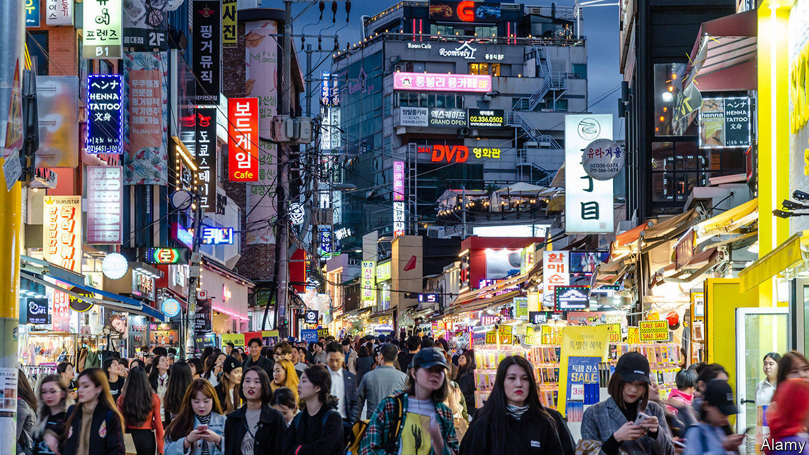

WHEN PARK HYE-SOO was a young girl, her path to success seemed clearly defined. “My parents said, study hard, get into a good university and everything will be fine, so I was a good daughter and did that,” she says. “But when I finished I didn’t know what to do and my parents didn’t either and I realised nobody had ever taught me how to make decisions for myself.”

Ms Park, now in her 40s, is a child of the Asian financial crisis. When she left university in the late 1990s, South Korea’s economy was in the doldrums and the model that had seemed obvious to her parents no longer held the same promise for people of her generation. For Ms Park, who ended up becoming an artist, success required abandoning most of the assumptions she had held about what constituted it, and years of looking for a new version.

Today her work is exhibited in London and New York as well as Seoul and her country is lavishing awards on her. Her mother, who for years was horrified by her daughter’s life choices, is at last proud of her. Ms Park won’t quite say that she is happy. “But I’m living the life I want.”

The journey that she has already made is one which her country still needs to complete. The increased willingness to challenge prevailing conditions and to try something new is behind many of the developments highlighted in this special report. In the 1980s South Koreans went out into the streets to demand an end to military dictatorship—and succeeded. At the end of the 2010s, they took to the streets once more and succeeded in removing a government which many felt had failed to live up to the promises of democratisation. Ms Park, the artist, is heartened by the increasing willingness to discuss social constraints. “When I was young we never talked about it,” she says. “Young people today do talk about things. They complain.”

“We care a lot about external validation of our choices”

In South Korea, complaining has begun to work. It has expanded the range of individual life choices that society will tolerate. Women are no longer obliged to get married or become domestic helpers to their husband’s family. Young graduates have a wider choice of job options. At work, they are less oppressed by hierarchy. They can occasionally say no to an evening of drunken carousing with the boss. Politicians are feeling the pressure to be more accountable to those who elected them.

This process is far from complete. Many Koreans still feel they must follow a narrow script for success: get into a good university, get a job at a chaebol, toil uncomplainingly until retirement. The pressure to do the same thing as everyone else is strong. “We care a lot more about external validation of our choices than about our personal assessment,” says Suh Eun-kook, who studies life satisfaction at Yonsei University in Seoul. “That is very disadvantageous for personal happiness—but changing it takes guts.” It may also still turn out to be a bad decision, points out Paul Chang of Harvard University. “There’s this cliché that South Koreans, particularly South Korean parents, are crazy for being so competitive—but actually it’s a rational response to a situation where there are not enough good jobs or places at the right universities.”

Everybody doing the same sensible thing has apparently also helped South Korea weather the covid-19 pandemic. Still, the outbreak has the potential to retard some of the developments discussed in this special report, perhaps severely.

Economically, deep crises, such as the one that is likely to result from the pandemic, tend to promote market consolidation. Large companies usually find it easier to weather economic storms, both because they are more likely to have bigger cash reserves than smaller firms, and because they are more effective at lobbying the government to include industry-specific measures that benefit them in fiscal-stimulus packages.

South Korean governments have a long-standing habit of turning to the chaebol in hard times; it is not clear yet whether the current one will be any different. If it is not, the pandemic could entrench the dualism of the economy that South Koreans had just begun shaking up, delaying long-term change.

As for social change, the consequences are more difficult to predict. But in the short term, it looks as though the pandemic may slow progress there, too. The measures which the government has so far taken to curb covid-19 affect different social groups in different ways. Closing schools, for instance, disproportionately affects women. There are already reports of mothers quitting their jobs to shoulder the additional responsibilities of caring for children and other relatives at home during the day.

Depending on how long the epidemic lasts and how widespread such responses are, that could prove a setback in advancing the goals of South Korean feminists, reinforcing traditional divisions of labour and social roles.

Like most countries in the world, South Korea may look different a few months from now. The challenge will be for its people not to go back to how things were, but to keep reimagining the future, even as they fight to hold on to their hard-won social and economic gains. ■

Read also on: <https://www.economist.com/special-report/2020/04/08/south-koreas-transformation-is-still-fragile>

|  |  |  |  |
| --- | --- | --- | --- |
| Previous | Articles | Sections | Next |

|  |  |  |
| --- | --- | --- |
| Special report | Sections | Finance and ... |

Business

Telecommunications: 5Geopolitics

.

Bartleby: It’s cold outside

.

Technology: SoftBank and sensibility

.

Online collaboration: Zoom in, Zoom out

.

Schumpeter: Strategic pile-up

.

|  |  |  |
| --- | --- | --- |
| Special report | Sections | Finance and ... |

|  |  |  |  |
| --- | --- | --- | --- |
|  | Articles | Sections | Next |

#### 5Geopolitics

# America does not want China to dominate 5G mobile networks

It is going about it the wrong way

Apr 8th 2020 | SAN FRANCISCO AND WASHINGTON, DC

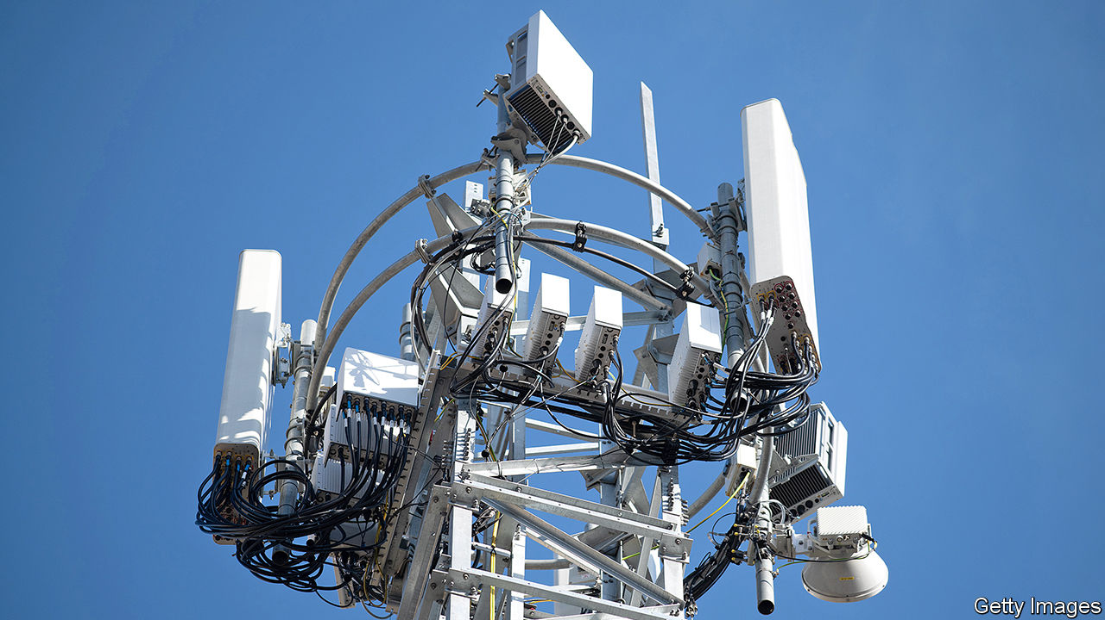

IN THE 1990S America’s telecoms industry was split between two rival factions. On one side were the “bellheads”, named after the former telephone monopolist, Bell, and representing firms created by its break-up in the 1980s. They championed “circuit switching”, which linked customers via dedicated connections with highly specialised, highly reliable hardware arranged in a strict hierarchy. They believed in proprietary technology, vertical monopolies and deference to regulators.

Set against them were the “netheads”. They had grown up with the internet, which is based on “packet switching”: information is digitised, cut into small packets, each routed along the best available connection to the destination, and then recombined. Netheads favoured open-source software, collaboration between firms and decentralised decision-making.

This old debate is playing out again, this time in mobile technology—specifically its fifth generation, or 5G. Present-day bellheads are behind America’s assault on Huawei, the world’s biggest maker of telecoms gear and China’s best shot at dominating the global 5G market. New netheads can be found among proponents of “fully virtualised mobile networks”, built on cheap hardware and controlled by software in a manner similar to computing clouds. They include Rakuten, a Japanese technology group, which launched the first full-scale virtualised network on April 8th. If netheads have their way, it may prove as momentous as Amazon’s launch in 2006 of its trailblazing cloud-computing arm.

Earlier iterations of mobile technology all had their winners (see chart): mobile carriers and handset producers like Nokia and Ericsson (2G), smartphone-makers, notably Apple, and online giants reaching consumers on such devices, such as Amazon or Google (3G and 4G). 5G will be no different. It is too early to say with conviction who will take the biggest slice of the $2trn annual connectivity boost to global GDP by 2030 that the McKinsey Global Institute, the consultancy’s think-tank, predicts in health care, manufacturing, transport and retail alone. But one thing is clear: America does not want it to be China. The battle over 5G is spilling over from commerce into geopolitics.

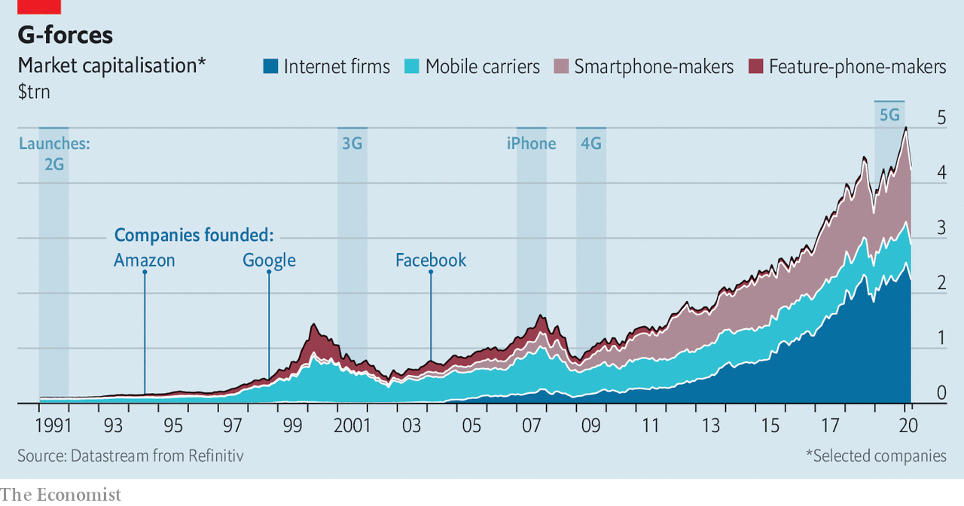

At first blush, Western panic over Huawei seems overblown. Many telecoms experts dismiss 5G as hype by makers of devices and networking kit drumming up business. They are partly right. 5G will not profoundly alter consumers’ lives. It promises faster connections, but often only in optimal conditions (with a base-station antenna in line of sight). Similar download speeds can be achieved by extending 4G. Outside China, South Korea and a few other Asian countries, the uptake of 5G may be barely half as quick as of 4G, which reached 30% of mobile users within five years of launch in 2009, reckons UBS, a bank.

## Edging ahead

But 5G is more than just a faster way to stream Netflix on the go. It enables networks that can support the “Internet of Things” (IoT): a world of connected devices from toothbrushes to tooling machines. Rather as the cloud has turned computing into a utility like electricity, 5G networks would permit moving more number-crunching to places where it is needed. The extra processing oomph could allow base stations on networks’ “edge” to guide self-driving cars, or robots on factory floors.

Cristiano Amon, president of Qualcomm, a big American maker of chips for smartphones, says that 5G will not just power telecoms but much of economic activity, making wireless networks into critical infrastructure. Self-serving, perhaps, given that his firm stands to make billions from 5G processors—but not implausible. The technology can be conceived of as the weft in a dense carpet of wireless connectivity whose warp comprises things like next-generation Wi-Fi, novel short-range links, constellations of low-orbit satellites and, yes, 6G (already under development).

It is Chinese dominance of this wireless tapestry that spooks many Western security hawks. If Huawei, suspected of links to the Chinese state, is allowed to build even parts of these networks, it could wreak havoc if ordered by its Communist overlords, worries Elsa Kania of the Centre for a New American Security, a think-tank. The risk is less that Huawei hoovers up data—exfiltration would probably be spotted and could be prevented by encryption. A bigger fear is that in a conflict between China and the West, the firm could shut down an enemy’s network, and maybe even turn IoT devices, such as driverless cars, into weapons.

Western security experts disagree on the practicality of such an attack—or its wisdom, given the retaliation it would invariably provoke. But the possibility has President Donald Trump’s administration in a bellheaded tizzy. It has obsessed over China’s hardware, bemoaned the lack of an all-American vertical monopoly of its own and declared 5G a “race”, which China must lose for America to win.

This zero-sum approach has had limited success, even on its own terms. American technology companies quickly found legal loopholes which let them keep selling to Huawei. On March 31st the firm reported a 19% rise in annual revenue last year, to $123bn. It spent $19bn with American suppliers in 2019, $8bn more than the year before. Despite threats to cut off the flow of American intelligence to allies that refuse to banish Huawei from their networks, only three of them—Australia, Japan and New Zealand—have complied. Even Britain, America’s closest partner in security matters, in January permitted its carriers to use Huawei kit in parts of the country.

America’s tough talk has backfired, prompting Huawei to redouble efforts to wean itself off American technology. Although such claims are hard to verify, Tim Danks, a Huawei executive, has said that of the 600,000 base stations the firm has shipped to mostly Chinese carriers, 50,000 had no American parts. Engineers who recently took apart Huawei’s top-end smartphone identified only a few American-designed chips.

Hawks in Washington are now urging Mr Trump to tighten the screws, for instance by lowering from 25% to 10% the share of American technology by value that products can contain for their makers, in America or elsewhere, to be allowed to supply Huawei. For all his China-bashing, Mr Trump appears to have demurred, instead heeding the concerns of America’s tech bosses, who warn that such a move would hurt their industry. A cabinet-level meeting at the White House in late March came up with a new plan. This would require any firm, domestic or foreign, that uses American chipmaking equipment or know-how to obtain an export licence if it wants to sell certain processors to Huawei.

Whatever its final shape and severity, the plan lays bare that for the Trump administration the 5G race is not about out-innovating China but hobbling it. It has no credible strategy for a speedy rollout of 5G across America, says Paul Triolo of Eurasia Group, a consultancy. Ideas such as having the state build a national network and rent capacity to carriers (as Mexico is doing in 4G) or letting a private firm operate a wholesale one have gone nowhere.

## Base instincts

Left to their own devices, American carriers have put up 10,000 5G base stations. Covid-19 lockdowns will slow installations in the West, even as China eases its own curbs now that its epidemic is apparently under control. Chinese carriers, which boast 150,000 base stations, want more than 1m across 330 cities by the end of 2020.

In the ultimate act of desperation, Washington is toying with European-style industrial policy, once considered antithetical to American capitalism. In February William Barr, the attorney-general, suggested that America put its “large market and financial muscle” behind Ericsson and Nokia, Huawei’s enfeebled European rivals, and the only firms besides Samsung of South Korea allowed to build 5G networks in America (Lucent, America’s last domestic producer, merged with Alcatel of France in 2006; Nokia later bought the pair). There has been talk of subsidies for the Europeans, sweeteners for a tie-up between them or a takeover by an American tech giant or private-equity firm.

Samm Sacks of New America, a think-tank, warns that European and, ironically, Chinese regulators may block any deal on competition grounds. More fundamentally, as Rakuten shows, the bellhead approach they embody is no longer the only game in town. Mobile networks have been the bellheads’ last bastion. Base stations rely on specialised hardware. Mixing kit from different suppliers in one network risks dropped connections as users move around and switch from one base station to another. So carriers don’t do it.

Many would like to, fed up with pricey, inflexible kit. Luckily, engineers can now replicate all functions of a network in software. New industry groups to promote such alternatives, such as the O-RAN Alliance, are devising open specifications for base stations. The Telecom Infra Project, which grew out of Facebook’s efforts to lower the costs of connectivity in poor countries, helps network operators everywhere procure and combine components from different producers. Some carriers, including Spain’s Telefónica and Vodafone in Britain, are testing the new approach.

But it is Rakuten that has built an entire network based on an open architecture. Though 4G for now, 5G is promised in June. The firm has assembled a network with kit from different suppliers (such as Nokia and America’s Cisco), built its own computing platform and manages it all using software from Altiostar, an American startup in which it has a majority stake. “We did our own integration, which was not easy. But there was no plan B,” says Tareq Amin, Rakuten’s chief technologist. He hopes other firms will follow its lead, perhaps even use its technology. A few are considering it. Asked if Rakuten was a model for Dish Network’s planned $10bn investment in 5G, the American satellite-TV provider’s boss, Charles Ergen, said that Dish “learned a lot” from the Japanese firm.

The “telco cloud”, as Pierre Ferragu of New Street, a research firm, calls it, looks poised to billow. When it does, carriers may be less desirous of Huawei gear, which tends to be cheaper than Ericsson’s or Nokia’s and no less nifty. Rakuten claims its network cost roughly half as much as a conventional one to build; some of its 5G base stations will be no pricier than a Wi-Fi router, it says. Emerging-world consumers should love it. So should security hawks. An open architecture gives operators more control over what gear goes into their networks; Rakuten’s network contains no “black box” it must blindly trust.

Huawei has dismissed the nethead approach as “a dream”. In contrast to Ericsson and Nokia, the Chinese giant has yet to join the O-RAN Alliance. Perhaps channelling his former self as a lawyer for telecoms firms, Mr Barr has called it “pie in the sky”. Stéphane Téral of Informa Tech, a research firm, warns that “making parts from different firms work well together is always tricky”; such niggles delayed Rakuten’s launch by six months. And many carriers that have already begun erecting conventional 5G base stations may have locked themselves into a single supplier for years to come.

Still, governments could promote the nethead alternative, argues Tom Wheeler, a former chairman of America’s Federal Communications Commission, now at the Brookings Institution, a think-tank. A bipartisan bill in the Senate would create a $750m research fund to spur the development of open-architecture networks and help carriers purchase such equipment. Some American lawmakers want to mandate the use of gear with open interfaces.

The Trump administration faces a clear choice. It can either bellheadedly try to beat the Chinese at their own game, going after Huawei and embracing industrial policy. Or it can do something altogether more American: help usher in innovation that lets many companies thrive at a time when cheaper, better connectivity is precisely what a post-pandemic world needs. ■

Read also on: <https://www.economist.com/business/2020/04/08/america-does-not-want-china-to-dominate-5g-mobile-networks>

|  |  |  |  |
| --- | --- | --- | --- |
|  | Articles | Sections | Next |

|  |  |  |  |
| --- | --- | --- | --- |
| Previous | Articles | Sections | Next |

#### Bartleby

# The pandemic may exacerbate the divide among workers

It’s cold outside

Apr 11th 2020 |

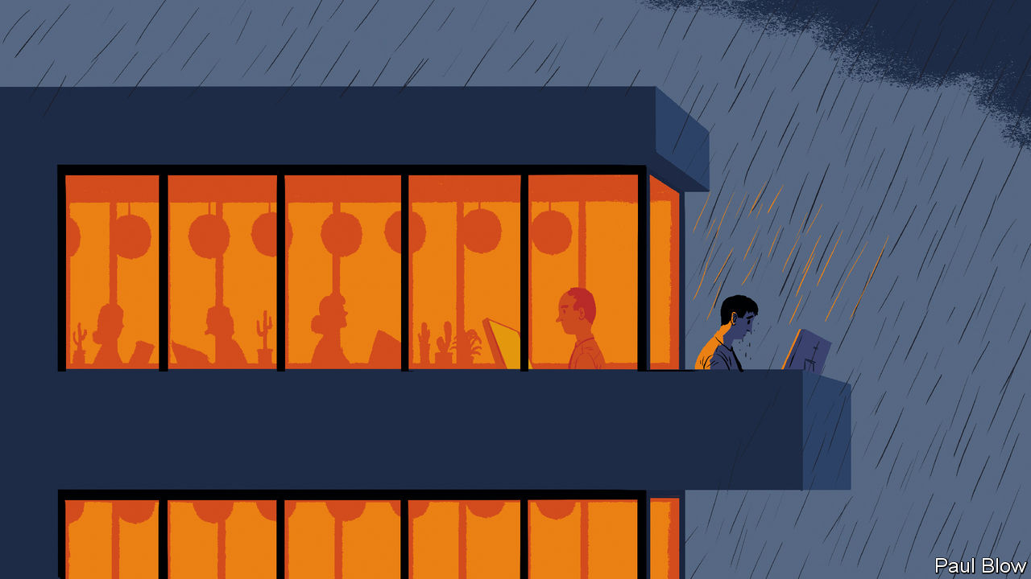

Editor’s note: The Economist is making some of its most important coverage of the covid-19 pandemic freely available to readers of The Economist Today, our daily newsletter. To receive it, register [here](https://www.economist.com/newslettersignup). For our coronavirus tracker and more coverage, see our [hub](https://www.economist.com/coronavirus)

CRISES OFFER the ultimate test for organisations. Under the pressure of a pandemic, many firms will change the way they operate. Three trends that were already in train may be accelerated. First, the way that meetings are undertaken. Second, the way that teams are organised. Third, the widening divide between company insiders, namely full-time employees, and outsiders, such as freelancers and contractors.

So many meetings have been conducted via Zoom and other apps that bosses may decide that this is a better approach than gathering everyone together in one fusty room. One estimate is that 2.1m people downloaded the Zoom app on March 23rd, the day Britain went into lockdown and the World Health Organisation warned that the pandemic was “accelerating”. Even when people start returning to offices, many of those who did not catch the virus will be nervous about being in close proximity to their colleagues.

Remote meetings have drawbacks. Conversations can be clunky and stilted, and not everyone (including Bartleby) welcomes the need to be on camera. So physical meetings will not disappear altogether, but they will be a smaller proportion of the total.

Another change will be a greater focus on communication between key employees. Worker interaction involves a lot more than meetings. Traditionally, people have popped over to each other’s desks for a brief chat. Often, these exchanges are all the more useful when they involve someone from a different department. Such informal interactions are not currently possible.

Email chains are an imperfect and cumbersome substitute. In the crisis, many firms have turned to apps like Slack, which allow teams to communicate on a dedicated forum. Stewart Butterfield, Slack’s chief executive, says the company started to detect a significant pickup in teams being created in South Korea and Japan in the middle of February. A bigger surge in business began in the week of March 9th, a hint that companies were beginning to take social distancing seriously. All told, use of Slack increased approximately 20% between February 1st and March 25th, while simultaneously connected users increased from 10.5m on March 16th to 12.5m on March 25th.

The divide between insiders and outsiders is probably the most significant change. The first group are likely to be protected by their employers, who will pay all or most of their salaries as long as they can afford to. The outsiders, whose ties with firms are looser, may be cast adrift. The divide helps explain a large part of the surge in unemployment claims on both sides of the Atlantic.

The insider/outsider split is one of the trends outlined by William Davidow and Michael Malone in “The Autonomous Revolution”, a new book. Permanent employees are an expensive burden, thanks to the associated costs like health care (in America) and pensions (everywhere). Online tools already let employers forecast workloads and schedule workers instantly. The current crisis may prompt firms to embrace these, as they reconsider which full-time workers are essential, and which are not.

The pandemic will also accelerate the trend towards automation. In some cases companies will increasingly rely on automated processes to fulfil tasks, because some workers may fall ill. In other cases the push may come from outside: more consumers will become used to shopping online, or interacting with websites rather than waiting ages for call centres to answer their queries. Those habits look likely to stick after the pandemic ends, reducing the need for human employees.

A reduction in the supply of secure, full-paid jobs may coincide with an increase in demand for such roles. The crisis will have taught a stark lesson to those who work in the gig economy: they are highly vulnerable. Independence and the ability to manage your own time sound appealing when work is plentiful. In hard times workers will appreciate security, however tiresome the daily commute may be. The spike in unemployment will only increase the desire for stable jobs. That seems likely to keep a downward pressure on wages.

Employees may be used to hearing that “we are all in the same boat”. But this crisis is cementing a class system aboard corporate vessels. The managers have the first-class cabins and core workers get en-suite accommodation but the freelancers and contractors are clinging unsteadily to the lifeboats.

Dig deeper:  
For our latest coverage of the covid-19 pandemic, register for The Economist Today, our daily [newsletter](https://www.economist.com/newslettersignup), or visit our [coronavirus tracker and story hub](https://www.economist.com/coronavirus)

Read also on: <https://www.economist.com/business/2020/04/11/the-pandemic-may-exacerbate-the-divide-among-workers>

|  |  |  |  |
| --- | --- | --- | --- |
| Previous | Articles | Sections | Next |

|  |  |  |  |
| --- | --- | --- | --- |
| Previous | Articles | Sections | Next |

#### SoftBank and sensibility

# Is SoftBank’s boss changing his ways?

Meet the new Son Masayoshi

Apr 8th 2020 |

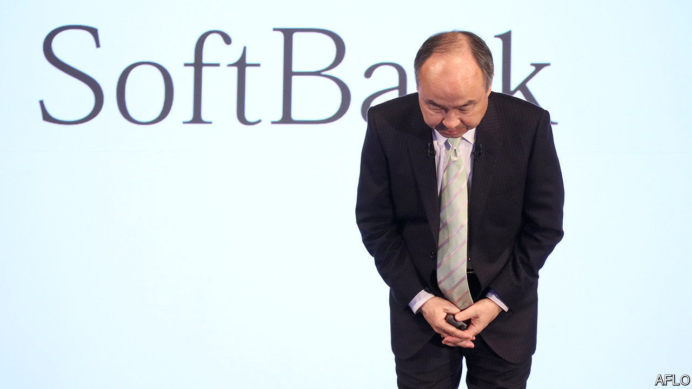

“STONE-COLD crazy” was how a private-equity boss described the $1.7bn golden parachute that SoftBank, a Japanese conglomerate, gave Adam Neumann, co-founder of WeWork, as part of the co-working empire’s bail-out last autumn. SoftBank appears to have come to its senses. On April 2nd it scrapped a deal to buy up to $3bn in WeWork shares, which would have made Mr Neumann a billionaire. SoftBank says American government probes into WeWork, whose initial public offering imploded in part over governance concerns, mean it doesn’t have to make the purchase. Two WeWork shareholders who would have benefited from the deal are suing SoftBank; Mr Neumann has yet to respond.

Breaking with Mr Neumann is just one example of a new, sober Son Masayoshi. In March SoftBank’s billionaire boss manoeuvred to reduce risk at his company. It is to sell $41bn of assets over 12 months to fund an $18bn share buy-back and pay off $23bn of debt. He may part with some of a prized 26% stake in Alibaba, a Chinese e-commerce titan. He even let a beloved startup go bust. OneWeb, which filed for bankruptcy on March 27th, planned to transmit broadband from satellites—a key part of Mr Son’s vision of ubiquitous connectivity.

He is under pressure to make concessions. Over the past few years SoftBank took on more debt. Mr Son spent $52bn to buy Sprint, an American telecoms group and Arm Holdings, a British chip-designer (SoftBank has just sold Sprint to T-Mobile, a telecoms rival). He then set up a $100bn tech-investing vehicle with cash from SoftBank, Saudi and Emirati sovereign-wealth funds, and a few private-sector investors. He splurged $75bn from it on stakes in 88 big tech startups (including WeWork).

As investors took fright at heavily indebted firms amid a pandemic-related market sell-off, SoftBank’s vital signs weakened. In February and March the cost of insuring its debt against default leapt by 2.72 percentage points. Standard & Poor’s, a credit-rating agency, cut SoftBank’s outlook to negative. The gap between SoftBank’s market value and that of its main underlying assets, such as its Alibaba stake, widened to 66% (see chart). That led Mr Son to announce the $41bn asset sale. Then Moody’s, another rating agency, added a two-notch downgrade, far into junk territory: selling prize assets amid a markets rout, it implied, looked desperate.

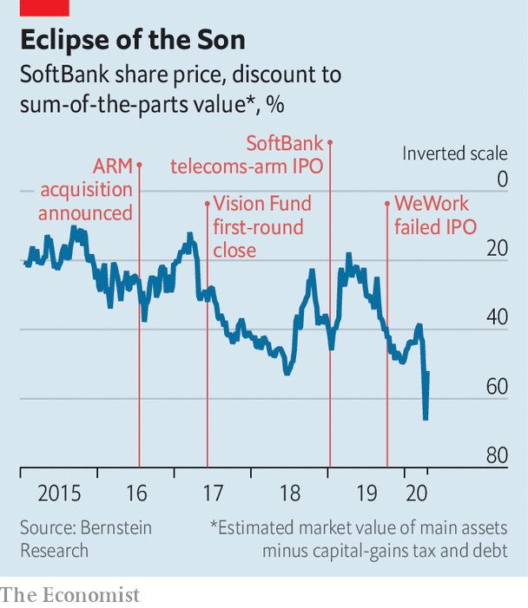

As long as Mr Son can pull off the asset sale and cut debt, says Mary Pollock of CreditSights, a research firm, SoftBank’s balance-sheet will emerge stronger. The Alibaba stake is still a get-out-of-jail-free card, she says. For the time being, Mr Son has probably eased fears about his entire empire collapsing under its weight of debt.

That will not stop investors worrying. If Vision Fund firms run into trouble during the pandemic, they fear, SoftBank may rescue them, as it did WeWork, which got $1.5bn on top of the cancelled share purchase. The fund has $15bn left for follow-on investments, enough for a few years. SoftBank has put in $27bn and pledged another $6bn. It could end up coughing up more.

“Masa is a visionary who loves big projects, and founders get star-struck by him,” says an investor close to SoftBank. “This needs to be tempered to be sustainable.” Mr Son overrode colleagues who asked about cashflow and profits at portfolio companies. Now things are changing at the Vision Fund, too. The dissenters are taken more seriously and the fund is being harder-headed. Firms are being asked to find other sources of capital. Profit, not just growth, has become more of a priority. Governance at certain firms is being scrutinised, sometimes at the behest of the two big Gulf investors, says a person close to the funds.

The Vision Fund could continue spilling red ink over SoftBank’s accounts for a while. In the last quarter of 2019 its $2bn loss all but wiped out the group’s profits. As markets tumble, unlisted startups will lose value in line with listed firms. But some of its companies, notably in e-commerce and health care, are thriving. Business at Coupang, a South Korean e-commerce firm, has soared. Vision Fund executives see Bytedance, the parent of TikTok, a video-sharing app, as another Alibaba in waiting.

Venture capitalists liken Mr Son to a Mississippi riverboat gambler. His risk-loving style is not going away, they say. But his recent losing streak will force him to play things safer—for a while.■

Read also on: <https://www.economist.com/business/2020/04/08/is-softbanks-boss-changing-his-ways>

|  |  |  |  |
| --- | --- | --- | --- |
| Previous | Articles | Sections | Next |

|  |  |  |  |
| --- | --- | --- | --- |
| Previous | Articles | Sections | Next |

#### Zooming in, Zoom out

# Zoom’s popularity has brought problems

The videoconferencing service is facing increased scrutiny

Apr 8th 2020 | SAN FRANCISCO

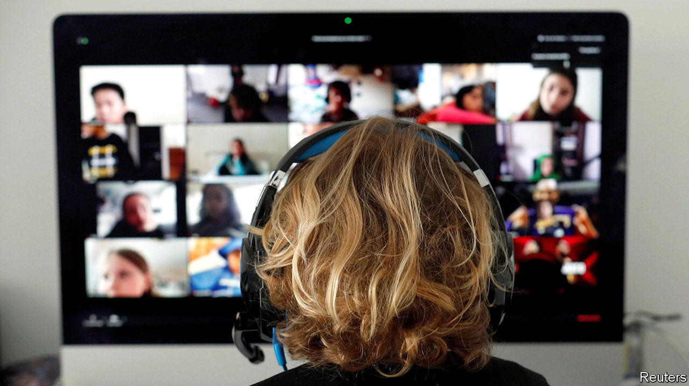

ERIC YUAN likes to crack jokes. But these days the boss of Zoom, a videoconference service of coronavirus-fuelled popularity, is in no mood for laughs. His firm, whose share price has surged by 49% since the end of January, is trying to avoid a serious case of whiplash.

Zoom, founded in 2011, is part of a trend in tech known as “the consumerisation of IT”. The idea is that corporate services should be as easy to use as consumer ones. Meetings on Zoom can be called with a few clicks and are free if they last no longer than 40 minutes and have fewer than 100 participants. Zoom also keeps oodles of spare capacity, ensuring a good service. Its 17 data centres around the world were built to withstand double the expected peak load. But as a consumer-business hybrid the company has focused much less on privacy and security than old-style corporate-IT firms.

The combination became a problem after the coronavirus hit. The number of daily users has exploded from 10m in December to more than 200m today. This is technically manageable. But with popularity comes scrutiny. Worrying reports come almost daily about data leaks, iffy encryption and “zoombombing”, the childish practice of gatecrashing meetings and showing porn or worse. “I really messed up,” admitted Mr Yuan on April 3rd, promising that the firm would make amends.

Zoom has every reason to relieve the tension inherent in a model that aims to provide a corporate service but is now used by people stuck at home and craving contact with the world beyond. Unless it does so it will create an opening for more business-oriented services, in particular Microsoft Teams, whose video service lags behind Zoom both in quality and popularity.

Rivalry between Zoom and Teams highlights a battle that has been brewing for a while. On one side are firms that provide specialised tools for online collaboration, such as Zoom and Slack, a corporate-messaging app. On the other are those that offer a complete range of such services, like Microsoft and Google. If, as many predict, working remotely becomes far more common even after the virus recedes, the competition to create the virtual office will intensify. Expect to hear more about Microsoft trying to entice customers into its world—and startups complaining that the ex-evil empire is back to its old tricks.■

Read also on: <https://www.economist.com/business/2020/04/08/zooms-popularity-has-brought-problems>

|  |  |  |  |
| --- | --- | --- | --- |
| Previous | Articles | Sections | Next |

|  |  |  |  |
| --- | --- | --- | --- |
| Previous | Articles | Sections | Next |

#### Schumpeter

# Strategic pile-up

The idea that some industries are too important to leave to markets is back on the agenda

Apr 8th 2020 |

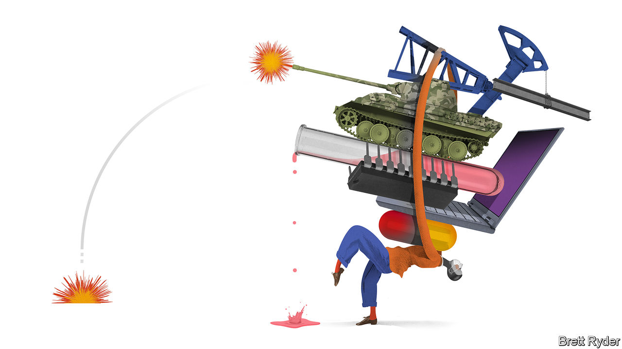

“IF WE LEARN anything from this crisis, [it is that] never again should we have to depend on the rest of the world for our essential medicines and counter-measures,” thundered Peter Navarro, a White House trade adviser, on April 3rd. A few days later President Donald Trump pressed 3M, an American multinational which makes medical masks, to divert more of them home, at the expense of other countries.

Mr Navarro and his boss are knee-jerk protectionists. But with the market for masks broken by covid-19 (see article), their worries are understandable. So are similar noises by other national leaders. Emmanuel Macron, the French president, often painted by critics as a free-trading neoliberal, has called relying on others for food supplies “madness” and his finance minister instructed supermarkets to buy only domestic produce. The EU has curbed exports of some medical gear. India, the world’s biggest maker of generic drugs, has done the same with hydroxychloroquine, an antimalarial drug that some suggest (with little evidence) might treat covid-19. Countries from Kazakhstan to Vietnam have cut food exports, leading the UN to warn of shortages.

Many of the restrictions will be lifted once the pandemic has passed. But not all, for the virus has reinforced an old idea that was already gaining ground again: that in an uncertain world, some industries are “strategic”, simply too important for countries to leave to unfettered markets, and so deserving of special protection. The notion is attractive in theory, but perilous in practice.

If the copious academic literature on strategic industries has a conclusion, it is that no one can agree on what counts as one. The narrowest definition covers sectors directly vital to war-fighting: makers of weapons and of stuff needed to forge them (steel) and operate them (energy). Even in the tightly integrated EU most countries shield national defence firms. At its most expansive, the concept can encompass any economic activity, since all of it contributes in some roundabout way to a state’s defensive capability. Everything is strategic in North Korea.

Many reasonable opinions fall somewhere between these two extremes. After the first world war Britain created the Forestry Commission to ensure a strategic supply of timber. Today America and China treat things like computer chips, artificial intelligence or genetic engineering as strategic. A government body called the Committee on Foreign Investment in the United States (CFIUS) scrutinises the national-security implications of deals involving American firms. Worried about losing strategic assets cheapened by the market rout to foreign buyers, Australia has just tightened its takeover rules. The EU is urging member states to do the same in sectors like utilities and transport.

In principle such rules are sensible. The trouble begins when their opacity—CFIUS rules, for instance, are notoriously hazy—allows politicians to extend the definition of “strategic” to include things that are tied not to national survival, but to perceived national greatness. Governments have long pampered loss-making national airlines, sometimes pretending that this has to do with the strategic importance of aircraft. In 2005, after PepsiCo briefly eyed Danone, a French yogurt-maker, France’s government vowed to protect it and other “strategic” companies from foreign suitors.

Many businesses covet the designation. No wonder: it can be a ticket to cushy cost-plus contracts (think Boeing), state subsidies (Chinese national champions like Huawei) and protection from irksome foreign competitors (just about anyone). And with a little ingenuity, almost any firm can argue its products deserve the label. After all, who can predict what will be useful in a crisis? In the second world war Britain retooled its furniture factories to produce parts for the Mosquito, a capable wooden fighter-bomber. Amid the current pandemic LVMH, a French luxury group, is turning some perfume factories over to make hand sanitiser.

Still, governments should resist indulging firms too liberally, for two reasons. First, sheltering them behind national-security arguments is, like all protectionism, expensive. The semiconductor industry, for instance, is ferociously high-tech. Its planetary-scale supply chain comprises ultra-specialised companies in Taiwan, Japan, South Korea and the Netherlands, each spending billions on research. Even a superpower would struggle to replicate all this within the borders of a single country, as America and China have both discovered. Makers of generic drugs are easier to nurture at home. But even there, global supply chains have arisen because they are efficient. Unwinding them will thus be costly, and the costs will be borne by consumers and taxpayers.

So will those stemming from protected firms’ tendency to grow bloated, inefficient or—as has happened with Boeing’s ill-fated 737 MAX plane—potentially dangerous. All this, critically, also makes them less able to respond effectively when a crisis does strike.

## Prisoners of their own minds

The second reason for governments to go easy on strategic protectionism is that it risks ushering in the baleful logic of the prisoner’s dilemma. Actions that appear to be in the interest of individual countries lead to a nationalistic, distrustful world that is bad for everyone. The present scramble for medical equipment is causing bitter rows, even between allies. Germany has accused America of diverting shipments of face-masks bound for Europe, decrying its actions as “modern piracy” and “Wild West tactics”. After the EU’s ban on the export of medical equipment, Aleksandar Vucic, Serbia’s president, declared that European solidarity “does not exist”.

The more that some states pursue such policies, the more it becomes rational for others to do the same. That risks leaving the world divided in the face of the next crisis, whether that is another pandemic, the next financial crash or a slow-burn disaster such as climate change. A few industries may indeed be “strategic”. But governments should anoint them cautiously. ■

Read also on: <https://www.economist.com/business/2020/04/08/strategic-pile-up>

|  |  |  |  |
| --- | --- | --- | --- |
| Previous | Articles | Sections | Next |

|  |  |  |
| --- | --- | --- |
| Business | Sections | Science and ... |

Finance and economics

Banks and the economic emergency: This time we’re different

.

Price gouging: Signal failure

.

Buttonwood: Stacked and whacked

.

Joe Stiglitz and the IMF: Pilgrimage to the gamma quadrant

.

Taken ill: The labour market’s turn for the worse

.

Free exchange: Special delivery

.

|  |  |  |
| --- | --- | --- |
| Business | Sections | Science and ... |

|  |  |  |  |
| --- | --- | --- | --- |
|  | Articles | Sections | Next |

#### This time we’re different

# How sick might banks get?

They have entered this crisis in better health than the previous one

Apr 8th 2020 |

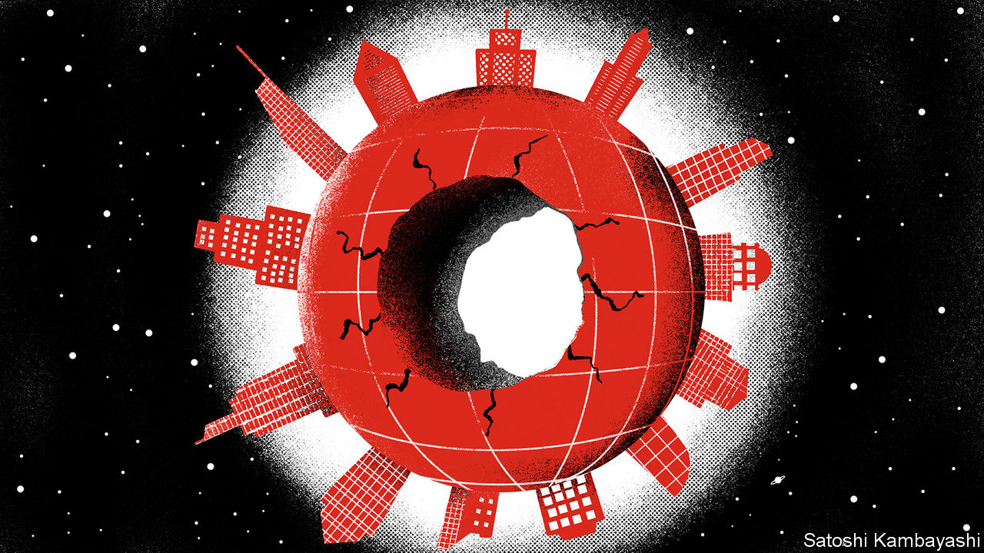

Editor’s note: The Economist is making some of its most important coverage of the covid-19 pandemic freely available to readers of The Economist Today, our daily newsletter. To receive it, register [here](https://www.economist.com/newslettersignup). For our coronavirus tracker and more coverage, see our [hub](https://www.economist.com/coronavirus)

FROM EBENEZER SCROOGE to Gru in “Despicable Me”, the villain redeemed is a time-honoured trope in fiction. There has been much talk lately of bankers enjoying a similar rehabilitation. Reckless overextension by lenders was the root cause of the financial crisis of 2007-09. This time the blame lies with a microbe, not moneymen, and banks are seen as potentially part of the solution, not least as conduits for massive state support for stricken firms and households.

The corona-crisis does indeed give banks a chance to improve their image. But it also presents them with some painful dilemmas and, worse, may ravage their bottom lines. Michael Corbat, boss of Citigroup, has warned that banks like his have to tread a “fine line” between supporting clients and undermining financial stability. They must conserve capital while also keeping dividend-dependent investors sweet. However they handle such choices, the risk of hefty losses looms: bank shares have fallen by twice as much as the stockmarket this year on fears of rising defaults.

The industry went into the crunch in decent shape. Capital cushions, depleted going into the last crisis, have since been plumped up. Banks have also been made less vulnerable to funding runs. This time the system has creaked but not buckled. Early evidence suggests that post-2009 efforts to push liquidity risk from banks into capital markets have worked, and to the extent that risk has rebounded it has been largely absorbed by central banks through their market-support programmes, not by commercial banks, says Huw van Steenis of UBS, a Swiss lender.

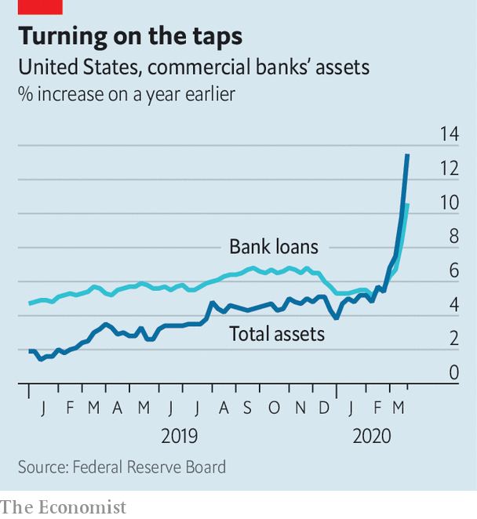

Under those schemes, and their own steam, banks have increased lending dramatically, especially in America (see chart). In March public companies there drew down $191bn from bank credit lines, after taking next to nothing in January and February. The odd one out is China, where loan growth is similar to last year’s rate. In 2008-09 officials arm-twisted lenders into leading stimulus efforts. They may fear that another such push could break them. Chinese banks’ assets have ballooned to 285% of GDP, from 195% in 2007.

To encourage banks to lend more and offer forbearance, regulators in the West have rushed to relax or delay rules brought in after the financial crisis. These cover everything from loan-loss accounting to the thickness of capital buffers (see chart). By one estimate, such (presumably temporary) regulatory forbearance has created $5trn of lending capacity.

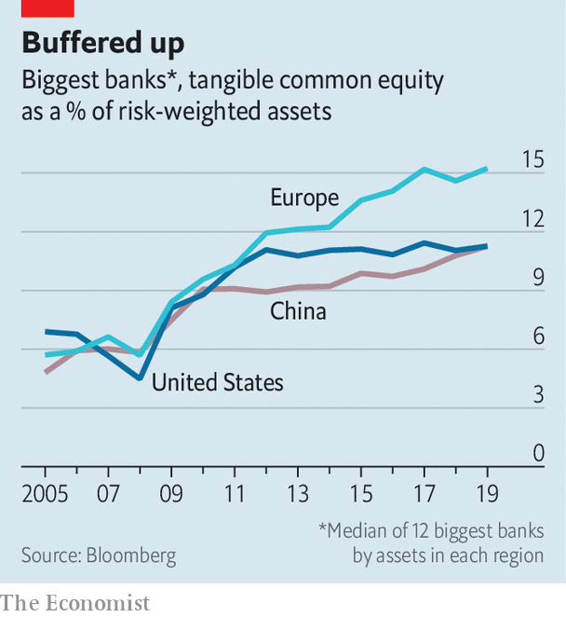

At the same time, regulators in Europe in particular have nudged or ordered banks to bolster their defences by freezing payouts to shareholders and star performers. British banks, for instance, are withholding £8bn-worth ($9.9bn) of dividends. American ones have not followed suit, though they have suspended share buy-backs. Bonuses are in regulators’ cross-hairs too: Andrea Enria, the European Central Bank’s top bank supervisor, has called for “extreme moderation”.

For now, the threat to banks does not look existential. “Unlike 2008, it’s primarily an earnings issue, not a balance-sheet one,” says Nathan Stovall of S&P Global Market Intelligence, a data provider. If charge-offs are similar to back then, American banks’ capital ratios would remain above their levels after recapitalisation in 2008-09.

But with major economies at a near-halt for an indeterminate period, loan losses could be bigger this time. Analysts cannot seem to downgrade bank-earnings forecasts quickly enough. Some now think American banks, which made combined profits of $230bn last year, could slip into loss in 2020. Investment banking won’t ride to the rescue. Equity issuance and corporate dealmaking have sagged (though debt-raising remains strong in pockets). Trading volumes and profits have leapt, as they often do early in a crisis, but are expected to fall dramatically.

Europe is in worse shape. A senior banker says the outlook for British lenders is “really shitty”. He fears some smaller banks and non-bank providers may not survive. Italian lenders, battered by the euro-crisis, were on the mend until covid-19, having cut their bad loans in half, but now look precarious again. Deutsche Bank, which has been struggling to get back to good health for years, risks a relapse.

In China, the shock to growth will push banks beyond the limits of what regulators had anticipated. In 2019 the central bank stress-tested the resilience of 30 banks in a variety of scenarios. In the most extreme hit to the economy envisaged—growth slowing to 4.15%—it said 17 of 30 banks would need more capital. The World Bank expects growth this year to be just 2.3%. S&P has estimated—based on assumed growth of 4.4%—that the bad-loan ratio could climb to nearly 8%, a quadrupling from its pre-virus level. The questionable-loan ratio could hit an eye-watering 13%.

The growing worry in the West is that the short-lockdown, quick-snapback scenario proves too rosy. Several more months of restrictions could mean years of losses on soured loans. Bankers may start to find that there is a fine line between forbearance and forgiveness: in America calls for credit-card interest to be waived indefinitely are growing louder.

Ultra-low interest rates set by central banks to fight the pandemic are another headwind. An important factor in a bank’s profits is its “net interest margin” (NIM)—the difference between the rate at which it makes loans and that at which it remunerates the deposits it has gathered. Even before the corona-crisis this was a scrawny 3.3% for American banks. With policy rates likely to stay on the floor until well after the pandemic has abated, NIMs will remain emaciated for years.

Whether banks end up drowning in red ink, or merely spattered with it, depends on a host of unknowns. “The tail event is no vaccine in a year,” says Sir Paul Tucker, chair of the Systemic Risk Council, a group of former policymakers. “Banks need to be stressed against such scenarios, as post-crisis capital requirements were not calibrated against anything like that.”

In a letter on April 6th Jamie Dimon, boss of JPMorgan Chase (JPM), assured shareholders the bank could comfortably withstand an extreme (“and, we hope, unlikely”) scenario, in which GDP falls by 35% and unemployment hits 14%, emerging with capital above the safe minimum. JPM is the strongest, most profitable of the world’s big banks. Others, faced with such a storm, could find themselves in trouble. ■

Dig deeper:  
For our latest coverage of the covid-19 pandemic, register for The Economist Today, our daily [newsletter](https://www.economist.com/newslettersignup), or visit our [coronavirus tracker and story hub](https://www.economist.com/coronavirus)

Read also on: <https://www.economist.com/finance-and-economics/2020/04/08/how-sick-might-banks-get>

|  |  |  |  |
| --- | --- | --- | --- |
|  | Articles | Sections | Next |

|  |  |  |  |
| --- | --- | --- | --- |
| Previous | Articles | Sections | Next |

#### Signal failure

# Many economists defend disaster profiteers. They are wrong

With price gouging, morality trumps economics

Apr 11th 2020 | SHANGHAI

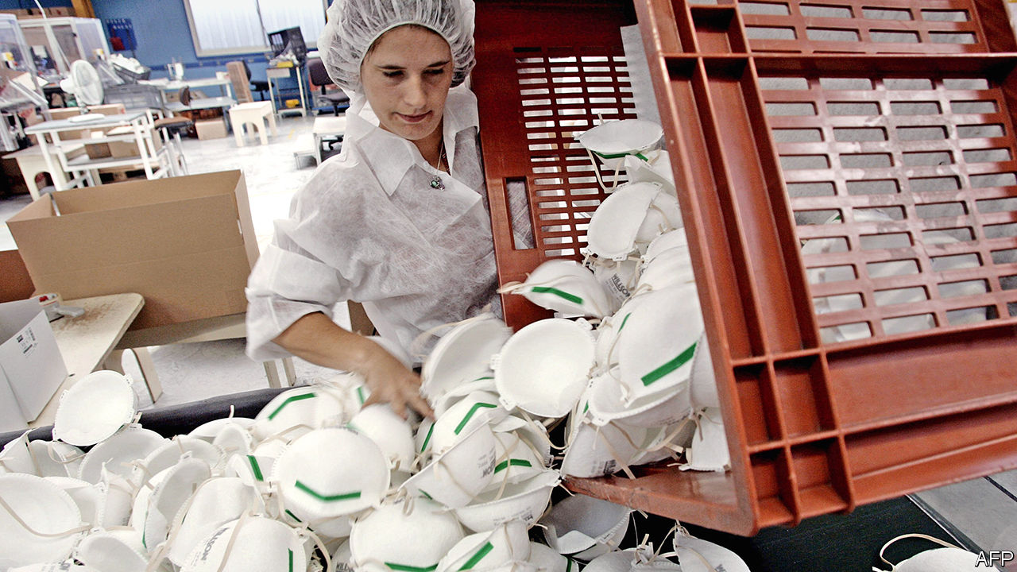

Editor’s note: The Economist is making some of its most important coverage of the covid-19 pandemic freely available to readers of The Economist Today, our daily newsletter. To receive it, register [here](https://www.economist.com/newslettersignup). For our coronavirus tracker and more coverage, see our [hub](https://www.economist.com/coronavirus)

MUCH ABOUT the pandemic sweeping across the world is unprecedented, but one aspect is all too familiar: price gouging in the wake of a disaster. In New York police arrested a man who had stockpiled medical gear, allegedly selling it for a 700% mark-up. Indonesian authorities seized 600,000 masks from hoarders. In Italy the government launched a probe into sky-high online prices for basic protective equipment. Such crackdowns are popular. Who could possibly endorse disaster profiteering? Many economists, as it turns out.

To be clear, it is not that they want the public to miss out on life-saving products. Quite the contrary. They believe that soaring prices stimulate greater output, and that policies to cap costs might limit supplies and so do more harm than good. In 2012 the University of Chicago surveyed 32 eminent economists about legislation that banned price gouging during a weather-related emergency. Only three supported the ban; more than half criticised it. Similar views have been aired in recent weeks. An economist with the Cato Institute, a conservative think-tank, lamented the “madness” of anti-gouging rules, saying that profits are what entice firms to meet rising demand for safety equipment.

Yet a closer look at one key piece of equipment—masks—during the coronavirus crisis shows that this standard view needs revamping. Economists are normally loth to tamper with prices, the most basic element of any market. But little about this pandemic has been normal. Price signalling alone would have been inadequate to the challenge of ensuring vast increases in supply.

First, consider the manufacture of masks. They might look simple, but producers need sterile factories and sophisticated machinery to churn out melt-blown fabric. Upfront costs would be hard to justify if the virus were quickly snuffed out. So in January, the early phase of the outbreak, Chinese firms began by scouring the world for masks rather than by making more of their own. It took government action to change that. Officials offered subsidies to firms producing safety gear: promising not outsized gains but an avoidance of losses. China went from making 20m masks per day before the crisis—half the world’s output—to nearly 120m by the end of February.

Profit, narrowly defined as the income earned from making masks, also fails to explain corporate motives. Regulation has been crucial. Companies in China could not resume operations until all their workers had masks, so automakers, phone manufacturers and oil giants all added mask-production lines. And big companies also want to look like good corporate citizens. Peter Navarro, a trade adviser to America’s president, accused 3M, one of the world’s biggest manufacturers of high-end masks, of putting money before people. In fact, 3M has stuck to its list prices and doubled its production.

Pricing is usually the best way to allocate resources, by revealing who is willing and able to pay for something. But there is no doubt now that masks are most essential for medical workers. Ordering large supplies at fixed prices is the right policy. The public benefit of a functioning health system far outweighs any harm in impeding sellers from maximising their profits. This was a point made to the University of Chicago’s survey by one of the dissenting economists, who argued that it was fair to cap prices after a natural disaster. “Efficiency is less important than distribution under such transitory conditions,” said Angus Deaton, now a Nobel laureate. In a global health crisis, his argument is even more compelling. Conventional morality—the revulsion against price gouging—trumps conventional economics. ■

Dig deeper:  
For our latest coverage of the covid-19 pandemic, register for The Economist Today, our daily [newsletter](https://www.economist.com/newslettersignup), or visit our [coronavirus tracker and story hub](https://www.economist.com/coronavirus)

Read also on: <https://www.economist.com/finance-and-economics/2020/04/11/many-economists-defend-disaster-profiteers-they-are-wrong>

|  |  |  |  |
| --- | --- | --- | --- |
| Previous | Articles | Sections | Next |

|  |  |  |  |
| --- | --- | --- | --- |
| Previous | Articles | Sections | Next |

#### Buttonwood

# Why a lot of startups will come to regret their unicorn status

After many funding rounds, they could be sitting under a mountain of debt-like claims

Apr 8th 2020 |

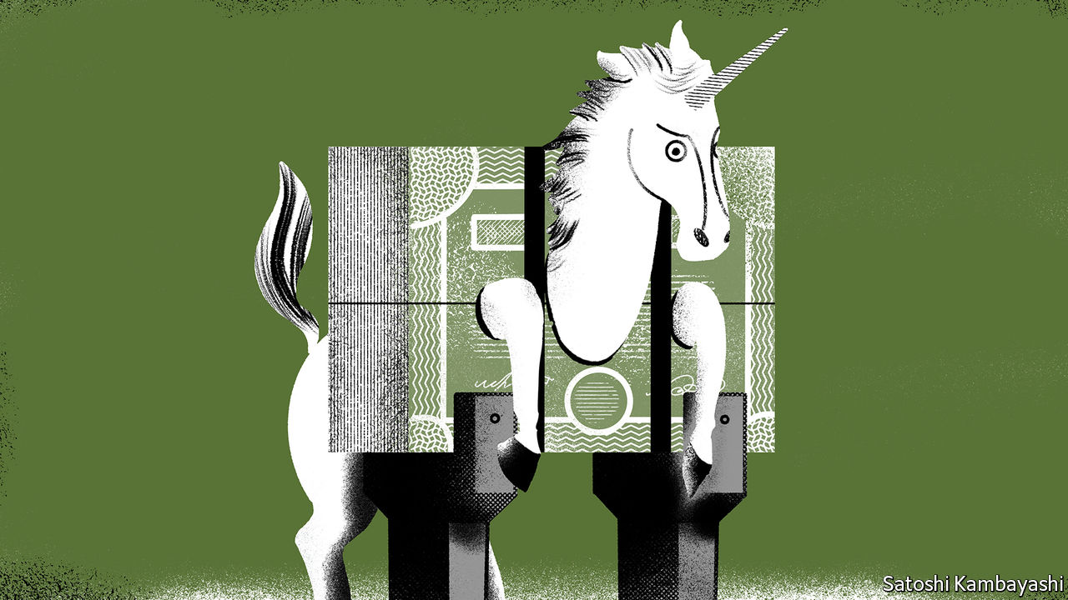

IN JULY 2006 Yahoo, a faded internet giant, offered to buy Facebook, then a fledgling, for $1bn. Billion-dollar offers for startups were then quite rare. “I thought we should at least consider it,” recalls Peter Thiel, an early Facebook backer, in his book, “Zero to One”. The initial reaction of Mark Zuckerberg, its founder, was firmly to say no. “This is just a formality,” he told his board. “We’re obviously not going to sell here.”

Entrepreneurs are supremely confident about their eventual success. They have to be. Startups usually fail; in the vernacular of Silicon Valley, they have a high “kill rate”. It takes unusual self-belief to even set up. Mr Zuckerberg’s was vindicated in spades. Until recently investors were tripping over themselves to throw money at would-be Zucks. Founders were willing to cede certain protections to their venture-capital (VC) backers to get a billion-dollar valuation. They will now regret it. They are, in effect, sitting under a mountain of debt-like claims on their companies.

Take the case of an imaginary startup. WeWhack is a tech platform that connects people who carry grudges to contract killers. (In a bull market for VC, the legal and moral concerns about the business model are dismissed as so much naysaying.) The founder, Mr Soprano, owns all of its common stock. An early-stage VC firm, called Seedy, gives him $20m in exchange for a 20% stake. Mr Soprano can boast that his company is worth $100m, the “post-money” valuation. This is the figure quoted in newspapers and trade magazines.

But in reality it is worth less. VC backers such as Seedy typically receive convertible preferred stock. This is a security that is specific to venture capital, says Jean-Noel Barrot of HEC Paris, a business school. “Convertible” means the security converts into common stock at “exit” ie, when the company is either sold to a bigger company or is listed on the stock exchange. “Preferred” means the backer will be paid back before common stockholders: it has liquidation preference. If, in our hypothetical case, the exit value is between $0 and $20m, Seedy gets everything. If it is between $20m and $100m, the VC gets $20m and Mr Soprano gets the rest. Only if the exit value is above $100m will both parties be paid in proportion to their shareholding.

Were Seedy granted common stock, Mr Soprano could in principle immediately sell WeWhack for $20m (the value of its cash holdings), pocket $16m (his 80% share) and return the rest to Seedy. Preferred stock is a disciplining device. It encourages the founder to use the $20m to create a firm that is worth a lot more.

Things become more complex as the business matures. Mr Soprano decides to sell a further 20% of WeWhack to fund its global expansion. There is lots of interest from VC firms. The highest bid comes from SoftMoney. It is willing to pay $150m for senior preferred convertible stock, meaning it is first in the queue at the exit, ahead of Mr Soprano and Seedy. The post-money valuation is $750m.

But Mr Soprano wants to be the founder of a unicorn, a startup valued at $1bn or more. SoftMoney says it will pay $200m, for a post-money valuation of $1bn, if it gets greater protection should things go wrong. It is granted two times liquidation preference: an assurance that it will make back its $200m twice over. WeWhack’s exit price must reach $400m before anyone else makes a cent. But Mr Soprano is fine with that. He is confident that his business is worth billions.

A good early-stage investment partner will advise founders not to go for a headline valuation if it comes with such terms, says Richard Wong, of Accel, a VC firm. They don’t always listen. After many funding rounds, a venture-backed company might have half a dozen layers in its capital stack, each with its own protections and voting rights.

When funds are raised at lofty values, it can create misalignment later on between founders, early-stage VCs and late-stage investors, says Simon Levene of Mosaic, a London-based VC firm. A founder sitting under a mountain of preference stock is like the manager of an over-indebted firm. In a bear market, his stake is probably worthless. So why not blow the company’s remaining cash on perks, take undue business risks (“gamble for redemption”) or simply give up? He may use his voting rights to stymie an exit for other investors. It can get messy.

Everyone can be a dreamer in a buoyant market. The kill rate is low. But when trouble strikes, it reverts to the mean—and, as a VC bigwig puts it, “a lot of things get whacked.”

Read also on: <https://www.economist.com/finance-and-economics/2020/04/08/why-a-lot-of-startups-will-come-to-regret-their-unicorn-status>

|  |  |  |  |
| --- | --- | --- | --- |
| Previous | Articles | Sections | Next |

|  |  |  |  |
| --- | --- | --- | --- |
| Previous | Articles | Sections | Next |

#### Pilgrimage to the gamma quadrant

# Joe Stiglitz and the IMF have warmed to each other

The fund seems to have won over its most fearsome critic

Apr 8th 2020 | HONG KONG

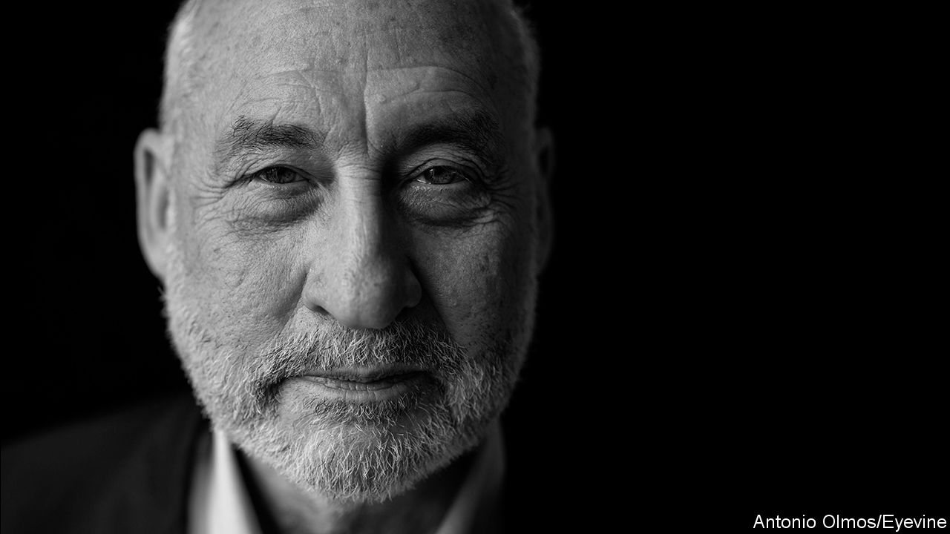

FEW JOBS are as daunting as minister of the economy of Argentina. But Martín Guzmán, who was given the post in December, has two things going for him. He is a brilliant student of unsustainable debt, which Argentina has in abundance, including $44bn owed to the IMF and almost $100bn of foreign-currency debt owed to private lenders. And he is a protégé of Joe Stiglitz, a Nobel-prizewinning economist at Columbia University who once served as chief economist of the World Bank.

That close affiliation presumably helped endear him to Argentina’s powerful vice-president, Cristina Fernández, who flouts economic orthodoxy but is fond of citing Mr Stiglitz. And the celebrated economist’s warm endorsement also gave Mr Guzmán credibility in his dealings with the IMF—or so the government must have hoped when it appointed him.

But the neat logic of his appointment surely suffers from an obvious flaw. Mr Stiglitz is admired as an economic theorist, but is also renowned as a bitter critic of the IMF. His book, “Globalisation and its Discontents”, published after the emerging-market crises from 1997 to 2001, castigates the fund for imposing unfettered capital flows, fiscal austerity and tight money on vulnerable countries. In a notorious passage, he speculated that Stan Fischer, a revered economist who was the fund’s second-in-command from 1994 to 2001, won a lucrative job at Citigroup as a reward for serving American financial interests at the IMF. In retaliation Ken Rogoff, then the fund’s chief economist, implied that Mr Stiglitz had wandered off into the “gamma quadrant”—a nerdy way of asking him what planet he was on. “It was”, Mr Stiglitz says now, “a very tense moment.”

The kind of allegations Mr Stiglitz made in his book still dog the IMF. As countries flock to it for help in handling the financial fallout of covid-19, many worry that the fund may demand austerity in return. And several of the stronger emerging economies that could qualify for the fund’s unconditional loans (known as flexible credit lines) have steered clear, fearing the stigma that any approach to the IMF still carries.

Given this bad blood, Mr Guzmán’s links with Mr Stiglitz might have been a liability rather than an asset. But the Argentines (who are nothing if not close students of the IMF) have grasped something that is still underappreciated elsewhere. Mr Stiglitz has warmed to the fund—and the fund has warmed to him.

“I’ve been amazed [and] impressed at the transformation of the IMF over the past decade and a half,” he says. The transformation began under Dominique Strauss-Kahn, the fund’s boss from 2007 to 2011, who responded to the global financial crisis with calls for stimulus, not austerity. It continued under his successor, Christine Lagarde, who championed the fund’s new concern for inequality. Economic disparities, the fund’s research demonstrated, were more damaging to growth than many economists presumed, and redistribution was less so. (These findings became a book, “Confronting Inequality” by Jonathan Ostry, Prakash Loungani and Andrew Berg, that carried a foreword by Mr Stiglitz and was published by his university.)

Kristalina Georgieva, who took over at the fund last year, “is making another very big step forward”, Mr Stiglitz says. They overlapped at the World Bank (where Ms Georgieva worked for about 20 years, all told) and kept in touch after Mr Stiglitz left. He wrote her a letter about Argentina shortly after she was appointed. And the fund quickly endorsed Mr Guzmán’s view that the country’s debt was “unsustainable”. That declaration has increased the pressure on Argentina’s creditors to forgive a hefty chunk of their claims.

The IMF’s fight against covid-19 may further redeem the institution in Mr Stiglitz’s eyes. He supports its desire for a new allocation of “special drawing rights”, which would give the fund’s poorer members a claim on the currency reserves of its richer ones (see article). It is an instrument he has promoted since at least 2006. Much of the fund’s habitual hard-nosedness reflects its fear that bail-outs might encourage imprudence. But such concerns hardly apply to a pandemic. Rescuing a country from the virus will not make it likelier to succumb to another outbreak.

Does Mr Stiglitz worry that his followers will like him less if he likes the fund more? He insists that he has stayed true to the “broad principles” that motivated his original criticisms. He has been “steadfast” in his belief that markets fail, capital can flow too freely, inequality matters and depressed economies need stimulus, not austerity. But he is, perhaps, more tactful. The revised edition of “Globalisation and its Discontents”, published in 2017, still mentions Mr Fischer’s departure for Citigroup. But the passage suggesting an explicit quid pro quo has disappeared. ■

Read also on: <https://www.economist.com/finance-and-economics/2020/04/08/joe-stiglitz-and-the-imf-have-warmed-to-each-other>

|  |  |  |  |
| --- | --- | --- | --- |
| Previous | Articles | Sections | Next |

|  |  |  |  |
| --- | --- | --- | --- |
| Previous | Articles | Sections | Next |

#### Lockdown and out

# Labour markets take a dramatic turn for the worse

America’s unemployment rate could rise to 15% this year

Apr 8th 2020 |

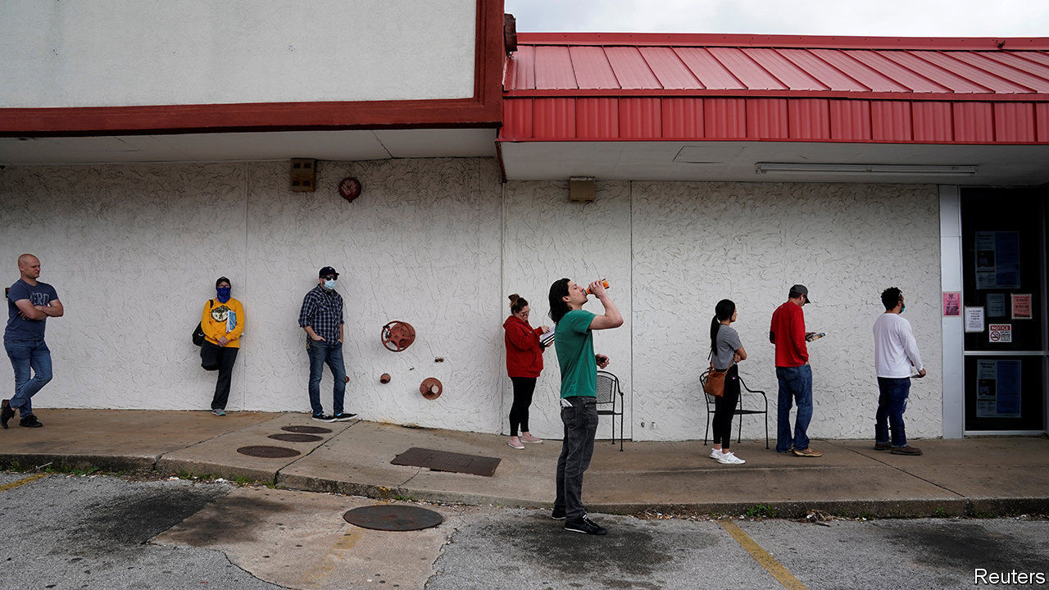

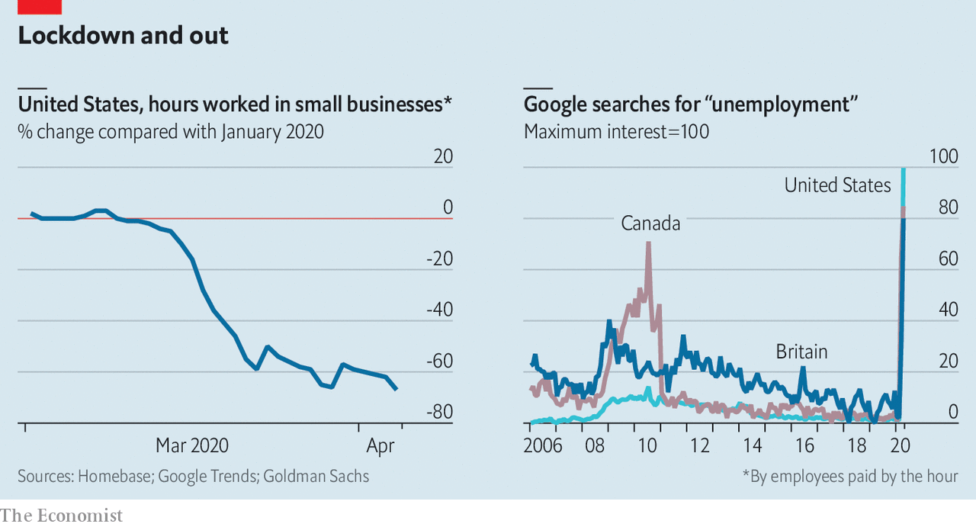

AFTER YEARS of robust health, labour markets have taken a dramatic turn for the worse. With the pandemic forcing shutdowns, many people are working fewer hours, if at all. Internet searches for “unemployment”, often a timely indicator of joblessness, are at record highs. Economists at Goldman Sachs expect the unemployment rate to reach 15% in America later this year. That is the highest for the best part of a century.

Read also on: <https://www.economist.com/finance-and-economics/2020/04/08/labour-markets-take-a-dramatic-turn-for-the-worse>

|  |  |  |  |
| --- | --- | --- | --- |
| Previous | Articles | Sections | Next |

|  |  |  |  |
| --- | --- | --- | --- |
| Previous | Articles | Sections | Next |

#### Free exchange

# Should the IMF dole out more special drawing rights?

Some economists are calling for an increase, but there are hurdles in the way

Apr 11th 2020 |

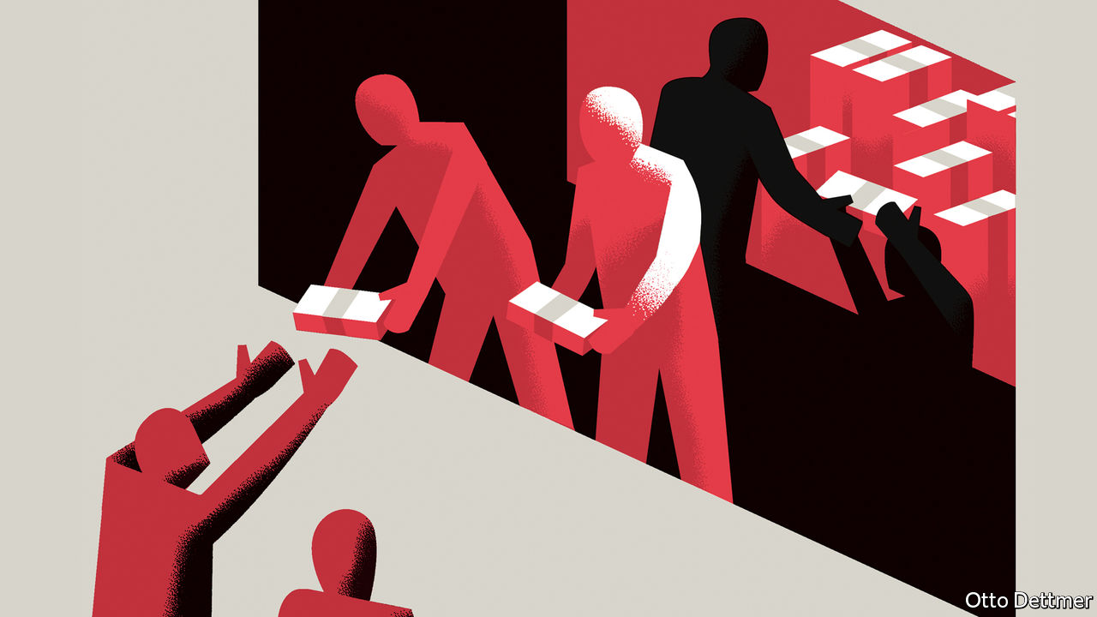

Editor’s note: The Economist is making some of its most important coverage of the covid-19 pandemic freely available to readers of The Economist Today, our daily newsletter. To receive it, register [here](https://www.economist.com/newslettersignup). For our coronavirus tracker and more coverage, see our [hub](https://www.economist.com/coronavirus)

GOVERNMENTS AROUND the world are seeing their finances savaged by the pandemic. And poor ones, who are also suffering from capital flight, are crying out for cash. The IMF, the world’s crisis lender, is already parcelling out loans. It may yet resort to a weirder weapon: the special drawing right (SDR), an arcane financial instrument designed in the 1960s. At present, some 204bn SDRs sit on the balance-sheets of finance ministries and central banks around the world. Each can, in theory, be swapped for currency worth $1.36. Governments in poor countries desperately need cash to retain investors’ confidence, pay off creditors and buy medical supplies. Some economists think an infusion of SDRs is part of the answer. Could this help tackle the corona-crisis?

When SDRs were introduced in 1969 they were intended to reduce the world’s dependence on dollars. At the time many of the world’s countries pegged their currencies to the greenback, which was itself tied to gold, under the so-called “Bretton Woods” system of fixed exchange rates. But the two components were in tension with one another. When too few dollars circulated in the world economy, perhaps as a result of America spending less on imports, countries would hoard greenbacks to defend their pegs, and global commerce ground to a halt. But creating enough dollars to satisfy the global demand for reserves imperilled the credibility of the dollar’s peg to gold. Providing an alternative reserve asset, it was thought, might provide an escape from this dilemma.

The idea was reminiscent of “bancor”, a global currency proposed by John Maynard Keynes in 1941. Like bancor, SDRs aim to share the so-called “seigniorage” benefits that accrue to America as a result of providing the world’s currency. To reinforce their balance-sheets with dollars, countries must, in aggregate, sell goods and services to America and hold on to the proceeds. But when SDRs are issued, everyone gets reserves without having to provide anything in return. Reserves fall like manna from heaven, rather than emerging from trade flows.

Yet SDRs failed to take off. The need for them became less pressing after America untethered the dollar from gold in 1971. And too few were issued. Keynes had proposed that the stock of bancors would grow in line with world trade. But political wrangling means that there have been only three allocations of SDRs, the most recent of which was in 2009. They make up less than 3% of non-gold reserves; by contrast, the dollar makes up over half.

As a source of liquidity, though, SDRs have their advantages. They are not a true currency, as they can be exchanged only between IMF members and not in private markets. Maurice Obstfeld of the University of California, Berkeley—and a former chief economist at the fund—sees them as a way to share risk. Countries are given SDRs in proportion to their IMF “quotas”, which determine their financial commitment to the fund and their voting rights. When they face a liquidity crunch, they can offer cash-rich countries SDRs in exchange for hard currency. They must pay interest, currently at a rate of 0.05%, on the amount of their SDRs they choose to convert, making exchanging an SDR a bit like drawing on an emergency overdraft—one that does not need to be repaid.

Are SDRs an appropriate crisis-fighting tool? The IMF reports that several poorer countries have called for it, and that members are discussing the idea. Rich countries are offering their citizens wads of cash with very few strings attached, say supporters. Why shouldn’t the IMF do the same for the world’s governments? Some economists want a huge allocation of SDRs, worth $4trn.

There are several hurdles in the way and these could take months to overcome. Most important, America is reluctant to issue any SDRs at all, let alone $4trn-worth. Its opposition stems from a belief that theIMF should not be printing money (when converted, SDRs increase the amount of cash in circulation). And, like other countries, it also dislikes the idea of handouts that come with so few strings attached. What if the financial lifeline allowed countries to slacken the pace of reforms, or made life easier for Iran? The IMF is supposed to support governments facing temporary liquidity problems, but also to insist on restructuring any debts that are unsustainable. An SDR allocation is described as liquidity support by its advocates, but it could help an otherwise insolvent country pay off its creditors. America’s opposition matters. Issuing SDRs worth more than $648bn would require approval from its Congress. Even a smaller issuance would require 85% of votes at the IMF. Uncle Sam, with a 16.5% share, has a veto.

Others point out that securing an SDR allocation would mean spending too much political capital for too little gain. Two-thirds would go to rich countries or those with plenty of reserves. In 2009 183bn SDRs were issued to help fight the global financial crisis. But Ousmène Mandeng of Economics Advisory, a consultancy, finds that emerging markets (excluding China and members of the European Union) swapped just 1.9bn for cash in 2009-10.

## Every little helps

However, SDRs do not have to be used to be useful. Their very presence on balance-sheets frees up dollars. And though the sums involved might be too small to matter to many countries, the share of a $500bn issuance flowing to the likes of Liberia or South Sudan would be worth 7-8% of GDP, says Sergi Lanau of the Institute of International Finance, an industry group. With global demand collapsing and the world scrambling for dollars, now is not the time to dwell on the question of whether countries face solvency or liquidity crises. Poor countries just need help, fast. It is worth taking some risks to make sure they get it.

It is perhaps no surprise that America has doubts about an instrument first designed to reduce the dollar’s dominance. Keynes proposed bancor just after sterling lost its sway. It might take the emergence of a serious challenger to the dollar’s crown before America sees the appeal of the SDR.

Dig deeper:  
For our latest coverage of the covid-19 pandemic, register for The Economist Today, our daily [newsletter](https://www.economist.com/newslettersignup), or visit our [coronavirus tracker and story hub](https://www.economist.com/coronavirus)

Read also on: <https://www.economist.com/finance-and-economics/2020/04/11/should-the-imf-dole-out-more-special-drawing-rights>

|  |  |  |  |
| --- | --- | --- | --- |
| Previous | Articles | Sections | Next |

|  |  |  |
| --- | --- | --- |
| Finance and ... | Sections | Books and arts |

Science and technology

Covid-19 (1): Maskarade

.

Covid-19 (2): Absence of evidence is not evidence of absence

.

|  |  |  |
| --- | --- | --- |
| Finance and ... | Sections | Books and arts |

|  |  |  |  |
| --- | --- | --- | --- |
|  | Articles | Sections | Next |

#### Disease transmission

# Should the public wear masks to slow the spread of SARS-CoV-2?

Yes, but not at the expense of those worn by medical staff

Apr 11th 2020 |

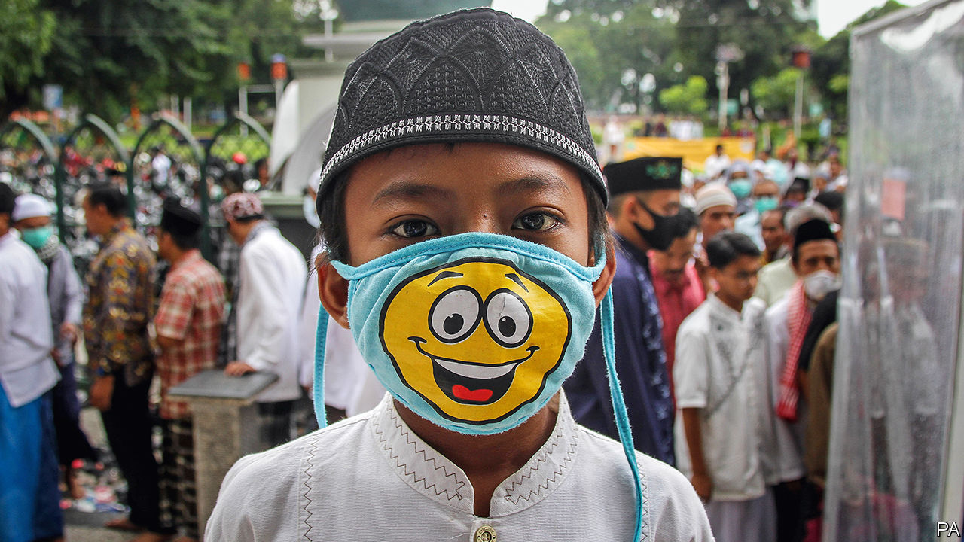

Editor’s note: The Economist is making some of its most important coverage of the covid-19 pandemic freely available to readers of The Economist Today, our daily newsletter. To receive it, register [here](https://www.economist.com/newslettersignup). For our coronavirus tracker and more coverage, see our [hub](https://www.economist.com/coronavirus)

THE WORLD HEALTH ORGANISATION (WHO) says don’t bother. The British government agrees. America’s Centres for Disease Control and Prevention (CDC) initially discouraged it but by the beginning of April had reversed course. In parts of Asia, including China, it is baked into public behaviour and encouraged by health agencies, even when there is no ongoing public-health crisis. The issue? Whether or not members of the public should wear face-masks in a bid to slow the spread of SARS-CoV-2, the virus responsible for the covid-19 pandemic.

Understanding all the ways that SARS-CoV-2 is transmitted is a matter of active scientific discussion. In the main, though, the virus hitches a ride on droplets of mucus or saliva that come out of the respiratory tracts of infected individuals. These may be expelled during normal breathing or, more commonly, as a cough that propels them a few metres into the air. Thus propelled, they may reach another person’s eyes, mouth or nose directly, and go on to infect cells in that individual’s airways. Or they may land on a surface, on which the virus particles they contain could survive for hours, or even days, and from which those particles may eventually be transferred to others who touch the surface and then touch their own face or mouth.

There is no doubt that masks form a barrier to transmission, by stopping droplets passing from infected to uninfected people close by. The WHO recommends standard surgical masks as part of the personal protective equipment to be worn by doctors and nurses who are caring for covid-19 patients in clinics and hospitals. The same goes for anyone caring for a patient at home. In most instances this is good enough, according to a meta-analysis of four randomised controlled trials that was published this month in Influenza by Mark Loeb of McMaster University, in Canada. Indeed, Dr Loeb found no significant differences between surgical masks and their more sophisticated cousins, N95 respirators, when it came to protecting health-care workers from viral infections transmitted by droplets—including those caused by coronaviruses.

This suggests that N95 respirators (which are thicker, more rigid, and designed to form a close seal around the nose and mouth) should be reserved for riskier situations. “N95” means they block at least 95% of particles smaller than 0.3 microns across. They are, therefore, appropriate for situations when the threat comes from objects smaller than exhaled droplets—meaning less than about five microns across. These particularly include times when doctors and nurses need to “intubate” a patient in an intensive care unit, by inserting the tube of a ventilator deep into that patient’s trachea. Intubation is a forceful procedure, and it creates aerosol particles (ie, smaller than five microns) that may carry viruses much farther through the air than droplets can manage. Though it remains unclear whether SARS-CoV-2 is transmitted via aerosols in this way, those performing intubations should be cautious, says Lisa Brosseau, a respiratory-protection and infectious-diseases scientist at the University of Illinois at Chicago.

Guidance for health-care workers is, therefore, clear: wear masks. Advice for members of the public has been more variable. Since the start of the outbreak the WHO and the CDC have advised people to avoid the use of masks unless they are in direct contact with symptomatic covid-19 patients. This is because such masks are a scarce resource. At the end of February Jerome Adams, America’s surgeon-general, beseeched his fellow citizens on Twitter to “seriously people—STOP BUYING MASKS!” because a run on them might cause supply problems for health-care workers.

A month or so later, the advice seems to be changing. The CDC now encourages the populace to wear homemade coverings for their mouths and noses. Dr Adams himself starred in an official video demonstrating how to use rubber bands around folded pieces of cloth to make DIY masks. Recently, the Czech Republic and Slovakia started requiring anyone stepping out into certain public places to use nose and mouth coverings. The same rule applies in Lombardy, in northern Italy, which was the centre of the covid-19 outbreak in that country. And Austria now requires masks in places such as supermarkets and pharmacies.

The changing advice is testament to an evolving understanding of SARS-CoV-2 itself, and also to continuing debate among scientists about how far previous research on the effectiveness of masks can usefully be brought to bear on the current crisis.

It might seem intuitively obvious that having people cover their noses and mouths in public would be useful. In fact, the science of the matter is not clear-cut. Extrapolating to the laity the research which shows that masks and respirators are effective for those who work in health care is actually problematic.

One reason is that doctors and nurses are better-trained than others in how to wear these devices. For example, surgical masks work less well when they become moist, and so need to be replaced regularly throughout the day. Health-care workers will do this routinely. A member of the public might not. As to N95 respirators, they are notoriously difficult to fit in a way that seals them properly to a user’s face. Yet not fitting them correctly can negate their benefits—as can touching the front of a mask, or taking it off in the wrong way and so contaminating your hands.

Nor do masks and respirators protect people’s eyes from virus particles. Only close-fitting goggles can do that. Finally, as Susan Michie, a health psychologist at University College London, observes, people might feel a false sense of security when wearing masks, and thus pay less attention to other important behaviours such as social distancing and handwashing.

This does not, of course, show that masks for the public are of no use. A better way to think about them in this context might be that, rather than helping healthy people shield themselves from infection, they could be used to stop those who are already infected broadcasting the virus into the air around them. Given that much transmission of SARS-CoV-2 is suspected to occur before someone who has the virus actually shows any symptoms (see following article), encouraging everyone to wear masks in public regardless of whether they are symptomatic could be a useful way to break the chain of transmission.

A study published in the current edition of Nature Medicine backs this idea up. Ben Cowling, an epidemiologist at Hong Kong University, measured the amount of virus shed, in half an hour of breaths and coughs, by participants infected with a variety of respiratory viruses, including influenza, rhinovirus and coronaviruses (though not SARS-CoV-2). In the case of those with coronaviruses, 30% of droplets and 40% of aerosol particles exhaled by participants without a surgical face-mask on contained virus particles. When they wore masks, that dropped to zero.

## Do it yourself

Rupert Beale, an infections biologist at the Francis Crick Institute in London, says that Dr Cowling’s study presents “strong and compelling” evidence in favour of the public wearing masks, but he warns that this approach should not be used in isolation. It could instead form part of a wider “exit strategy” from lockdown, combined with tried-and-tested measures including continued social distancing and thorough handwashing.

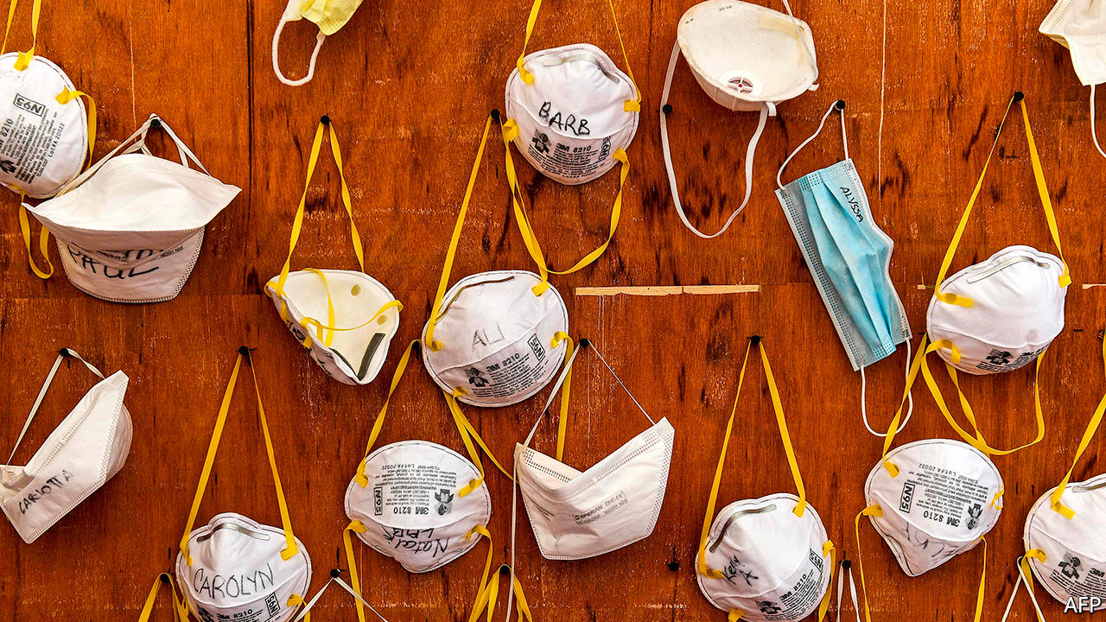

This only works, though, if there are enough masks to go around. According to the WHO, “the chronic global shortage of personal protective equipment is now one of the most urgent threats to our collective ability to save lives. We must provide the protection health-care workers deserve to save our lives.”

Which means that, if mask-wearing is to become a widespread weapon in the armoury, members of the public may have to make their own. This is not as bad as it sounds. An experiment carried out in 2013 by Public Health England, that country’s health-protection agency, found that a commercially made surgical mask filtered 90% of virus particles from the air coughed out by participants, a vacuum cleaner bag filtered out 86%, a tea towel blocked 72% and a cotton T-shirt 51%—though fitting any DIY mask properly and ensuring a good seal around the mouth and nose is crucial.

Elaine Shuo Feng, an epidemiologist at Oxford University, has surveyed the varying advice given to members of the public around the world. In a commentary published recently in the Lancet Respiratory Medicine she and her colleagues argued that the absence of robust evidence on the public use of masks should not prevent precautionary action. It would be rational, they conclude, to recommend that people in quarantine who are not symptomatic wear face-masks if they need to leave home for any reason, in order to prevent potential asymptomatic or presymptomatic transmission if they unknowingly have the virus. Vulnerable populations, such as older adults and those with underlying medical conditions, should probably also wear face-masks if available.

For everyone else, washing hands and maintaining social distance is the most important way to keep transmission down. Wearing masks in public does no harm, and may do some good—but that is always providing it does not reduce the supply available to local doctors and nurses. ■

Dig deeper:  
For our latest coverage of the covid-19 pandemic, register for The Economist Today, our daily [newsletter](https://www.economist.com/newslettersignup), or visit our [coronavirus tracker and story hub](https://www.economist.com/coronavirus)

Read also on: <https://www.economist.com/science-and-technology/2020/04/11/should-the-public-wear-masks-to-slow-the-spread-of-sars-cov-2>

|  |  |  |  |
| --- | --- | --- | --- |
|  | Articles | Sections | Next |

|  |  |  |  |
| --- | --- | --- | --- |
| Previous | Articles | Sections | Next |

#### Silent disease-spreading

# How important is “silent spreading” in the covid-19 epidemic?

Possibly, very

Apr 11th 2020 |

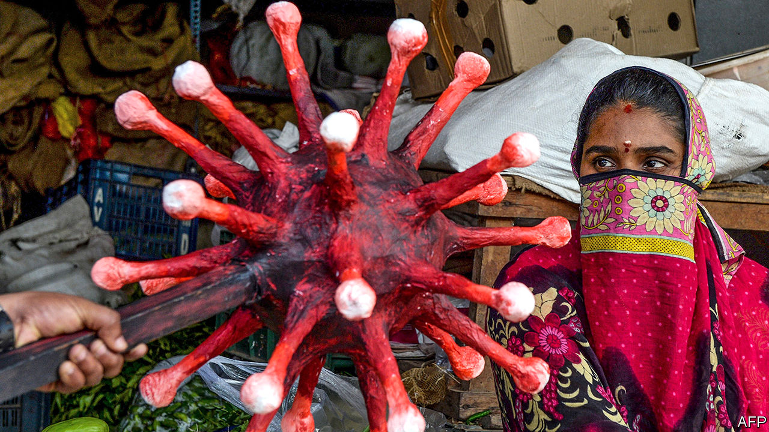

Editor’s note: The Economist is making some of its most important coverage of the covid-19 pandemic freely available to readers of The Economist Today, our daily newsletter. To receive it, register [here](https://www.economist.com/newslettersignup). For our coronavirus tracker and more coverage, see our [hub](https://www.economist.com/coronavirus)

FEW STORIES are as prominent in the study of infectious diseases as that of Mary Mallon, a cook to wealthy families, and also to a maternity hospital, in New York in the early 1900s. As she went from one employer to another, typhoid fever, then deadly in one case in ten, followed in her wake. Public-health officials eventually joined the dots and identified her as a carrier of Salmonella typhi, the bacterium that causes the disease. What was striking about Typhoid Mary, as the newspapers nicknamed her, was that she herself was healthy—proof that people could harbour and transmit S. typhi without showing symptoms of the illness it causes.

Such silent transmission, as epidemiologists call the phenomenon, has since been observed in many diseases—among them measles, influenza and HIV/AIDS. A fresh addition to the list is SARS-CoV-2, the coronavirus behind the covid-19 pandemic now raging. Accumulating evidence suggests a substantial chunk of the infections it causes are transmitted by people whose symptoms have not yet appeared—or even, like Mallon, who never develop symptoms at all. That has implications for the methods countries are employing to curb the pandemic (see article).

Currently, none of the evidence on asymptomatic transmission is watertight. According to Gerardo Chowell of Georgia State University, in Atlanta, the best way to determine the share of SARS-CoV-2 infections that happen in this way is to follow up a large number of households in which someone is already infected and then track who subsequently infects whom. For this to work, everyone involved would have to be tested daily. If this were done, comparing subtle variations from person to person in the virus’s genetic material would show who caught it from whom.

Definitive studies of this nature are not yet available, though some are probably in the works, Dr Chowell reckons. In the meantime, a growing collection of other research is shedding light on the matter. This work comes in three strands.

The first is a set of studies of people in groups for which unusual circumstances have made possible tallying each and every infection. These studies permit a fairly precise estimate of the share of those infected who have no symptoms. One such group are the passengers and crew of the Diamond Princess, a cruise ship on-board which the infection rate exploded because of a bungled quarantine. Of 634 people thus infected, 52% had no symptoms at the time of testing, including 18% who never developed symptoms. The residents of Vo, an Italian town in which all 3,300 people were tested twice, is another much-cited example. Of those in Vo found to be infected, 50-75% had no symptoms at the time of the test. A smaller but similarly useful cohort was several planeloads of Japanese evacuated from Wuhan, the Chinese city where the epidemic began. Among the 12 people in this group found to be infected, five have never developed symptoms.

## The rest is silence

All this suggests that the number of infected people unwittingly infecting others could be quite large. What is unclear is how infectious these people actually are. That is what the second strand of research on the asymptomatic and presymptomatic transmission of SARS-CoV-2 deals with. It draws on various laboratory studies. In several of these the amount of the virus in nasal and throat swabs taken from infected people who were presenting no symptoms at the time was similar to the amount found in those who had symptoms. Indeed, for those who do go on to develop symptoms, the amount of virus they have in them peaks close to the onset of those symptoms, which suggests that it may be easily transmissible at an early stage of infection.

As a persistent cough is a common symptom, it might be expected that those who are symptomatic are more effective in spreading the virus than those who are not. Contrariwise, however, those with symptoms often feel unwell and take to their beds. They are, therefore, coughing mainly onto their sheets and blankets rather than onto strangers in the street.

The third strand of research into the question of silent spreading is mathematical modelling. One such study was published in Science on March 31st by Luca Ferretti of Oxford University and his colleagues. It used data on 40 infected people for whom the source of their infection was known with high probability, and the timing of their symptoms and those of the people who infected them was well documented. The researchers estimate that between a third and a half of transmission occurs from people who are without symptoms at that point—a result which broadly agrees with estimates from similar studies by others.

Collectively, all this research may help explain why SARS-CoV-2 has spread with such ferocity. But the study, in particular, of those who are infected but never present symptoms is also crucial to understanding how that spread may ebb—for the pool of those who have been infected and are, therefore, immune to reinfection at least in the short term also includes these people. Pandemics end when the pathogen causing them runs out of individuals to infect. Some of those susceptible will have died. Enough of the rest would then be immune for the population to have developed “herd immunity”. In the case of the current pandemic of SARS-CoV-2, the more silent infections there have been, the faster this herd immunity will arrive.■

Dig deeper:  
For our latest coverage of the covid-19 pandemic, register for The Economist Today, our daily [newsletter](https://www.economist.com/newslettersignup), or visit our [coronavirus tracker and story hub](https://www.economist.com/coronavirus)

Read also on: <https://www.economist.com/science-and-technology/2020/04/11/how-important-is-silent-spreading-in-the-covid-19-epidemic>

|  |  |  |  |
| --- | --- | --- | --- |
| Previous | Articles | Sections | Next |

|  |  |  |
| --- | --- | --- |
| Science and ... | Sections | Economic and ... |

Books and arts

Art and injustice: Vengeance is hers

.

London fiction: Through the trapdoor

.

Postcards from doomsday: This is the end

.

Do the right thing: Walking on by

.

Soviet dissidents: Keeping the flame alight

.

Trollope’s world: The way to live now

.

TV drama: A Flemish Robin Hood

.

|  |  |  |
| --- | --- | --- |
| Science and ... | Sections | Economic and ... |

|  |  |  |  |
| --- | --- | --- | --- |
|  | Articles | Sections | Next |

#### Vengeance is hers

# A new breed of feminist avengers are righting overlooked wrongs

Now and in the past, revenge drama is popular when ideas of power and justice are in flux

Apr 8th 2020 |



HE DOES NOT recognise her, and protests only gently when she handcuffs him to the bed. He is enjoying his bachelor weekend and assumes that this woman, in her short, tight nurse’s costume, is a stripper ordered for the festivities. While she assembles her props she reminisces about her best friend, Nina, whom the man raped at a party when they were students, and who later committed suicide.

The man begins to panic, denying that the crime ever took place. “It’s every guy’s worst nightmare, getting accused like that!” he protests. “Can you guess what every woman’s worst nightmare is?” his captor retorts, before reaching into her medical bag and producing a scalpel.

Cassie (Carey Mulligan), the protagonist of “Promising Young Woman”, which had its premiere at the Sundance Film Festival in January, has been trying to avenge her friend’s assault for almost a decade. She began by going to bars, acting as if she were “too drunk to stand” and waiting for a “nice guy” to take her home, before shaming them for their predatory behaviour. Then, hearing that Nina’s rapist has returned to their college town to get married, Cassie sets about targeting everyone she considers responsible for her death: a friend who was dismissive of her experience, the university official who “felt there wasn’t sufficient evidence” to take action, the lawyer who bullied Nina until she dropped her case and, ultimately, the attacker himself.

“Promising Young Woman” is the latest in a spate of recent films, plays and television series that depict women taking revenge for wrongs committed against them. Like other crime dramas, several of these narratives focus on sexual abuse, only now the women are more than ornamental corpses. “Sweet/Vicious”, a television show, follows two students-turned-vigilantes as they hunt down young men who have carried out sexual assaults on campus. The protagonist of “M.F.A.”, a feature film, goes on a spree murdering college rapists after accidentally killing her own attacker in self-defence.

Some of these stories have unfolded in the past, such as “The Nightingale”, a film set in colonial Tasmania during the 1820s. Others are modern retellings of old tales, such as “Women Beware Women”, a play of 1623 by Thomas Middleton that was recently produced at the Globe theatre in London, in which a powerful duke sexually assaults a young bride. Separately, Middleton’s work has been reimagined by Simon Stone, an Australian theatre director, for “The Revenge Trilogy”, performed at the Théâtre de l’Odéon in Paris last year, which also adapted scripts by William Rowley (“The Changeling”), William Shakespeare (“Titus Andronicus”) and John Ford (“’Tis Pity She’s a Whore”). Despite their varied milieus, all these productions are concerned with sex, power and its misuse.

Other modern revenge dramas portray different types of abuse. In “Judy and Punch”, a film about the puppeteers who gave their names to their famous creations, Punch is a drunk who beats Judy and leaves her for dead. An adaptation of “Medea”—in which a woman wreaks a terrible punishment on the man who abandoned her, reworked by Mr Stone from Euripides’s tragedy—recently closed in New York, following runs in Amsterdam, Madrid and London. A new version of “The Visit” by Tony Kushner, a Pulitzer-prizewinning playwright, was on at the National Theatre in London before covid-19 struck. The main character was impregnated as a teenager and cast out of her hometown. Decades later she returns as the world’s wealthiest woman, promising to enrich the locals in exchange for her old lover’s life.

This boom in fictional retribution follows a historical pattern. Though revenge has inspired dramatists for millennia, the theme is especially popular in times of political and social upheaval, when attitudes to power and justice are in flux. “Revenge became a central theme in Greek tragedy at a time when Athenian law courts were heatedly debating questions about causation, responsibility and guilt,” says Tanya Pollard of Brooklyn College. Aeschylus and others “started wrestling with questions about how to assign blame and mete out punishment to stop cycles of violence”.

## The new avengers

In early modern Britain, when Middleton and his contemporaries were at work, the law was changing from a system of private redress to one administered centrally. Emma Smith of Oxford University says the period saw “a huge amount of litigation”, particularly relating to personal grievances such as ownership rights. Yet old habits, such as duelling, persisted in real life and on stage, as did doubts over the law’s fairness to ordinary people.

From the 1950s onwards, as war, protests and scandal increased scepticism of authority among American audiences, they came to love cowboys and mafiosi who took the law into their own hands. In Britain, meanwhile, revenge plays were frequently staged during the industrial unrest of the late 1970s; others were inspired by the Troubles in Northern Ireland.

Another kind of injustice and indignation is galvanising storytellers now. As prominent court cases have highlighted the difficulties of prosecuting sexual crimes—and as patience with the system runs out—wronged female characters have assumed the avenger’s mantle. “If the law is ineffective, the rough justice of vigilantes has its appeal,” says John Kerrigan of Cambridge University. In this genre women make compelling heroes, Mr Kerrigan thinks, because they are “more often denied justice along official channels dominated by men and the interests of power”.

The women in these stories turn to revenge only after they are failed by the institutions supposed to protect them. Legitimate recourse against Punch is denied to Judy in a town ruled by the mob. In “The Visit” Claire takes Alfred, the father of her child, to court to establish paternity; he pays his friends to testify that she was promiscuous. (After she gains her fortune, she hires the judge who presided over the case to work as her butler, a symbolic confirmation that justice can be bought.) Jeremy Herrin, the director, says the drama explores what happens when trauma is left to fester without resolution.

Similarly, the assaults in “M.F.A.” and “Promising Young Woman” are reported to a university official—in both cases, a woman—who does nothing. “I kept seeing a lot of the same story in the news,” says Leah McKendrick, the writer of “M.F.A.”. “A young female is raped on a college campus, she’s brave enough to report it and is treated like a liar and a gossip and a problem.” She began work on the film in 2014 in pursuit of “some fantastical justice”; it was released just as Harvey Weinstein’s depredations began to be exposed.

“For anyone who’s felt outraged at being treated unfairly,” says Ms Pollard, the academic, “it can be cathartic to cheer on a fictional surrogate who’s licensed to act out our grievances.” But like the #MeToo movement with which the genre has coincided, these feminist revenge dramas are less interested in vanquishing a single bad guy than in purging a rotten system. And, like the most enduring avengers of previous eras, the best new stories feel both acutely contemporary and ageless. “There are elements to [“Promising Young Woman”] that are timely,” Emerald Fennell, the writer and director of the film, has said; all the same, “women have been talking about [these issues] for many, many centuries.” ■

Read also on: <https://www.economist.com/books-and-arts/2020/04/08/a-new-breed-of-feminist-avengers-are-righting-overlooked-wrongs>

|  |  |  |  |
| --- | --- | --- | --- |
|  | Articles | Sections | Next |

|  |  |  |  |
| --- | --- | --- | --- |
| Previous | Articles | Sections | Next |

#### Through the trapdoor

# “You People” dramatises the underside of London

Nikita Lalwani’s novel insists on the humanity of individuals who often seem invisible

Apr 8th 2020 |

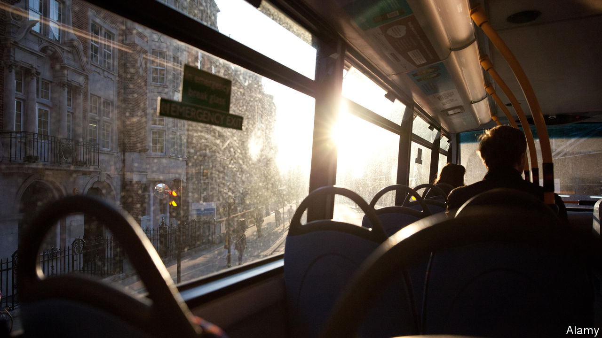

You People. By Nikita Lalwani.Viking; 240 pages; £12.99.

SIVARAM SHAN is on a London bus when he is insulted by a mother with a sick child. Heading home after a long hospital wait, the woman has no doubt who is to blame for the health system’s burdens, slapping him with the lazy xenophobic slur that provides the title of Nikita Lalwani’s emotive third novel.

It opens in 2003 in a south-west London neighbourhood on the cusp of gentrification. There, alongside a Polish greasy spoon, an Australian pub and a Chinese grocery, sits the Pizzeria Vesuvio. Its Singaporean owner, Tuli, is a ponytailed live wire who sweeps in wearing a gangster’s floor-length leather coat and presents himself as the local benefactor, serving off-menu cigarettes and loans to waifs and strays.

Tuli’s devoted but hard-up employees include Nia, a 19-year-old Welsh-Indian waitress and Oxford drop-out, and Shan himself, a trainee geologist who has fled to Britain from the Sri Lankan civil war. Compelled to claim asylum after his father was murdered on the street by government forces, he is unable to trace the wife and young son he left behind.

This sinuous morality tale unfurls from the alternating perspectives of Nia and Shan. Slinking along like a thriller, it encompasses people-smuggling, the labyrinthine inhumanity of Britain’s immigration system, alcoholism and a class prejudice that cuts both ways. Kindness and its motives are a constant preoccupation. There are worlds within worlds in this metropolis, an incubator of crippling loneliness as well as of very real, if makeshift, communities. “This is London,” Shan reflects as he traverses a grim dual carriageway fringed with blossoming trees. “This contrary indication of motor-loud madness and real, actual breathing life.”

As Shan navigates the instability and sheer exhaustion of life as an illegal migrant, Tuli steps in to help find his missing family, opening a trapdoor into a shady underworld. Meanwhile, Nia (the least convincing of Ms Lalwani’s characters) reveals demons of her own.

Theirs is a dark story, but even at its bleakest, Ms Lalwani’s prose has a balletic lightness. She notes the way a would-be rapist is “sticky with the eyes”, or a drug-dealer’s “large white wedding cake of a trainer”, then pivots to calculate the toll exacted by the moral challenges that Shan and his counterparts face every day. Her blunt title ultimately comes to seem at once an accusation of her readers and an ethical imperative: to recognise the individuality of struggling people who can often seem invisible to the likes of the diners at the Vesuvio.

Read also on: <https://www.economist.com/books-and-arts/2020/04/08/you-people-dramatises-the-underside-of-london>

|  |  |  |  |
| --- | --- | --- | --- |
| Previous | Articles | Sections | Next |

|  |  |  |  |
| --- | --- | --- | --- |
| Previous | Articles | Sections | Next |

#### This is the end

# The eccentric consolation of “Notes from an Apocalypse”

Mark O’Connell’s postcards from doomsday are oddly uplifting

Apr 8th 2020 |

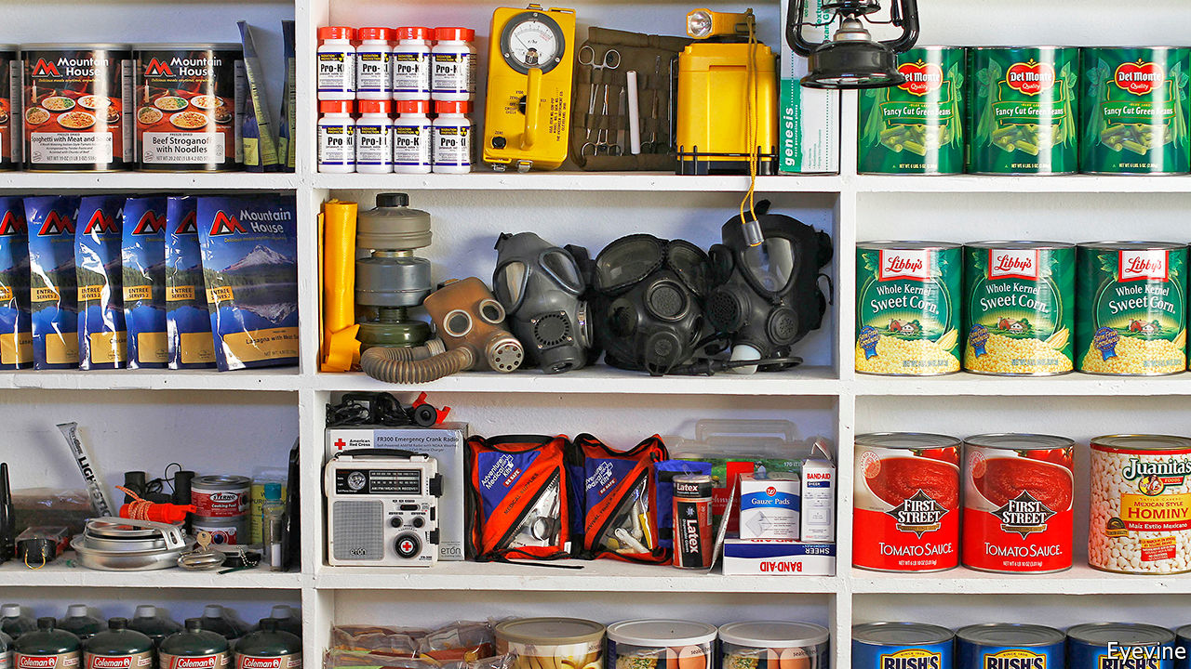

Notes from an Apocalypse. By Mark O’Connell.Doubleday; 272 pages; $26.95. Granta; £14.99.

FOR MUCH of human history, Mark O’Connell points out in “Notes from an Apocalypse”, the world has been about to end. As St Augustine observed in the fifth century, the earliest followers of Jesus believed themselves to be living in the last days of creation. In the centuries since, humans have faced plagues and fires and floods and earthquakes and wars and the threat of nuclear annihilation—perpetually proclaiming the end of days. All the while, the world has continued spinning on its axis. But, the author asks, amid an increasingly irreversible climate crisis, what if now really is the end?

When he began writing this book, Mr O’Connell says, he was depressed, a malaise brought on by an obsession with the future—or rather, with the possible lack of it. He pondered the individual’s role in the age of climate change, and his own responsibilities as a father. “I couldn’t sneeze without thinking it was a portent of end times,” he writes. He was spending too much time on the internet (he had set his home-page to an online forum devoted to the topic of “collapse”). In the grip of this doomsday spiral, Mr O’Connell set out to probe both the reality and the idea of the looming crisis, embarking on what he calls “a series of perverse pilgrimages”.

He delves into the internet subculture of “preppers”, a group mostly comprising American men who stockpile freeze-dried food and guns. He treks to the Black Hills of South Dakota, where a property magnate is hawking survivalist bunkers, and stops at a Mars Society Convention in California. He goes on a nature retreat with a group that believes Western civilisation is destined to disintegrate and seeks alternative forms of society. For his best chapter, he goes to the ruins of Chernobyl and considers the ironies of apocalypse tourism.

These vignettes offer a fascinating insight into a species obsessed with its own demise—and into the ways humankind is trying to confront the hard-to-bear reality of climate change. These range from the absurd (colonisation of Mars), to the selfish (billionaires buying up New Zealand), to the poignant (difficult conversations with young children). Along the way, Mr O’Connell moves nimbly between scenes and eras, skipping from the poetry of Czeslaw Milosz to a history of the Grand Tour. It helps that he is funny, too. Oddly, all these ruins leave him feeling more peaceful, though the process of parenting might also have helped.

Readers, for their part, will emerge feeling doomed—yet oddly uplifted. “The fact that the world is continuing on as always—that the sun is shining, and the bees circling the clover, and the tomatoes ripe in the fields—doesn’t mean it hasn’t already come to an end,” Mr O’Connell reflects. One of the strengths of his book is that it simultaneously makes the reverse of that proposition clear: the world is ending, and, as usual, it is carrying on. “Notes from an Apocalypse” was written before the covid-19 pandemic, but it offers a timely if eccentric consolation all the same. ■

Read also on: <https://www.economist.com/books-and-arts/2020/04/08/the-eccentric-consolation-of-notes-from-an-apocalypse>

|  |  |  |  |
| --- | --- | --- | --- |
| Previous | Articles | Sections | Next |

|  |  |  |  |
| --- | --- | --- | --- |
| Previous | Articles | Sections | Next |

#### Walking on by

# Why do so many people fail to do what they know is right?

Catherine Sanderson tries to find out—and asks what can be done to turn bystanders into “moral rebels”

Apr 8th 2020 |

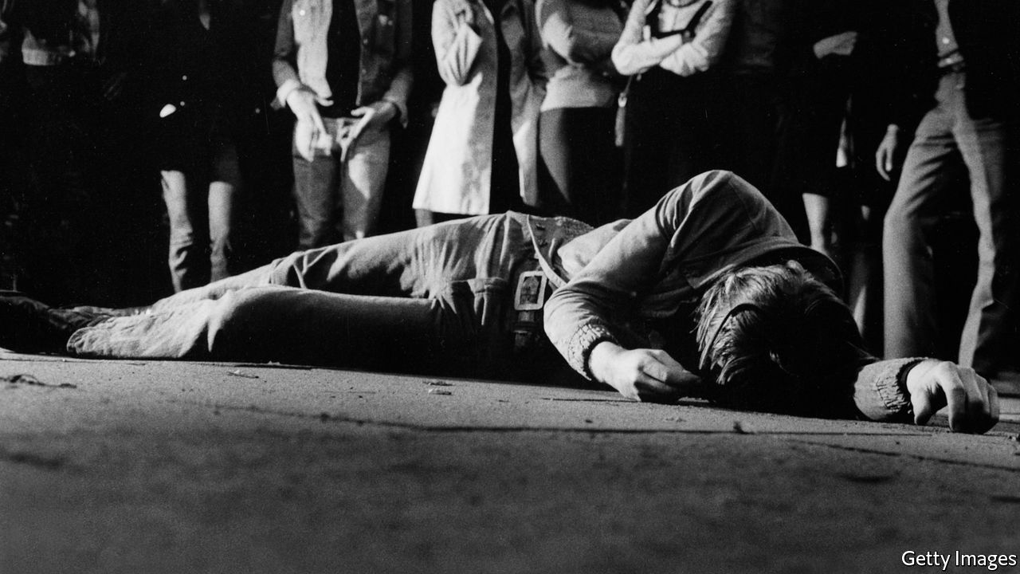

Why We Act. By Catherine Sanderson.Belknap Press; 272 pages; $27.95. Published in Britain as “The Bystander Effect”; William Collins; £20.

WHAT WOULD you do if you saw someone lying unconscious in the street? Would it make a difference if you were rushing to an important appointment? Why do so many people who say they deplore racism and sexism do little to challenge them in practice? And what can be done to purge the conformism that deters complaints about toxic colleagues, for fear of ostracism or career setbacks?

These are among the questions that Catherine Sanderson, an American professor of psychology, addresses in her new book, an examination of moral courage and its disappointing scarcity. Ms Sanderson thinks bullying, political corruption and corporate crime flourish because of “the failure of good people to stand up and do the right thing”. Drawing on an abundance of research in social psychology, she probes why this is the case—analysing, for instance, how witnesses to wrongdoing perform “subconscious cost-benefit analysis”, which typically reinforces the “natural human tendency to stay silent”.

Ms Sanderson maintains that even minor transgressions should be called out, because getting away with them makes the offender more likely to graduate to worse ones. She describes how people who socialise in groups generally leave poor tips for waiting staff, “assuming that their own contributions will not be noticed and that others will contribute more to compensate”. This is known as “social loafing”; in other contexts, such willingness to hide in a crowd can have graver consequences.

The author elucidates several similar terms. “Evaluation apprehension” is being inhibited from taking action by worries about looking silly. “Pluralistic ignorance” is the phenomenon whereby someone privately rejects a certain doctrine or attitude, yet goes along with it on the incorrect assumption that it is widely held.

This book’s chief virtue lies in its wealth of instructive examples—whether about employees’ silence over fraud at Enron, the murder of James Bulger, a Merseyside toddler, or the efforts of the helicopter pilot Hugh Thompson Jr to halt the My Lai massacre. The downside is that its insights are sometimes banal. “We tend to feel greater connection to members of our own group,” Ms Sanderson writes, as a prelude to explaining why Manchester United football fans are more likely to help a distressed person wearing their team’s shirt than one in the colours of their rivals Liverpool. “Creating a greater sense of connectivity at school”, she advises, can “go a long way toward combating the widespread apathy of high schoolers”.

A new lexicon is required, the author concludes. To this end, she cites Jeffrey Wigand, a biochemist who in the 1990s revealed that Brown & Williamson, a tobacco firm, was manipulating its products to make them more addictive. Mr Wigand thinks the word “whistleblower” is “laden with pejorative connotations” and should be replaced by “person of conscience”.

Ms Sanderson prefers the term “moral rebels”, and sets out some practical strategies to inspire more of them. “Create a culture of speaking up,” she suggests, and encourage children to question authority. But she is aware of the obstacles, too. “We need to develop our ability to feel empathy,” she writes, while conceding this will be tricky in an age suffused with narcissism. ■

Read also on: <https://www.economist.com/books-and-arts/2020/04/08/why-do-so-many-people-fail-to-do-what-they-know-is-right>

|  |  |  |  |
| --- | --- | --- | --- |
| Previous | Articles | Sections | Next |

|  |  |  |  |
| --- | --- | --- | --- |
| Previous | Articles | Sections | Next |

#### Keeping the flame alight

# A chronicle of heroism in the Soviet Union

Historians who think the dissident movement was ineffective are mistaken

Apr 8th 2020 |

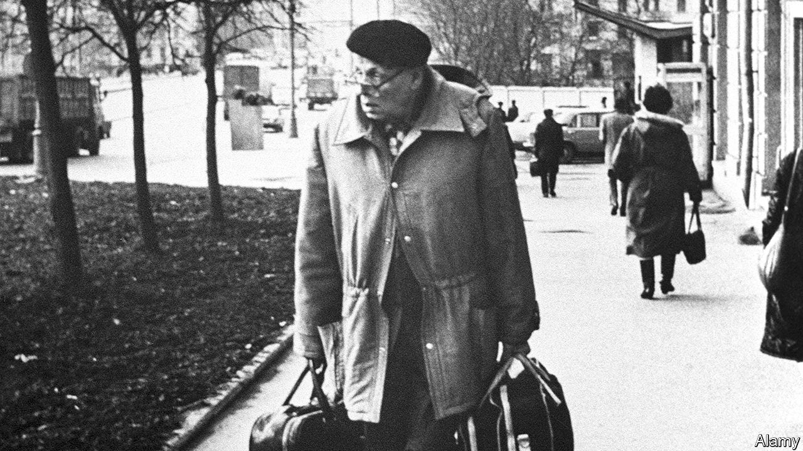

The Dissidents. By Peter Reddaway.Brookings Institution Press; 320 pages; $29.99 and £25.50.

IT IS FASHIONABLE for academics to argue that the doughty band of dissidents who fought for freedom in the Soviet Union, during the decades between the death of Josef Stalin and the collapse of communism under Mikhail Gorbachev, made little difference to the course of history: bigger forces—contradictions, in the old Sov-speak—caused the system to perish from within. Yet the likes of Andrei Sakharov and Alexander Solzhenitsyn surely did help pull down the creaking edifice of the totalitarian state by remorselessly exposing its falsehoods and speaking truth to power. Moreover, whether abroad or in internal exile or jail, the dissidents—and an array of less known heroes documented in Peter Reddaway’s remarkable memoir—did keep alive the notion of Russian decency and the flame of freedom.

As a student of Russian at Cambridge, Mr Reddaway was drawn into the dissidents’ shadowy world, making the first of three visits to the Soviet Union in 1960. He listened assiduously to a wide range of Soviet citizens, from taxi-drivers to academicians, recording their views in meticulous but engrossing detail. A stint at Moscow State University ended in his expulsion in 1964, five months before Nikita Khrushchev’s fall, probably because he helped the wife of a defector for whom he had briefly served as a guide in Cambridge. For the next 24 years he doggedly catalogued, translated and disseminated the campaigns and experiences—often in prisons, labour camps and mental asylums—of a vast range of dissidents.

By dint of their contacts with the likes of Mr Reddaway, they put the abuse of human rights in the Soviet Union under the world’s spotlight. The Kremlin pretended to be impervious to Western claims that, long after Stalin’s death, dissidents still languished behind bars. Yet it plainly minded when taken to task for flouting the human-rights provisions of the Helsinki Accords, which it had reluctantly signed in 1975 as a token of East-West detente, spawning the dissidents’ Helsinki Human Rights Group in Moscow a year later. This gave a fillip to Sakharov and others who argued for a “legalist” approach to opposition, which cited the authorities’ violations of their own rules and obligations.

Soviet leaders also minded when—thanks to papers smuggled out by dissidents dragged off to mental hospitals that were jointly overseen by venal psychiatrists and the KGB—the representative Soviet body was forced out of the World Psychiatric Association in 1983. Drawing on archives in Moscow that were briefly opened in 1992, Mr Reddaway reveals that Yuri Andropov, the long-serving head of the KGB who briefly became head of state, authorised in his own words “a plan to develop a network of psychiatric institutions to help defend the Soviet system”, and that from 1975 to 1988 some 2,438 dissidents, according to KGB records, were subjected to their malign care. Thanks to extraordinarily brave medics such as Anatoly Koryagin and Alexander Podrabinek (who both served long prison sentences), this abuse was exposed in the 1960s and 1970s. That was also a signal achievement for Mr Reddaway and his own dedicated coterie in Britain, America and the Netherlands.

The most impressive and durable of the dissident networks within the Soviet Union was probably the one that published 64 issues of the courageous Chronicle of Current Events in 1968-82, including, early on, a seminal essay by Sakharov. All but two editions were smuggled out and then translated and circulated by Mr Reddaway and others. From the early 1970s Amnesty International also distributed it, giving it a still wider reach. After the Soviet Union fell, one of its editors, Sergei Kovalev, became a prominent MP and leading light in the creation of Memorial, a valiant outfit that still seeks to chronicle all the victims of Soviet and now, under President Vladimir Putin, post-Soviet repression.

The memoir highlights two particularly noteworthy dissidents abetted by Mr Reddaway, Anatoly Marchenko and General Pyotr Grigorenko. Marchenko’s “My Testimony”, published in 1969 in the West (and in 1967 in samizdat), showed that the gulag—the web of labour camps across the Soviet Union—had by no means ended with the demise of Stalin. When Marchenko died in 1986, he had spent a total of 20 years in prison for non-violent dissent. Grigorenko was a military hero with a chestful of medals for valour. But when he started to agitate against the system, he was incarcerated in a string of mental asylums.

Mr Reddaway was also active in aiding those punished for promoting the rights of Christians, Jews, Crimean Tatars and other minorities. Many of the nationalist dissidents in far-flung parts of the Soviet empire became prominent when its fake federalism began to buckle during Mr Gorbachev’s reforms. This, too, contradicts the notion that the dissidents had scant effect as agents of change.

## Reds away

After a lifetime entangled with Russia, Mr Reddaway has a wealth of revealing anecdotes beyond the world of dissidents. He once watched Vyacheslav Molotov, Stalin’s erstwhile foreign minister, reading in a library in Moscow. He knew people close to Lazar Kaganovich, the longest-surviving of Stalin’s ministers, as well as a host of literary luminaries, such as Kornei Chukovsky and Bella Akhmadulina. Boris Pasternak’s brother and son confided in him. On his return to Moscow in the heady days of glasnost, after being banned for 24 years, he was embraced by an array of writers, from old-school communists to nationalists, Slavophiles to Westernisers.

Above all, like the people he defended, he never lost heart. Whereas most Western experts were sure the Soviet Union would endure, as far back as 1962 Mr Reddaway was writing: “Ultimately, I’m afraid, I see a new revolution as the only outcome—in 30 years’ time?” Most of the dissidents he befriended shared his view that the Soviet Union was unreformable unless the communist system was junked. In 1970 a Dutch publishing house set up with Mr Reddaway’s help issued Andrei Amalrik’s “Will the Soviet Union survive until 1984?”

Yet this book evinces no sense of triumphalism. How could it? Mr Putin has spent most of his life ensuring that dissent against the state be suppressed. Still, Mr Reddaway’s memoir makes clear that the dissidents’ cause will live on. ■

Read also on: <https://www.economist.com/books-and-arts/2020/04/08/a-chronicle-of-heroism-in-the-soviet-union>

|  |  |  |  |
| --- | --- | --- | --- |
| Previous | Articles | Sections | Next |

|  |  |  |  |
| --- | --- | --- | --- |
| Previous | Articles | Sections | Next |

#### The way to live now

# Anthony Trollope is the king of Victorian box sets

His novels are a perfect diversion in a time of isolation

Apr 8th 2020 |



ANTHONY TROLLOPE’S novels are almost custom-made for prolonged confinement. There are a lot of them—47 in all, divided up between single-hits (“The Way We Live Now”) and “box sets”, such as the six parliamentary books and six clerical ones. And they are utterly addictive: pacier than Dickens and with a wider variety of characters than Austen. Timothy West’s superb audio versions of the best-known means you can listen to them while cooking or walking (if you are allowed out).

Trollope is sometimes considered a niche author for greying Anglophiles. He wrote about quintessentially British institutions such as the Houses of Parliament and the Church of England. He lived in the high Victorian era when women and servants knew their places and men wore gigantic beards. Don’t be put off: his appeal transcends his time and class. The lead singer of the Pet Shop Boys, Neil Tennant, wrote the song “Can You Forgive Her?” after reading Trollope’s novel of the same name.

His greatest theme is an eternal one: the lust for power and prestige, and the way it colours and warps human affairs. This theme dominates his ecclesiastical and parliamentary novels alike; it involves his female characters just as much as his men. Arguably, the most accomplished politician in his books is a woman, Lady Glencora Palliser, who brilliantly proves that, whatever the technical rules of the franchise, the dinner table was as much a centre of power as the Cabinet table.

Lady Glencora is only one of dozens of unforgettable characters, who are every bit as boldly drawn as Dickens’s, and more plausible. Obadiah Slope is an oleaginous young clergyman who divides his energies between ingratiating himself with the powerful and laying down the moral law to everyone else. Mrs Proudie is a clerical wife consumed by ambition—and by disappointment with her husband. Nathaniel Hawthorne described Trollope’s world as “just as real as if some giant had hewn a great lump out of the earth and put it under a glass case, with all its inhabitants going about their daily business and not suspecting that they were made a show of”.

Part of the appeal lies in Trollope’s ability to summon up a vanished society of vicarage tea parties, where clerical careers are decided, and country-house shooting weekends, where the fate of the nation may hang in the balance. But part also lies in Trollope’s knack for choosing subjects that echo powerfully today. “The Way We Live Now” (1875) is as much a portrait of the last few decades as it is of the high Victorian age, and every bit as addictive as HBO’s hit series “Succession”.

The novel’s anti-hero, Augustus Melmotte, is one of the great portraits of the businessman as ogre—a “horrid, big, rich scoundrel”, “a bloated swindler” and “vile city ruffian” who bears an uncanny resemblance to the late Robert Maxwell (and to living figures who had best not be named for legal reasons). Despite his foreign birth and mysterious past, Melmotte forces his way into British society by playing on the greed of bigwigs who despise him yet compete for his favours. He buys his way into the House of Commons; he floats a railway company that is ostensibly designed to build a line between Mexico and America but is really a paper scheme for selling shares. The Ponzi scam eventually collapses, exposing Britain’s great commercial empire for a greed-fuelled racket and its high society as a hypocritical sham.

“The Way We Live Now” is an excellent place to begin an affair with Trollope. It is relatively short by his standards and exquisitely executed. If you don’t like it, Trollope’s world is not for you. If you do, another 46 novels await you. ■

Read also on: <https://www.economist.com/books-and-arts/2020/04/08/anthony-trollope-is-the-king-of-victorian-box-sets>

|  |  |  |  |
| --- | --- | --- | --- |
| Previous | Articles | Sections | Next |

|  |  |  |  |
| --- | --- | --- | --- |
| Previous | Articles | Sections | Next |

#### A Flemish Robin Hood

# Armchair travel and “Thieves of the Wood”

All the world’s a stage on Netflix

Apr 8th 2020 |



THE SCENE is a small city in 18th-century Flanders. Some 50,000 French soldiers are stationed nearby; supplying them leaves little food for the peasantry. The first thing the new bailiff, Baru (Tom van Dyck), sees is a ragged family who stole two rabbits being flogged, branded and banished. “That’s a bit harsh, isn’t it?” he asks. “We’ll have no scum here,” says a new colleague.

At first, “Thieves of the Wood” tries a little too hard to demonise the bad guys. The mayor, after raising taxes on the poor, organises a party. “I’ll have fawns at my castle tonight,” he tells a fellow noble in an equally opulent wig. This turns out to mean that he and his friends put on terrifying animal masks and chase orphan girls into a dark wood. But soon the series starts to grip.

The hero is Jan de Lichte, a Flemish Robin Hood played by a soft-spoken Matteo Simon, who wages war on the toffs out of sympathy for their victims. He steals from the rich, gives to the poor and rallies them to resist their oppressors. His highway robberies and guerrilla raids are intricately planned, sumptuously filmed and teeth-clenchingly unpredictable.

The mayor may be a caricature, but the bailiff is not. Baru pursues Jan because he believes in the law—though he also lusts after the trappings of office (among other things). A battle of wills unfolds between the dashing rebel and the flawed defender of order.

One of the boons of Netflix is that you can watch box sets from anywhere, in their original languages with English subtitles. Particularly in a lockdown, it is a joy to explore the world via dramas in Galician (try “Bitter Daisies”, a murder mystery) or Zulu, one of several tongues spoken in “Queen Sono”, a sort of African James Bond.

Unlike Bond—or Robin Hood—Jan de Lichte was a real person. By all accounts he was a thug, robbing the poor and murdering rivals. (The romanticised version is based on “De Bende van Jan de Lichte”, a novel by Louis Paul Boon, a Belgian writer.) Still, many of the show’s details are accurate. The punishments endured by 18th-century Flemish outlaws were every bit as barbaric as they seem on screen. There are worse fates than being stuck on the sofa. ■

Read also on: <https://www.economist.com/books-and-arts/2020/04/08/armchair-travel-and-thieves-of-the-wood>

|  |  |  |  |
| --- | --- | --- | --- |
| Previous | Articles | Sections | Next |

|  |  |  |
| --- | --- | --- |
| Books and arts | Sections | Graphic detail |

Economic and financial indicators

Economic data, commodities and markets

.

|  |  |  |
| --- | --- | --- |
| Books and arts | Sections | Graphic detail |

|  |  |  |  |
| --- | --- | --- | --- |
|  | Articles | Sections | Next |

# Economic data, commodities and markets

Apr 8th 2020 |

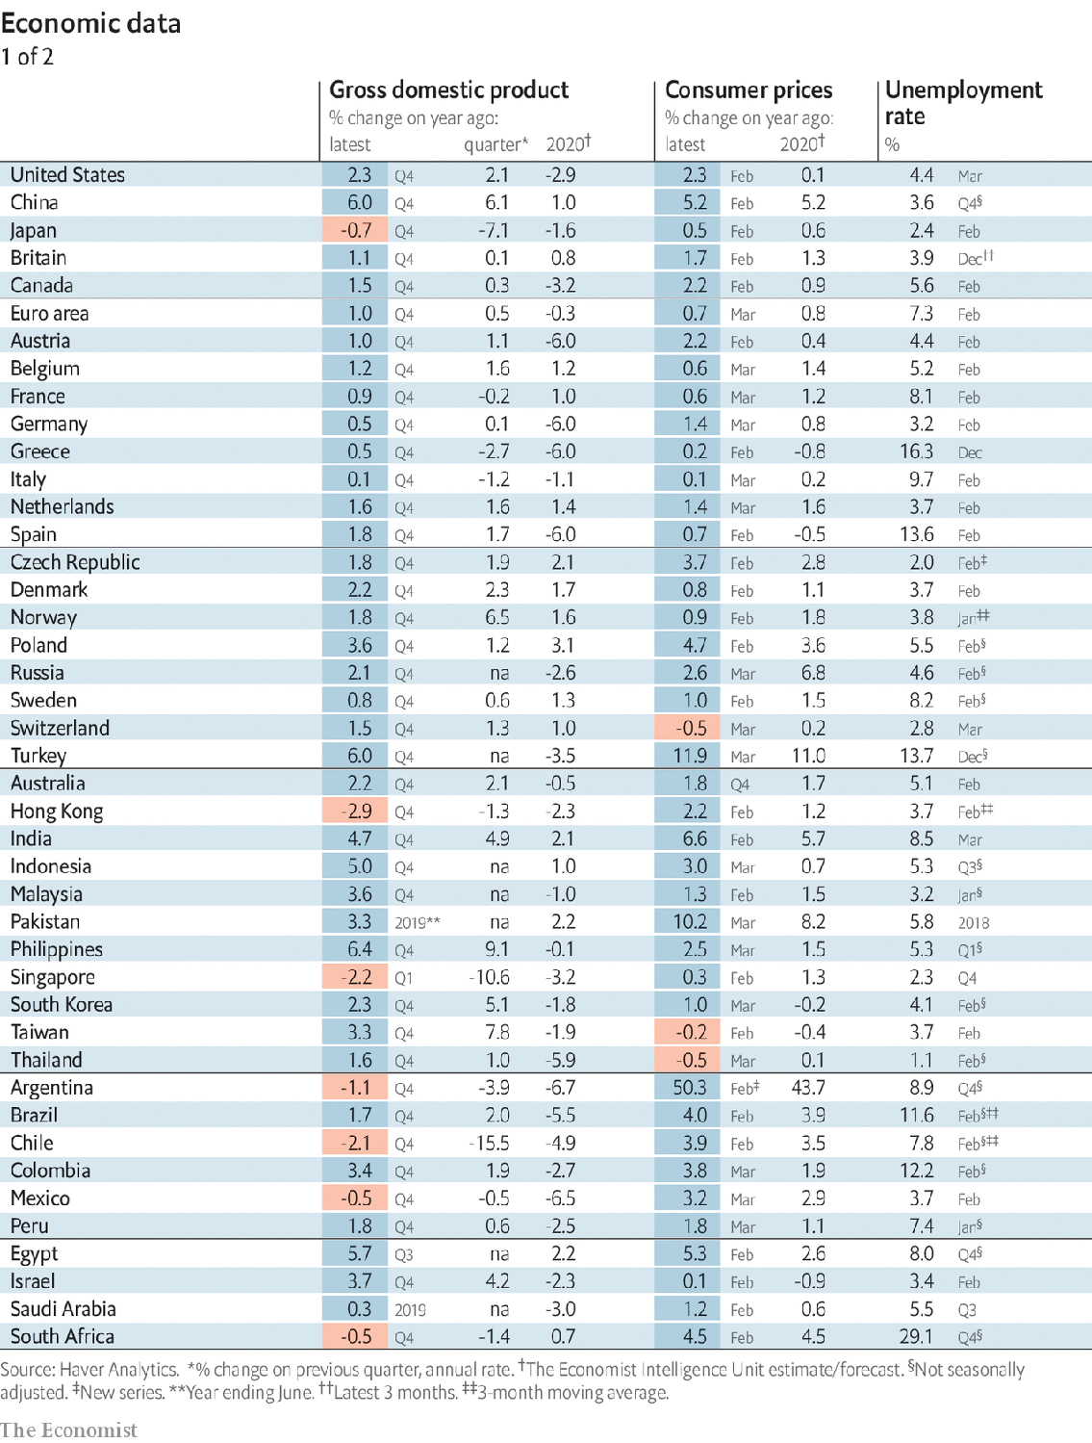

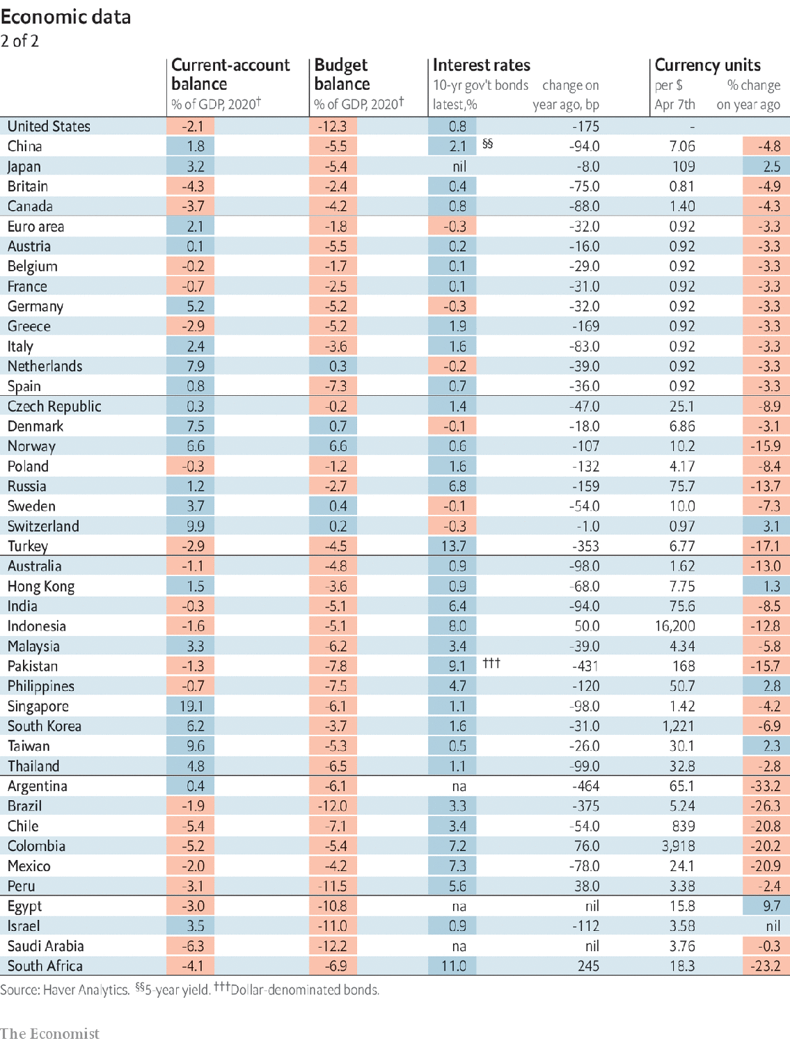

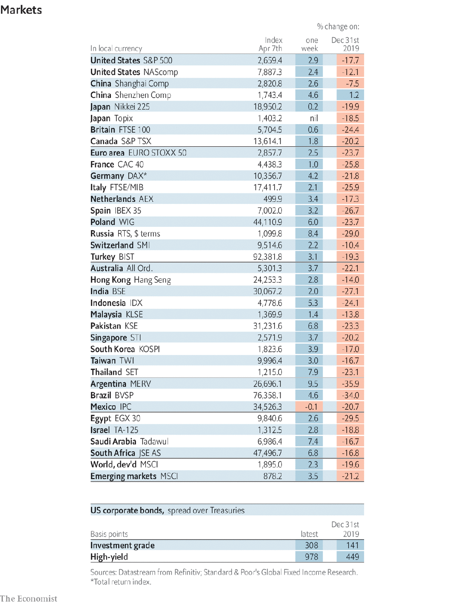

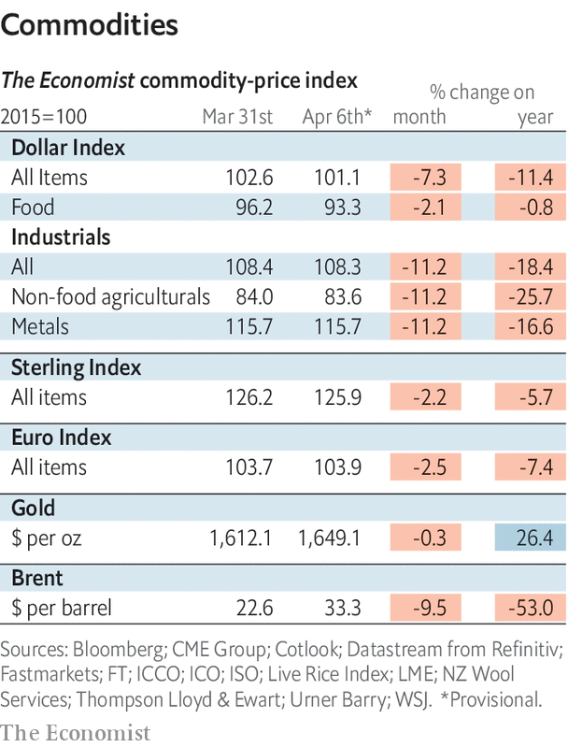

Read also on: <https://www.economist.com/economic-and-financial-indicators/2020/04/08/economic-data-commodities-and-markets>

|  |  |  |  |
| --- | --- | --- | --- |
|  | Articles | Sections | Next |

|  |  |  |
| --- | --- | --- |
| Economic and ... | Sections | Obituary |

Graphic detail

Measuring covid-19: Footprints of the invisible enemy

.

|  |  |  |
| --- | --- | --- |
| Economic and ... | Sections | Obituary |

|  |  |  |  |
| --- | --- | --- | --- |
|  | Articles | Sections | Next |

#### Footprints of the invisible enemy

# Why a study showing that covid-19 is everywhere is good news

If millions of people were infected weeks ago without dying, the virus must be less deadly than official data suggest

Apr 11th 2020 |

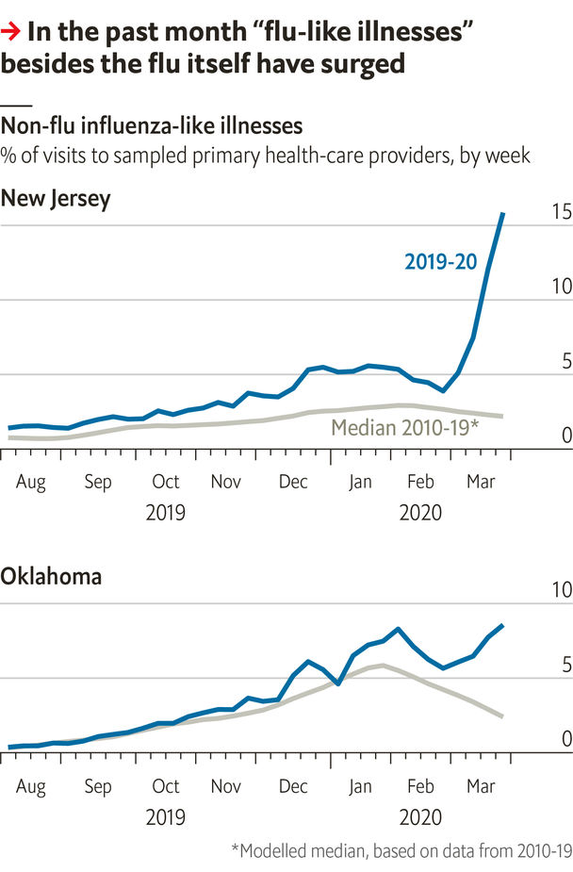

ONE OF THE few things known for sure about covid-19 is that it has spread faster than official data imply. Most countries have tested sparingly, focusing on the sick. Just 0.1% of Americans and 0.2% of Italians have been tested and come up positive. In contrast, a study of the entire population of the Italian town of Vò found a rate of 3%.

The lack of testing has set off a hunt for proxies for covid-19 infection, from smart-thermometer readings to Google searches for “I can’t smell”. A new paper by Justin Silverman and Alex Washburne uses data on influenza-like illness (ILI) to show that SARS-CoV-2 is now widespread in America.

Every week, 2,600 American clinicians report the share of their patients who have ILI—a fever of at least 37.8°C (100°F) and a cough or sore throat, without a known non-flu reason. Unsurprisingly, ILI is often caused by flu. But many other ailments also produce ILI, such as common colds, strep throat and, now, covid-19. The authors assume that the share of these providers’ patients with ILI who do have the flu matches the rate of flu tests that are positive in the same state and week. This lets them estimate how many people have ILI seriously enough to call a doctor, but do not have the flu—and how many more people have had non-flu ILI in 2020 than in prior years.

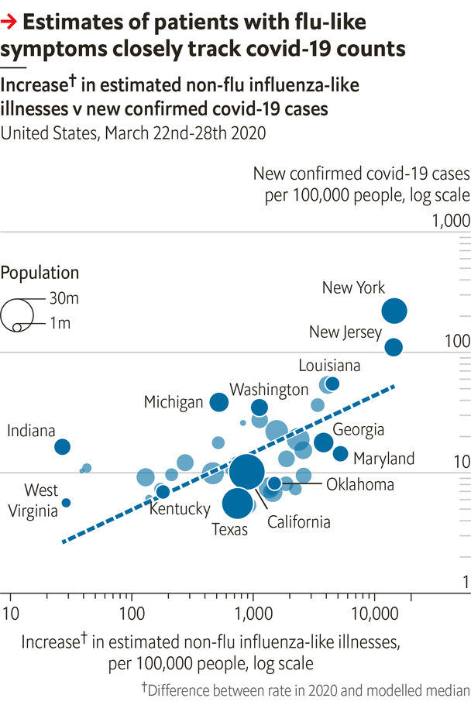

They find that non-flu ILI has surged. Its rise has the same geographic pattern as covid-19 cases: modest in states with few positive tests, like Kentucky, and steep in ones with big outbreaks, such as New Jersey. In total, estimated non-flu ILI from March 8th to 28th exceeded a historical baseline by 23m cases—200 times the number of positive covid-19 tests in that period. This may overstate the spread of covid-19, since non-flu ILI has other causes. It could also be too low, because people with asymptomatic or mild covid-19 would not report non-flu ILI.

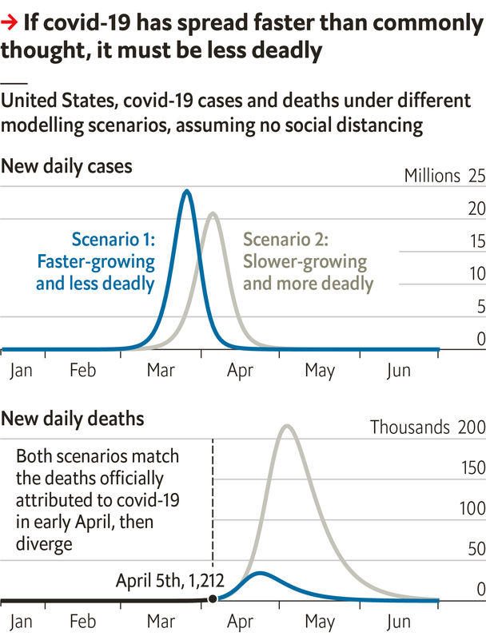

This sounds alarming, but should be reassuring. Covid-19 takes 20-25 days to kill victims. The paper reckons that 7m Americans were infected from March 8th to 14th, and official data show 7,000 deaths three weeks later. The resulting fatality rate is 0.1%, similar to that of flu. That is amazingly low, just a tenth of some other estimates. Perhaps it is just wrong, possibly because the death toll has been under-reported. Perhaps, though, New York’s hospitals are overflowing because the virus is so contagious that it has crammed the equivalent of a year’s worth of flu cases into one week. ■

Sources: “Using ILI surveillance to estimate state-specific case detection rates”, by J. Silverman & A. Washburne; Johns Hopkins CSSE

Read also on: <https://www.economist.com/graphic-detail/2020/04/11/why-a-study-showing-that-covid-19-is-everywhere-is-good-news>

|  |  |  |  |
| --- | --- | --- | --- |
|  | Articles | Sections | Next |

|  |  |  |
| --- | --- | --- |
| Graphic detail | Sections |  |

Obituary

Catherine Hamlin: Faith healing

.

|  |  |  |
| --- | --- | --- |
| Graphic detail | Sections |  |

|  |  |  |  |
| --- | --- | --- | --- |
|  | Articles | Sections | Next |

#### Healing hands

# Catherine Hamlin died on March 18th

The obstetric surgeon who brought relief to thousands of poor Ethiopian women was 96

Apr 8th 2020 |

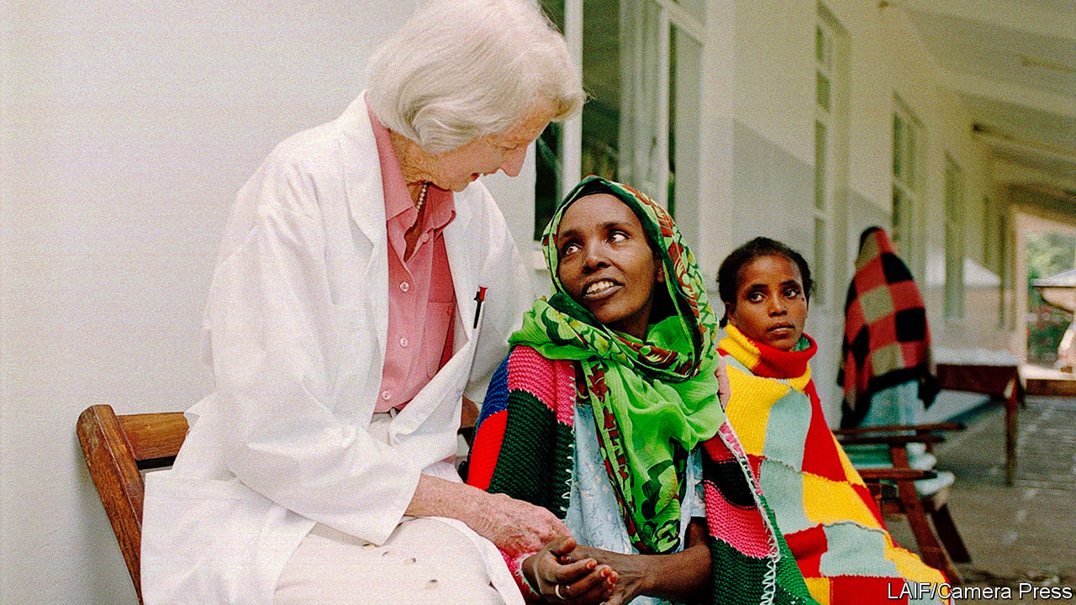

THE AD IN the Lancet called for a gynecologist to set up a midwifery school for nurses in Ethiopia. In the end they got two for the price of one—Catherine, who had grown up in a wealthy Sydney family, and her husband, Reg, from New Zealand. She was reminded of her homeland as soon as she saw the rugged, biblical landscape. It looked a bit like New South Wales, with its armies of gum trees arrayed along steep hillsides as in the Blue Mountains. She liked the lemony light of early morning when she would start the day with a cup of tea on her veranda and a passage from the Bible. But in other ways it wasn’t like home at all.

No one was there to meet the couple when, with their six-year-old son, Richard, they stepped off the dusty flight from Djibouti, where their ship had docked. The telegram announcing their arrival in Addis Ababa was not delivered until two weeks after they got there. Ethiopia had more pressing needs too, it turned out, than either midwifery or teaching.

Each day, when the hospital gates swung open, she found them there, the young women who believed she might be their last hope. Some had been carried for hundreds of kilometres on the back of their fathers or mothers, others had spent years saving for the bus fare. One arrived at night and, finding the gate shut, tried to hang herself. In the morning the guards cut her down; Dr Hamlin operated, and cured her.

They all had terrible internal injuries, such as had not been seen in Europe, America or Australia since the 19th century. Here these were endemic, owing to the malnutrition that meant the bodies of Ethiopian girls remained small. The attitude of the Ethiopian Orthodox church which encouraged child marriage—to keep girls virtuous, they insisted—only made things worse, as did the lack of obstetric care, especially in rural areas. Betrothed at eight or nine, girls would find themselves pregnant in their early teens. When they went into labour, sometimes with no one to help but a wogesha, a village doctor offering a potion made of herbs, it went on and on. There was nothing to do but squat and push, often for five or six days. If the fetus did not survive, the only reason the mother could eventually deliver was because babies get smaller when they are dead.

But then, as she discovered, the mother wakes up to an even greater horror: her bed is soaked and stinks. Her protracted labour has left her so badly injured that her vagina has ruptured, her bladder is shredded, her rectum torn. Urine and faeces leak out of her without cease. Soon, her husband leaves her. Her family and her village community turn their backs on her. She lies on her bed, her legs drawn up to her chin to try to stem the flow; shame is her only company.

The Hamlins would sit up late into the night in their little mud-built house in the hospital grounds, studying the history of obstetric fistula, as these injuries were known, which was first written about in 1550BC. They went over the evolution of the treatment, rereading the autobiography of Marion Sims, who, in the 1850s had treated similar injuries among American slave women. Of the two of them, he was the conventional one, doing things the way they had always been done. She was the more flexible, ever prepared to experiment, radically cutting away scar tissue, for example, or trying out a technique known as the Martius fat-pad graft in which a piece of fat partly cut from the side of the vagina was used to repair the bladder—and create a reinforcement between the bladder muscle and the skin of the vagina, offering protection in a future pregnancy. When she wrote to Heinrich Martius of her success after doing the surgery hundreds of times, he replied: “I’m glad you’re curing these women with my operation. I’ve only done 26.” Her small hands, wearing surgical scrubs during the week and white gloves for church on Sundays, were perfect for suturing within the small confined spaces of women’s bodies.

Some patients were too far gone, and died. But many recovered and went home—always in a new dress that she gave them for the journey. Others made a life in the hospital as assistants to the nurses, like Enatanesh Demisse whose urethra Dr Hamlin rebuilt using muscle taken from her leg, or Lete Birhan, who was not only incontinent when she arrived, but also paralysed from the waist down having been knocked over by a car. Once treated by the doctor, Lete, in her wheelchair, became a stalwart of the hospital’s physiotherapy department.

## Oprah signs a cheque

Soon the hospital was curing more than 90% of its patients. Surgeons came from around the world to see her work. Having delivered several of the imperial princesses, she asked the emperor for land so the hospital could expand. In 1993, when Reg died, she found herself, at almost 70, taking on yet more tasks. The hospital had survived the Derg, which overthrew the emperor in 1974, and the famine that stalked the country. By then she had treated more than 25,000 fistula cases. To help it grow she taught herself to speak to crowds of people and to ask for money. She told Oprah Winfrey, whom she’d never heard of before flying to Chicago to appear on her television show in 2004, that she was a professional beggar. Oprah signed her a personal cheque for $450,000, a year’s running expenses for the hospital.

She was still operating when she was 92, stopping only when she could no longer stand without her sticks to make that first incision. She even built the midwifery school the original Lancet ad had called for. She did all this, she told Oprah, because she believed that was what God wanted her to do. She was not a missionary doctor, but a doctor who was a Christian. She loved the spirituality of the Ethiopians and was not rigid about where she herself worshipped, moving from church to church wherever she liked the message or the minister. She thought of herself as an ordinary woman. The Ethiopians called her Emaye, Amharic for mother. They thought of her as a saint. ■

Read also on: <https://www.economist.com/obituary/2020/04/08/catherine-hamlin-died-on-march-18th>

|  |  |  |  |
| --- | --- | --- | --- |
|  | Articles | Sections | Next |